Extraction of cellulose microfibers from waste fallen leaves and fabrication of a degradable composite film for packaging applications
Vinitsa Chanthavongª, M. N. Prabhakar^{b}*, Lee Dong Woo^{b}, Jung-il Song^{c}
ª Changwon National University, Department of Smart Manufacturing Engineering, 20 Changwondaehak-ro, Uichang-gu, Changwon, Gyeongsangnam-do, 51140, Republic of Korea
^{b} Changwon National University, Research Institute of Mechatronics, Department of Mechanical Engineering, 20 Changwondaehak-ro, Uichang-gu, Changwon, Gyeongsangnam-do, 51140, Republic of Korea
^{b} Changwon National University, Department of Mechanical Engineering, 20 Changwondaehak-ro, Uichang-gu, Changwon, Gyeongsangnam-do, 51140, Republic of Korea

*Corresponding author: dr_prabhakar@changwon.ac.kr

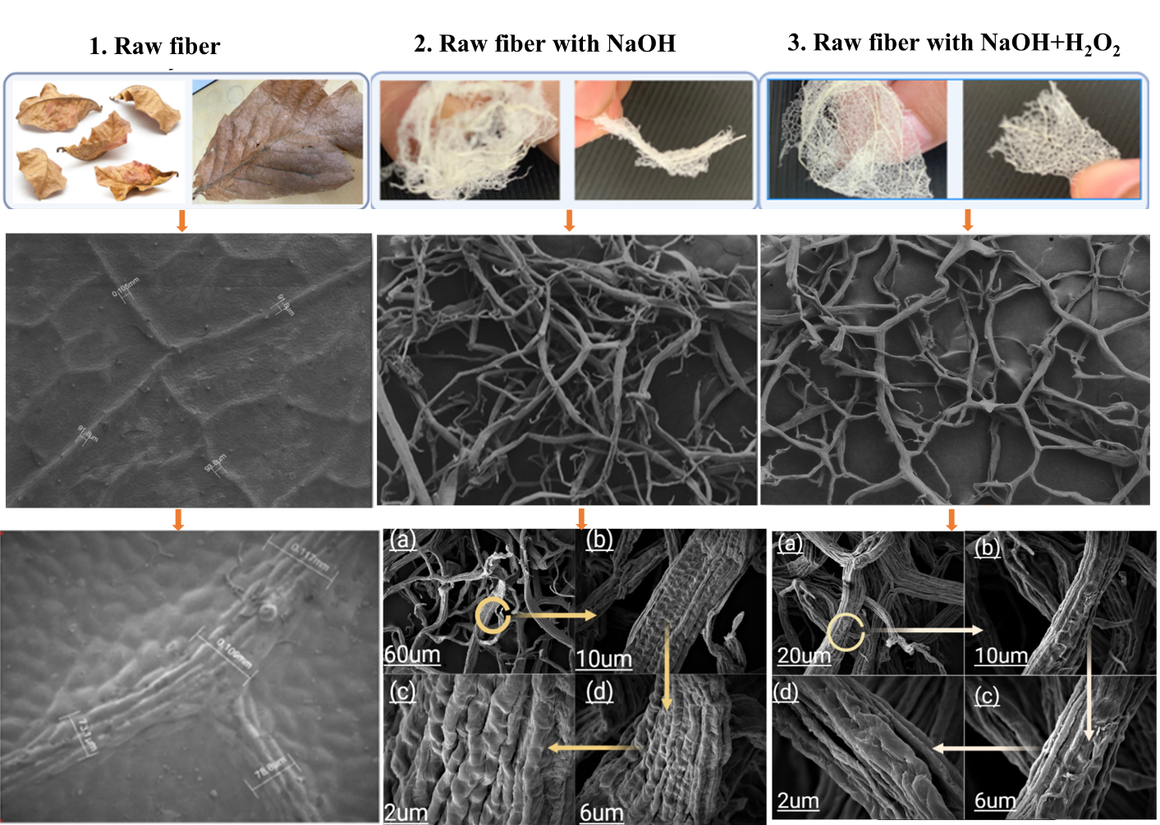

SIFig.1.SEM of raw fiber and cellulose fiber. (1) raw fiber without treatment, (2) waste fallen dried leaves with only NaOH treatment, and (3) waste fallen dried leaves with alkaline treatment.

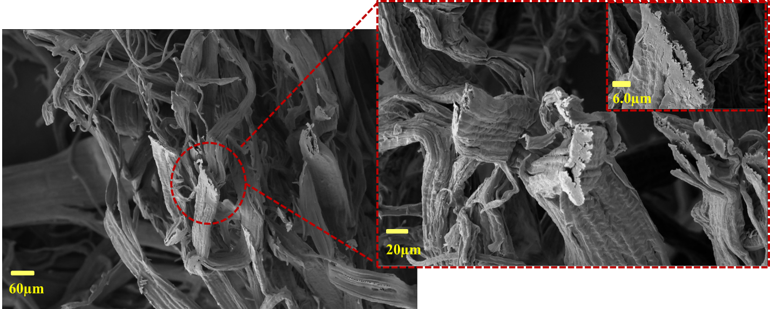

SIFig. 2. Fracture surface of CMFs

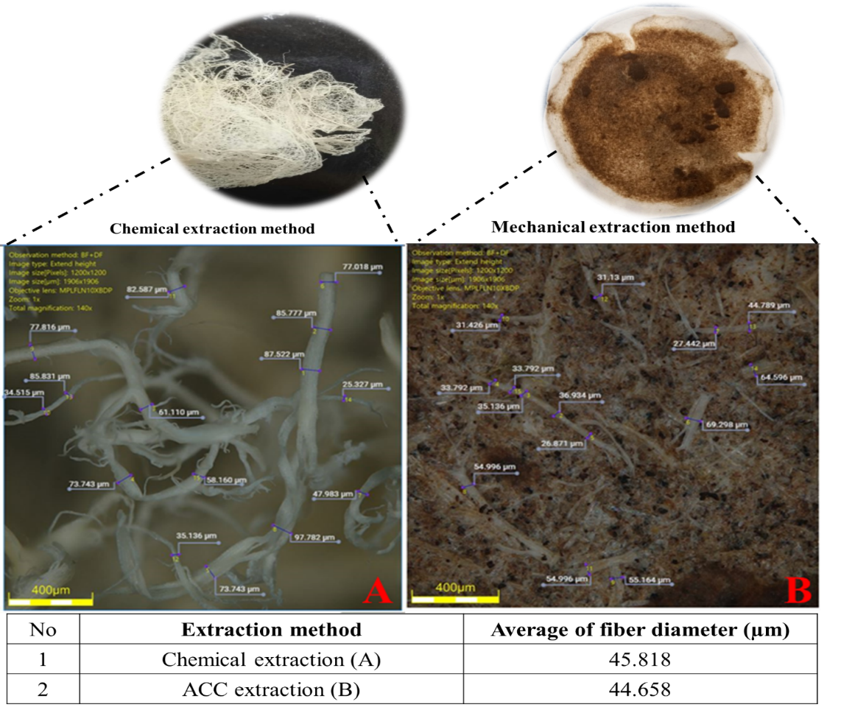
SIFig. 3. 3D images and diameter of CMFs from (A) chemical and (B) mechanical extraction processes
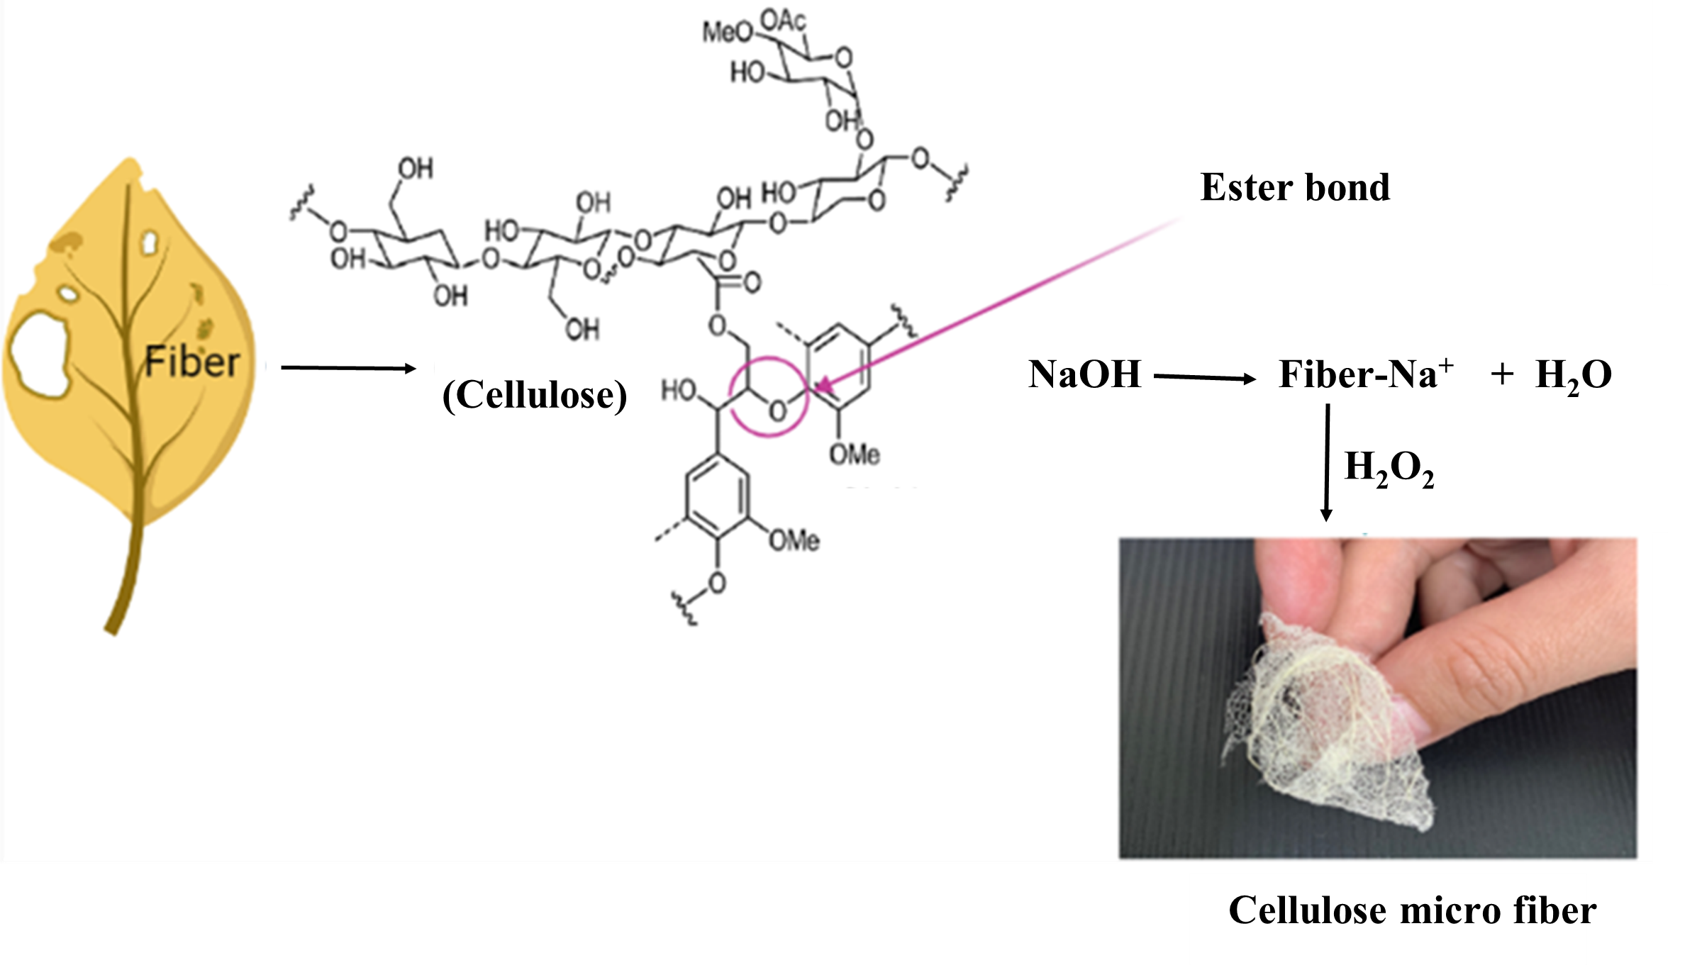
SIFig. 4. Schemitic representation of reaction of NaOH with –OH groups of natural fibers

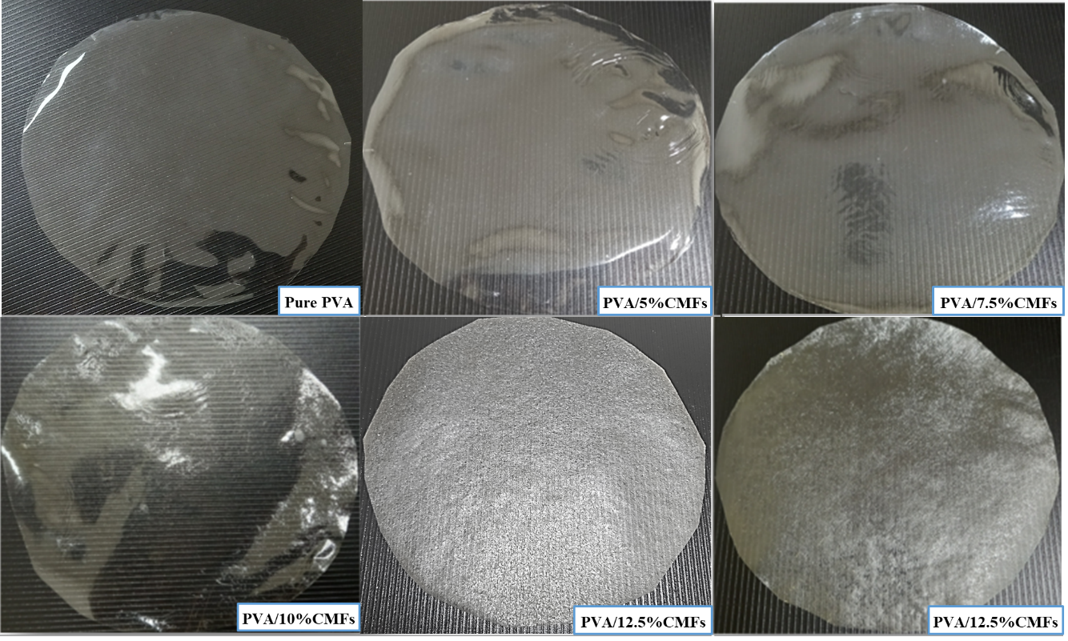

SIFig. 5 Digital images of pure PVA and CMFs/PVA composite films
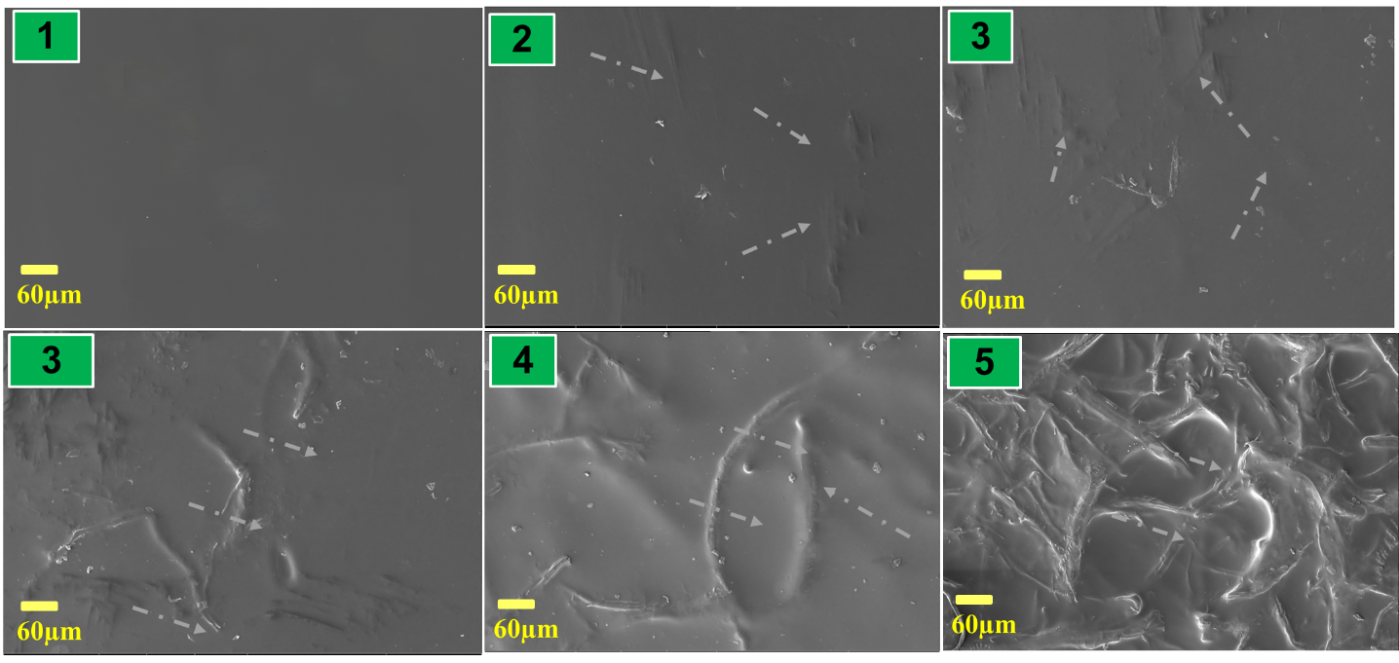
SIFig. 6. SEM images of (1) Pure PVA, (2) PVA/5% cellulose, (3) PVA/7.5% cellulose, (4) PVA/10% cellulose and (5) PVA/12.5% cellulose and (6) PVA/15% cellulose
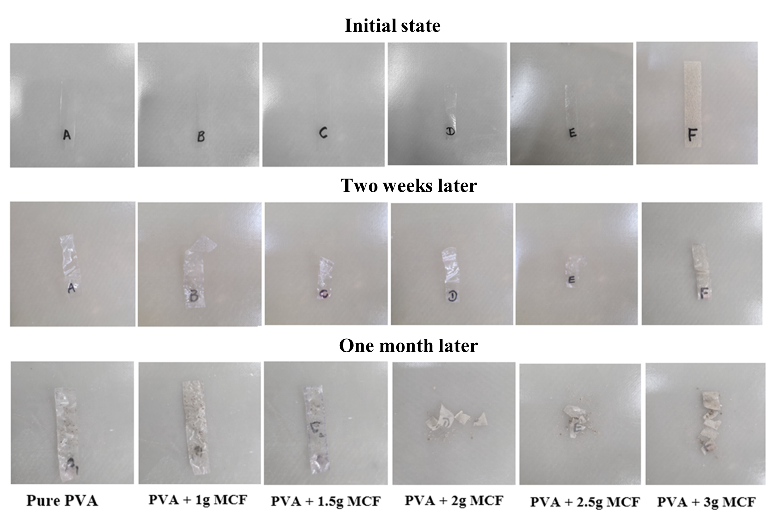
SIFig. 7. The biodegradable test in soil of PVA film in 2 weeks and 1 month shows that plastic film degrades more quickly with increasing CMFs concentration.

