Table 7: Factor loadings with eigen and variance values
Variable | Dim.1 | Dim.2 | Dim.3 | Dim.4 | Dim.5 | Eigen value | Percentage of variance | Cumulative percentage of variance
Information flow | 0.712 | 0.074 | 0.182 | -0.306 | -0.097 | 5.974 | 39.825 | 39.825
Hospital staff relations | 0.732 | 0.133 | 0.246 | -0.255 | -0.233 | 1.733 | 11.550 | 51.376
Delivery of drugs | 0.623 | 0.482 | 0.243 | -0.306 | -0.148 | 1.368 | 9.118 | 60.493
Waiting time | 0.599 | 0.522 | 0.240 | -0.121 | 0.115 | 1.249 | 8.328 | 68.821
Accessibility to health services | 0.617 | 0.342 | 0.017 | -0.033 | 0.064 | 0.894 | 5.958 | 74.779
Laboratory testing procedures | 0.330 | -0.092 | 0.377 | 0.051 | 0.836 | 0.713 | 4.755 | 79.534
Believability/trust for health information | 0.688 | -0.483 | 0.204 | 0.141 | -0.042 | 0.583 | 3.890 | 83.424
Interpretability | 0.708 | -0.448 | 0.248 | 0.246 | -0.177 | 0.504 | 3.359 | 86.783
Understandability | 0.652 | -0.429 | 0.315 | 0.311 | -0.147 | 0.409 | 2.724 | 89.506
Price | 0.594 | 0.329 | -0.166 | 0.480 | -0.015 | 0.367 | 2.450 | 91.956
Timeliness | 0.612 | 0.270 | -0.150 | 0.465 | -0.002 | 0.312 | 2.083 | 94.039
Believability/trust for drugs/vaccines | 0.619 | -0.390 | -0.306 | -0.416 | 0.123 | 0.284 | 1.891 | 95.930
Effectiveness | 0.636 | -0.332 | -0.380 | -0.394 | 0.067 | 0.247 | 1.645 | 97.575
Accessibility | 0.661 | 0.002 | -0.537 | 0.080 | 0.021 | 0.202 | 1.349 | 98.924
Price of drugs | 0.586 | 0.132 | -0.486 | 0.143 | 0.129 | 0.161 | 1.076 | 100.000

Table 8 Factor loadings with communality and uniqueness values
No | Variable | Dim.1 | Dim.2 | Dim.3 | Dim.4 | Dim.5 | Communality | Uniqueness
1 | Information flow | 0.712 | 0.074 | 0.182 | -0.306 | -0.097 | 0.648 | 0.352
2 | Hospital staff relations | 0.732 | 0.133 | 0.246 | -0.255 | -0.233 | 0.733 | 0.267
3 | Delivery of drugs | 0.623 | 0.482 | 0.243 | -0.306 | -0.148 | 0.795 | 0.205
4 | Waiting time | 0.599 | 0.522 | 0.24 | -0.121 | 0.115 | 0.716 | 0.284
5 | Accessibility to health services | 0.617 | 0.342 | 0.017 | -0.033 | 0.064 | 0.504 | 0.496
6 | Laboratory testing procedures | 0.33 | -0.092 | 0.377 | 0.051 | 0.836 | 0.961 | 0.0392
7 | Believability/trust for health information | 0.688 | -0.483 | 0.204 | 0.141 | -0.042 | 0.771 | 0.229
8 | Interpretability | 0.708 | -0.448 | 0.248 | 0.246 | -0.177 | 0.856 | 0.144
9 | Understandability | 0.652 | -0.429 | 0.315 | 0.311 | -0.147 | 0.827 | 0.173
10 | Price | 0.594 | 0.329 | -0.166 | 0.48 | -0.015 | 0.719 | 0.281
11 | Timeliness | 0.612 | 0.27 | -0.15 | 0.465 | -0.002 | 0.686 | 0.314
12 | Believability/trust for drugs/vaccines | 0.619 | -0.39 | -0.306 | -0.416 | 0.123 | 0.817 | 0.183
13 | Effectiveness | 0.636 | -0.332 | -0.38 | -0.394 | 0.067 | 0.819 | 0.181
14 | Accessibility | 0.661 | 0.002 | -0.537 | 0.080 | 0.021 | 0.731 | 0.269
15 | Price of drugs | 0.586 | 0.132 | -0.486 | 0.143 | 0.129 | 0.634 | 0.366

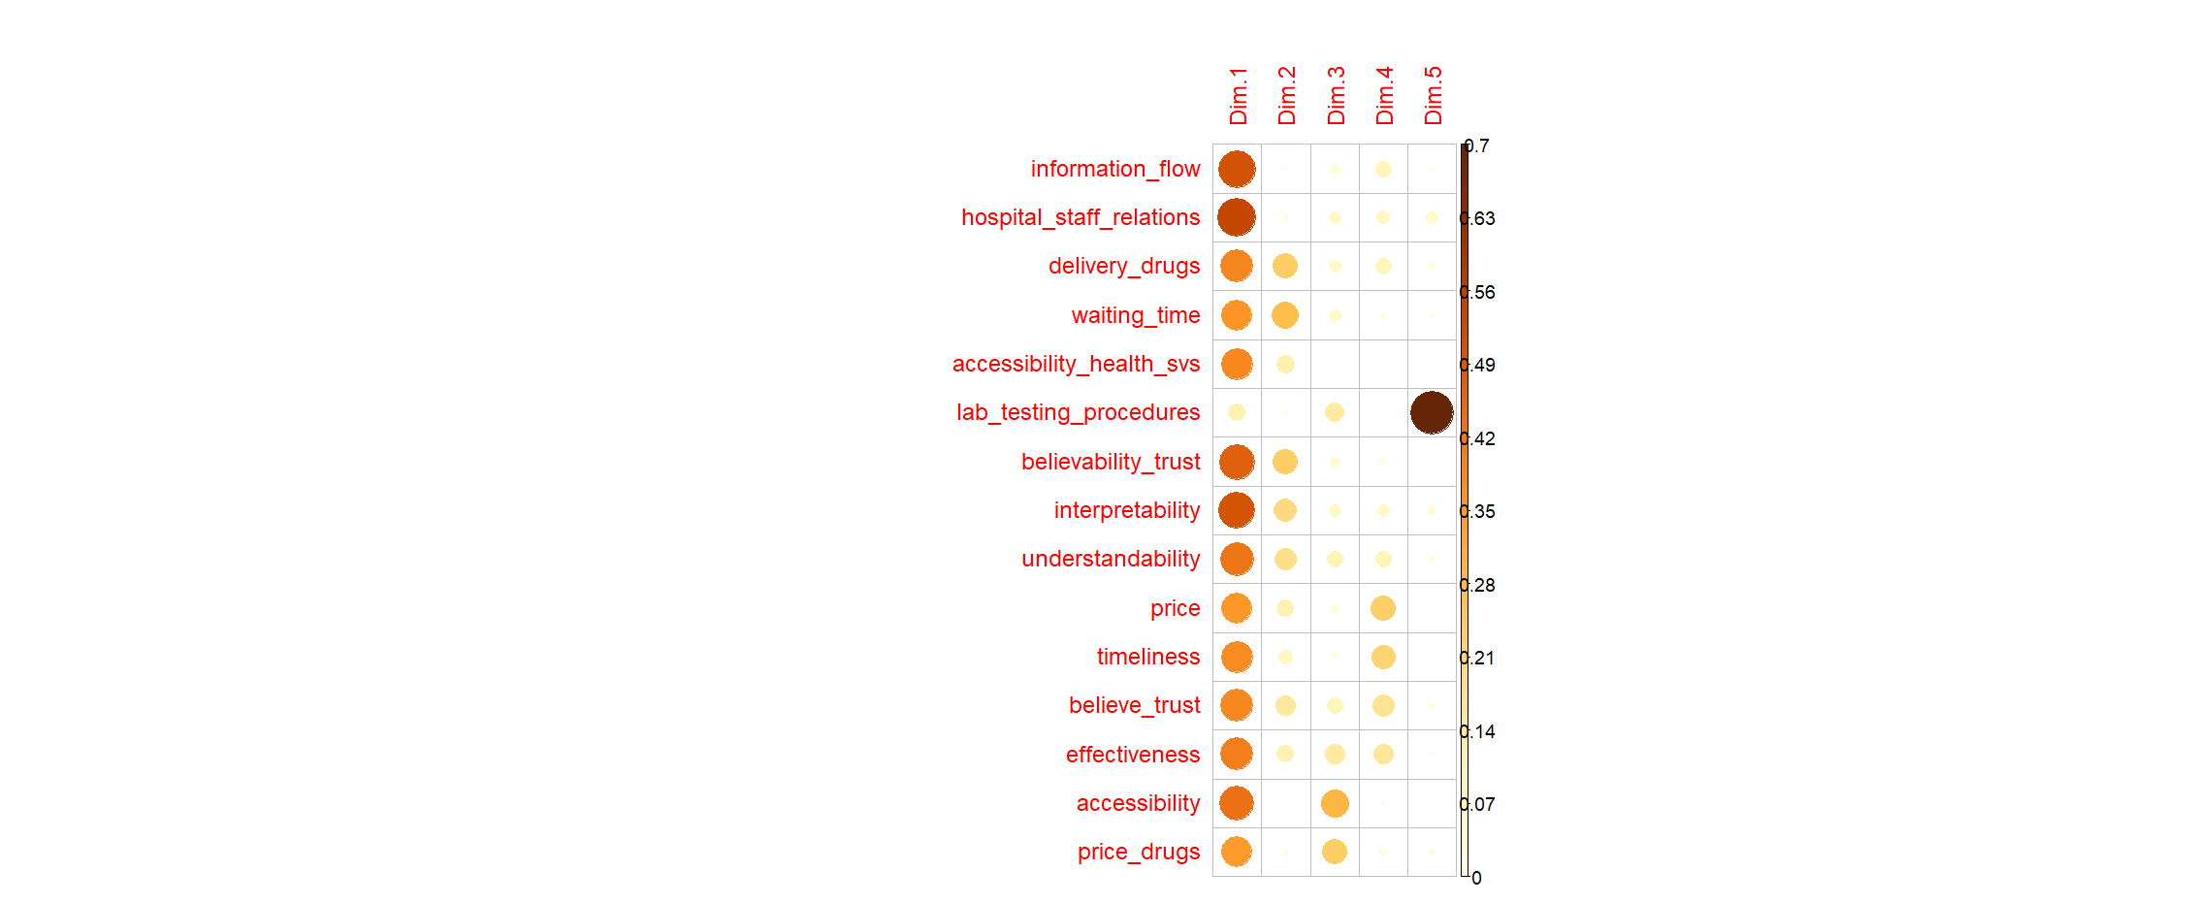
Figure 6: Contribution of the different variables to the principal components

