A pan-cancer analysis of the core pre-mRNA 3′ end processing factors, and their association with prognosis, tumor microenvironment, and potential targets

Xiangyu Li^{1,3}, Yu Che^{1,3}, Xiaoyan Wang^{2,*}, Yong Zhu^{1,*}

¹Institute of Life Sciences, Chongqing Medical University Chongqing 400016 , P R China.
²Chongqing Medical and Pharmaceutical College Chongqing 401331, P R China.
³These authors contributes equally: Xiangyu Li and Yu Che
*Corresponding Author: Xiaoyan Wang and Yong Zhu

Email:438618931@qq.com (Dr Wang), yongz59@cqmu.edu.cn (Dr Zhu)

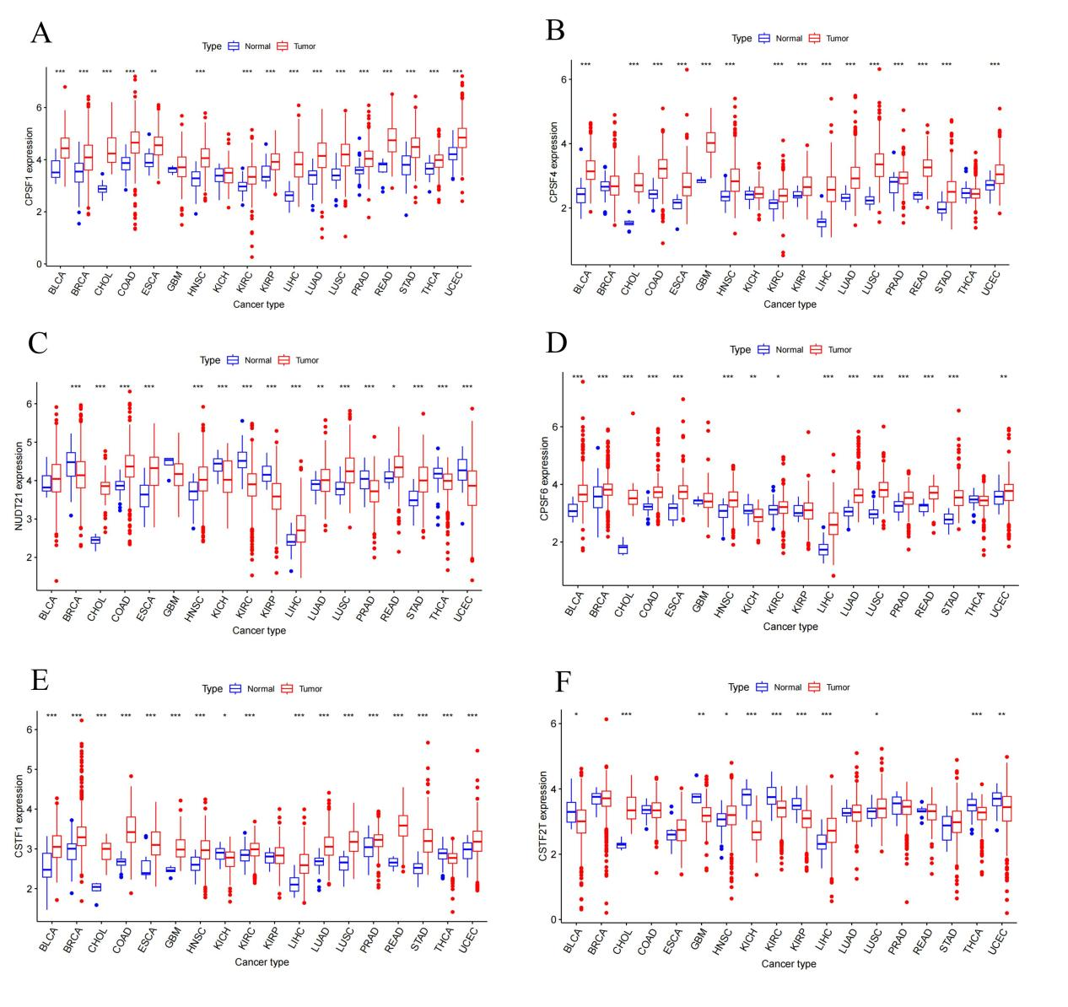
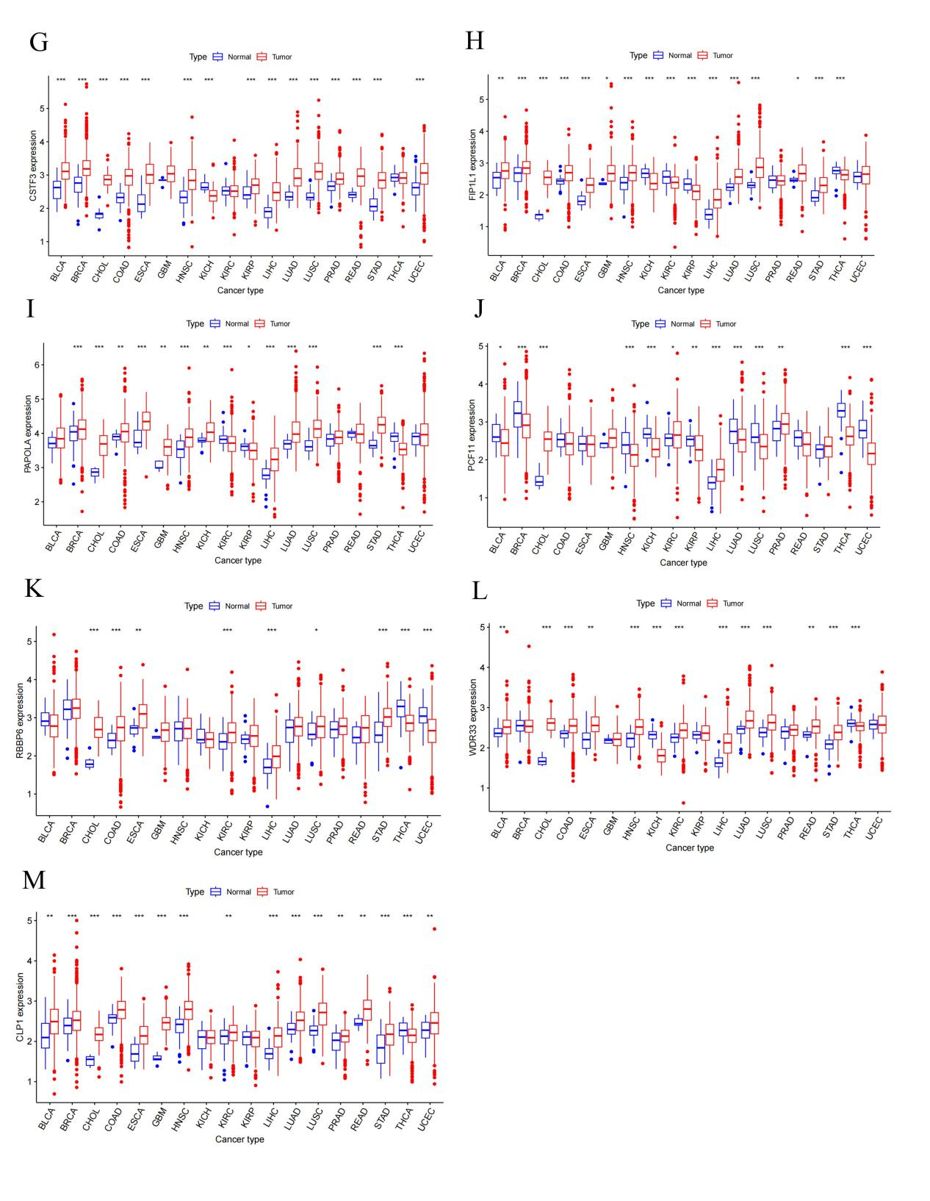
Figure S1 pre-mRNA 3′ end processing factors expression levels in different cancer types and normal tissue. (A) CPSF1, (B) CPSF4, (C) NUDT21, (D) CPSF6, (E) CSTF1, (F) CSTF2T, (G) CSTF3, (H) FIP1L1, (I) PAPOLA, (J) PCF11, (K) RBP6, (L) WDR33, (M) CLP1. The red rectangle box represents gene expression levels in tumor tissue and the blue rectangle box represents normal tissue. * P < 0.05, ** P < 0.01, and *** P < 0.001. Red- and blue-colored names indicate high and low expressions of the corresponding pre-mRNA 3′ end processing factors, respectively. BLCA, bladder urothelial carcinoma; BRCA, breast invasive carcinoma; CHOL, Cholangiocarcinoma; COAD, Colon adenocarcinoma; ESCA, Esophageal carcinoma; GBM, glioblastoma multiforme; HNSC, head and neck squamous cell carcinoma; KICH, Kidney Chromophobe; KIRC, kidney renal clear cell carcinoma; KIRP, kidney renal papillary cell carcinoma; LIHC, Liver hepatocellular carcinoma; LUAD, Lung adenocarcinoma; LUSC, Lung squamous cell carcinoma; PRAD, Prostate adenocarcinoma; READ, Rectum adenocarcinoma; STAD, Stomach adenocarcinoma; THCA, Thyroid carcinoma; UCEC, uterine corpus endometrial carcinoma. (For interpretation of the references to color in this figure legend, the reader is referred to the web version of this article.)

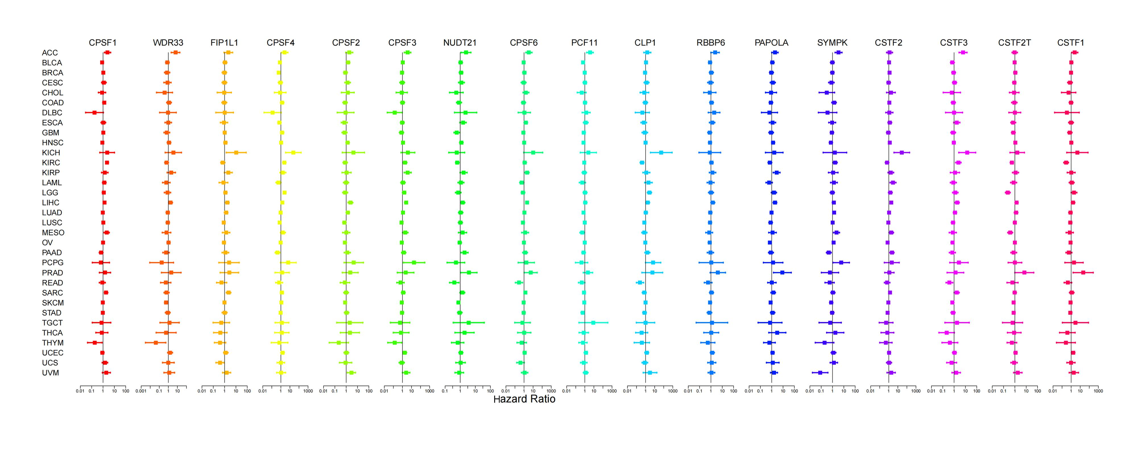
Figure S2 Correlation analysis of pre-mRNA 3′ end processing factors expression with survival by the COX method in different types of cancers. Different colored lines indicate the risk value of different genes in tumors, hazard ratio < 1 represent low risk and hazard ratio > 1 represent high risk.
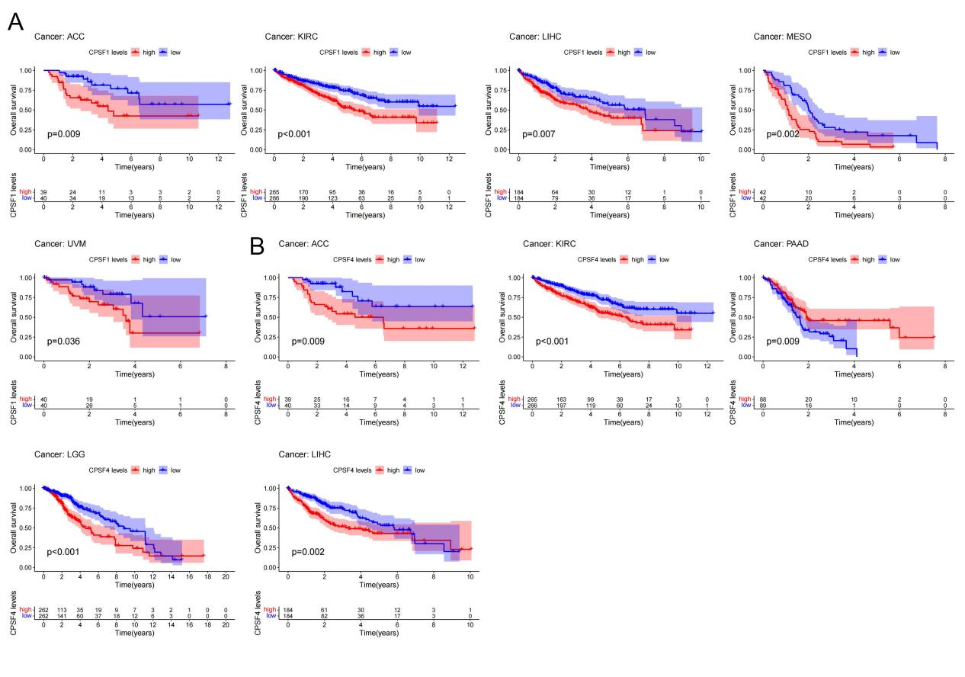
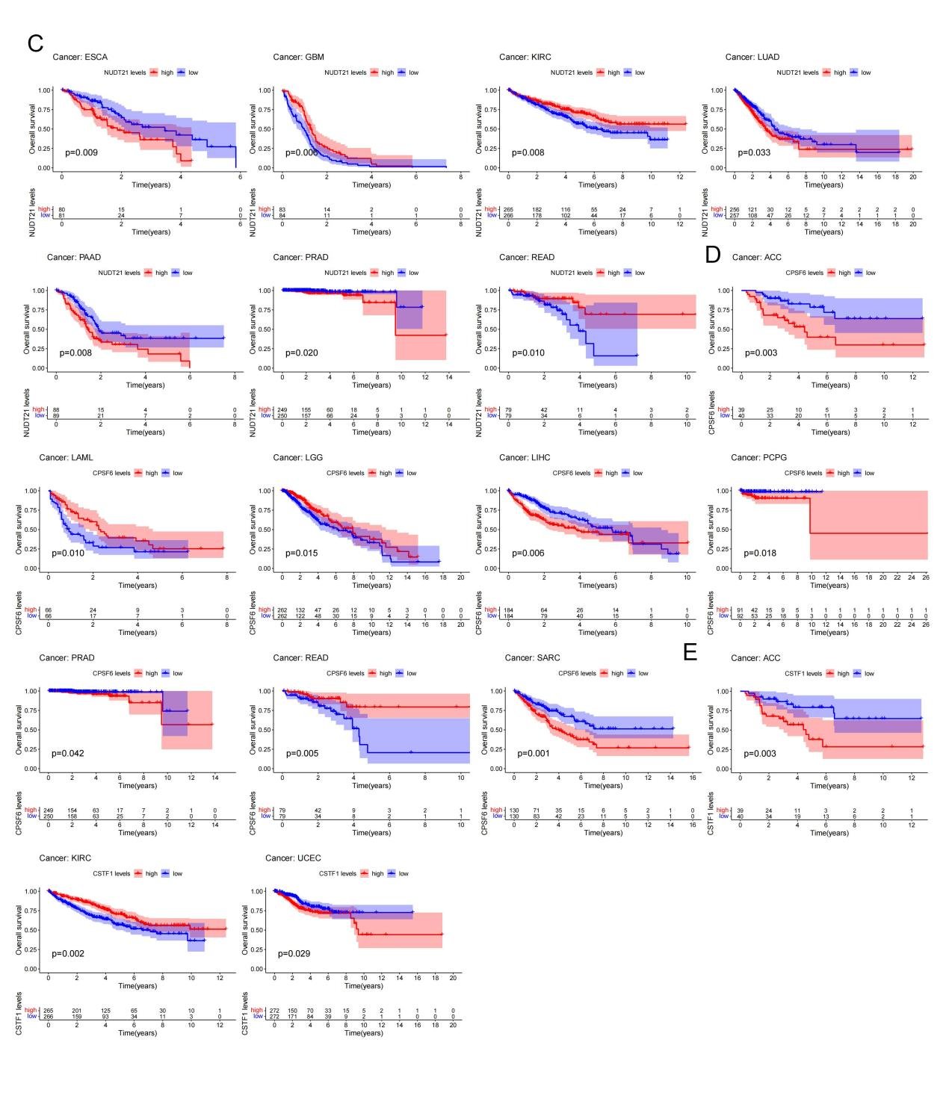
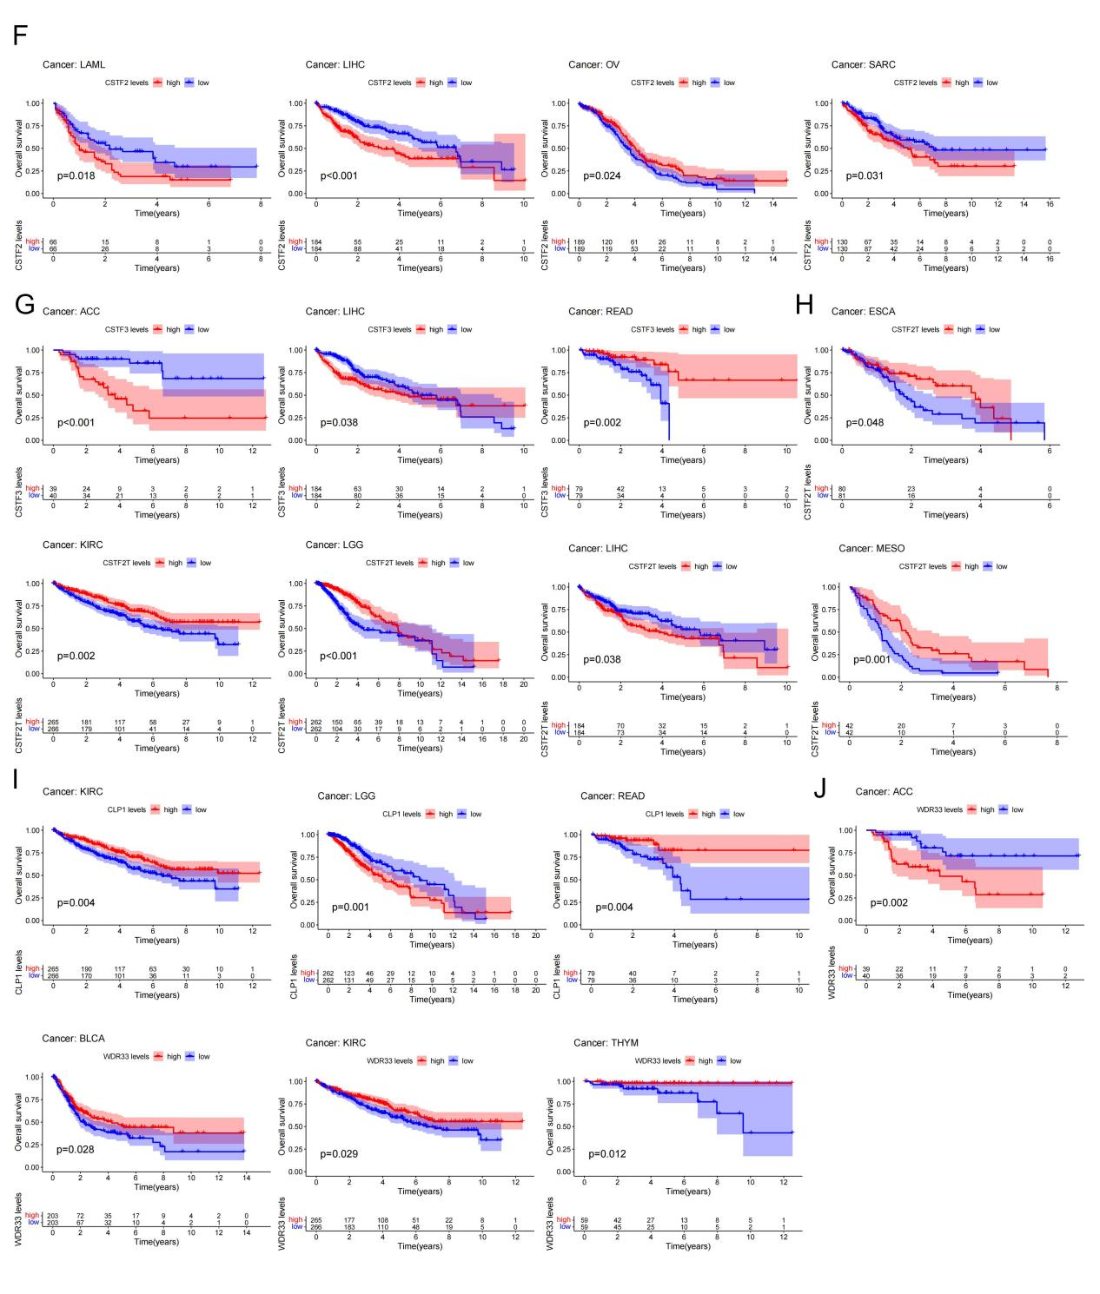
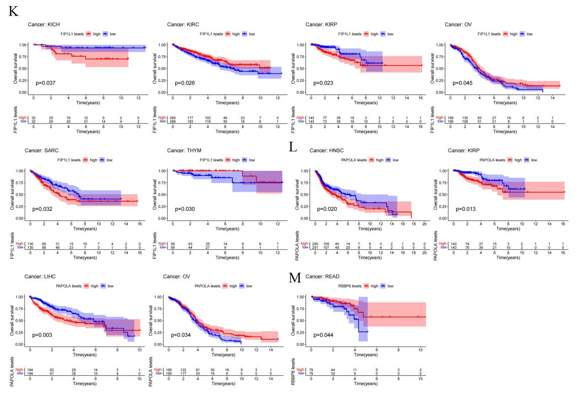
Figure S3 Kaplan-Meier survival curves comparison of high and low expression of pre-mRNA 3′ end processing factors in pan-cancer. OS survival curves of pre-mRNA 3′ end processing factors in different cancers: (A) CPSF1, (B) CPSF4, (C) NUDT21, (D) CPSF6, (E) CSTF1, (F) CSTF2T, (G) CSTF3, (H) CSTF2T, (I) CLP1, (J) WDR33, (K) FIP1L1, (L) PAPOLA, (M) RBP6.
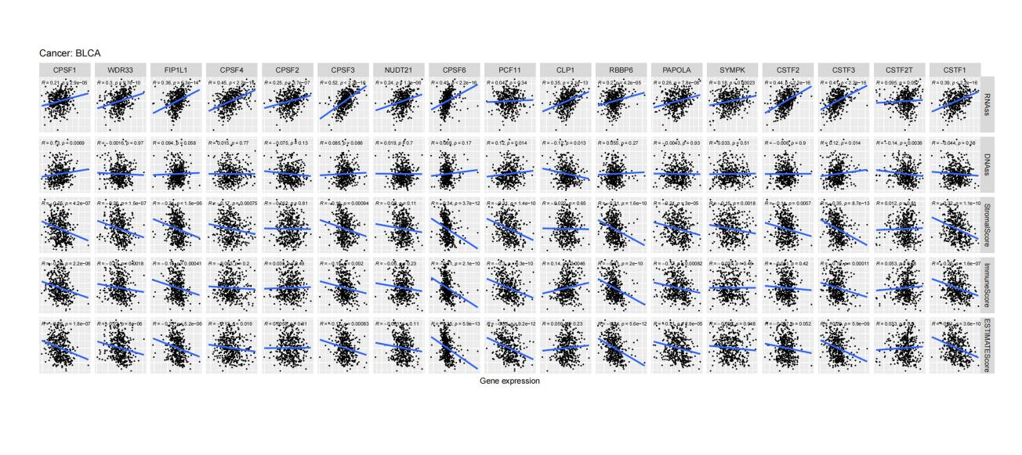
FigureS4 Correlation analysis of the expression of pre-mRNA 3′ end processing factors with RNAss, DNAss, stromal score, immune score, and ESTIMATE score in BLCA.

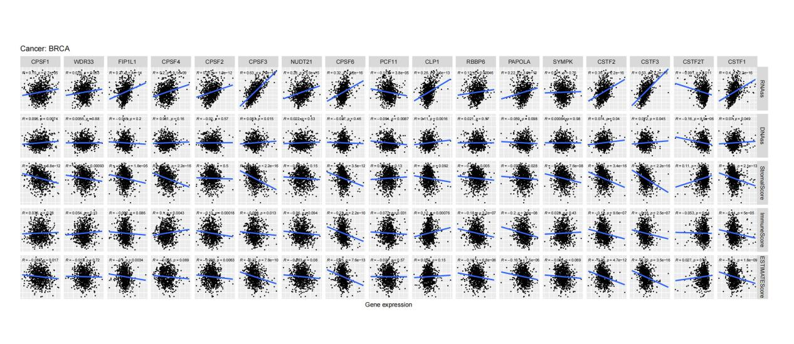
FigureS5 Correlation analysis of the expression of pre-mRNA 3′ end processing factors with RNAss, DNAss, stromal score, immune score, and ESTIMATE score in BRCA.
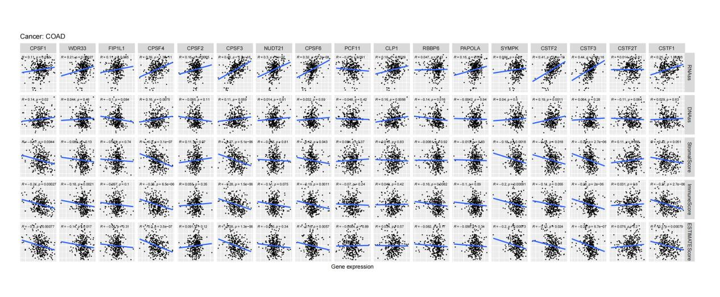
FigureS6 Correlation analysis of the expression of pre-mRNA 3′ end processing factors with RNAss, DNAss, stromal score, immune score, and ESTIMATE score in COAD.

