Supplementary materials
Multilayer factors associated with excess all-cause mortality during the Omicron and non-Omicron waves of the COVID-19 pandemic: time series analysis in 29 countries

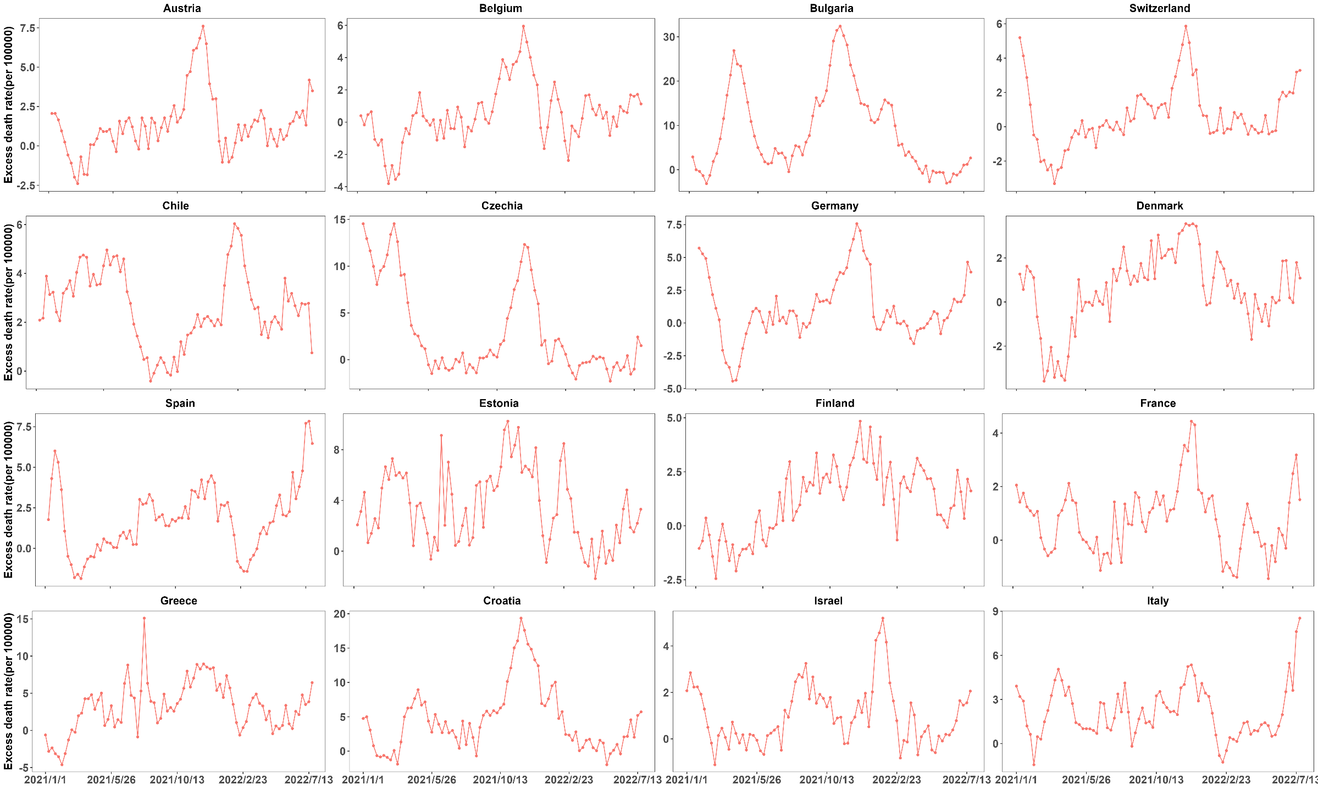
Figure S1. The weekly excess mortality due to the COVID-19 pandemic across 29 countries/states.
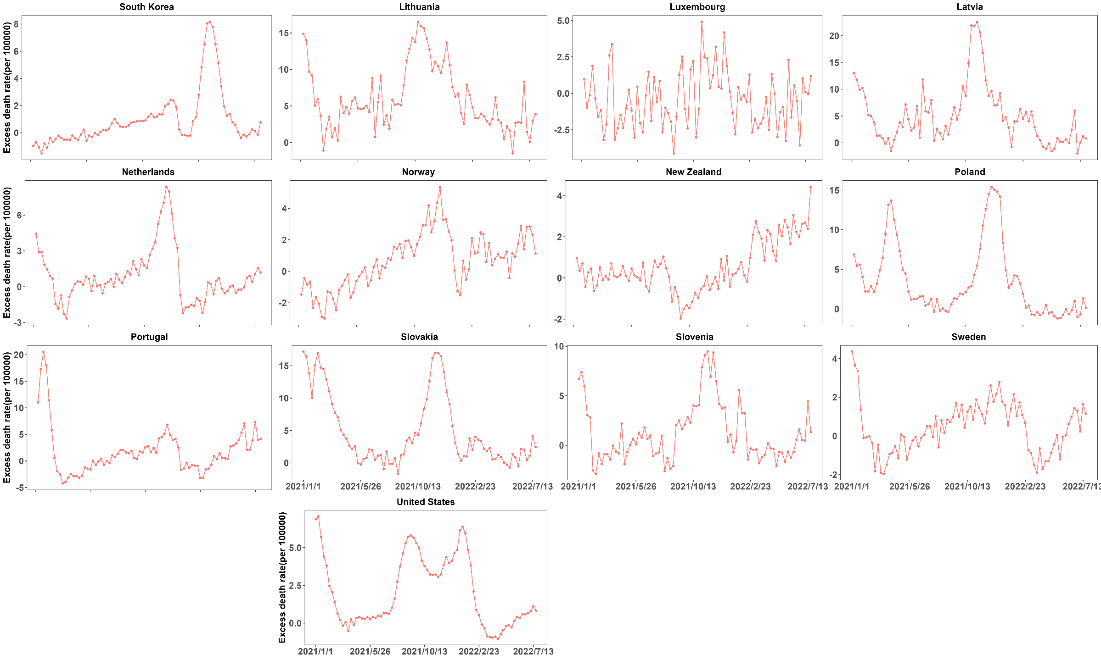
Figure S1. The weekly excess mortality due to the COVID-19 pandemic across 29 countries/states (Continued).

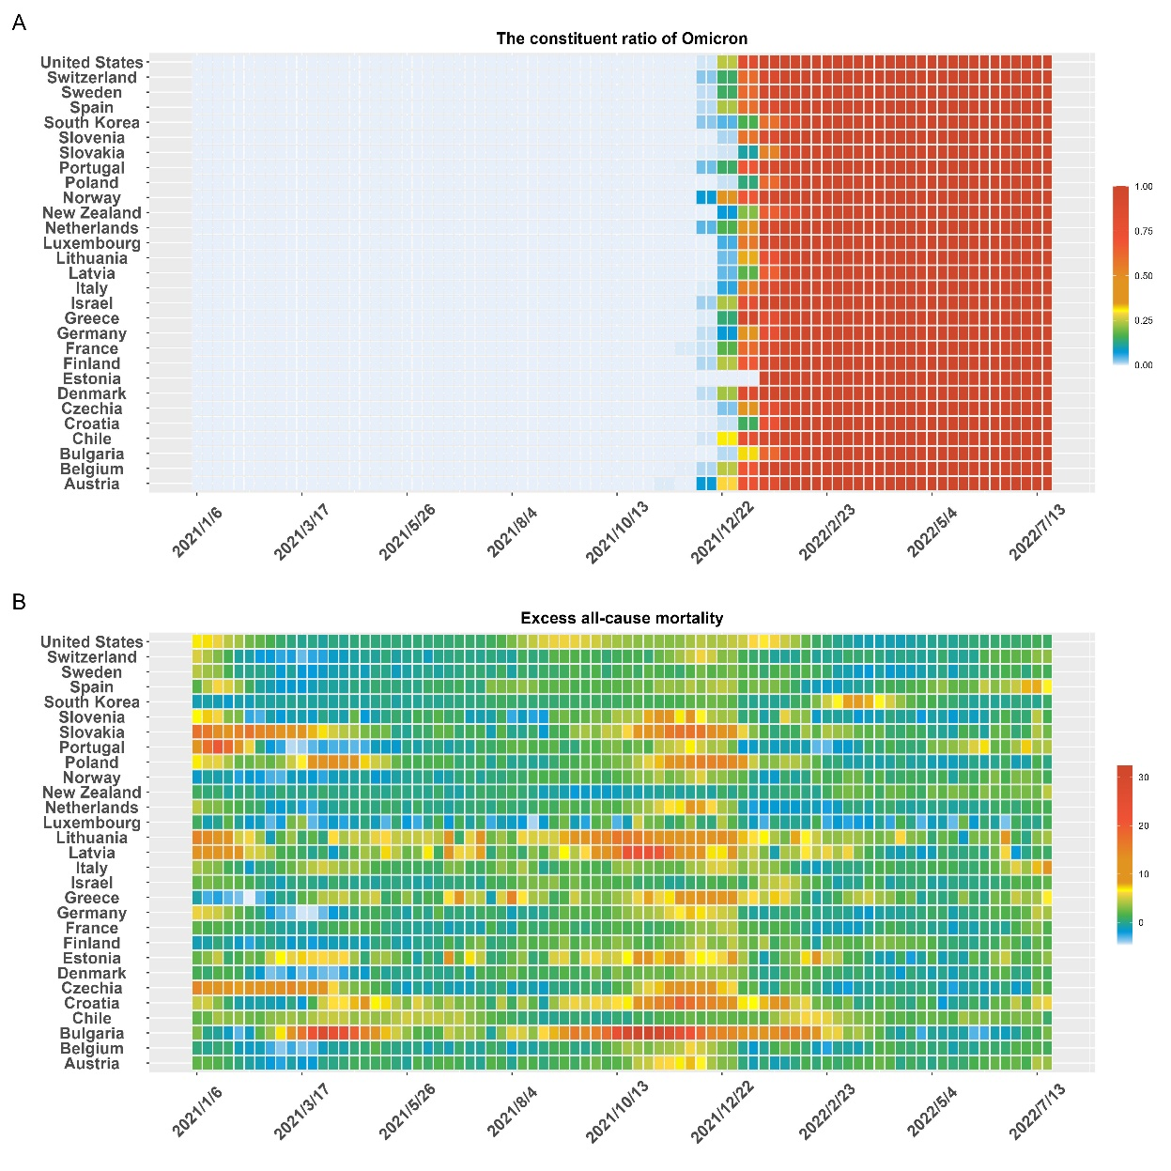
Figure S2. The constituent ratio of Omicron (A) and weekly excess all-cause mortality rate (B) across 29 countries/states.

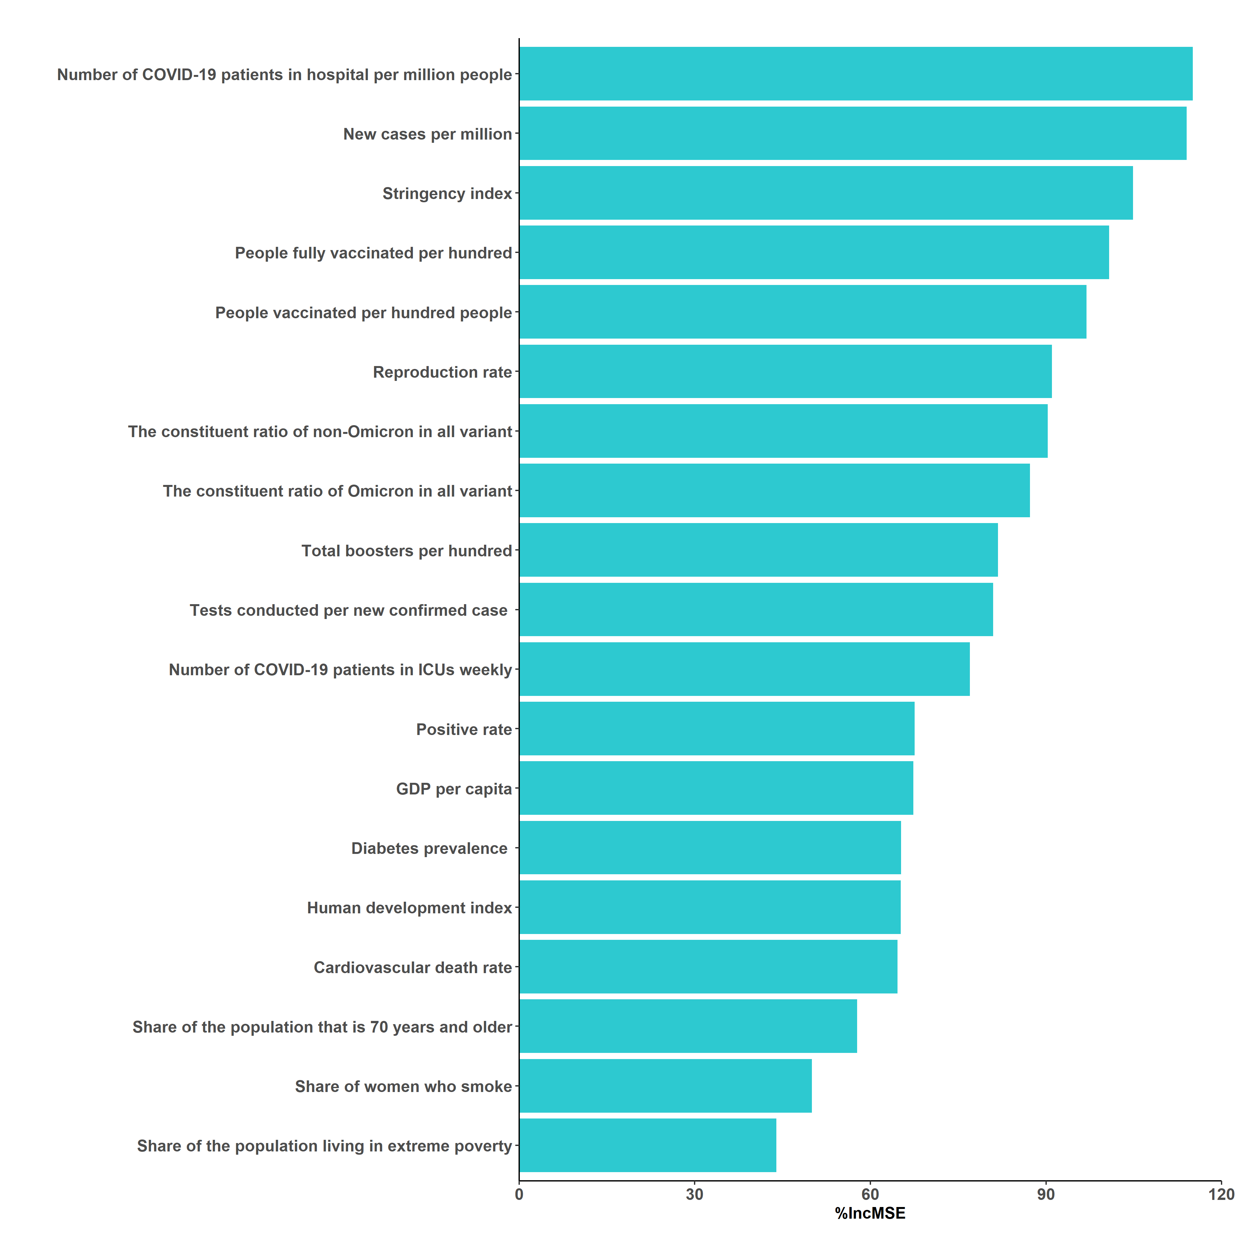
Figure S3. Ranking of contribution variables to excess mortality rate due to the COVID-19 pandemic.
Table S1 The weekly excess deaths and mortality rate by Country for Omicron and Non-Omicron Periods.
Location | variates | Excess deaths | The weekly excess mortality rate (per 100 000) | Z | P
Austria | Non-Omicron | 109.6(25.13,183.35) | 1.23(0.28,2.06) | 42.21 | 0.479
 | Omicron | 101.34(33.69,144.98) | 1.14(0.38,1.63)
Belgium | Non-Omicron | 28.53(-69.13,204.67) | 0.25(-0.6,1.77) | 42.21 | 0.740
 | Omicron | 69.89(-35.3,149.05) | 0.6(-0.3,1.29)
Bulgaria | Non-Omicron | 745.78(232.5,1245.66) | 10.76(3.35,17.97) | 42.20 | <0.001
 | Omicron | 78.33(-45.68,385.62) | 1.13(-0.66,5.56)
Chile | Non-Omicron | 441.61(222.91,727.4) | 2.28(1.15,3.75) | 42.22 | 0.234
 | Omicron | 525.08(389.63,698.29) | 2.71(2.01,3.6)
Croatia | Non-Omicron | 203.65(88.97,281.4) | 4.99(2.18,6.9) | 42.21 | 0.008
 | Omicron | 76.46(20.91,188.04) | 1.87(0.51,4.61)
Czechia | Non-Omicron | 241.59(19.21,991.07) | 2.3(0.18,9.42) | 42.20 | <0.001
 | Omicron | -31.98(-88.79,40.18) | -0.3(-0.84,0.38)
Denmark | Non-Omicron | 59.13(-27.58,107.38) | 1.01(-0.47,1.84) | 42.21 | 0.373
 | Omicron | 16.49(-2.79,64.24) | 0.28(-0.05,1.1)
Estonia | Non-Omicron | 62.57(25.37,82.52) | 4.71(1.91,6.21) | 42.20 | <0.001
 | Omicron | 19.93(-1.25,39.68) | 1.5(-0.09,2.99)
Finland | Non-Omicron | 37.72(-39.08,123.21) | 0.68(-0.71,2.23) | 42.22 | 0.027
 | Omicron | 103.06(52.56,130.39) | 1.86(0.95,2.36)
France | Non-Omicron | 700.62(27.6,980.56) | 1.09(0.04,1.52) | 42.21 | 0.086
 | Omicron | 191.46(-204.91,895.33) | 0.3(-0.32,1.39)
Germany | Non-Omicron | 768.99(-29.79,2859.02) | 0.92(-0.04,3.43) | 42.21 | 0.117
 | Omicron | 216.19(-214.48,872.52) | 0.26(-0.26,1.05)
Greece | Non-Omicron | 384.43(95.48,597.4) | 3.67(0.91,5.7) | 42.21 | 0.479
 | Omicron | 348.43(97.34,463.27) | 3.33(0.93,4.42)
Israel | Non-Omicron | 71.54(12.56,154.91) | 0.81(0.14,1.75) | 42.21 | 0.988
 | Omicron | 59.24(8.62,145.04) | 0.67(0.1,1.64)
Italy | Non-Omicron | 1294.37(649.43,1956.6) | 2.18(1.09,3.3) | 42.21 | 0.057
 | Omicron | 744.8(348.98,1857.59) | 1.25(0.59,3.13)
Latvia | Non-Omicron | 102.6(44.42,180.86) | 5.44(2.36,9.59) | 42.20 | <0.001
 | Omicron | 15.7(-0.94,75.16) | 0.83(-0.05,3.99)
Lithuania | Non-Omicron | 169.47(119.3,306.51) | 6.05(4.26,10.93) | 42.20 | <0.001
 | Omicron | 85.14(71.53,111.15) | 3.04(2.55,3.96)
Luxembourg | Non-Omicron | -3(-12.14,8.38) | -0.47(-1.91,1.32) | 42.21 | 0.238
 | Omicron | -3.49(-12.61,0.73) | -0.55(-1.99,0.12)
Netherlands | Non-Omicron | 154.36(27.31,449.83) | 0.88(0.16,2.58) | 42.20 | <0.001
 | Omicron | -36.56(-176.88,74.38) | -0.21(-1.01,0.43)
New Zealand | Non-Omicron | 1.78(-25.72,23.43) | 0.03(-0.5,0.46) | 42.23 | <0.001
 | Omicron | 105.21(42.78,127.19) | 2.06(0.84,2.5)
Norway | Non-Omicron | 12.79(-54.07,95.76) | 0.24(-1,1.78) | 42.22 | 0.049
 | Omicron | 61.28(33.03,104.08) | 1.14(0.61,1.93)
Poland | Non-Omicron | 1170.84(502.72,2877.29) | 3.05(1.31,7.5) | 42.20 | <0.001
 | Omicron | -109.94(-273.53,410.82) | -0.29(-0.71,1.07)
Portugal | Non-Omicron | 145.44(-88.86,319.67) | 1.41(-0.86,3.11) | 42.21 | 0.769
 | Omicron | 54.35(-91.95,326.97) | 0.53(-0.89,3.18)
Slovakia | Non-Omicron | 244.69(78.3,666.14) | 4.49(1.44,12.22) | 42.20 | <0.001
 | Omicron | 71.18(32.31,120.82) | 1.31(0.59,2.22)
Slovenia | Non-Omicron | 23.9(-17.54,81.65) | 1.13(-0.83,3.85) | 42.21 | 0.073
 | Omicron | -7.41(-15.57,11.64) | -0.35(-0.74,0.55)
South Korea | Non-Omicron | 114.95(-202.17,459.36) | 0.22(-0.39,0.89) | 42.22 | 0.004
 | Omicron | 426.98(-58.23,1958.41) | 0.82(-0.11,3.78)
Spain | Non-Omicron | 811.68(110.44,1436.12) | 1.71(0.23,3.03) | 42.22 | 0.479
 | Omicron | 939.74(396.22,1422.95) | 1.98(0.84,3)
Sweden | Non-Omicron | 48.2(-38.7,144.82) | 0.46(-0.37,1.39) | 42.21 | 0.554
 | Omicron | 40.24(-86.69,132.3) | 0.39(-0.83,1.27)
Switzerland | Non-Omicron | 29.5(-44.45,144.92) | 0.34(-0.51,1.67) | 42.21 | 0.806
 | Omicron | 30.31(-23.65,103.87) | 0.35(-0.27,1.2)
The United States | Non-Omicron | 9781.74(1400.47,14139.83) | 2.91(0.42,4.2) | 42.20 | 0.004
 | Omicron | 1593.76(-1074.79,3585.08) | 0.47(-0.32,1.07)
Total | Non-Omicron | 122.83(2.03,507.41) | 1.47(0.05,4.02) | 19.73 | <0.001
 | Omicron | 66.02(-11.82,218.69) | 0.86(-0.2,2.23)

Table S2. The Wilcoxon test for weekly excess mortality with different Omicron waves definition criteria.
 | Variants |  | Omicron proportion ≥60% |  |  |  |  |  | Omicron proportion ≥70%
 | Variants |  | Median | P₂₅ | P₇₅ | Z | P |  | Median | P₂₅ | P₇₅ | Z | P
All | Non-Omicron |  | 1.46 | 0.05 | 4.02 | 19.91 | <0.001 |  | 1.46 | 0.05 | 3.97 | 20.17 | <0.001
 | Omicron |  | 0.86 | -0.21 | 2.23 |  |  |  | 0.85 | -0.22 | 2.23
0-14 years | Non-Omicron |  | -0.01 | -0.15 | 0.11 | 23.05 | 0.926 |  | -0.02 | -0.15 | 0.11 | 23.48 | 0.633
 | Omicron |  | -0.02 | -0.15 | 0.11 |  |  |  | -0.02 | -0.15 | 0.11
15-64 years old | Non-Omicron |  | 0.39 | 0.06 | 1.14 | 18.46 | <0.001 |  | 0.39 | 0.06 | 1.13 | 18.84 | <0.001
 | Omicron |  | 0.20 | -0.05 | 0.52 |  |  |  | 0.20 | -0.05 | 0.53
65-74 years old | Non-Omicron |  | 2.96 | 0.19 | 8.73 | 18.09 | <0.001 |  | 2.94 | 0.18 | 8.67 | 18.42 | <0.001
 | Omicron |  | 1.17 | -1.36 | 4.42 |  |  |  | 1.22 | -1.43 | 4.43
75-84 years old | Non-Omicron |  | 8.67 | 1.17 | 19.65 | 21.18 | <0.001 |  | 8.70 | 1.22 | 19.62 | 21.25 | <0.001
 | Omicron |  | 7.46 | 0.42 | 15.19 |  |  |  | 7.30 | 0.36 | 15.11
≥85 years old | Non-Omicron |  | 15.44 | -11.52 | 48.81 | 21.56 | 0.002 |  | 15.50 | -11.49 | 47.96 | 21.34 | 0.002
 | Omicron |  | 8.42 | -14.57 | 37.75 |  |  |  | 8.12 | -14.67 | 38.03
Male | Non-Omicron |  | 1.62 | 0.20 | 4.35 | 19.78 | <0.001 |  | 1.62 | 0.20 | 4.29 | 20.04 | <0.001
 | Omicron |  | 0.97 | -0.13 | 2.55 |  |  |  | 0.96 | -0.13 | 2.55
Female | Non-Omicron |  | 1.39 | -0.18 | 3.70 | 20.15 | <0.001 |  | 1.39 | -0.18 | 3.68 | 20.42 | <0.001
 | Omicron |  | 0.78 | -0.43 | 2.32 |  |  |  | 0.77 | -0.44 | 2.31

