SUPPLIMENTRY FILE:

Investigation of the rheological alterations in Iota carrageenan subsequent the exchange of potassium with calcium ions.
Shashank Kailkhura, Akanksha Bhatt, Priyank Purohit*
Department of Pharmacy, Graphic Era Hill University Dehradun, Dehradun, 28008, India

- Reaction with CaCl₂
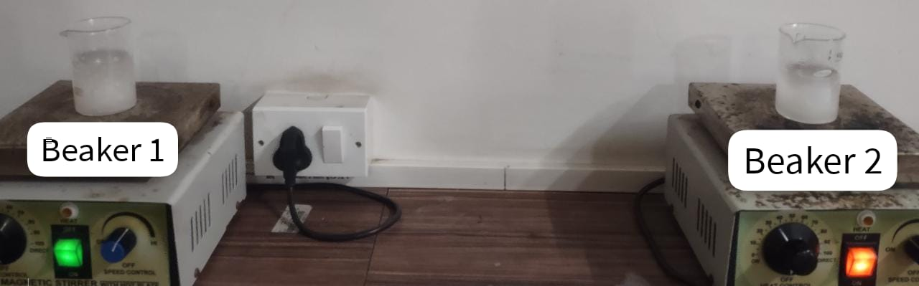

Beaker 1 and beaker 2 showing Step I and II

Finally, combine the resulting solution
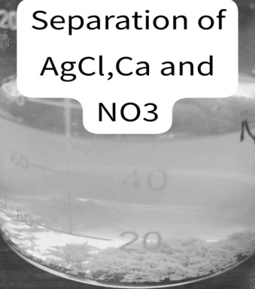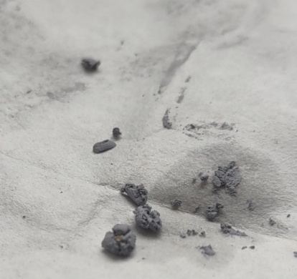
AgCl₂ ppt

Viscosity:

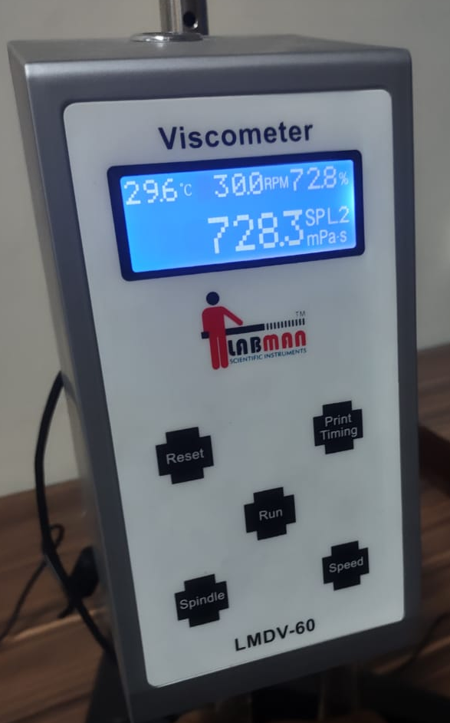

Conductivity Test:
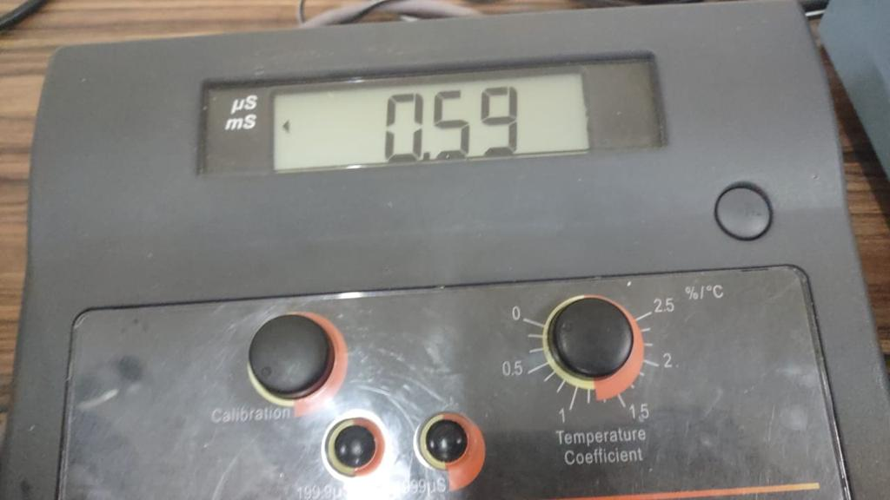
Ca linked carrageenan Conductivity in hot water.
Optimization of the solvent:

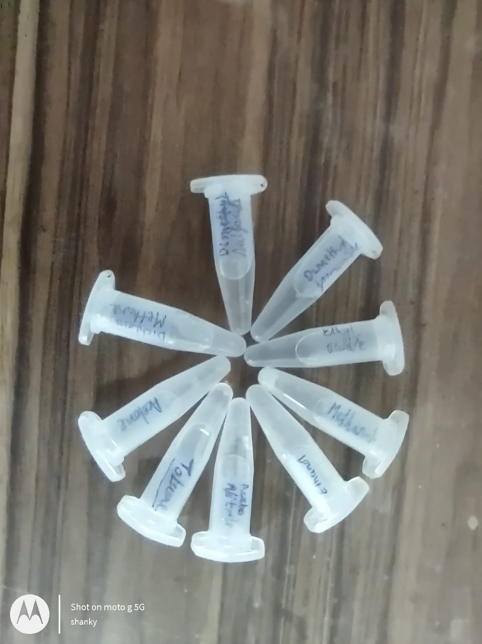
Solubility profile of ca linked iota carrageenan in different solvents. Ca-iota-Carrageenan is completely soluble in Ethyl Acetate and water
Effect of temperature in the water and carrageenan system:
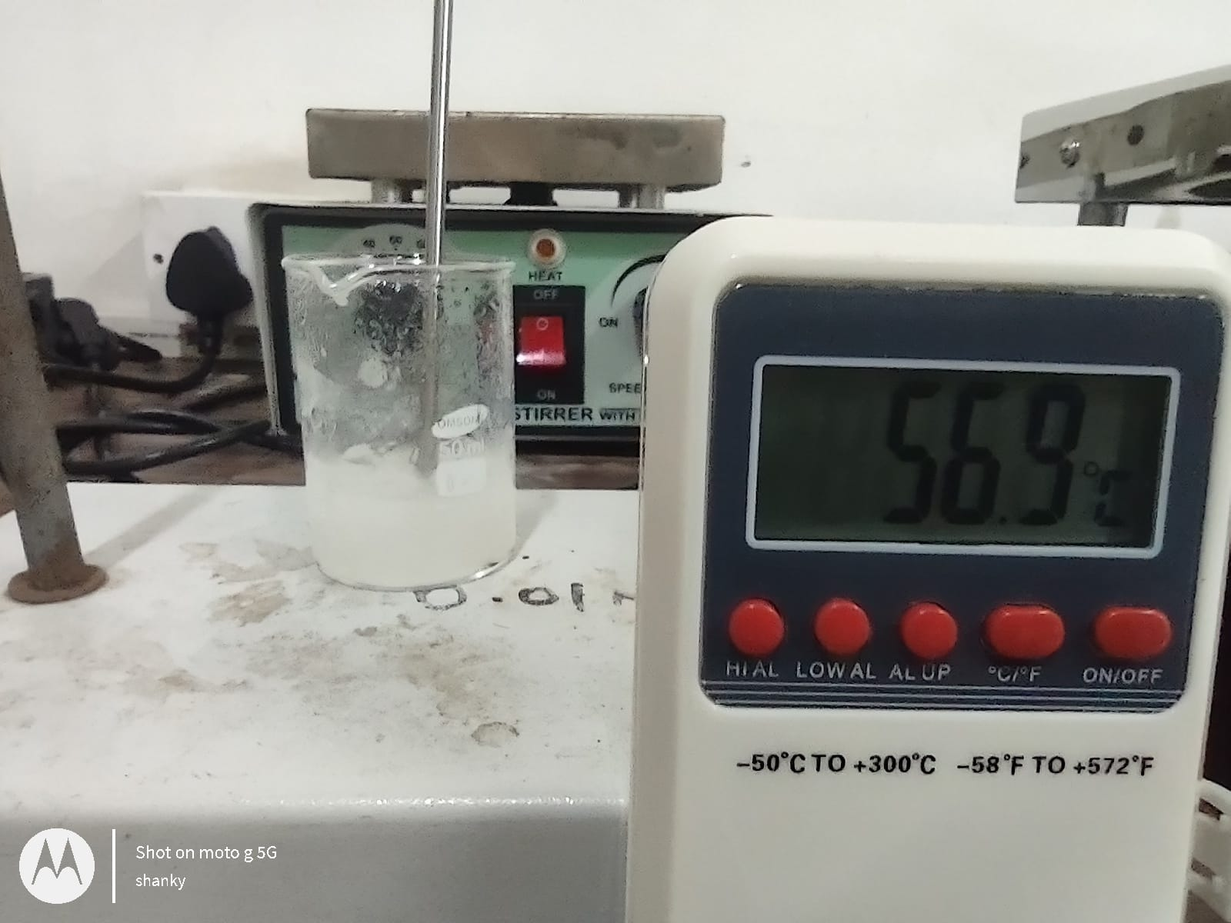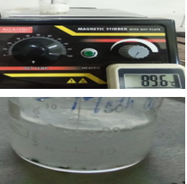
Gelling point: In water at this temperature At Continues heat (89.6º C): Gel formation

Reaction of calcium linked carrageenan at different temperature:

