Supporting Information

Molecularly Imprinted Electrochemical Sensor based on α-Cyclodextrin Dual-functional Monomers and MXene Nanosheets for Highly Sensitive and Selective Detection of Alkylresorcinols in Whole Wheat Foods

Yangyang Wen ^{a,†}, Mengyao Wang ^{a,†}, Shichao Zhao ª, Haoran Fan ^{b}, Hongyan Li ^{b,}*, Jing Wang ^{b,}*, Baoguo Sun^{b}

ª College of Chemistry and Materials Engineering, Beijing Technology and Business University, Beijing 100048, China
^{b} Key Laboratory of Geriatric Nutrition and Health, Ministry of Education, Beijing Technology and Business University, Beijing, 100048, China
† These authors contributed equally to this work
* Corresponding author e−mail:
Hongyan Li: hongyan.li@btbu.edu.cn; Jing Wang: wangjing@th.btbu.edu.cn

Table S1 Inclusion rates of AR21 in AR21/αCD complex.
Ingredients∗ | 1:1 | 1:2 | 1:3 | 1:4
AR21/αCD | 1.05% ± 1.39% | 79.00% ± 0.14% | 86.18% ± 0.10% | 93.79% ± 0.07%
∗ The molar ratio of AR21 to α-CD added before the inclusion process.

The inclusion rates of AR21 were calculated based on the following equation:
Inclusion rate (%) = [(c_{total}−c₁) / c_{total}] × 100%
where c_{total} and c₁ were the AR21 concentrations in the mixed solution before and after inclusion treatment. The AR21 concentrations were measured by HPLC method. To ensure the accuracy of analysis, methanol washing solutions were collected and the AR21 concentration in washing solutions were also included in the value of c₁.

Table S2 The fitted impedance parameters of different electrodes.
Electrode | Rs (Ω) | Rct (Ω)
GE | 106.7 | 714.7
MXene/GE | 90.1 | 85.3
DMIP/MXene/GE | 92.3 | 110.5
SMIP/MXene/GE | 81.6 | 189.3
NIP/MXene/GE | 88.0 | 299.4
DMIP/MXene/GE after incubation of 0.5 μg·mL⁻¹ AR21 | 96.9 | 252.9
DMIP/MXene/GE after incubation of 25 μg·mL⁻¹ AR21 | 83.2 | 431.0

Table S3 Comparison of the proposed sensor with other reported electrochemical sensors.
Electrodes | Analytes | Method | Linear range | LOD | Recovery (%) | Real Sample | Ref
MIP-N-Mo2C/GCE | Resveratrol | DPV | 10⁻⁶ ~ 1 mM | 0.437 nM | 94.1 ~ 110.5 | Grape seed | [1]
Res-MIP/Au@Ag/ITO | Trans resveratrol | CV | 0.02 ~ 9.0 nM | 7.1 pM | 96.7 ~ 106.3 | Grape seed extract | [2]
MIP/GO/GC | EGCG | DPV | 3 × 10⁻⁵ ~ 0.01 mM | 8.78 nM | 96.2 ~ 105.7 | Tea | [3]
ART-MIM/G/GCE | Artemisinin | DPV | 1.0 × 10⁻⁵ ~ 0.04 mM | 2.0 nM | 100.0 ~ 110.5 | Pulverized A. annua L. | [4]
MIP/MWNTs/GCE | Rutin | DPV | 4.0 × 10⁻⁴ ~ 0.01 mM | 0.11μM | / | Rutin in tablets | [5]
MIPs/AuNPs/β-CD/GR/GCE | Quercetin | DPV | 0.001 ~ 1.0 μM | 0.1 nM | 97.5 ~ 102.1 | Pharmaceutical | [6]
MIP-CPE | Curcumin | CV | 0.1 ~ 50 mM | 10.1 nM | 90.77 ~ 105.7 | Curcuma powder and Cookies | [7]
MIP-CuO | Gallic acid | CV and DPV | 1 ~ 100 µM and 100 ~ 900 µM | 12.6 nM | / | GT samples | [8]
AA-MI-PANI/ITO | Vitamin C | DPV | 0.05 ~ 0.4 mM | 0.018 mM | / | Limcee, Vitchew CZ and Suck Vit Tablets | [9]
GE/MXene/MIP electrochemical sensor | AR21 | CV | 0.005 ~100 µg·mL⁻¹  (equal to 1.236 × 10⁻⁵ ~ 0.247 uM) | 2.52 ng·mL⁻¹  (equal to 6.227 × 10⁻³ uM) | 96.3 ~ 103.5 | Wheat grain, bran, flour, whole wheat noodles and breads | This work

Table S4 Comparison of proposed electrochemical sensor with other methods for the AR21 detection.
Methods | Linear range  (µg·mL⁻¹) | LOD∗  (µg·mL⁻¹) | LOQ∗  (µg·mL⁻¹) | Recovery (%) | RSD% | Real Sample | Ref
HPLC | 5 ~ 500 | 0.18 | 0.59 | / | 1.19 | Whole wheat flour, wheat flour and wheat bran | [10]
HPLC | 0.0970 ~ 9.70 | 0.0039 | 0.0117 | 94.5~104 | 3.06 ~ 3.29 | Whole wheat flour, wheat flour and wheat bran | [11]
GC-MS | 0.015~1.5 | 0.00809 | 0.0243 | 75 ~ 108 | / | Plasma, adipose tissue | [12]
LC-MS | 0.023 ~ 12.367 | 75 pg | 250 pg | 36 | / | Plasma | [13]
Spectrophotometric method | 0.0 ~ 5.0 | 0.253 | 0.768 | 99.5 ~ 102.9 | 3.9 ~ 7.9 | Wheat bran extract | [14]
GC-MS and LC-MS/MS | 0.001 ~ 5 | 0.00032 and 0.00084 | 0.00107 and 0.00280 | 94.17 ~ 99.15 and 97.41 ~ 99.06 | 3.22 ~ 4.12 and 2.25 ~ 3.81 | / | [15]
CDs-MIPs based fluorescence sensor | 0.015 ~ 60 | 0.004 | / | 98.57~103.82 | 0.52~3.34 | Whole flour, flour, wheat bran and cereal products | [16]
DMIP/MXene/GE electrochemical sensor | 0.005 ~ 100 | 0.00252 | 0.00841 | 96.3 ~ 103.5 | 0.65 ~ 2.87 | Wheat grain, bran, flour, whole wheat noodles and breads | This work
∗ To make the results clearer, the data were recalculated using the same unit, based on the mass of samples and the volume of solvent.

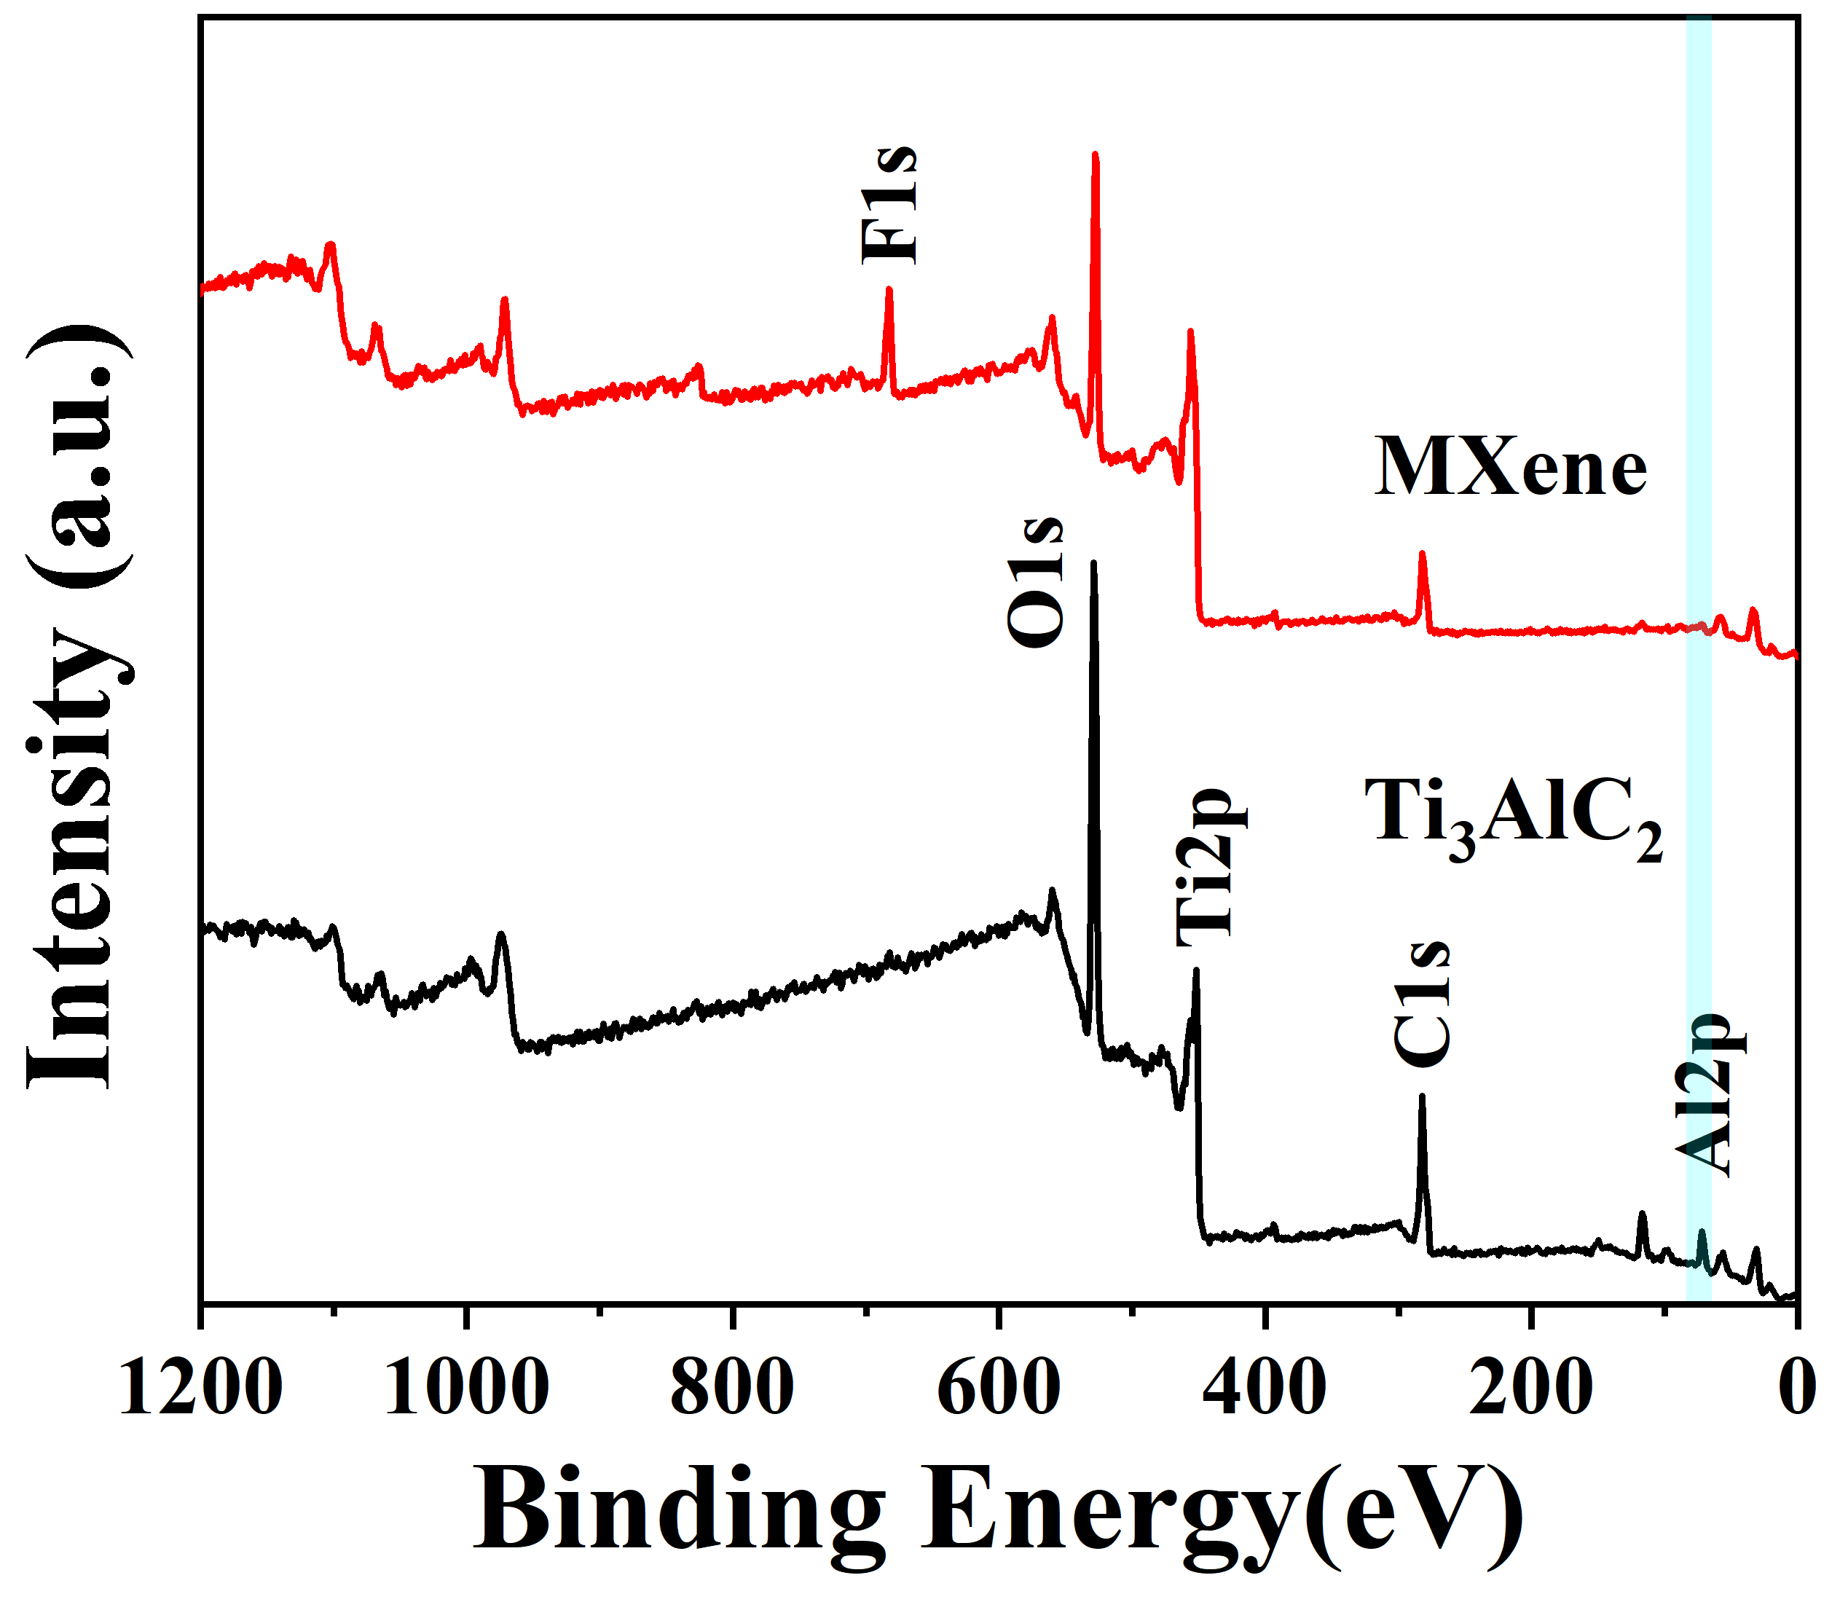
Fig. S1 The XPS survey scans of Ti₃AlC₂ and MXene.

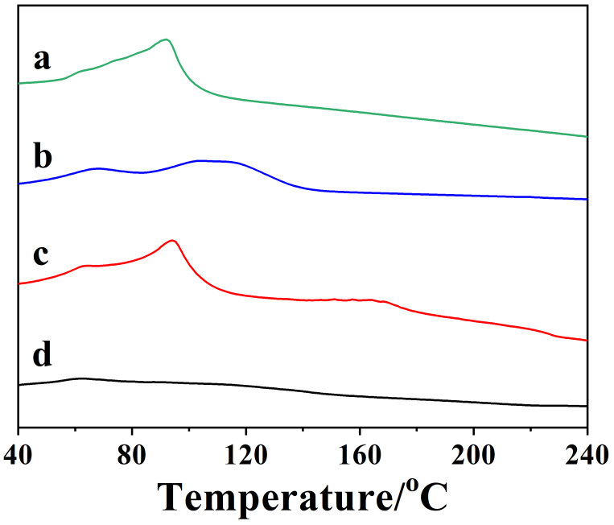
Fig. S2 DSC curves: (a) AR21, (b) α-CD, (c) physical mixture of AR21/α-CD (1:4) and (d) AR21/αCD complex.

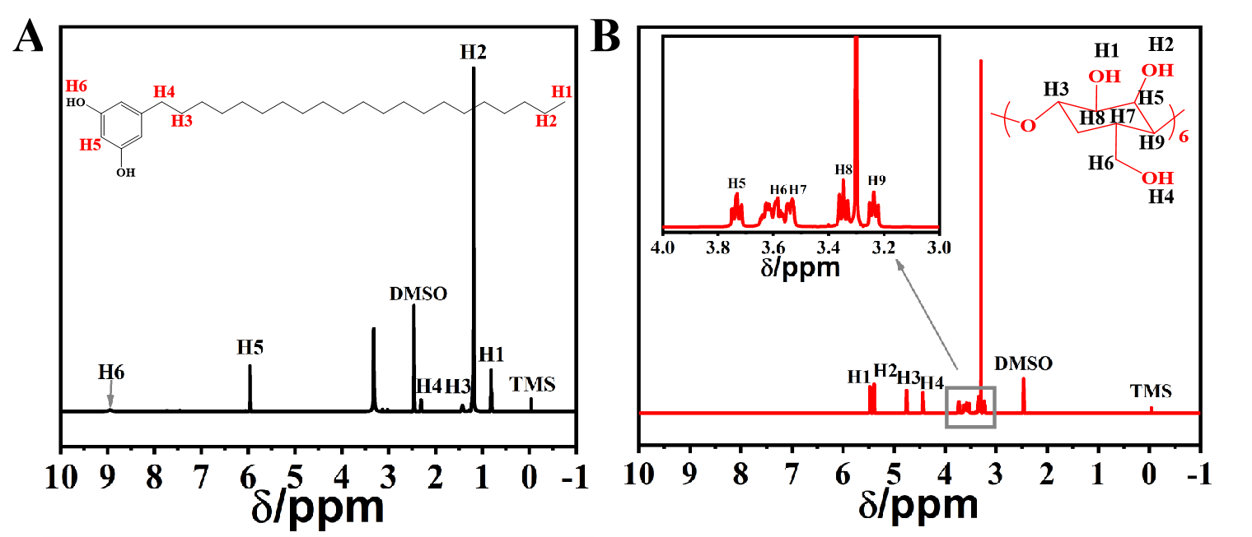
Fig. S3 The ¹H NMR spectra of pure AR21 (A) and α-CD (B).

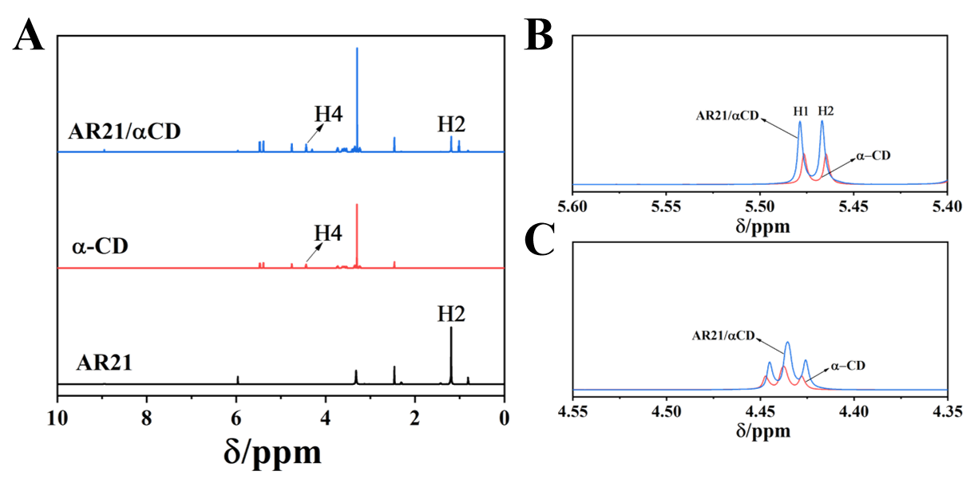
Fig. S4 (A) ¹H NMR spectra of AR21, α-CD, AR21/αCD complex. (B-C) Enlarged ¹H NMR spectra of α-CD and AR21/αCD.

To determine the molar ratio of α-CD to AR21 in the complex, we used the integral area of the TMS peak as a reference with an assigned value of 1. The molar ratio was calculated based on the integral area of the AR21 H2 peak at 1.197 ppm and the integral area of the α-CD H4 peak at 4.439 ppm (Fig S4A) using the following equation:
Molar ratio =
Where S_{AR21/αCD:H4} represents the integral area of the AR21/αCD peak at 4.439 ppm, S_{AR21/αCD:H2} indexes to the integral area of the AR21/αCD peak at 1.197 ppm, S_{α−CD:H4} represents the integral area of the α-CD H2 peak at 4.439 ppm, and S_{AR21:H2} denotes the integral area of AR21 H2 peak at 1.197 ppm.

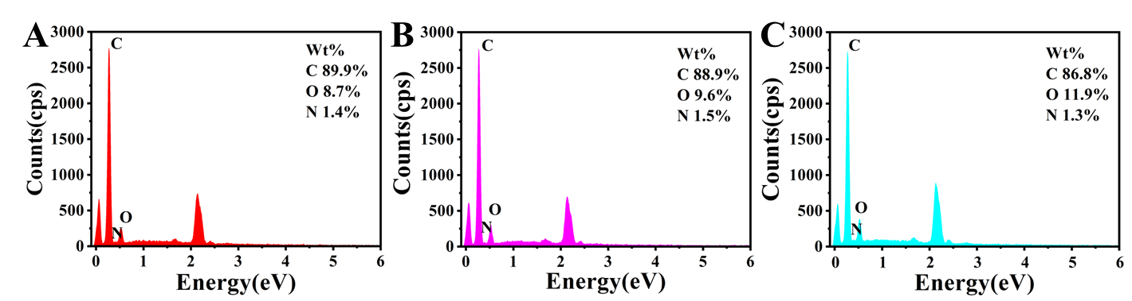
Fig. S5 EDS profiles of (A) DMIP, (B) SMIP, and (C) NIP.

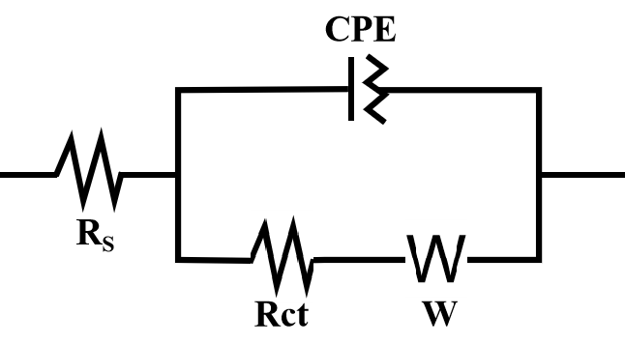
Fig. S6 The equivalent circuit diagram fitted from Nyquist plots, which consists of a charge transfer resistance (R_{ct}), and a Warburgh impedance (W), a constant phase element (CPE) and an active electrolyte resistance (R_{s}).

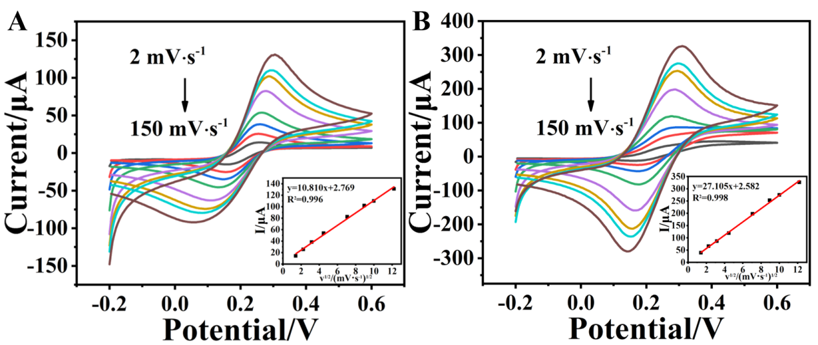
Fig. S7 CV curves at different scan rates (from 2 to 150 mV·s⁻¹) of (A) GE and (B) MXene/GE. Inset: linear relationship of peak current and square root of scan rate (ν½).

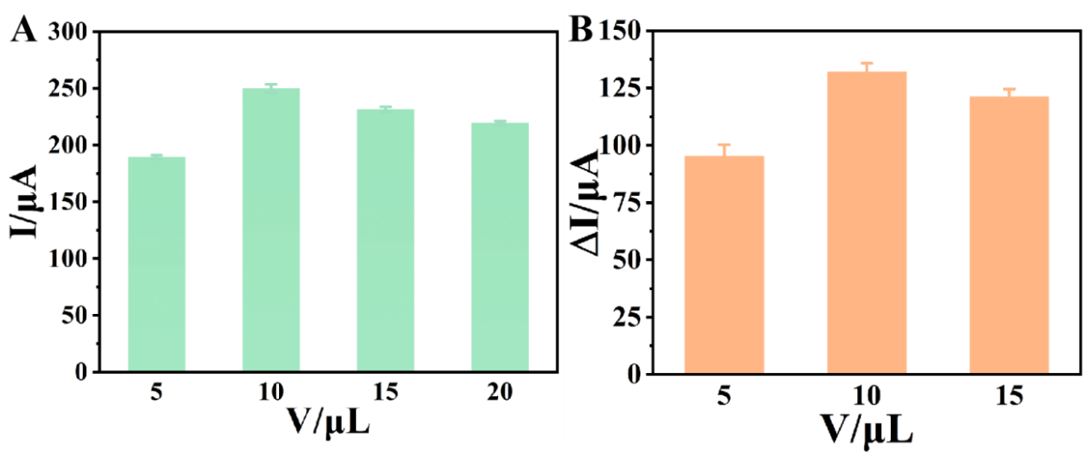
Fig. S8 (A) Optimization of MXene dosage, with the MXene concentration of 4 mg·mL⁻¹. (B) Current responses (△I) of the DMIP/MXene/GE electrodes modified with different volumes of DMIP solution (4 mg·mL⁻¹), where △I was collected before and after the incubation of AR21 solution (100 μg·mL⁻¹).

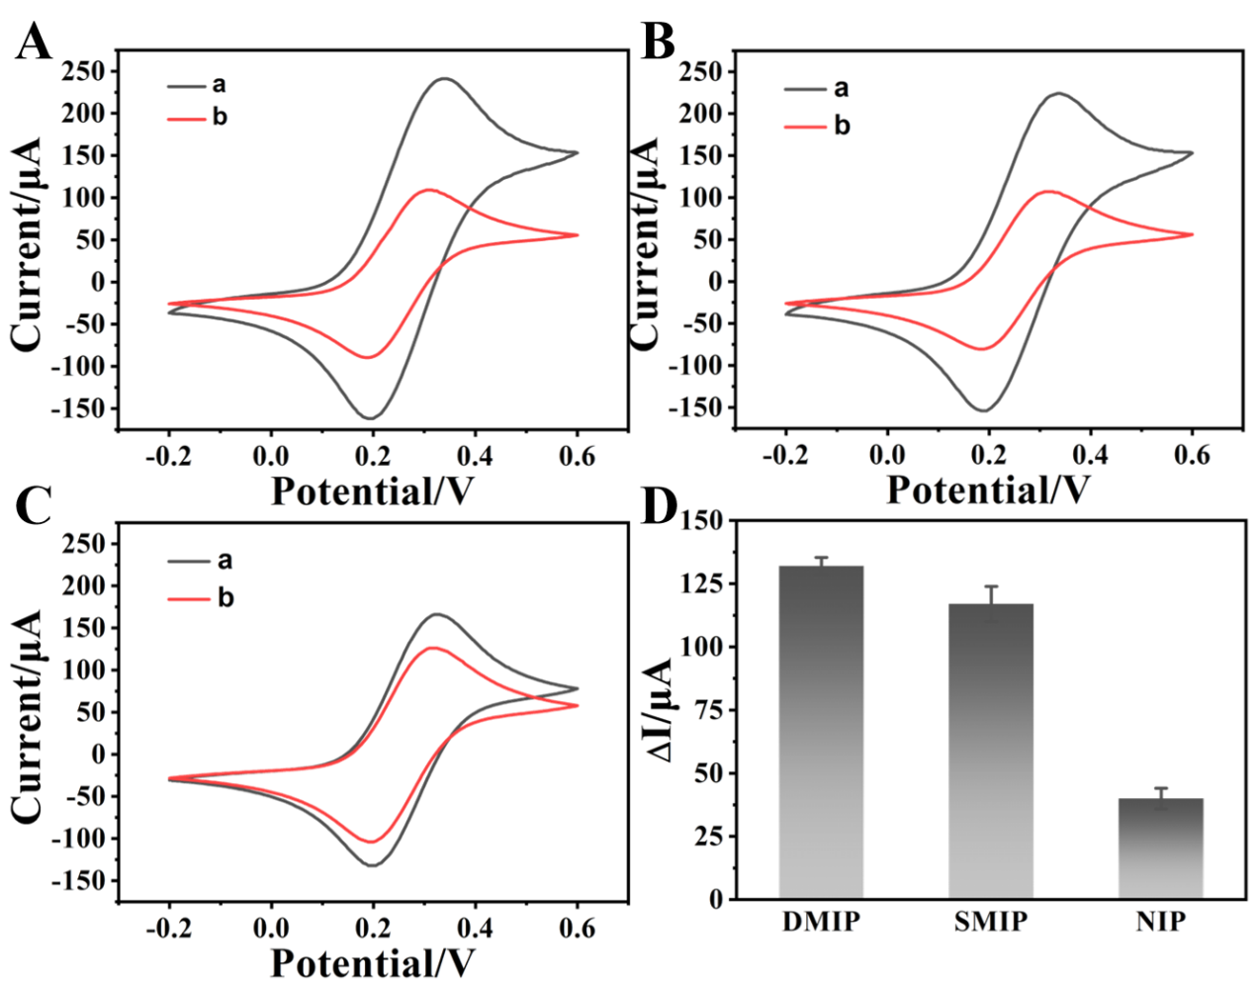
Fig. S9 CV profiles (scan rate: 50 mV·s⁻¹) of different modified electrodes (A) DMIP/MXene/GC, (B) SMIP/MXene/GC, (C) NIP/MXene/GC in an electrolyte solution of 5 mM [Fe(CN)₆]^{3−/4−} containing 0.1 M KCl without (a) and with (b) the incubation of 100 μg·mL⁻¹ AR21. (D) Current responses (△I) of different electrodes before and after the incubation of 100 μg·mL⁻¹ AR21.
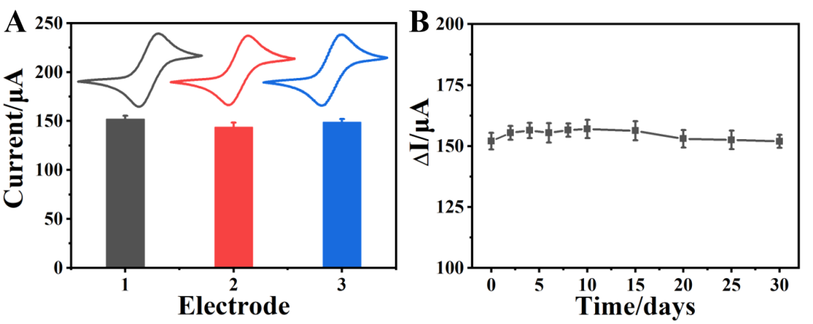
Fig. S10 (A) Reproductivity of the DMIP/MXene/GE based sensor. (B) Long−term stability of the DMIP/MXene/GE at 4 ℃ over a 30−day period.

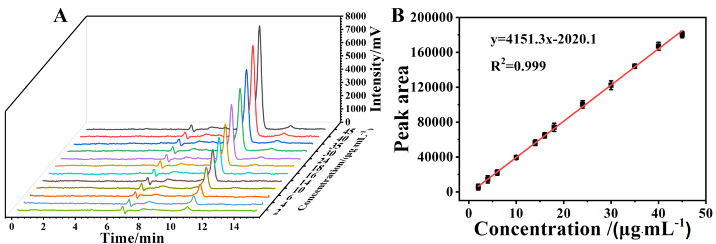
Fig. S11 (A) A standard HPLC chromatogram of AR21 (2 ~ 45 ug·mL⁻¹). (B) The calibration curve of peak areas derived from HPLC spectrum and AR21 concentrations.

Reference

1. Yanrui L, Lili Z, Yue H, Xinsheng P, Jiangyan D (2017) A novel electrochemical sensor based on a molecularly imprinted polymer for the determination of epigallocatechin gallate. Food Chemistry 221:1128-1134.
2. Dongyang W, Jia W, Junjie Z, Yangguang L, Yang Z, Yingchun L, Bang-Ce Y (2019) Novel electrochemical sensing platform based on integration of molecularly imprinted polymer with Au@Ag hollow nanoshell for determination of resveratrol. Talanta 196:479-485.
3. Lu H, An J, Huang Y, Cui H, Yang J, Li L, Ding Y (2022) Molecularly Imprinted Electrochemical Sensor Based on Nitrogen-doped Molybdenum Carbide Nanosphere for Trace Analysis of Resveratrol. Chemistry-an Asian Journal.
4. Lu B, Xia J, Wang Z, Zhang F, Yang M, Li Y, Xia Y (2015) Molecularly imprinted electrochemical sensor based on an electrode modified with an imprinted pyrrole film immobilized on a beta-cyclodextrin/gold nanoparticles/graphene layer. Rsc Advances 5(101):82930-82935.
5. Zhou Q, Zhai HY, Pan YF, Li K (2017) A simple and sensitive sensor based on a molecularly imprinted polymer-modified carbon paste electrode for the determination of curcumin in foods. Rsc Advances 7(37):22913-22918.
6. Wang C, Wang Q, Zhong M, Kan X (2016) Boronic acid based imprinted electrochemical sensor for rutin recognition and detection. Analyst 141(20):5792-5798.
7. Das D, Biswas D, Hazarika AK, Sabhapondit S, Roy RB, Tudu B, Bandyopadhyay R (2021) CuO Nanoparticles Decorated MIP-Based Electrode for Sensitive Determination of Gallic Acid in Green Tea. Ieee Sensors Journal 21(5):5687-5694.
8. Bai H, Wang C, Chen J, Peng J, Cao Q (2015) A novel sensitive electrochemical sensor based on in-situ polymerized molecularly imprinted membranes at graphene modified electrode for artemisinin determination. Biosensors & Bioelectronics 64:352-358.
9. Roy AK, Nisha VS, Dhand C, Malhotra BD (2011) Molecularly imprinted polyaniline film for ascorbic acid detection. Journal of Molecular Recognition 24(4):700-706.
10. YanYu Z, Yong F, Peng L, QinQin H, Ji X, Qin L, MinHao X, QiuHui H (2020) Comparative analysis of alkylresorcinols homologue composition in whole wheat flour and refined wheat flour. Scientia Agricultura Sinica 53(10):2055-2065.
11. Yu-fei W, Xue-song Z, Xue-song X, Chao G, Zhu W (2018) Establishment of the liquid fluorometric method for determination of alkylresorcinols in whole wheat. Acta Nutrimenta Sinica 40(4):392-397.
12. Wierzbicka R, Wu H, Franek M, Kamal-Eldin A, Landberg R (2015) Determination of alkylresorcinols and their metabolites in biological samples by gas chromatography-mass spectrometry. Journal of Chromatography B-Analytical Technologies in the Biomedical and Life Sciences 1000:120-129.
13. Ross AB, Redeuil K, Vigo M, Rezzi S, Nagy K (2010) Quantification of alkylresorcinols in human plasma by liquid chromatography/tandem mass spectrometry. Rapid Communications in Mass Spectrometry 24(5):554-560.
14. Bernal FA, Orduz-Diaz LL, Guerrero-Perilla C, Coy-Barrera ED (2016) Diazo Coupling Reaction of Catechins and Alkylresorcinols with Diazotized Sulfanilic Acid for Quantitative Purposes in Edible Sources: Method Development and Validation. Food Analytical Methods 9(2):411-418.
15. Qinqin H, Fengjiao F, Peng L, Yan F, Yanyu Z, Yong F (2021) Analysis of alkylresorcinol homologues in wheat flour by GC-MS and LC-MS/MS. Food Science, China 42(14):187-194.
16. Wen Y, Li J, Zhao S, Fan H, Li H, Wang J, Sun B (2023) A highly efficient molecularly imprinted fluorescence sensor for assessing whole wheat grains by the rapid and sensitive detection of alkylresorcinols. Biosensors & Bioelectronics 223.

