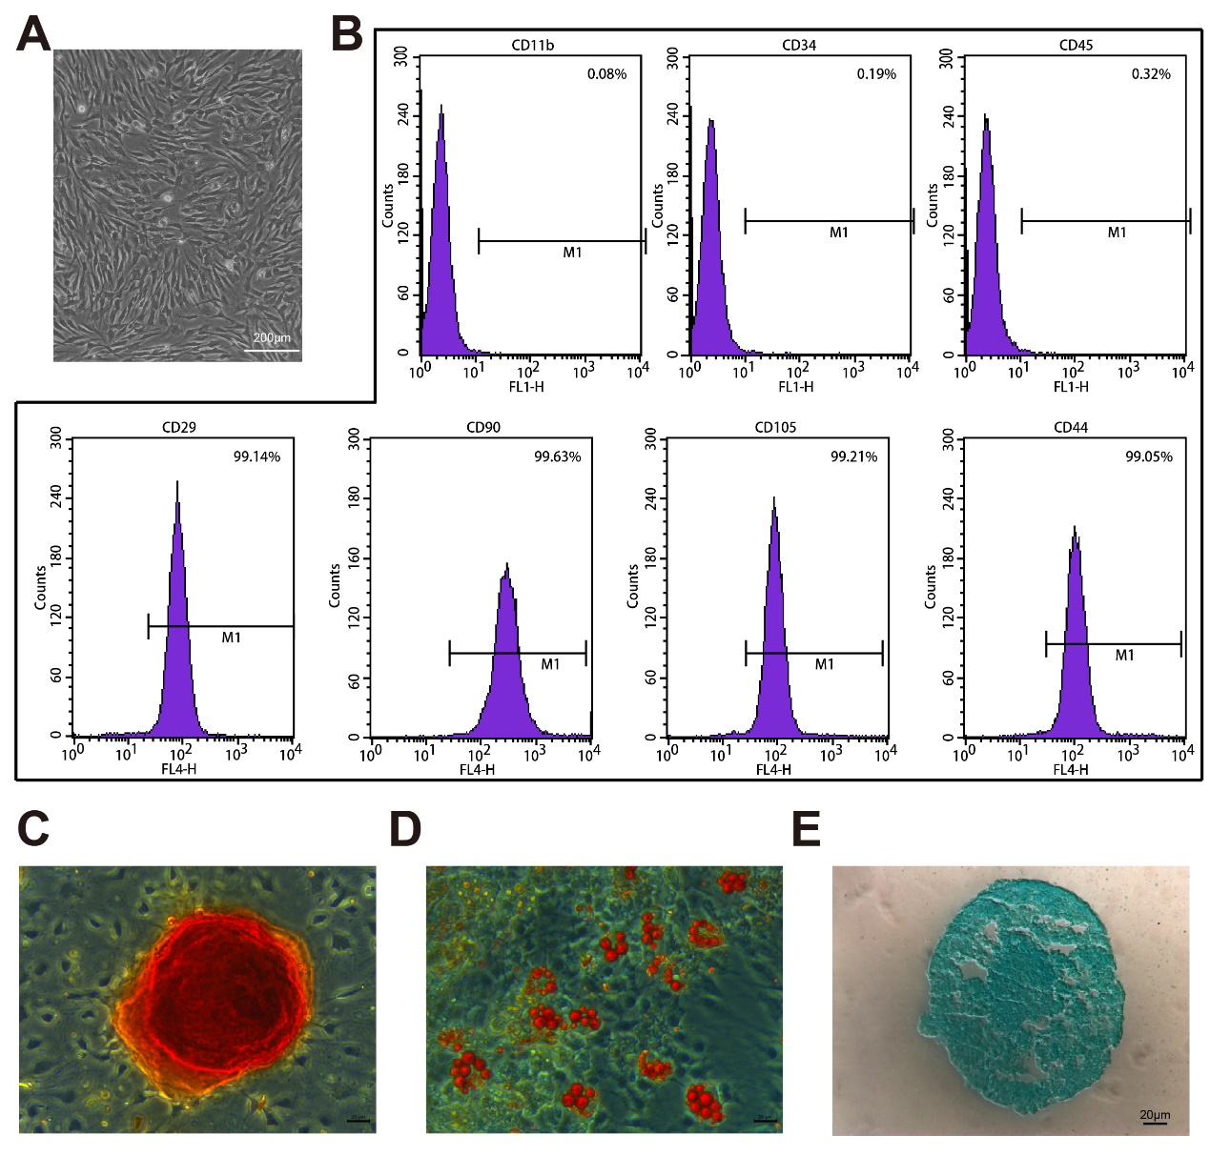
Supplementary material Figure 1: Identification of bone marrow mesenchymal cells. A. Morphological map of bone marrow mesenchymal cells in the third generation. B. Flow cytometry analysis of negative (CD11b, CD34, CD45) and positive (CD29, CD90, CD105, CD44) markers of bone marrow mesenchymal cells (n = 3). C–E. Representative images of bone marrow mesenchymal cell differentiation potential: C, osteogenic differentiation; D, lipogenic differentiation, E, chondrogenic differentiation (n = 3). Scale bars: 200 μm, 20 μm.

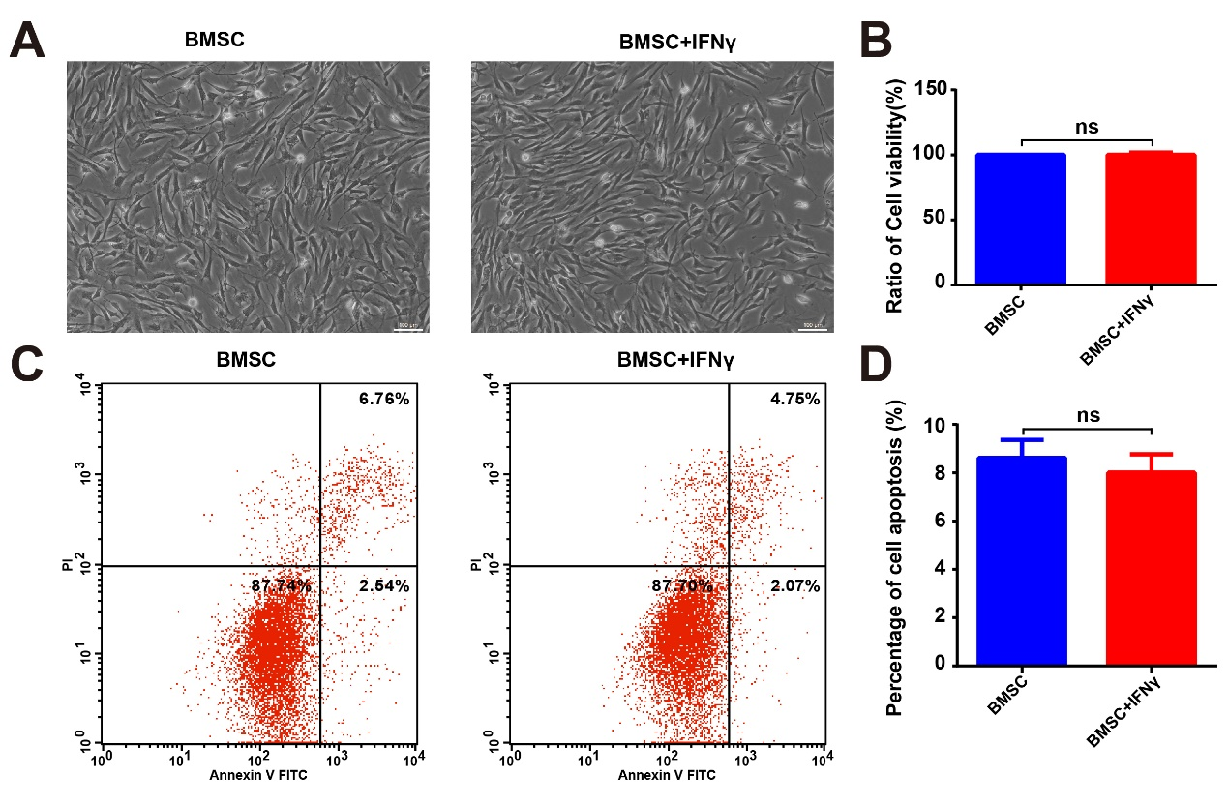
Supplementary material Figure 2: Effect of IFNγ on BMSCs. A. Morphological map of BMSCs after the addition of IFNγ. B. Comparison of cell viability between the BMSC and BMSC+IFNγ groups as determined by CCK8 assay (n = 5). C. Representative flow cytometry diagram of the effect of IFNγ on BMSCs apoptosis. D. Comparison of the apoptosis ratio between the two groups of cells (n = 5). Scale bars: 100 μm. ns: No significant difference.

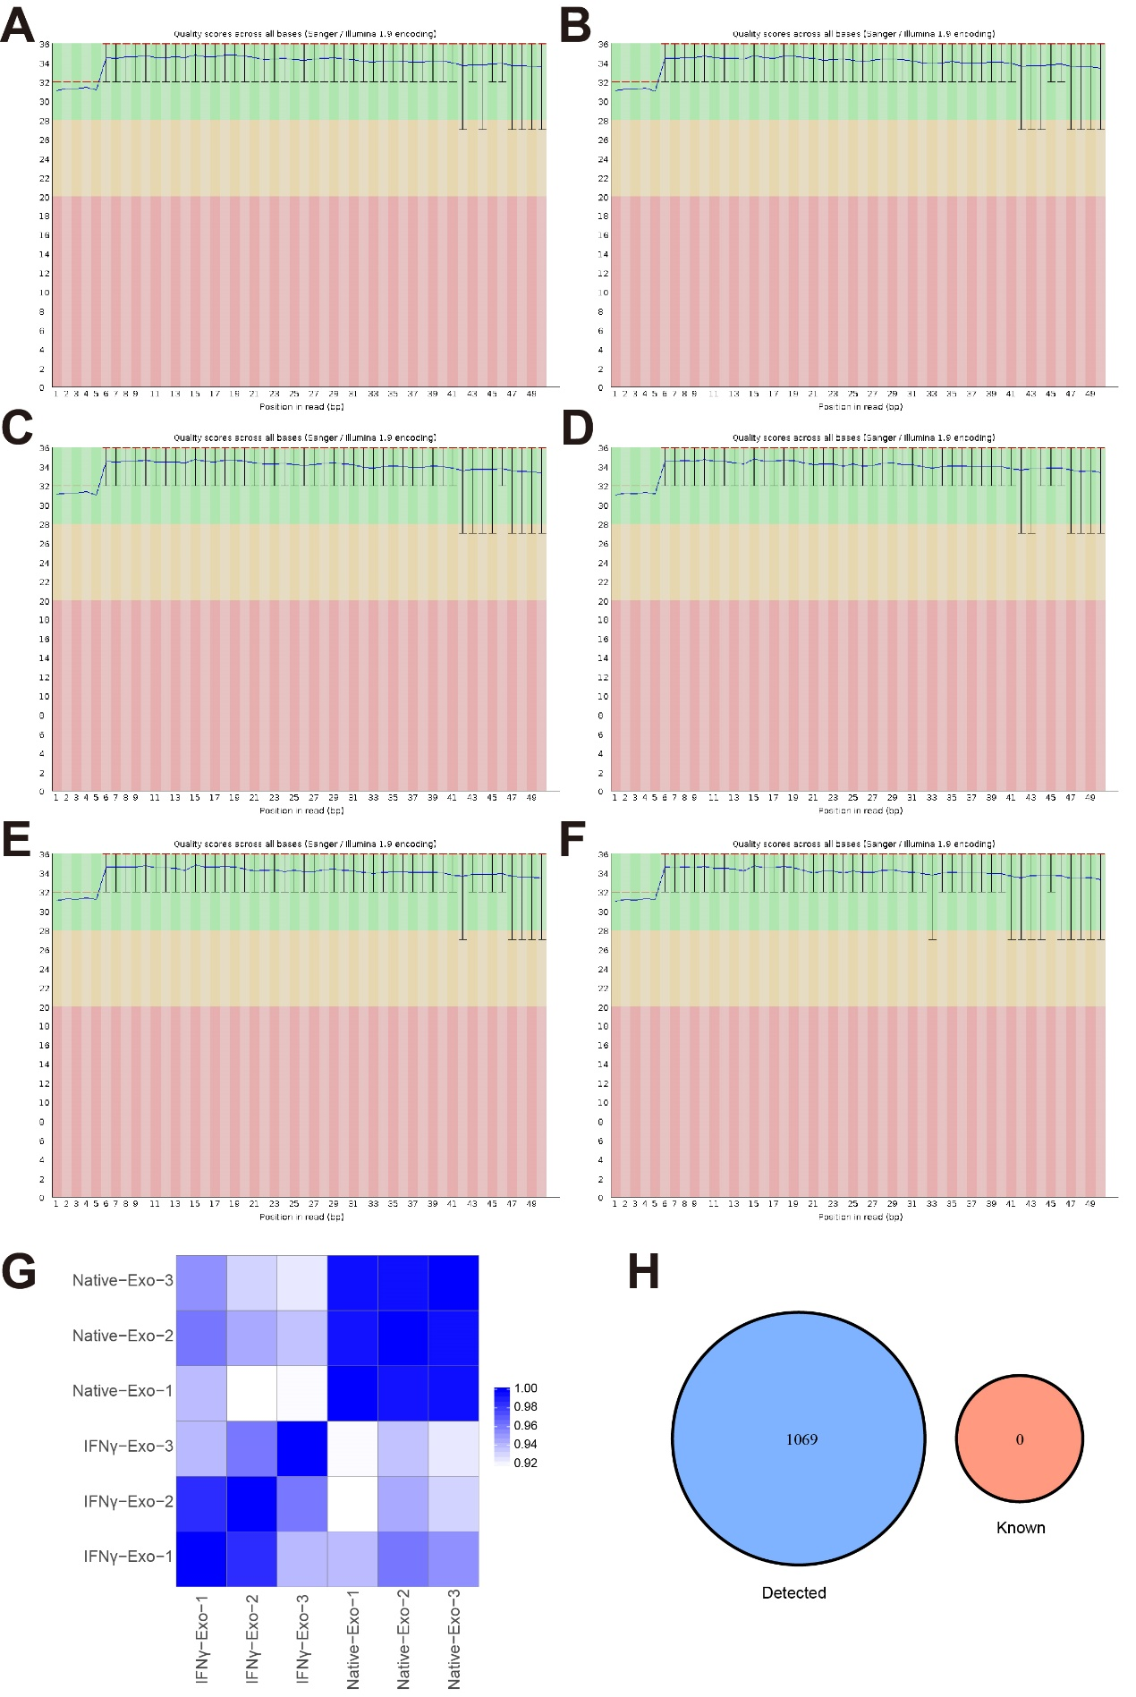
Supplementary material Figure 3: Quality of tRF and tiRNA sequencing. A–F. tRF and tiRNA-seq quality score plot. The position in the read is plotted on the X-axis, and the Q value is plotted on the Y-axis. The red line represents the median Q score, and the blue line represents the mean Q score. The complot represents the interquartile range, and the whiskers represent the 10% and 90% points. A Q score greater than 30 (> 99.9% correct) is considered high-quality data. G. Heatmap of the correlation coefficient from all samples. The color in the panel represents the correlation coefficient of the two samples. Blue represents the two samples with a high correlation coefficient, and white represents the low similarity of the two samples. The presented plot was generated with the R gplots package. H. Venn diagram based on several known and detected tRFs and tiRNAs. This diagram shows the number of tRFs and tiRNAs detected in this project and collected in the tRFdb.

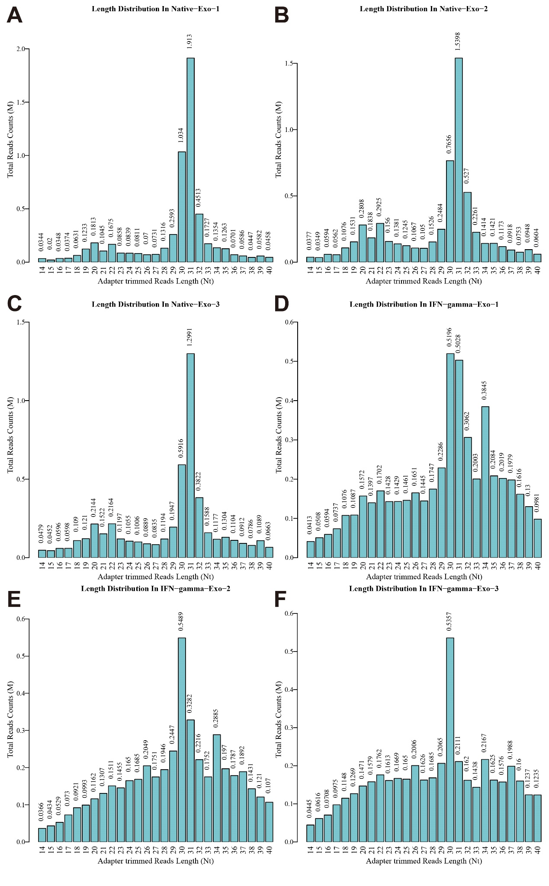
Supplementary material Figure 4: Scatter plot between Native-Exo and IFNγ-Exo groups for tRF and tiRNA. The CPM values of all tRFs and tiRNAs are plotted. The values of the X and Y axes in the scatter plot are the averaged CPM values of each group (log₂ scaled). tRFs and tiRNAs higher than the top line (red dots, up-regulation) or lower than the bottom line (green dots, down-regulation) indicate a fold-change of > 1.5 between the two compared groups. Gray dots indicate non-differentially expressed tRFs and tiRNAs.

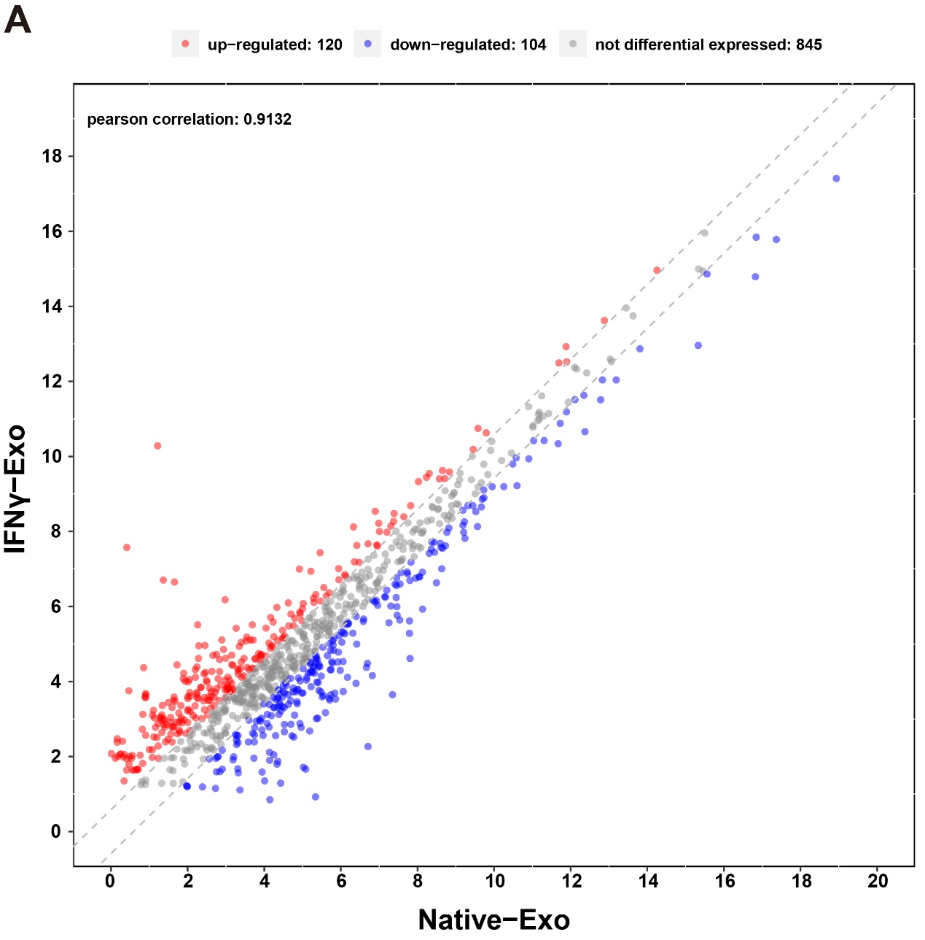
Supplementary material Figure 5: A–F. Read length distribution. Bar chart showing the total read counts against the lengths of the trimmed reads.

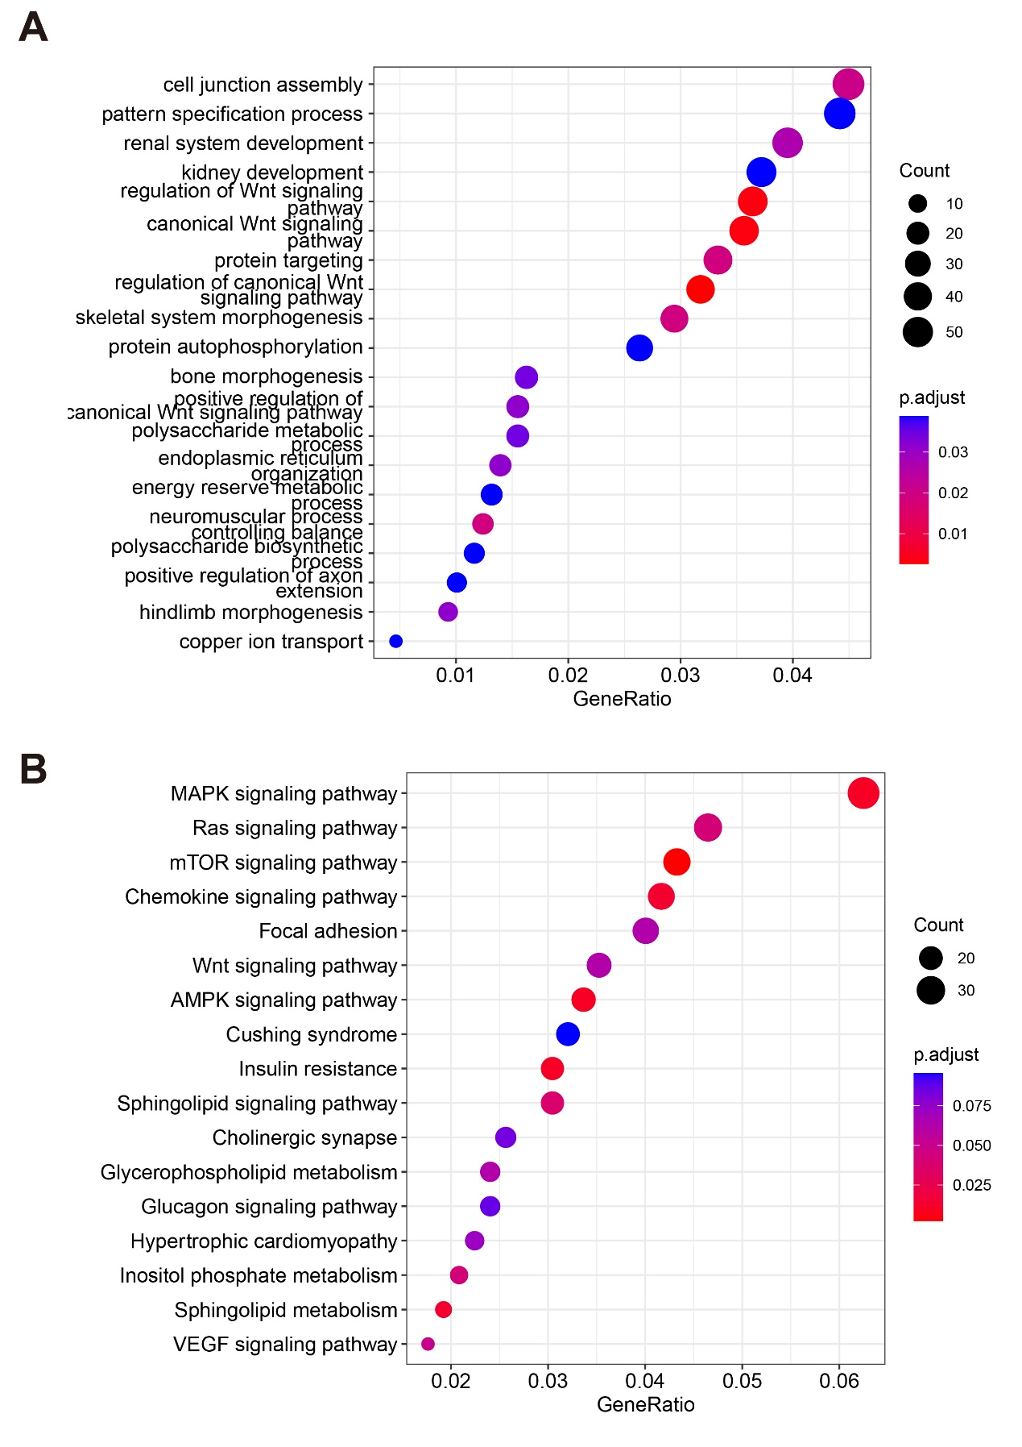
Supplementary material Figure 6: Top 17 GO (A) and KEGG (B) enrichment items. The left panel represents the GO or KEGG pathway, the right panel represents enrichment, and the size of the solid circle indicates the number of genes.

