Additive interaction of mid- to late-life depression and cerebrovascular disease on the risk of dementia: A nationwide population-based cohort study

Yoo Jin Jang^{1†}, Cinoo Kang^{2†}, Woojae Myung³, Shinn-Won Lim⁴, Young Kyung Moon¹, Ho Kim^{5*}, and Doh Kwan Kim^{1*}

1. Supplementary tables
Table S1 Medications prescribed according to the respective dementia and depression ICD-10 codes................2
Table S2 ICD-10 code definitions of dementia, depression, CVD, and 14 other diseases from the Charlson comorbidity index....................................................................................................................................................3
Table S3 Observed results according to dementia subtype……............................................................................4
Table S4 Lagged-time analysis result considering depression as a misdiagnosis or a prodrome of dementia......4
Table S5 Sensitivity analysis for the interaction effect of depression and CVD on the risk of the dementia onset when depression, CVD, and dementia were defined only by the ICD-10 codes (not considering medication use) with at least 1 hospital visit...........................................................................................................................................................................5

2. Supplementary figure
Fig. S1 Unadjusted survival curves for dementia onset according to exposure diseases……....................................6

Table S1 Medications prescribed according to the respective dementia and depression ICD-10 codes
Condition | Name | Drug Code
Outcome disease
Dementia | donepezil | 148601ATB 148601ATD 148602ATB 148602ATD 148603ATB
 | rivastigmine | 224501ACH 224502ALQ 224503ACH 224504ACH 224505ACH 224506CPC 224507CPC 224508CPC
 | galantamine | 385201ATB 385202ATB 385203ACR 385203ATR 385204ACR 385204ATR 385205ACR 385205ATR
 | memantine | 190001ALQ 190001ATB 190001BIJ 190002ASY
Exposure Disease
Depression | escitalopram | 474801ATB 474802ATB 474803ATB 474804ATB 521101ATD 521102ATD
 | fluoxetine | 161501ACH 161501ATB 161502ACH 161502ATB 161502ATD 161502ATR 161504ACR
 | fluvoxamine | 162501ATB 162502ATB
 | paroxetine | 209301ATB 209302ATB 209304ATR 209305ATR 209306ATR 209304ATE 09305ATE
 | citalopram | 428301ATB
 | sertraline | 227001ATB 227002ATB
 | Amitriptyline | 107501ATB 107502ATB 107504ATB
 | amoxapine | 108001ATB 108002ATB
 | bupropion | 428101ATB 428102ATR 428103ATR
 | clomipramine | 136301ACH 136302ACH
 | desvenlafaxine | 626401ATR 626402ATR
 | duloxetine | 495501ACE 495501ACH 495501ATE 495501ATB 495502ACE 495502ACH 495502ATB
 | imipramine | 173701ATB
 | milnacipran | 355801ACH 355802ACH 355803ACH
 | mirtazapine | 196201ATB 196201ATD 196202ATB 196202ATD 196204ATB 196204ATD
 | moclobemide | 196701ATB
 | nortriptyline | 203401ATB 203402ATB
 | rasagiline | 625201ATB
 | selegiline | 226401ATB
 | tandospirone | 484401ATB 484402ATB
 | trazodone | 242901ACH 242901ATB 242902ATB 242903ATR
 | venlafaxine | 247502ACR 247502ATR 247504ACR 247504ATR
 | vortioxetine | 628501ATB 628502ATB 628503ATB 628504ATB
Abbreviations: ICD-10, International Classification of Diseases, 10th revision

Table S2 ICD-10 code definitions of dementia, depression, CVD, and 14 other diseases from the Charlson comorbidity index
Condition | ICD-10 Code
Exposure Diseases
Depression | F32, F33
CVD | I60, I61, I62, I63, I64, I65, I66, I67, I68, I69
Outcome disease
Dementia | F00, F01, F02, F03, G30, G31
AD | F00, G30
VD | F01
Non-AD or non-VDª | F02, F03, G31
Covariates
Comorbidities
Myocardial infarction | I21, I22, I252
Congestive heart failure | I110, I130, I132, I255, I42, I43, I50
Peripheral vascular disease | I70, I71, I731, I738, I739, I771, I790, I792, K551, K558, K559, Z958, Z959
Chronic pulmonary disease | I278, I279, J40, J41, J42, J43, J44, J45, J46, J47, J60, J61, J62, J63, J64, J65, J66, J67, J684, J701, J703
Connective tissue disorder | M05, M06, M32, M33, M34, M315, M351, M353, M360
Peptic ulcer | K25, K26, K27, K28
Mild liver disease | B18, K73, K74, K700, K701, K702, K703, K709, K713, K714, K715, K717, K760, K762, K763, K764, K768, K769, Z944
Uncomplicated diabetes | E100, E101, E106, E108, E109, E110, E111, E116, E118, E119, E120, E121, E126, E128, E129, E130, E131, E136, E138, E139, E140, E141, E146, E148, E149
Complicated diabetes^{b} | E102, E103, E104, E105, E107, E112, E113, E114, E115, E117, E122, E123, E124, E125, E127, E132, E133, E134, E135, E137, E142, E143, E144, E145, E147
Hemiplegia | G81, G82, G041, G114, G801, G802, G830, G831, G832, G833, G834, G839
Moderate or severe renal diseases | I120, I131, N032, N033, N034, N035, N036, N037, N052, N053, N054, N055, N056, N057, N18, N19, N250, Z490, Z491, Z492, Z940, Z992
Non-metastatic solid cancer^{c} | C0, C1, C30, C31, C32, C33, C34, C37, C38, C39, C40, C41, C43, C45, C46, C47, C48, C49, C50, C51, C52, C53, C54, C55, C56, C57, C58, C6, C70, C71, C72, C73, C74, C75, C76, C81, C82, C83, C84, C85, C88, C90, C91, C92, C93, C94, C95, C96, C97
Moderate or severe liver diseases | I850, I859, I864, I982, K704, K711, K721, K729, K765, K766, K767
Metastatic solid cancer | C77, C78, C79, C80
Abbreviations: AD, Alzheimer's disease; CVD, cerebrovascular disease; ICD-10, International Classification of Diseases, 10th revision; VD, vascular dementia
ªIncludes dementia in other diseases classified elsewhere (F02), unspecified dementia (F03), and other degenerative diseases of the nervous system that have not been classified elsewhere (G31)
^{b}Diabetes complicated with retinopathy, neuropathy, or renal disease
^{c}Non-metastatic solid cancer including leukemia, lymphoma, and multiple myeloma
Table S3 Observed results according to dementia subtype
Dementia Subtype | Frequency | Proportion | Cumulative Frequency
No dementia | 229,502 | 94.74 | 229,502
Alzheimer’s disease | 9,729 | 4.02 | 239,231
Vascular dementia | 1,306 | 0.54 | 240,537
Other dementias | 1,700 | 0.70 | 242,237

Table S4 Lagged-time analysis result considering depression as a misdiagnosis or a prodrome of dementia
Lagged Timeª | aHR^{b} | 95% CI |  | p-value
1 year | 1.60 | 1.51 | 1.68 | <0.0001
2 year | 1.29 | 1.21 | 1.36 | <0.0001
Abbreviations: aHR, adjusted hazard ratio; CI, confidence interval
ªIf depression occurs shortly before dementia onset (during the lagged-time period), it was categorized into the “no depression” group
^{b}All models were adjusted for demographic characteristics (age, sex, residential area, and income level), cerebrovascular disease, and 14 comorbidities (myocardial infarction, congestive heart failure, peripheral vascular disease, chronic pulmonary disease, connective tissue disorder, peptic ulcer, mild liver disease, uncomplicated diabetes, complicated diabetes, hemiplegia, moderate or severe renal diseases, non-metastatic solid cancer, moderate or severe liver diseases, and metastatic solid cancer)

Table S5 Sensitivity analysis for the interaction effect of depression and CVD on the risk of dementia onset when depression, CVD, and dementia were defined only by the ICD-10 codes (not considering medication use) with at least 1 hospital visit
 | Risk of Dementia by Exposure, HR (95% CI) |  |  |  | Additive Interaction (95% CI) |  |  | Multiplicative Interactionª (95% CI)
 | No Depression  or CVD | Depression | CVD | Depression and CVD | APª | RERIª | SIª | Multiplicative Interactionª (95% CI)
Model 1^{b} | 1 [Reference] | 2.14  (2.05-2.24) | 3.73  (3.62-3.84) | 5.42  (5.18-5.67) | 0.10  (0.05-0.15) | 0.55  (0.29-0.8) | 1.14  (1.08-1.21) | 0.68  (0.64-0.72)
Model 2^{c} | 1 [Reference] | 2.11  (2.02-2.21) | 2.93  (2.84-3.01) | 4.44  (4.25-4.65) | 0.09  (0.04-0.14) | 0.4  (0.19-0.61) | 1.13  (1.06-1.21) | 0.72  (0.67-0.77)
Model 3^{d} | 1 [Reference] | 2.06  (1.97-2.16) | 2.84  (2.75-2.92) | 4.23  (4.04-4.43) | 0.08  (0.03-0.13) | 0.33  (0.12-0.53) | 1.11  (1.04-1.19) | 0.72  (0.68-0.77)
Dementia Subtype^{e}
AD | 1 [Reference] | 2.18  (2.04-2.32) | 2.53  (2.42-2.65) | 4.17  (3.90-4.46) | 0.11  (0.04-0.18) | 0.46  (0.16-0.76) | 1.17  (1.06-1.29) | 0.76  (0.69-0.83)
VD | 1 [Reference] | 2.09  (1.78-2.44) | 6.74  (6.19-7.34) | 8.37  (7.36-9.53) | 0.06  (-0.08-0.21) | 0.54  (-0.48-1.57) | 1.08  (0.94-1.24) | 0.60  (0.49-0.72)
Non-AD or Non-VD^{f} | 1 [Reference] | 1.94  (1.82-2.07) | 2.50  (2.39-2.62) | 3.60  (3.35-3.87) | 0.04  (-0.04-0.13) | 0.16  (-0.12-0.44) | 1.07  (0.96-1.19) | 0.74  (0.67-0.82)
Age^{g}
50 to 64 years | 1 [Reference] | 2.56  (2.36-2.79) | 3.67  (3.49-3.86) | 5.94  (5.47-6.44) | 0.12  (0.03-0.20) | 0.70  (0.21-1.19) | 1.16  (1.05-1.29) | 0.63  (0.56-0.71)
Above 64 years | 1 [Reference] | 1.88  (1.79-1.98) | 2.47  (2.38-2.57) | 3.64  (3.44-3.85) | 0.08  (0.02-0.14) | 0.29  (0.07-0.5) | 1.12  (1.03-1.22) | 0.78  (0.72-0.85)
Sex^{g}
Male | 1 [Reference] | 2.47  (2.31-2.65) | 4.24  (4.03-4.46) | 6.08  (5.64-6.55) | 0.06  (-0.02-0.14) | 0.37  (-0.09-0.83) | 1.08  (0.98-1.18) | 0.58  (0.52-0.64)
Female | 1 [Reference] | 1.85  (1.74-1.96) | 2.32  (2.24-2.41) | 3.43  (3.23-3.63) | 0.08  (0.01-0.14) | 0.26  (0.04-0.48) | 1.12  (1.02-1.23) | 0.80  (0.74-0.87)
Abbreviations: AD, Alzheimer's disease; AP, attributable proportion due to interaction; CI, confidence interval; CVD, cerebrovascular disease; HR, hazard ratio; RERI, relative excess risk due to interaction; SI, synergy index; VD, vascular dementia
ªNull hypothesis for each interaction is AP = 0, RERI=0, SI=1, and multiplicative interaction=1
^{b}Unadjusted model
^{c}Adjusted for demographic characteristics (age, sex, residential area, and income level)
^{d}Adjusted for demographic characteristics (age, sex, residential area, and income level) and 14 comorbidities (myocardial infarction, congestive heart failure, peripheral vascular disease, chronic pulmonary disease, connective tissue disorder, peptic ulcer, mild liver disease, uncomplicated diabetes, complicated diabetes, hemiplegia, moderate or severe renal diseases, non-metastatic solid cancer, moderate or severe liver diseases, and metastatic solid cancer)
^{e}Subgroup analysis for dementia subtype was based on Model 3 (adjusted for demographic characteristics and 14 comorbidities) and conducted separately by considering the other dementia subtypes as a competing risk
^{f}Includes dementia in other diseases classified elsewhere (F02), unspecified dementia (F03), other degenerative diseases of the nervous system, and not elsewhere classified (G31)
^{g}Subgroup analyses for age and sex were based on Model 3 (adjusted for demographic characteristics and 14 comorbidities). Age or sex was not considered as a covariate in each subgroup analysis

Fig. S1 Unadjusted survival curves for dementia onset according to the exposure diseases
A. Unadjusted survival curves for dementia onset according to the exposure of depression
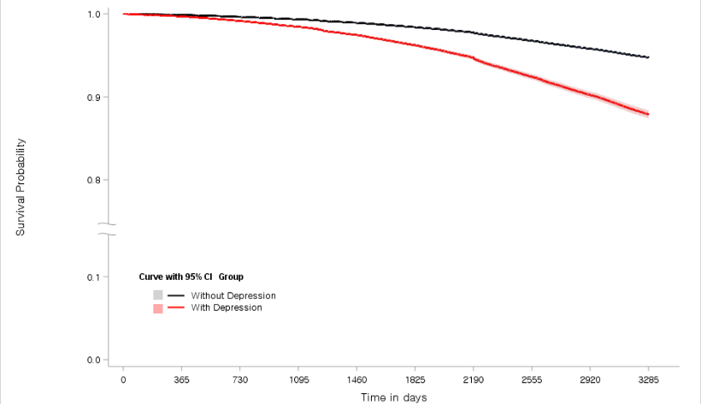
B. Unadjusted survival curves for dementia onset according to the exposure of CVD
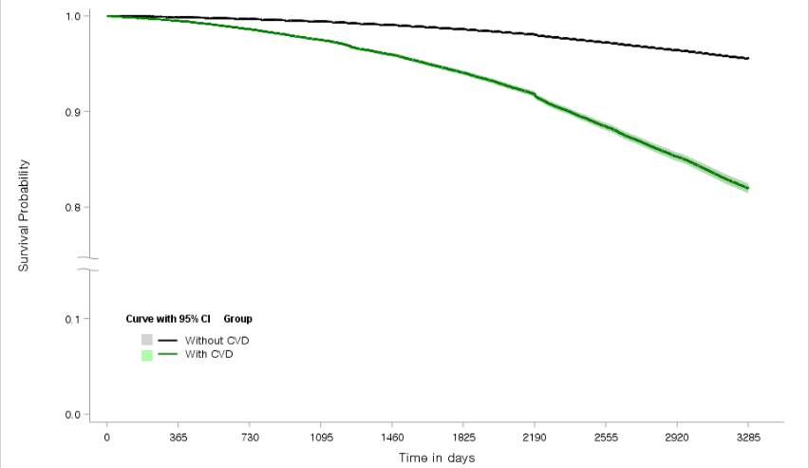
C. Unadjusted survival curves for dementia onset according to the exposures of depression and CVD
