Protein  Name | Protein  PDB | Grids | Compounds | Docking Score (kcal/mol) | Hydrogen bond interaction | Binding site interactions
PI3K | 1E7U | Center_x = 23.028  center_y = 62.413  center_z = 20.582  size_x = 42  size_y = 51  size_z = 50 | Aegeline | -7.5 | ARG:849 | 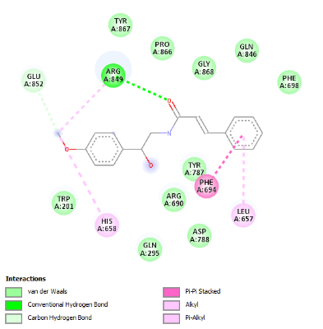
 |  |  | Auraptene | -8 | CYS: 869  ARG:690 | 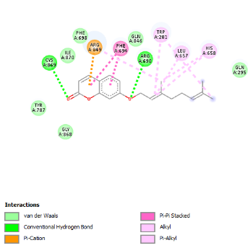
 |  |  | Bergapten | -8.2 | CYS: 869  ARG:690 | 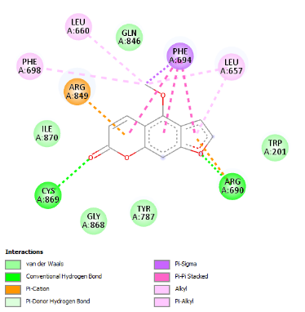
 |  |  | Imperatorin | -8.9 | ARG:690 | 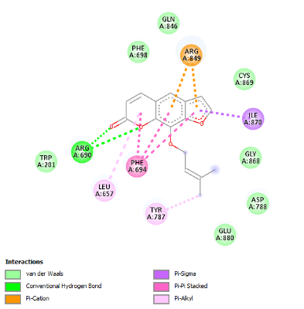
 |  |  | Marmesin | -7.7 | GLN:291  GLN:846 | 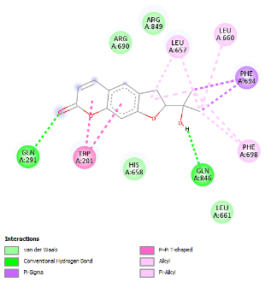
 |  |  | Nodakenin | -8.8 | TYR:210  GLU:852  GLN:291 | 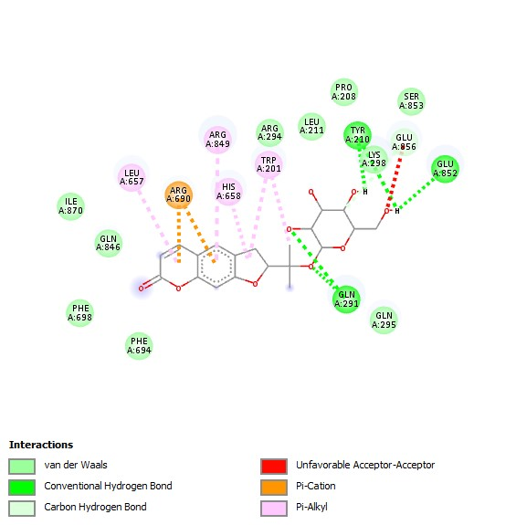
EGFR  (Endothelial Growth Factor Receptor) | 3G5X | center_x = 23.094  center_y = 18.130  center_z = 60.451  size_x = 40  size_y = 40  size_z = 40 | Aegeline | -7.6 | THR:18  SER:68 | 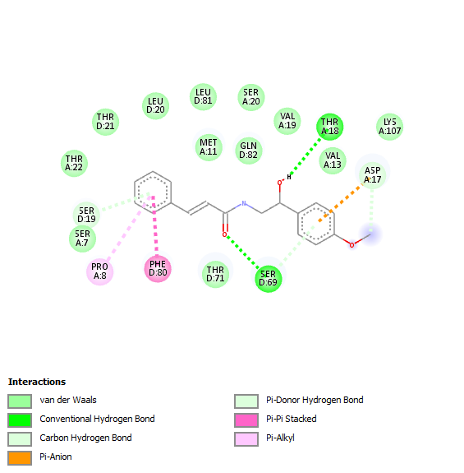
 |  |  | Auraptene | -8.2 | LEU:20  SER:19 | 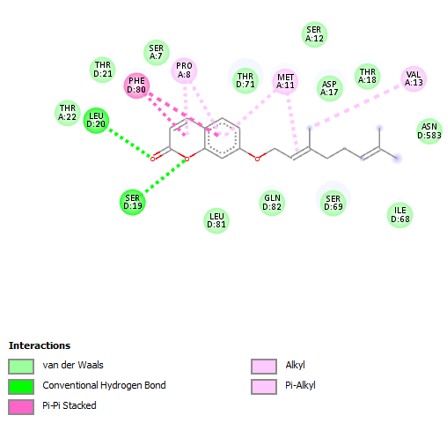
 |  |  | Bergapten | -6.8 | SER:69 | 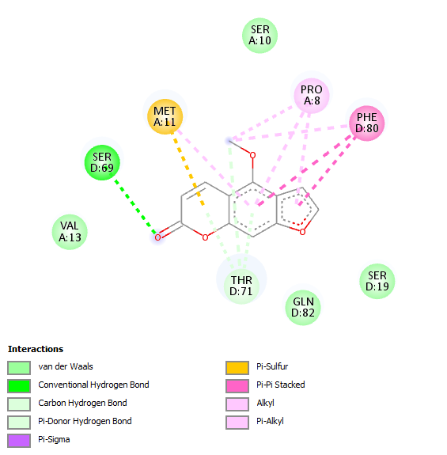
 |  |  | Imperatorin | -7.9 | SER:19 | 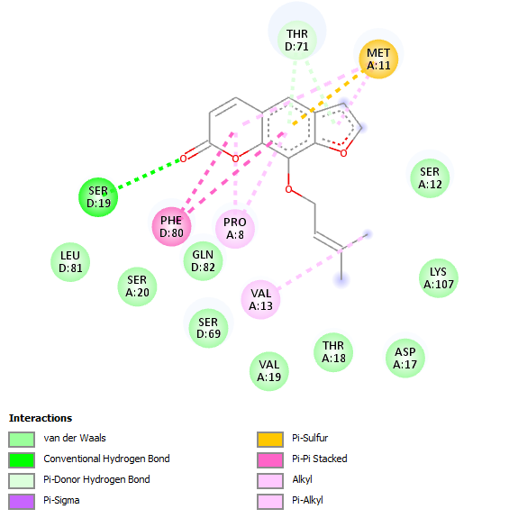
 |  |  | Marmesin | -8.1 | SER:69  THR:22 | 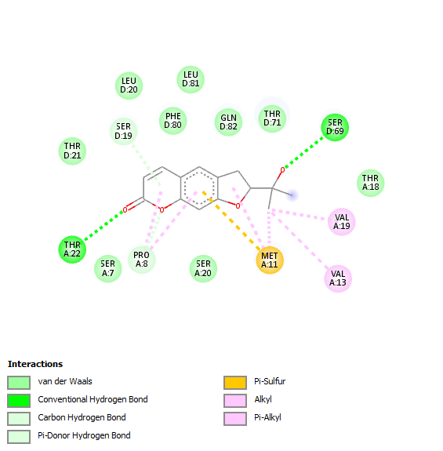
 |  |  | Nodakenin | 10.1 | SER D:19  SER D:69  LEU: 20  THR: 18 | 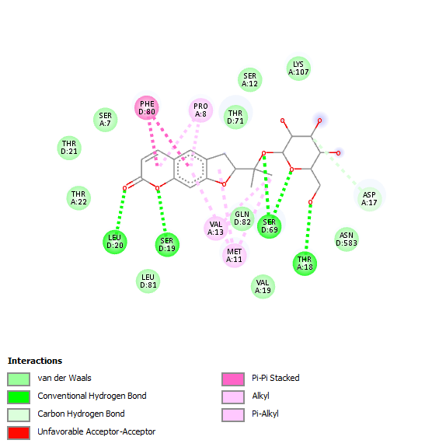
MAPK1  (Mitogen Activated Protein Kinase 1) | 4FUX | center_x = 18.517  center_y = 6.377  center_z = 16.735  size_x = 40  size_y = 45  size_z = 50 | Aegeline | -7.0 | ARG: 89  LYS: 97  ASP: 98 | 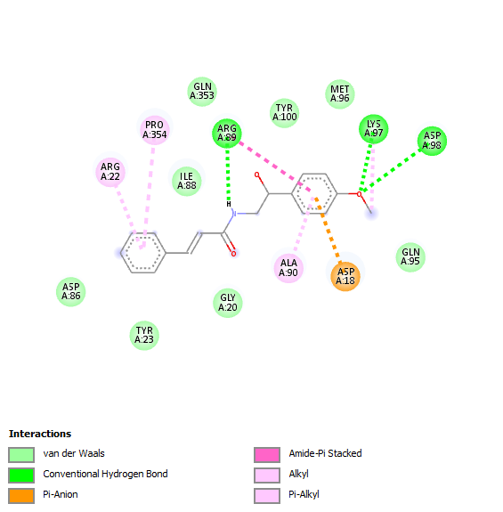
 |  |  | Auraptene | -6.1 | ASP: 109 | 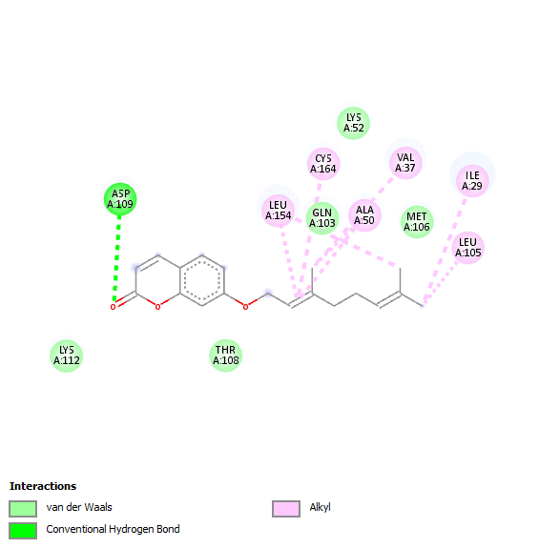
 |  |  | Bergapten | -6.0 | ASP: 109  MET: 106 | 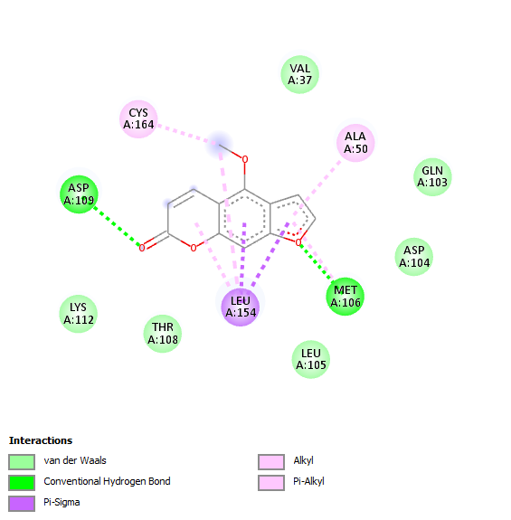
 |  |  | Imperatorin | -6.5 | -- | 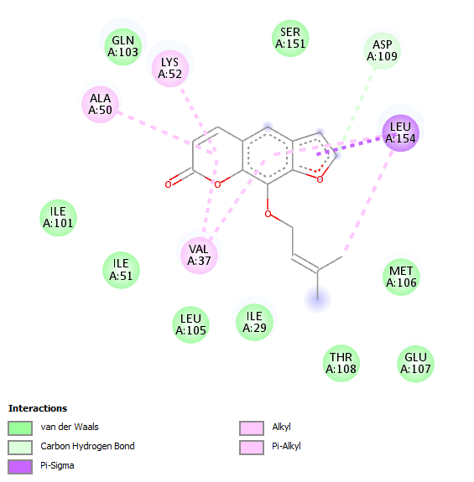
 |  |  | Marmesin | -6.7 | LYS: 52 | 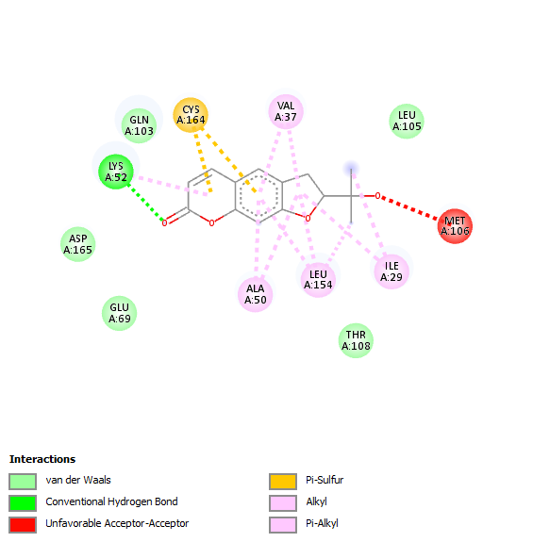
 |  |  | Nodakenin | -8.0 | THR: 108  LYS: 62  GLU: 69 | 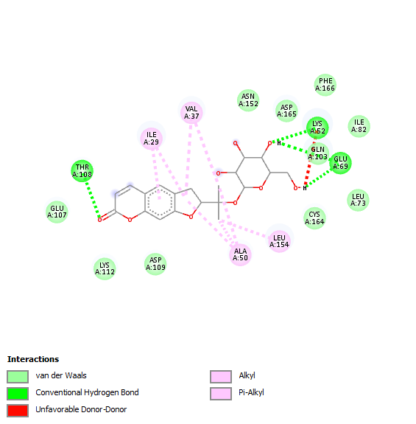
AKT1 | 7WSW | center_x = 164.895  center_y = 189.623  center_z = 195.270  size_x = 48  size_y = 66  size_z = 67 | Aegeline | -8.1 | -- | 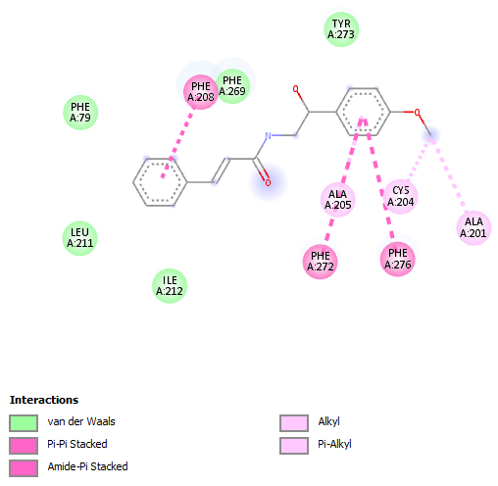
 |  |  | Auraptene | -7.7 | -- | 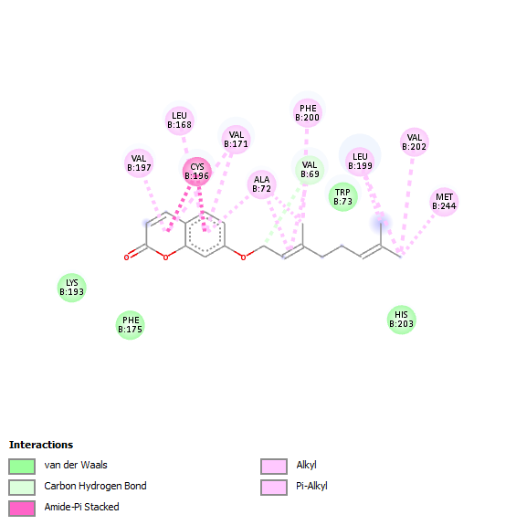
 |  |  | Bergapten | -6.9 | ARG:169  TRP:135 | 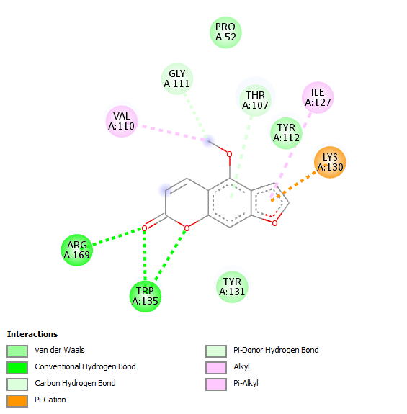
 |  |  | Imperatorin | -7.4 | ARG A:170  ARG A:169  THR:107 | 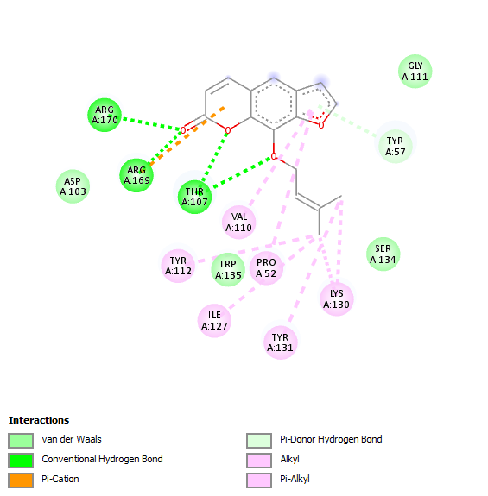
 |  |  | Marmesin | -7.7 | TYR: 240  HIS: 203  TRP: 73 | 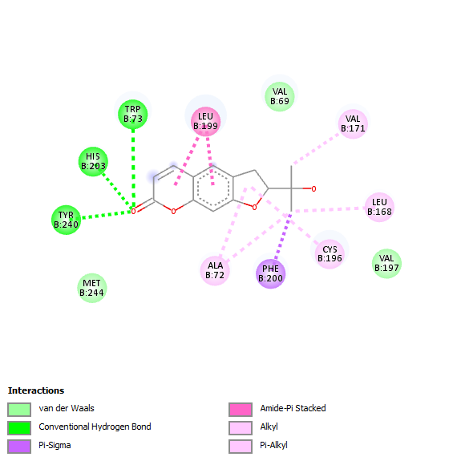
 |  |  | Nodakenin | -8.2 | GLU: 61  ARG: 177  ARG: 58  PRO: 52 | 