Synthesis, Characterization, and Photophysical Interaction of Anthraquinone Azo Hydrazone Tautomer and Biosensor for Mycobacterium Tuberculosis
Pampapathi Shekharagouda,^{[a]} G P Mamatha,*^{[a]} G Nagaraju,^{[b]} Chethan Krishnamurthy,[C] Siddan Gouthaman. [d]

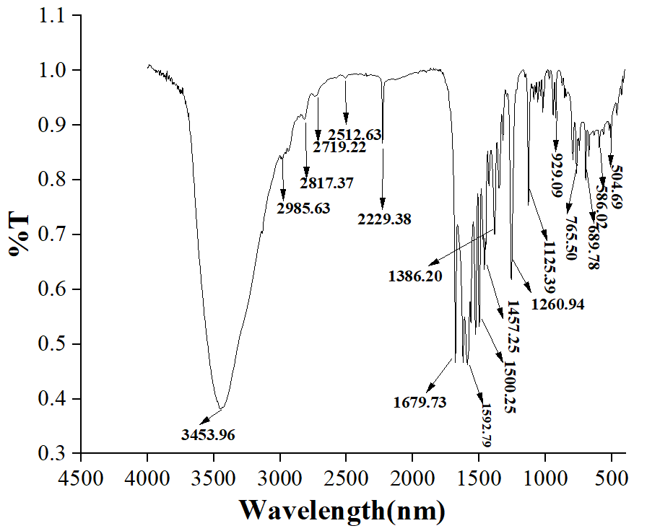
Fig.s1. FT-IR spectrum of Q1compound

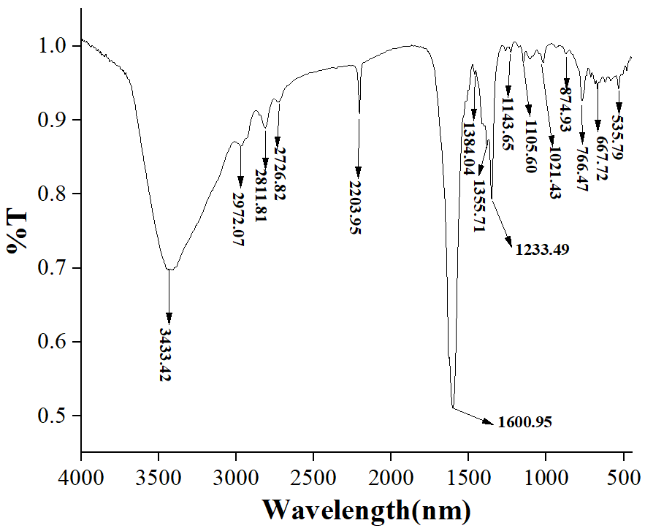

Fig.s2. FT-IR spectrum of Q2compound

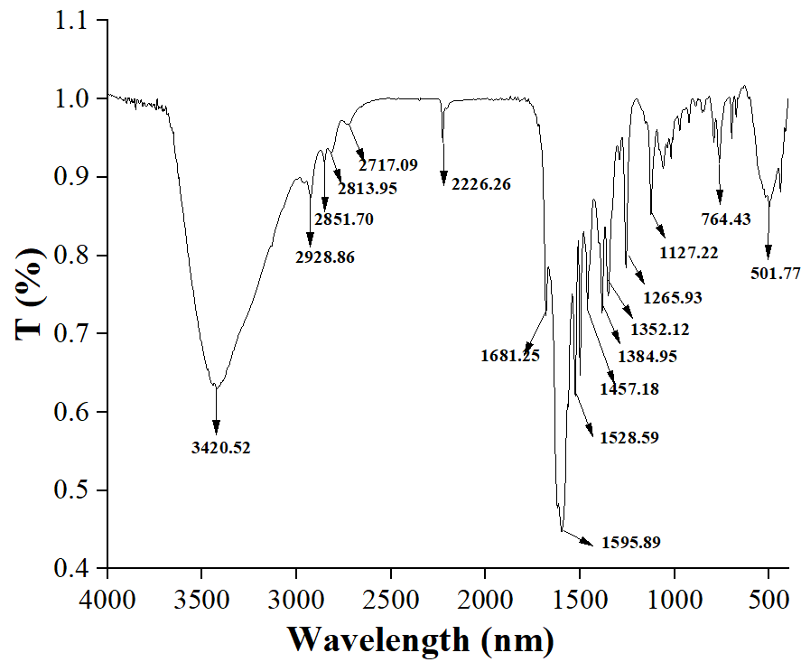

Fig.s3. FT-IR spectrum of Q3 compound

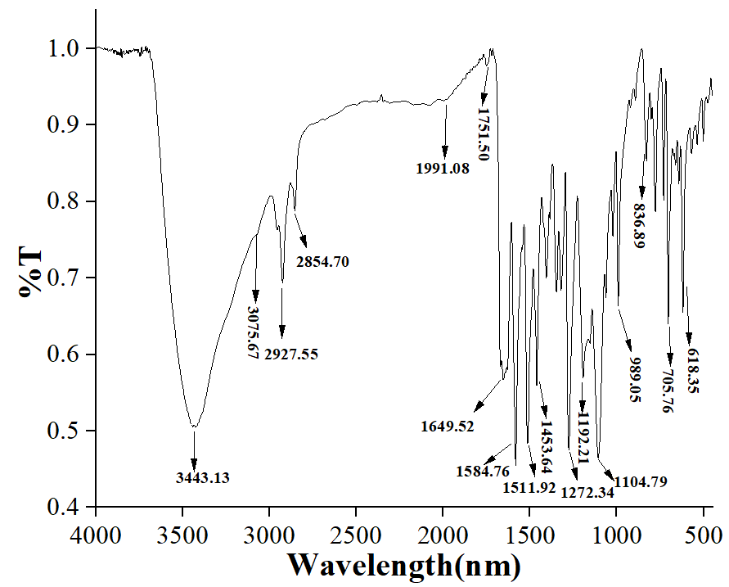

Fig. s4. FT-IR spectrum of Q4 compound

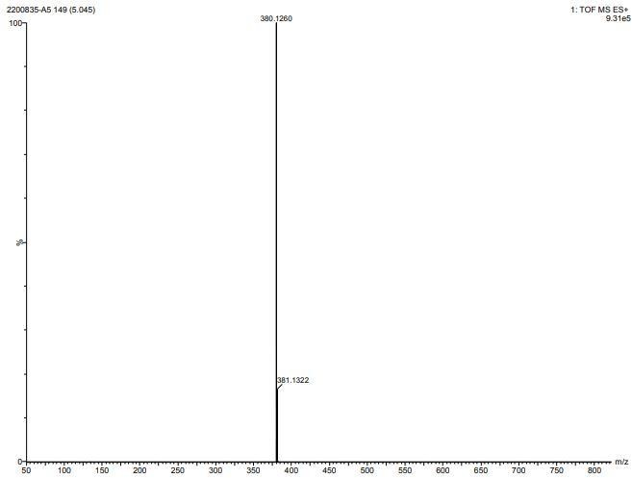

Fig. s5. HR-MS spectrum of Q1 compound
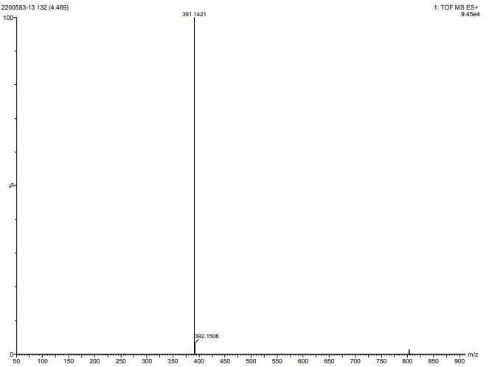

Fig. s6. HR-MS spectrum of Q2 compound

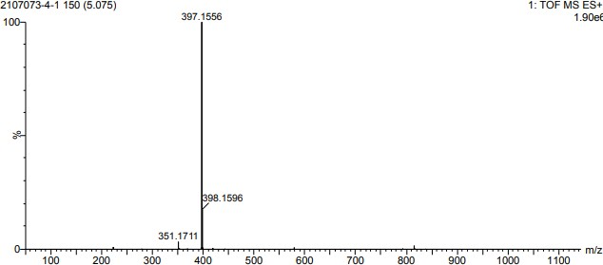

Fig. s7. HR-MS spectrum of Q3 compound

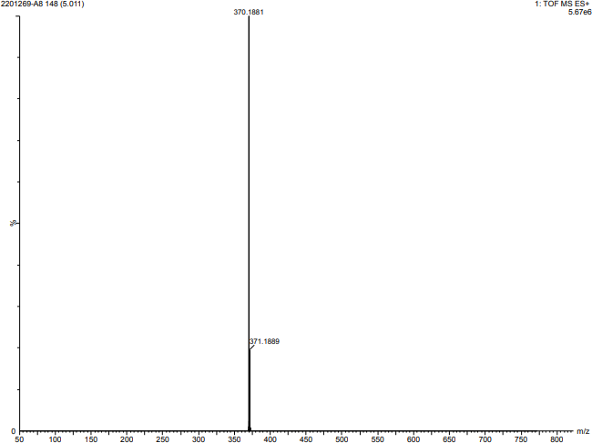

Fig. s8. HR-MS spectrum of Q4 compound

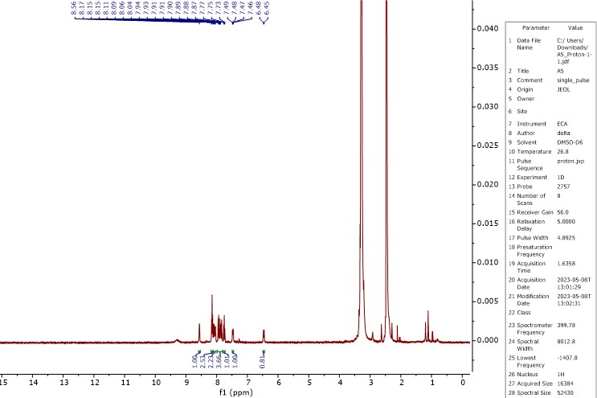

Fig. s9. ¹H NMR spectrum of Q1compound

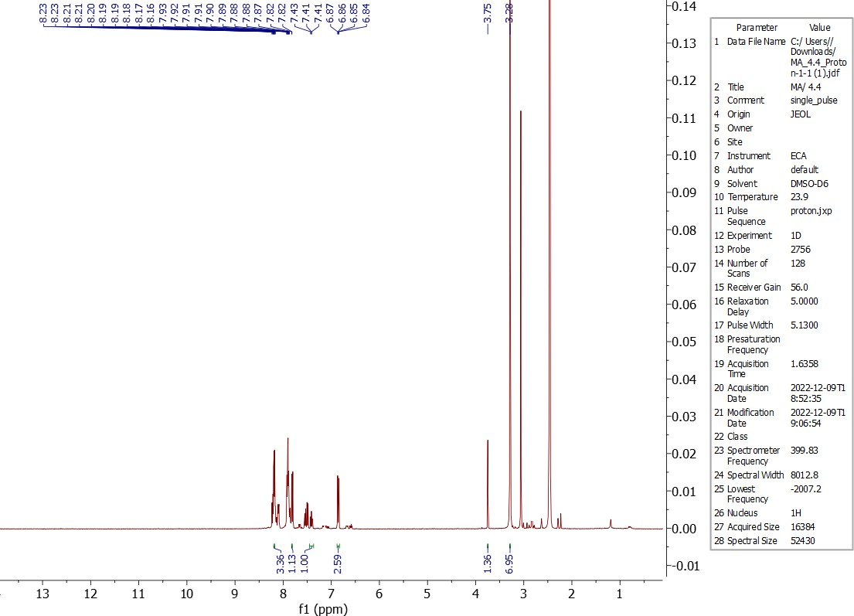

Fig. s10. ¹H NMR spectrum of Q1compound

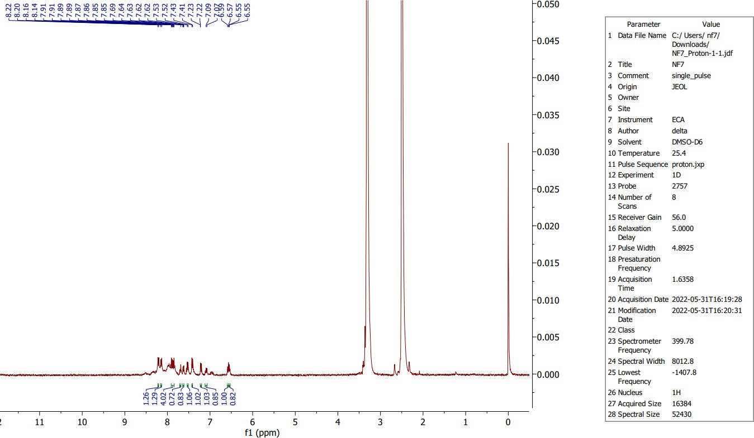

Fig. s11. ¹H NMR spectrum of Q3 compound

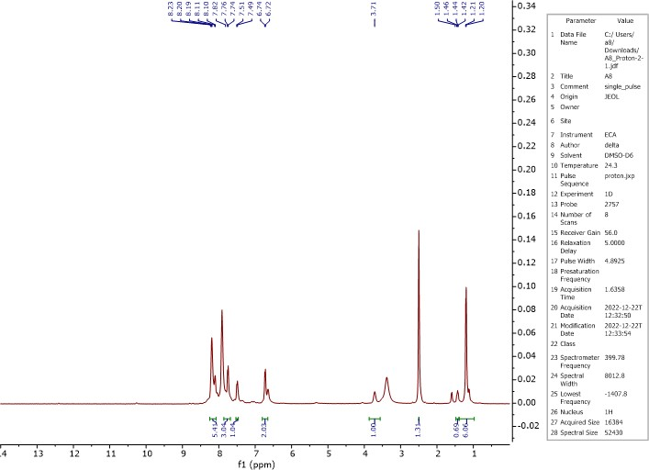

Fig. s12. ¹H NMR spectrum of Q4 compound

Table s1 absorption maxima, emission maxima and stoke shift values in wavenumber
Solvents | SMB |  |  | SMP |  |  | SPB |  |  | SPP
Solvents | $${\overline{ν}}_{A}$$  (cm⁻¹) | $${\overline{ν}}_{F}$$  (cm⁻¹) | $$∆\overline{v}$$  (cm⁻¹) | $${\overline{ν}}_{A}$$  (cm⁻¹) | $${\overline{ν}}_{F}$$  (cm⁻¹) | $$∆\overline{v}$$  (cm⁻¹) | $${\overline{ν}}_{A}$$  (cm⁻¹) | $${\overline{ν}}_{F}$$  (cm⁻¹) | $$∆\overline{v}$$  (cm⁻¹) | $${\overline{ν}}_{A}$$  (cm⁻¹) | $${\overline{ν}}_{F}$$  (cm⁻¹) | $$∆\overline{v}$$  (cm⁻¹)
Toluene | 22727 | 18349 | 4379 | 24390 | 19960 | 4430 | 22676 | 17212 | 5464 | 25510 | 18975 | 6535
THF | 20408 | 18182 | 2226 | 23753 | 19569 | 4183 | 22624 | 17153 | 5472 | 25316 | 18762 | 6555
DCM | 20325 | 17544 | 2781 | 23641 | 19493 | 4147 | 22624 | 17065 | 5560 | 25126 | 18484 | 6641
Ethanol | 20202 | 17483 | 2720 | 23419 | 19048 | 4372 | 22573 | 17007 | 5567 | 24814 | 18416 | 6398
Methanol | 20040 | 17391 | 2649 | 23310 | 18657 | 4653 | 22472 | 16807 | 5665 | 24570 | 18182 | 6388
Acetonitrile | 19646 | 17483 | 2164 | 23256 | 18315 | 4941 | 22472 | 16835 | 5637 | 24450 | 18149 | 6301
DMF | 19569 | 17301 | 2268 | 23148 | 18083 | 5065 | 22371 | 17153 | 5219 | 24390 | 17575 | 6816
DMSO | 19268 | 16694 | 2573 | 21882 | 17921 | 3961 | 22272 | 17153 | 5119 | 24213 | 17422 | 6791

Table s2 Value of E_{HOMO,} E_{LUMO,} and energy band gap (ΔΕ) calculated from DFT- B3LYP/6-311G(d)-IEF-PCM basis set
Solvents | Q1 |  |  | Q2 |  |  | Q3 |  |  | Q4
Solvents | E_{HOMO}  (eV) | E_{LUMO}  (eV) | ΔΕ  (eV) | E_{HOMO}  (eV) | E_{LUMO}  (eV) | ΔΕ  (eV) | E_{HOMO}  (eV) | E_{LUMO}  (eV) | ΔΕ  (eV) | E_{HOMO}  (eV) | E_{LUMO}  (eV) | ΔΕ  (eV)
Toluene | −6.303 | −3.152 | 3.151 | −5.435 | −3.011 | 2.424 | −5.345 | −2.566 | 2.779 | −5.121 | −2.552 | 2.569
THF | −6.336 | −3.131 | 3.205 | −5.411 | −3.006 | 2.405 | −5.344 | −2.455 | 2.889 | −5.086 | −2.597 | 2.489
DCM | −6.386 | −3.112 | 3.274 | −5.409 | −2.954 | 2.455 | −5.221 | −2.489 | 2.732 | −5.097 | −2.617 | 2.480
Ethanol | −6.333 | −3.178 | 3.155 | −5.374 | −2.854 | 2.52 | −5.389 | −2.438 | 2.951 | −5.111 | −2.593 | 2.518
Methanol | −6.343 | −3.109 | 3.234 | −5.357 | −2.811 | 2.546 | −5.386 | −2.411 | 2.975 | −5.122 | −2.594 | 2.528
Acetonitrile | −6.353 | −3.203 | 3.15 | −5.352 | −2.843 | 2.509 | −5.421 | −2.399 | 3.022 | −5.119 | −2.531 | 2.588
DMF | −6.352 | −3.159 | 3.193 | −5.346 | −2.816 | 2.530 | −5.428 | −2.385 | 3.043 | −5.121 | −2.471 | 2.650
DMSO | −6.434 | −3.115 | 3.319 | −5.342 | −2.989 | 2.353 | −5.299 | −2.387 | 2.912 | −5.103 | −2.436 | 2.667

