Supporting Information (SI)
Selective adsorption of tetracycline by β-CD-immobilizing sodium alginate aerogel coupled with ultrafiltration for reclaimed water
Xi Quanª, Jun Zhangª, Linlin Yinª, Wei Zuoª, Yu Tianª

ª State Key Laboratory of Urban Water Resource and Environment (SKLUWRE), School of Environment, Harbin Institute of Technology, Harbin 150090, China

*Corresponding author. Tel: +(86) 451 8628 3077, Fax: +(86) 451 8628 3077, E-mail: hitsunyboy@126.com

The Supporting Information includes: 1 Table, 5 Figs, 5 Pages.

Tables caption
Table S1. Element analysis.
Fig.s caption
Fig. S1. Schematic presentation of β-CD/NaAlg
Fig. S2. Adsorption capacity of TC on the β-CD/NaAlg aerogel in five successive cycles of desorption-adsorption.
Fig. S3. (a) Removal of TC by UF membrane, β-CD/NaAlg aerogel, and β-CD/NaAlg aerogel-UF; (b) Removal of tetracycline, chlortetracycline and oxytetracycline by β-CD/NaAlg aerogel.
Fig. S4. Removal of tetracycline antibiotic by β-CD/NaAlg aerogel-UF.
Fig. S5. Effect of Cr ions, humic acid, reclaimed water on TC adsorption on β-CD/NaAlg aerogel.

Table S1. Element analysis
Sample | Element Analysis
Sample | C(%) | O(%) | Cl(%) | Na(%) | Ca(%)
β-CD | 59.14 | 39.96 | 0.43 | 0.12 | 0.34
NaAlg aerogel | 49.01 | 36.97 | 6.63 | 2.01 | 5.39
β-CD/NaAlg aerogel | 56.70 | 39.83 | 0.47 | 0.76 | 2.24
β-CD/NaAlg aerogel  (after adsorption) | 59.17 | 38.72 | 0.72 | 0.85 | 0.54

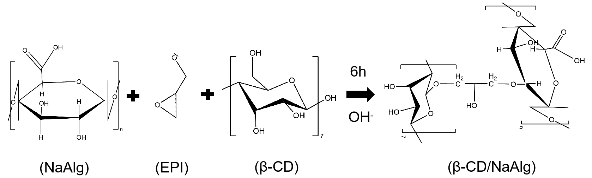
Fig. S1. Schematic presentation of β-CD/NaAlg

Fig. S2. Adsorption capacity of TC on the β-CD/NaAlg aerogel in five successive cycles of desorption-adsorption.

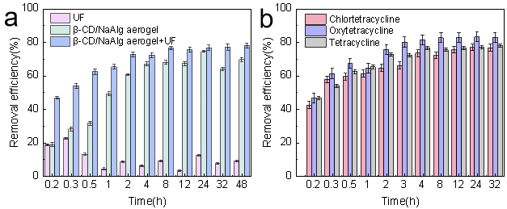
Fig. S3. (a) Removal of TC by UF membrane, β-CD/NaAlg aerogel, and β-CD/NaAlg aerogel-UF; (b) Removal of tetracycline, chlortetracycline and oxytetracycline by β-CD/NaAlg aerogel.
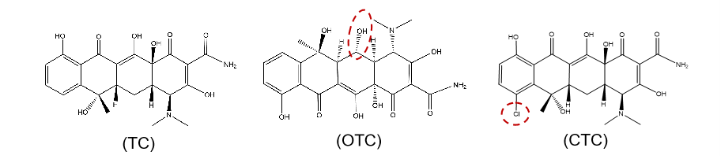
Fig. S4. Removal of tetracycline antibiotic by β-CD/NaAlg aerogel-UF.
Fig. S5. Effect of Cr ions, humic acid, reclaimed water on TC adsorption on β-CD/NaAlg aerogel.

