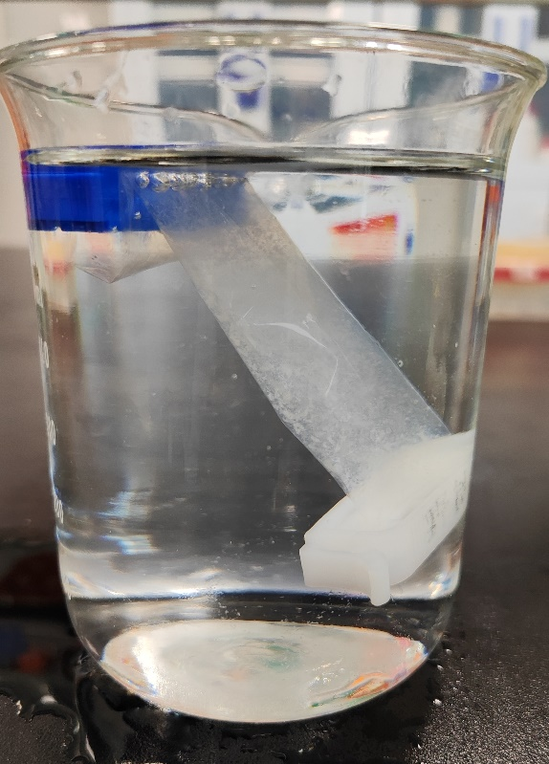
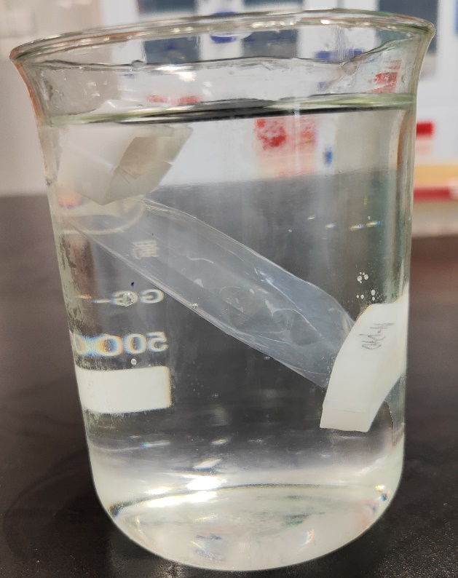
B
A

Fgure S1 N protein dialysis results of different purification processes. A The N protein precipitated in dialysis step (N protein was not treated with PEI and ammonium sulfate). B The N protein treated with PEI and ammonium sulfate did not precipitate in dialysis (Figure S 1B).

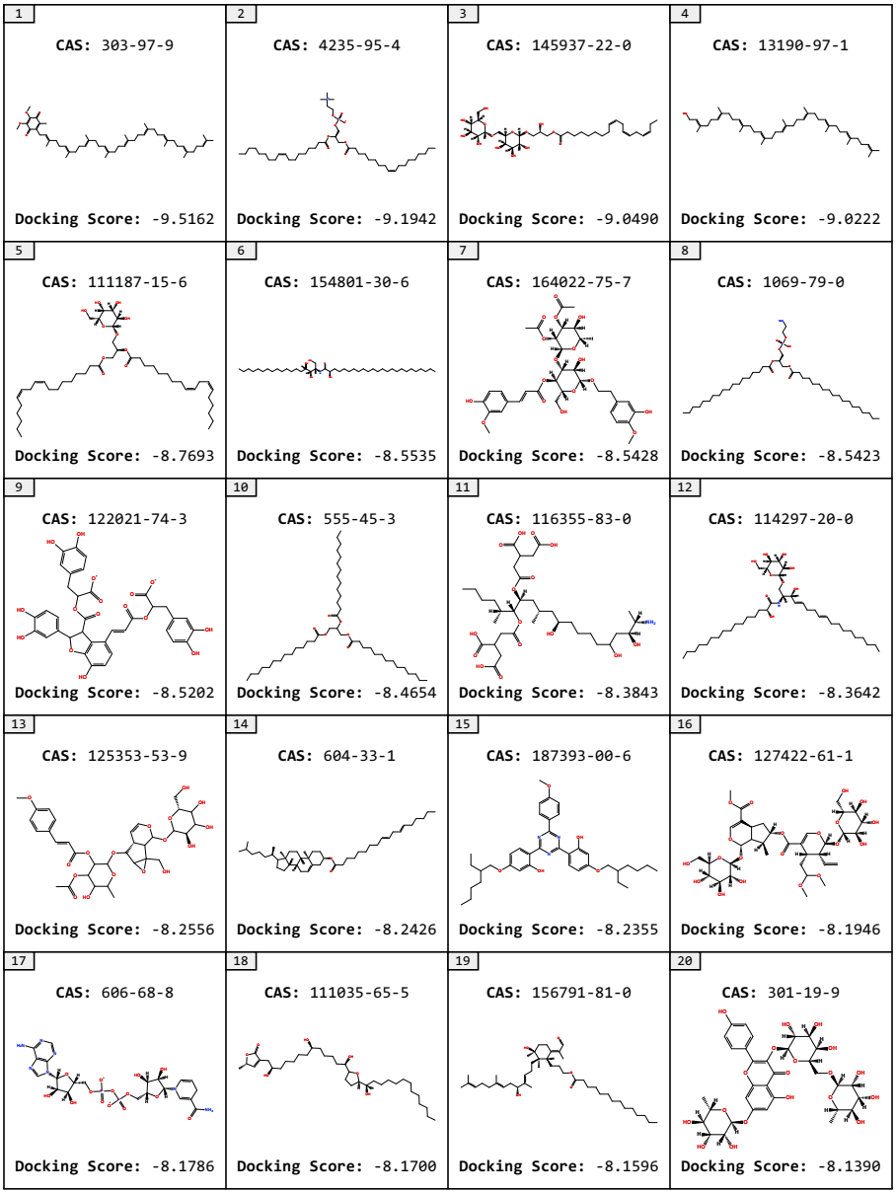
Figure S2. The Top20 compounds of natural products and natural product derivatives.

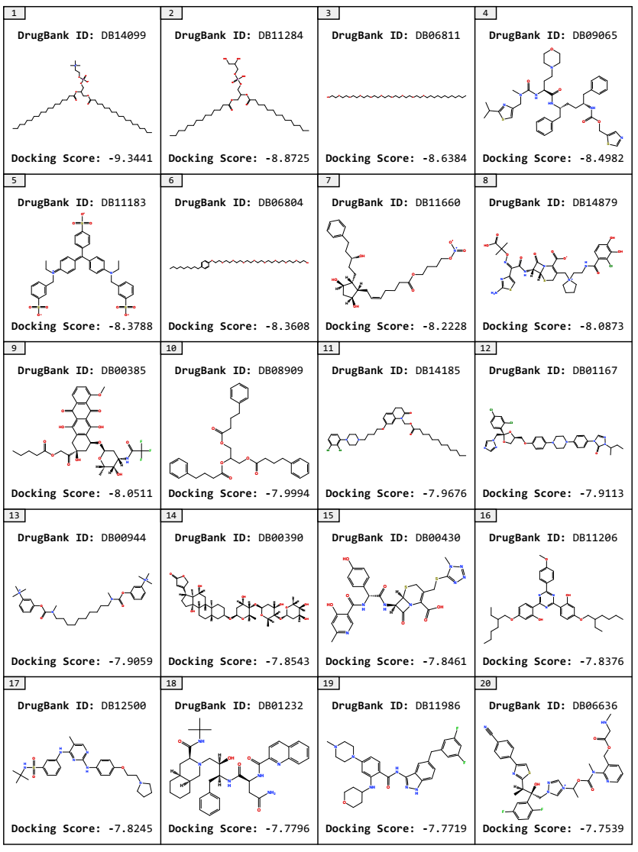
Figure S3. The Top20 compounds of approved drug molecules.

