Supporting information
Computer-aided rational design strategy based on protein surface charge to improve the thermal stability of a novel esterase from Geobacillus jurassicus

Runfei Song¹, Jin Zhang¹, Mengyu Zhu¹, Lin Lin^{2,3}, Wei Wei¹*, Dongzhi Wei¹

¹State Key Laboratory of Bioreactor Engineering, Newworld Institute of Biotechnology, East China University of Science and Technology, Shanghai 200237, People’s Republic of China
²School of Chemical and Environmental Engineering, Shanghai Institute of Technology, Shanghai 201418, People’s Republic of China
³Research Laboratory for Functional Nanomaterial, National Engineering Research Center for Nanotechnology, Shanghai 200241, People’s Republic of China
* Corresponding author:
Wei Wei: Newworld Institute of Biotechnology, State Key Laboratory of Bioreactor Engineering, East China University of Science and Technology, 130 Meilong Road, 200237, Shanghai, China. Tel: +86-21-64251803, Fax: +86-21-64251803, Email: weiwei@ecust.edu.cn

Table S1. The strains and plasmids used in this study.
Strains and plasmids | Relevant features | Source
Strains
Geobacillus jurassicus DSMZ 15726 | Original strain | Laboratory
E. coli (DH5α) | F⁻ψ80lacZΔM15Δ (lacZYA-argF) U169 endA1 recA1 hsdR17 (rk⁻, mk⁻) supE44λ⁻thi-1 gyrA96 relA1 phoA | Novagen
E. coli (BL21) | F⁻, ompT, hsdS (rBB-mB), gal, dcm (DE3) | Novagen
BL21-pET-28a-gju768 | Recombinant strain, E. coli BL21(DE3) carrying plasmid pET-28a-gju768 | This study
Plasmid
pET-28a (+) | E. coli expression vector; Kan^{r} | Novagen
pET-28a-gju768 | pET-28a based vector, carrying gju768 gene; Kan^{r} | This study

Table S2. Results of GetArea screening of amino acids located on the surface of the protein.
Residue | Apolar | Backbone | Sidechain | Ratio (%) | In/Out
MET 1 | 128.80 | 33.86 | 110.16 | 69.6 | Out
GLN 6 | 30.58 | 26.42 | 97.63 | 67.9 | Out
LEU 8 | 101.99 | 17.51 | 101.99 | 69.8 | Out
GLY 11 | 34.34 | 57.73 | 0.00 | 66.2 | Out
LEU 20 | 77.12 | 5.91 | 77.12 | 52.7 | Out
GLU 21 | 68.55 | 33.02 | 76.51 | 54.2 | Out
ASP 24 | 40.48 | 19.61 | 99.02 | 87.6 | Out
GLU 25 | 41.67 | 6.85 | 78.41 | 55.5 | Out
ARG 26 | 44.99 | 15.22 | 126.57 | 64.7 | Out
THR 37 | 58.95 | 32.08 | 83.32 | 78.5 | Out
HIS 42 | 84.85 | 20.76 | 97.35 | 63.0 | Out
HIS 45 | 73.21 | 6.36 | 82.33 | 53.3 | Out
TYR 48 | 71.37 | 0.00 | 104.47 | 54.1 | Out
GLU 67 | 48.00 | 37.23 | 71.19 | 50.4 | Out
GLY 69 | 20.15 | 44.16 | 0.00 | 50.6 | Out
GLN 70 | 37.11 | 33.01 | 86.12 | 59.9 | Out
GLY 71 | 54.81 | 86.37 | 0.00 | 99.1 | Out
SER 73 | 59.87 | 14.83 | 50.62 | 65.4 | Out
GLU 74 | 50.59 | 7.68 | 117.37 | 83.1 | Out
ARG 75 | 64.01 | 4.94 | 102.83 | 52.6 | Out
LYS 76 | 78.76 | 1.83 | 121.22 | 73.7 | Out
GLN 78 | 31.31 | 8.70 | 72.83 | 50.7 | Out
ASP 83 | 18.89 | 5.52 | 77.76 | 68.8 | Out
ARG 87 | 34.87 | 2.78 | 105.78 | 54.1 | Out
THR 90 | 44.30 | 0.00 | 55.05 | 51.8 | Out
SER 97 | 34.05 | 2.23 | 39.30 | 50.8 | Out
ASN 101 | 28.98 | 35.47 | 82.10 | 71.8 | Out
HIS 102 | 71.80 | 27.54 | 87.93 | 56.9 | Out
PRO 107 | 56.28 | 5.01 | 56.25 | 53.5 | Out
LYS 108 | 108.56 | 9.72 | 152.34 | 92.6 | Out
PRO 130 | 102.85 | 3.41 | 102.82 | 97.7 | Out
ASP 149 | 25.49 | 1.09 | 59.14 | 52.3 | Out
ASP 153 | 23.23 | 0.52 | 68.96 | 61.0 | Out
LYS 156 | 97.53 | 15.61 | 117.28 | 71.3 | Out
ARG 157 | 93.15 | 31.92 | 153.03 | 78.3 | Out
ARG 158 | 48.82 | 26.82 | 122.12 | 62.5 | Out
ARG 159 | 99.10 | 30.10 | 187.49 | 95.9 | Out
ASP 161 | 42.97 | 10.39 | 85.28 | 75.5 | Out
PRO 163 | 76.60 | 36.68 | 62.80 | 59.7 | Out
PRO 165 | 79.06 | 7.54 | 71.53 | 68.0 | Out
PRO 166 | 109.30 | 4.83 | 108.27 | 100.0 | Out
THR 167 | 90.52 | 5.07 | 97.09 | 91.4 | Out
ALA 170 | 58.21 | 8.90 | 52.53 | 80.9 | Out
LEU 171 | 96.76 | 0.42 | 96.57 | 66.1 | Out
GLU 174 | 48.06 | 10.69 | 105.97 | 75.1 | Out
LYS 175 | 98.28 | 11.63 | 109.71 | 66.7 | Out
ALA 177 | 35.51 | 5.34 | 34.39 | 53.0 | Out
ARG 178 | 72.03 | 8.87 | 132.09 | 67.6 | Out
LYS 183 | 71.50 | 34.37 | 82.34 | 50.1 | Out
GLU 186 | 71.15 | 11.76 | 95.28 | 67.5 | Out
ALA 189 | 66.79 | 38.84 | 48.35 | 74.5 | Out
LYS 199 | 42.35 | 21.44 | 84.96 | 51.6 | Out
ALA 200 | 45.57 | 9.25 | 39.09 | 60.2 | Out
GLN 202 | 69.95 | 34.92 | 128.36 | 89.3 | Out
VAL 203 | 81.81 | 16.99 | 76.53 | 62.6 | Out
ALA 207 | 49.17 | 2.73 | 46.67 | 71.9 | Out
GLU 211 | 49.06 | 6.75 | 97.85 | 69.3 | Out
PRO 218 | 85.13 | 18.65 | 77.90 | 74.1 | Out
GLU 221 | 45.78 | 20.09 | 123.61 | 87.5 | Out
GLY 222 | 39.95 | 65.96 | 0.00 | 75.6 | Out
ASN 223 | 6.96 | 2.96 | 68.50 | 59.9 | Out
GLU 224 | 72.03 | 7.43 | 103.31 | 73.2 | Out
ASP 225 | 60.54 | 21.61 | 79.20 | 70.1 | Out
PRO 233 | 71.73 | 14.97 | 71.66 | 68.1 | Out
HIS 234 | 115.67 | 23.32 | 137.45 | 88.9 | Out
LYS 238 | 119.87 | 3.87 | 160.17 | 97.4 | Out
ARG 241 | 92.61 | 8.66 | 164.84 | 84.3 | Out
GLU 242 | 43.46 | 6.36 | 100.26 | 71.0 | Out
ARG 249 | 68.51 | 2.45 | 124.07 | 63.5 | Out
ARG 252 | 41.82 | 28.66 | 134.92 | 69.0 | Out
GLU 253 | 37.69 | 33.17 | 88.50 | 62.7 | Out
Negative charged amino acids (Glu and Asp) shown in bold

Table S3. Results of simulation of single mutations by Discovery Studio 3.5.
Mutation | Mutation Energy | Effect of Mutation | VDM Term | Electrostatic Term | Entropy Term
GLU21>GLN | 0.44 | NEUTRAL | 0.1 | 0.51 | 0.17
ASP24>ASN | -0.72 | STABILIZING | -0.19 | -1.27 | 0.01
GLU25>GLN | -0.33 | NEUTRAL | 0.41 | -1.4 | 0.2
GLU67>GLN | -1 | STABILIZING | -0.28 | -2.21 | 0.31
GLU74>GLN | -0.4 | NEUTRAL | 0.02 | -0.89 | 0.04
ASP83>ASN | -1.06 | STABILIZING | -1.36 | -1.14 | 0.24
ASP149>ASN | -0.26 | NEUTRAL | -0.76 | 0.09 | 0.09
ASP153>ASN | -0.88 | STABILIZING | -0.7 | -1.17 | 0.07
ASP161>ASN | -0.62 | STABILIZING | -0.71 | -0.53 | 0
GLU174>GLN | -0.62 | STABILIZING | -0.75 | -1.39 | 0.57
GLU186>GLN | -1.07 | STABILIZING | -0.04 | -2.23 | 0.09
GLU211>GLN | -0.75 | STABILIZING | 0.35 | -1.96 | 0.07
GLU221>GLN | -1.04 | STABILIZING | -0.31 | -1.8 | 0.02
GLU224>GLN | -0.83 | NEUTRAL | 0.19 | -1.96 | 0.07
ASP225>ASN | -0.84 | STABILIZING | -0.29 | -1.49 | 0.07
GLU242>GLN | -0.49 | NEUTRAL | -0.76 | -1.1 | 0.55
GLU253>GLN | -0.69 | STABILIZING | -0.91 | -2.23 | 1.1
Stable mutations shown in bold

Table S4. Results of simulation of single mutations by both PoPMuSiC and FoldX.
Residue number | Wild-type residue | Mutant residue | ΔΔG of the mutation ª predicted by PoPMuSiC | ΔΔG of the mutation ª predicted by FoldX
24 | ASP | ASN | -0.04 | -0.22
67 | GLU | GLN | 0.13 | 0.58
83 | ASP | ASN | 0.24 | -2.18
153 | ASP | ASN | 0.14 | -3.43
161 | ASP | ASN | -0.01 | 0.42
174 | GLU | GLN | -0.24 | -2.33
186 | GLU | GLN | -0.01 | -0.40
211 | GLU | GLN | 0.11 | -1.44
221 | GLU | GLN | -0.09 | -1.00
225 | ASP | ASN | -0.07 | -8.63
253 | GLU | GLN | -0.05 | -2.51
ª in kcal/mol; ΔΔG<0 means stabilizing mutation

Table S5. Results of PyMOL measurements of Ds_{Cα-Cα}.
Residue number | Wild-type residue | Mutant residue | Ds_{Cα-Cα} (Å)
24 | ASP | ASN | 31.50
174 | GLU | GLN | 9.80
186 | GLU | GLN | 11.80
221 | GLU | GLN | 27.50
225 | ASP | ASN | 23.90
253 | GLU | GLN | 23.30
Mutation sites with Ds_{Cα-Cα} > 20 Å were shown in bold
Table S6. Results of simulation of mutations.
Mutation | Ratio (%) | Effect of mutation predicted by Discovery Studio 3.5 | ΔΔG of the mutation predicted by PoPMuSiC | ΔΔG of the mutation predicted by FoldX | Ds_{Cα-Cα} (Å)
D24N | 87.6 | STABILIZING | -0.04 | -0.22 | 31.50
E221Q | 87.5 | STABILIZING | -0.09 | -1.00 | 27.50
D225N | 70.1 | STABILIZING | -0.07 | -8.63 | 23.90
E253Q | 62.7 | STABILIZING | -0.05 | -2.51 | 23.30

Table S7. The primers used to construct the mutants.
Mutation sites |  | Primer name | Sequence (5’→3’)
D24 | D24N-F |  | ggcagccgttcgttccgcttttccagc
D24 | D24N-R |  | gctggaaaagcggaacgaacggctgcc
E221 | E221Q-F |  | ccggtcctcgtttccctgataaagtggtttaatttgctcgtaaaact
E221 | E221Q-R |  | agttttacgagcaaattaaaccactttatcagggaaacgaggaccgg
D225 | D225N-F |  | gaggaattgcagccggttctcgtttccttcataaa
D225 | D225N-R |  | tttatgaaggaaacgagaaccggctgcaattcctc
E253 | E253Q-F |  | atgggtcgcggatccgaattcatggtgatcattgaacaggaactatt
E253 | E253Q-R |  | ttgtcgacggagctcgaattcttacacatgctggcgaaacca

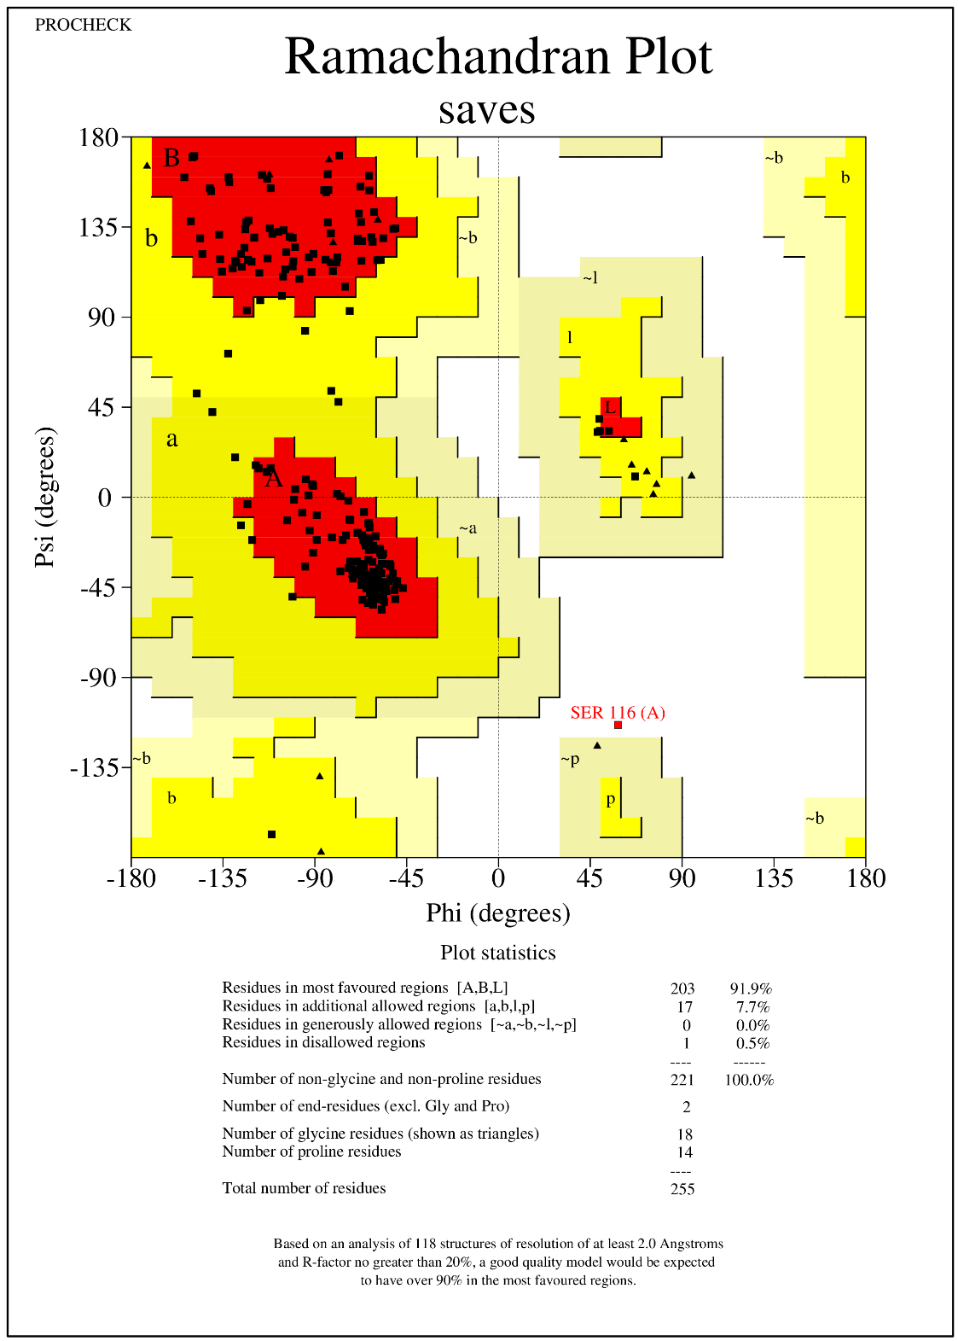
Fig. S1 Ramachandran plot of the Gju768. Areas A, B, L represent most favored regions, areas a, b, l, prepresent additional allowed regions, areas ˜a, ˜b, ˜l, ˜p represent generously allowed regions and white background represents disallowed regions.

Fig. S2 Location of mutants D24N, E221Q, D225N, and E253Q in the Gju768 three-dimensional structure.
Fig. S3 SDS-PAGE analysis of the recombinant protein in E. coli. Lane M, protein marker; lane 1-3, 5-7, the crude extract, precipitation and supernatant of WT and E253Q; lane 4 and 8, purified WT and E253Q after Ni²⁺ affinity chromatography.

Fig. S4 SDS-PAGE analysis of the recombinant protein in E. coli. Lane M, protein marker; lane 1-3, 5-7, 9-11, the crude extract, precipitation and supernatant of D24N, E221Q, and D225N; lane 4 ,8, and 12, purified D24N, E221Q, and D225N after Ni²⁺ affinity chromatography.

