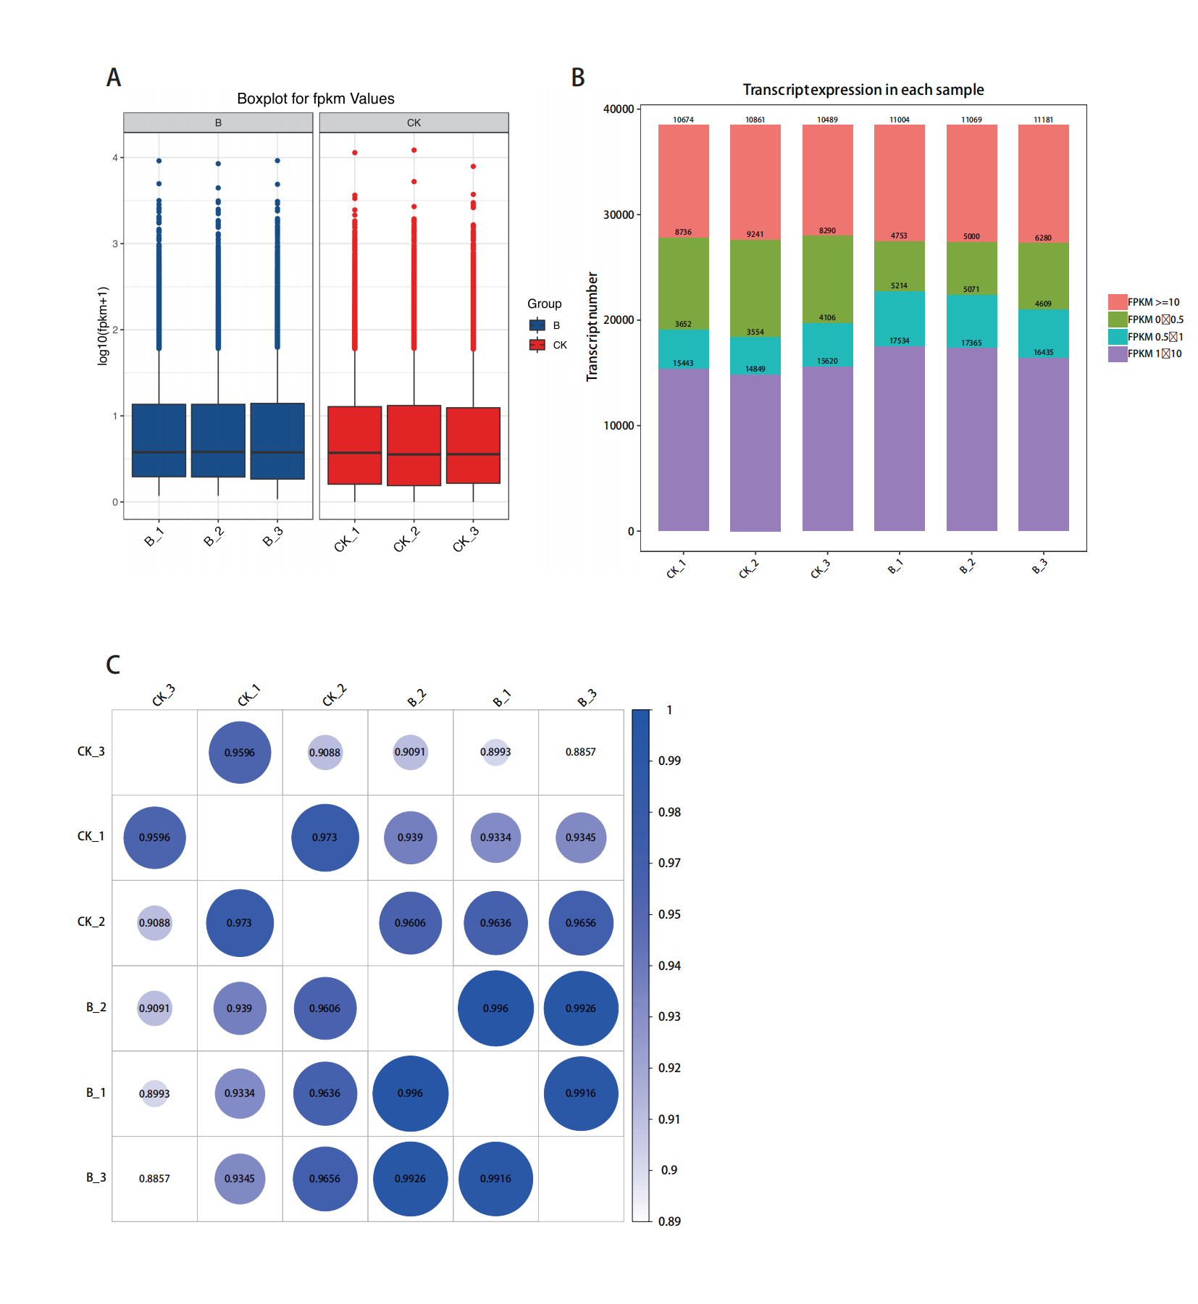
Figure S1. Evaluation of RNA sequencing reads. A: Boxplot for FPKM value from different treatments (CK or B: mepiquat chloride) and replicates (1-3). B: FPKM distribution along with different treatments (CK or B: mepiquat chloride) and replicates (1-3). C: The correlation plot for different treatments (CK or B: mepiquat chloride) and replicates (1-3).

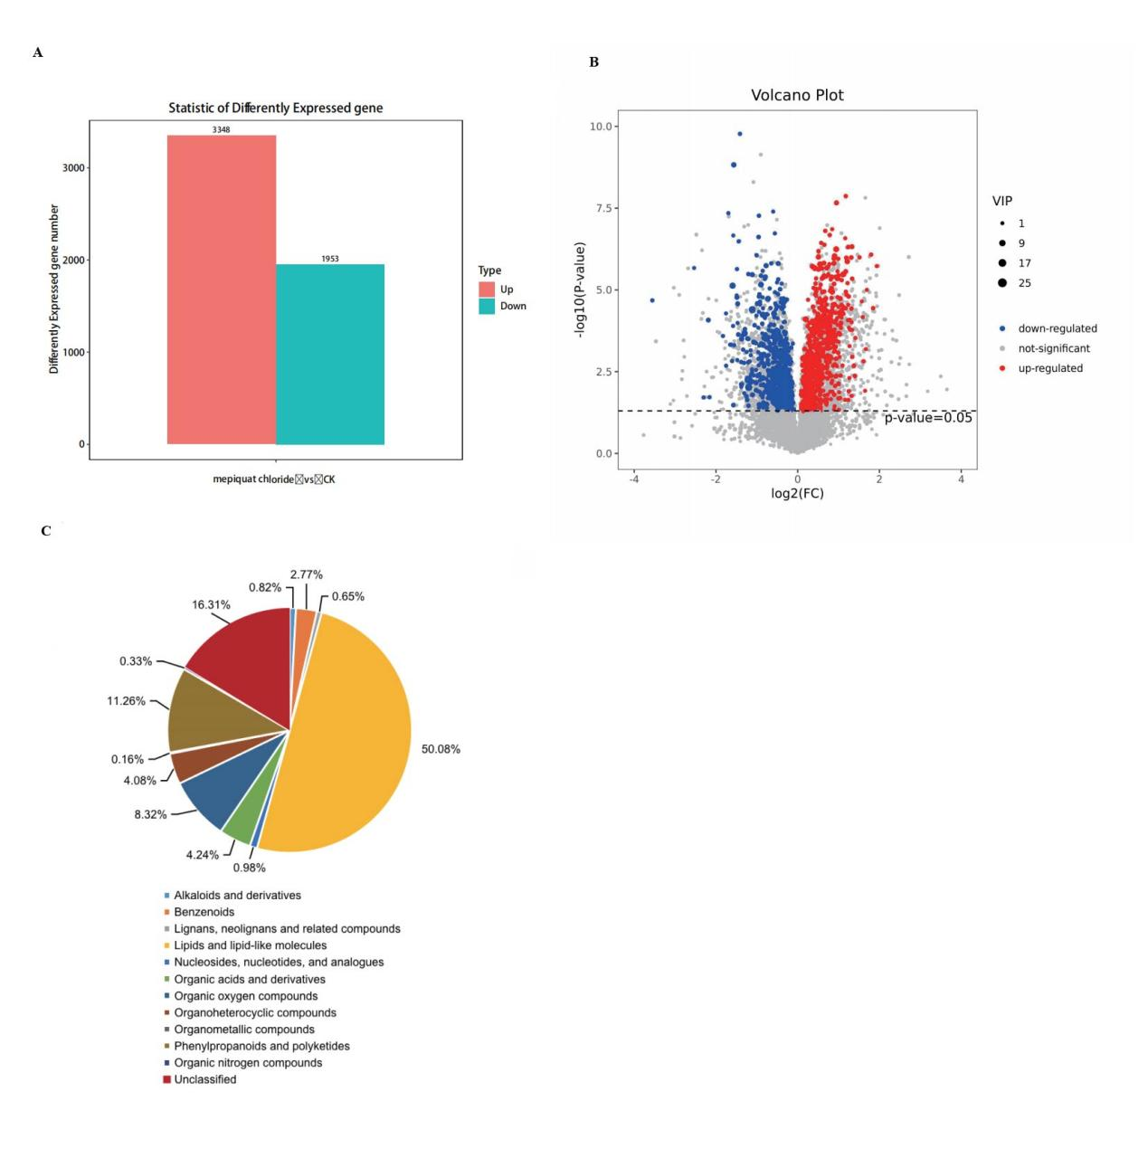
Figure S2. Global overview of the distribution of metabolites and transcripts under the treatment of mepiquat chloride. A: Statistics of up-and down-regulated genes. B: Volcano plot summarizing up-and down-regulated metabolites. C: Types of differential metabolites.

Table S1 The primers used for the qRT-PCR analysis of rapeseed
Gene name | Gene ID | Primer
EIF4A | TRINITY_DN22417_c0_g1_i5 | 5'-CAACACGAGAACTGGCACAAC-3'
 |  | 5'-GAACCCCACTTGAAAGAATACG-3'
FBA | TRINITY_DN25416_c0_g3_i1 | 5'-CGCTGCCCACTACATTCG-3'
 |  | 5'-CCATCATACCGTCCAACCAT-3'
MDH2 | TRINITY_DN18500_c1_g1_i3 | 5'-GGAAGCCTGGAATGACCC-3'
 |  | 5'-CCAGCGGACTTGAGAACCT-3'
tktA | TRINITY_DN10963_c0_g1_i1 | 5'-TCCTGGTCACCCCGAAGT-3'
 |  | 5'-GCGGCTTCGCTACCAATA-3'
CS | TRINITY_DN12305_c0_g2_i1 | 5'-CTCAGCACACACCATCAACCT-3'
 |  | 5'-GCACGCTCCAGATGTAGTCC-3'
IDH1 | TRINITY_DN18451_c0_g1_i6 | 5'-TGACCAATACCGAGCAAAGG-3'
 |  | 5'-GTCAAAGCGACACCACCATC-3'
SOD1 | TRINITY_DN10586_c0_g1_i2 | 5'-GGTCAGGGAAACAGCAAGG-3'
 |  | 5'-CTGCTCCTAAGCGGCAATAC-3'
CAT | TRINITY_DN28777_c1_g1_i4 | 5'-ATCACCCAGGAGGACAGCA-3'
 |  | 5'-CTTGGCATTCTCGTTCAGGT-3'

Table S2 Differential genes of SOD, CAT and LOX
Gene_id | FoldChange | qValue | Regulation | KEGG gene name | KEGG description
TRINITY_DN10492_c0_g1_i1 | 0.055 | 0.221042992 | Down | SOD2 | superoxide dismutase, Fe-Mn family
TRINITY_DN10586_c0_g1_i2 | 19.83303151 | 4.02E-10 | Up | SOD1 | superoxide dismutase, Cu-Zn family
TRINITY_DN10612_c0_g1_i1 | 17.54479813 | 0.00030711 | Up | SOD2 | superoxide dismutase, Fe-Mn family
TRINITY_DN13626_c0_g1_i1 | Inf | 0.199033707 | Up | SOD1 | superoxide dismutase, Cu-Zn family
TRINITY_DN14699_c0_g1_i1 | 15.16103676 | 0.107276521 | Up | SOD2 | superoxide dismutase, Fe-Mn family
TRINITY_DN21912_c0_g1_i2 | 0.628202431 | 0.089060105 | Down | SOD2 | superoxide dismutase, Fe-Mn family
TRINITY_DN33614_c0_g1_i1 | Inf | 0.067824563 | Up | SOD1 | superoxide dismutase, Cu-Zn family
TRINITY_DN11671_c0_g1_i1 | Inf | 0.197938911 | Up | katE, CAT, catB, srpA | catalase
TRINITY_DN11671_c0_g3_i1 | Inf | 0.198829142 | Up | katE, CAT, catB, srpA | catalase
TRINITY_DN12129_c0_g1_i1 | 0.009394912 | 0.108800977 | Down | katE, CAT, catB, srpA | catalase
TRINITY_DN20930_c0_g1_i1 | Inf | 1.16E-09 | Up | katE, CAT, catB, srpA | catalase
TRINITY_DN28777_c1_g1_i4 | 15.10278718 | 3.48E-27 | Up | katE, CAT, catB, srpA | catalase
TRINITY_DN28777_c1_g3_i1 | 14.47777303 | 1.25E-13 | Up | katE, CAT, catB, srpA | catalase
TRINITY_DN30258_c0_g1_i1 | 15.67781734 | 0.09456303 | Up | katE, CAT, catB, srpA | catalase
TRINITY_DN33508_c0_g1_i1 | 13.25085856 | 0.01578707 | Up | katE, CAT, catB, srpA | catalase
TRINITY_DN35453_c0_g1_i1 | 66.91298077 | 0.002683354 | Up | katE, CAT, catB, srpA | catalase
TRINITY_DN18214_c0_g1_i13 | 0.517510289 | 0.020925209 | Down | LOX2S | lipoxygenase

Table S3 Signal transduction-related differentially expressed genes(Cont)
Gene_id | log2FoldChange | qValue | KEGG gene name | Pfam Description
Auxin
TRINITY_DN17295_c0_g1_i1 | -1.375200176 | 0.060821824 | SAUR | Auxin responsive protein
TRINITY_DN17539_c0_g1_i1 | 3.917113305 | 1.97E-05 | SAUR | --
TRINITY_DN20166_c0_g1_i4 | -0.711741382 | 0.214485159 | IAA | --
TRINITY_DN20969_c0_g1_i2 | 0.763633113 | 0.162547779 | IAA | AUX/IAA family
TRINITY_DN22937_c0_g1_i1 | 1.233293822 | 0.001715197 | AUX1, LAX | Transmembrane amino acid transporter protein
TRINITY_DN27164_c0_g2_i3 | 0.707716397 | 0.074832215 | GH3 | GH3 auxin-responsive promoter
TRINITY_DN32308_c0_g1_i1 | 2.842421328 | 0.103449352 | IDO, INDO | Indoleamine 2,3-dioxygenase
TRINITY_DN27967_c2_g3_i7 | -0.675835583 | 0.089943229 | IAA | AUX/IAA family
Cytokinin
TRINITY_DN16963_c0_g1_i3 | -0.649652791 | 0.043693643 | AHP | Hpt domain
TRINITY_DN21384_c0_g1_i3 | 0.75536648 | 0.069315254 | ARR-A | Response regulator receiver domain
TRINITY_DN19275_c0_g1_i1 | 1.976991813 | 3.33E-11 | AHP | Hpt domain
TRINITY_DN29519_c0_g7_i1 | 0.909621621 | 0.099830196 | ARR-A | --
TRINITY_DN12654_c0_g1_i1 | 2.38546116 | 0.228378194 | CYP735A | Cytochrome P450
Gibberellin
TRINITY_DN22734_c0_g2_i1 | -1.511747704 | 0.02124226 | GID1 | --
TRINITY_DN11102_c0_g1_i1 | 1.877938383 | 0.142356794 | E1.14.11.13 | --
TRINITY_DN25178_c0_g1_i6 | 0.739565144 | 0.17749506 | KAO | Cytochrome P450

Refer to Table S3 (continued)
Gene_id | log2FoldChange | qValue | KEGG gene name | Pfam Description
TRINITY_DN26863_c0_g1_i3 | -1.212324092 | 0.138143312 | CYP82G1 | Cytochrome P450
Abscisic acid
TRINITY_DN18541_c0_g1_i2 | 0.744188764 | 0.232157127 | PYL | Polyketide cyclase / dehydrase and lipid transport|Polyketide cyclase / dehydrase and lipid transport
TRINITY_DN22028_c0_g1_i1 | 0.599972056 | 0.04411222 | PYL | Polyketide cyclase / dehydrase and lipid transport
TRINITY_DN26352_c0_g2_i4 | 0.652151038 | 0.061859402 | PP2C | Protein phosphatase 2C
TRINITY_DN25584_c0_g1_i6 | -0.618247065 | 0.09422339 | ABF | bZIP transcription factor|Basic region leucine zipper
TRINITY_DN18641_c0_g1_i2 | 1.368483462 | 0.1558537 | AOG | UDP-glucoronosyl and UDP-glucosyl transferase
TRINITY_DN24039_c0_g1_i2 | 1.058700468 | 0.027719977 | CYP707A | Cytochrome P450
TRINITY_DN26692_c0_g1_i2 | -0.919780943 | 0.001280835 | CYP707A | Cytochrome P450
TRINITY_DN29648_c2_g2_i1 | -1.812767606 | 0.009739874 | AAO3 | --
Ethylene
TRINITY_DN29293_c0_g1_i2 | 0.74095418 | 0.00089992 | EIN3 | Ethylene insensitive 3
TRINITY_DN29858_c0_g1_i1 | 2.420487726 | 0.036868459 | ACS | --
TRINITY_DN17290_c0_g10_i1 | Inf | 0.135404996 | ACO, acnA | Aconitase family (aconitate hydratase)
TRINITY_DN17290_c0_g2_i1 | -5.734018913 | 0.177503273 | ACO, acnA | Aconitase family (aconitate hydratase)|Aconitase C-terminal domain
TRINITY_DN17290_c0_g8_i1 | 3.21571284 | 0.026692763 | ACO, acnA | Aconitase C-terminal domain|Aconitase family (aconitate hydratase)
TRINITY_DN17290_c0_g9_i1 | 2.846557437 | 0.000898735 | ACO, acnA | Aconitase family (aconitate hydratase)|Aconitase C-terminal domain
Brassinolide
TRINITY_DN26927_c0_g1_i6 | -0.637292465 | 0.211388317 | BSK | Protein tyrosine kinase|Protein kinase domain
TRINITY_DN27017_c0_g2_i1 | -1.088344626 | 0.102023038 | BSK | --

Refer to Table S3 (continued)
gene_id | log2FoldChange | qValue | KEGG gene name | Pfam Description
TRINITY_DN20128_c0_g1_i1 | 1.814792053 | 0.205188043 | TCH4 | Glycosyl hydrolases family 16|Xyloglucan endo-transglycosylase (XET) C-terminus
TRINITY_DN29186_c0_g1_i12 | -2.288966292 | 0.000848197 | TCH4 | Glycosyl hydrolases family 16|Xyloglucan endo-transglycosylase (XET) C-terminus
Jasmonic acid
TRINITY_DN14607_c0_g1_i2 | -1.671188092 | 1.29E-08 | JAZ | tify domain|Divergent CCT motif
TRINITY_DN22733_c0_g1_i3 | -2.009651054 | 0.000485231 | JAZ | tify domain
TRINITY_DN22914_c0_g1_i3 | -0.632225975 | 0.006356949 | JAZ | tify domain|Divergent CCT motif
TRINITY_DN27550_c1_g2_i12 | -1.225893381 | 4.16E-08 | JAZ | tify domain
TRINITY_DN22792_c2_g1_i1 | -3.205243034 | 0.060971198 | MYC2 | bHLH-MYC and R2R3-MYB transcription factors N-terminal|Helix-loop-helix DNA-binding domain
TRINITY_DN28140_c0_g1_i2 | -0.680999099 | 0.002373764 | MYC2 | bHLH-MYC and R2R3-MYB transcription factors N-terminal|
TRINITY_DN26729_c0_g2_i6 | -0.94467665 | 0.059171658 | JAR1_4_6 | GH3 auxin-responsive promoter
Salicylic acid
TRINITY_DN2225_c0_g1_i1 | 4.332637428 | 0.219674398 | PR1 | Cysteine-rich secretory protein family
TRINITY_DN15326_c0_g1_i1 | Inf | 0.010037971 | PR1 | Cysteine-rich secretory protein family
TRINITY_DN33153_c0_g1_i1 | -3.228054471 | 0.210611254 | PR1 | Cysteine-rich secretory protein family
TRINITY_DN36392_c0_g1_i1 | -2.040342997 | 0.037512961 | PR1 | Cysteine-rich secretory protein family
TRINITY_DN25152_c0_g3_i8 | -0.591968542 | 0.024501807 | TGA | bZIP transcription factor|Basic region leucine zipper|Seed dormancy control
TRINITY_DN26190_c0_g2_i1 | -0.907235907 | 0.064383068 | NPR1 | NPR1/NIM1 like defence protein C terminal|BTB/POZ domain|Ankyrin repeats (3 copies)|Ankyrin repeats (many copies)

Table S4 Differentially expressed transcription factors (TFs) under cold treatment between B treatment and Control treatment
Family | Gene_id | CK | B | FoldChange | Regulation
AP2/ERF-ERF | TRINITY_DN12121_c0_g1_i1 | 5.5056 | 21.6188 | 3.9267 | Up
AP2/ERF-ERF | TRINITY_DN14186_c0_g1_i1 | 548.7216 | 313.3635 | 0.5711 | Down
AP2/ERF-ERF | TRINITY_DN15550_c0_g1_i1 | 52.9359 | 101.6782 | 1.9208 | Up
AP2/ERF-ERF | TRINITY_DN15732_c0_g1_i1 | 29.2428 | 57.8987 | 1.9799 | Up
AP2/ERF-ERF | TRINITY_DN16395_c0_g1_i1 | 880.5569 | 1751.6199 | 1.9892 | Up
AP2/ERF-ERF | TRINITY_DN16452_c0_g1_i1 | 1406.4770 | 475.1611 | 0.3378 | Down
AP2/ERF-AP2 | TRINITY_DN16525_c0_g1_i1 | 8.9558 | 26.9658 | 3.0110 | Up
AP2/ERF-ERF | TRINITY_DN16770_c0_g1_i1 | 1.7067 | 62.3891 | 36.5550 | Up
AP2/ERF-ERF | TRINITY_DN17616_c0_g1_i1 | 347.1115 | 209.0324 | 0.6022 | Down
AP2/ERF-ERF | TRINITY_DN17961_c0_g1_i1 | 10.6580 | 32.2499 | 3.0259 | Up
AP2/ERF-ERF | TRINITY_DN18489_c0_g1_i1 | 1461.5283 | 2444.1759 | 1.6723 | Up
AP2/ERF-ERF | TRINITY_DN18675_c0_g1_i3 | 5542.2816 | 3597.2505 | 0.6491 | Down
AP2/ERF-ERF | TRINITY_DN18801_c0_g1_i1 | 118.9390 | 436.0624 | 3.6663 | Up
AP2/ERF-ERF | TRINITY_DN19535_c0_g1_i1 | 1171.3466 | 724.9163 | 0.6189 | Down
AP2/ERF-ERF | TRINITY_DN19633_c0_g2_i1 | 79.8403 | 222.8133 | 2.7907 | Up
AP2/ERF-ERF | TRINITY_DN19766_c0_g1_i1 | 939.3505 | 1486.9753 | 1.5830 | Up
AP2/ERF-RAV | TRINITY_DN20422_c0_g1_i1 | 2359.6079 | 1485.0472 | 0.6294 | Down
AP2/ERF-ERF | TRINITY_DN21480_c0_g1_i1 | 62.8503 | 190.3903 | 3.0293 | Up
AP2/ERF-ERF | TRINITY_DN21579_c0_g1_i1 | 7139.2200 | 1328.4149 | 0.1861 | Down

Refer to Table S4 (continued)
Family | Gene_id | CK | B | FoldChange | Regulation
AP2/ERF-ERF | TRINITY_DN23304_c0_g1_i1 | 329.5125 | 1308.8107 | 3.9720 | Up
AP2/ERF-ERF | TRINITY_DN23776_c0_g1_i1 | 656.6161 | 274.6170 | 0.4182 | Down
AP2/ERF-ERF | TRINITY_DN23948_c0_g1_i2 | 10234.7097 | 6245.5065 | 0.6102 | Down
AP2/ERF-ERF | TRINITY_DN24574_c0_g1_i1 | 47.3216 | 213.8142 | 4.5183 | Up
AP2/ERF-ERF | TRINITY_DN25207_c0_g1_i1 | 3217.6841 | 5285.4429 | 1.6426 | Up
AP2/ERF-ERF | TRINITY_DN25287_c0_g1_i3 | 1680.5751 | 962.3347 | 0.5726 | Down
AP2/ERF-ERF | TRINITY_DN25677_c0_g1_i1 | 4364.5104 | 2480.3967 | 0.5683 | Down
AP2/ERF-RAV | TRINITY_DN26171_c1_g1_i4 | 390.3777 | 115.0184 | 0.2946 | Down
AP2/ERF-ERF | TRINITY_DN26297_c0_g1_i2 | 1814.3500 | 3416.2922 | 1.8829 | Up
AP2/ERF-ERF | TRINITY_DN28896_c0_g2_i1 | 20104.8328 | 6753.7243 | 0.3359 | Down
AP2/ERF-ERF | TRINITY_DN8934_c0_g1_i1 | 5.1810 | 21.3660 | 4.1239 | Up
C2H2 | TRINITY_DN1103_c0_g1_i1 | 0.0000 | 5.8042 | Inf | Up
C2H2 | TRINITY_DN11106_c0_g1_i1 | 4.1590 | 40.2794 | 9.6849 | Up
C2H2 | TRINITY_DN14078_c0_g1_i1 | 0.3511 | 11.5208 | 32.8096 | Up
C2H2 | TRINITY_DN16203_c0_g1_i1 | 36.3129 | 77.7712 | 2.1417 | Up
C2H2 | TRINITY_DN173_c0_g1_i1 | 1.0367 | 17.2626 | 16.6518 | Up
C2H2 | TRINITY_DN19114_c0_g1_i1 | 174.6142 | 290.1657 | 1.6618 | Up
C2H2 | TRINITY_DN19324_c0_g1_i1 | 74.8557 | 145.5700 | 1.9447 | Up
C2H2 | TRINITY_DN20144_c0_g1_i1 | 194.8948 | 394.9262 | 2.0264 | Up
C2H2 | TRINITY_DN21117_c0_g1_i2 | 3.4734 | 135.7029 | 39.0687 | Up
C2H2 | TRINITY_DN22172_c0_g1_i1 | 2782.0536 | 1298.1960 | 0.4666 | Down
C2H2 | TRINITY_DN23308_c0_g1_i1 | 5.5191 | 63.0144 | 11.4176 | Up
C2H2 | TRINITY_DN25236_c0_g1_i1 | 1920.7091 | 1238.7263 | 0.6449 | Down

Refer to Table S4 (continued)
Family | Gene_id | CK | B | FoldChange | Regulation
C2H2 | TRINITY_DN25515_c0_g1_i3 | 1169.5190 | 728.4923 | 0.6229 | Down
C2H2 | TRINITY_DN26223_c0_g1_i2 | 266.2442 | 516.4011 | 1.9396 | Up
C2H2 | TRINITY_DN32114_c0_g1_i1 | 0.0000 | 9.3083 | Inf | Up
C2H2 | TRINITY_DN32670_c0_g1_i1 | 0.0000 | 13.3789 | Inf | Up
C2H2 | TRINITY_DN7905_c0_g1_i1 | 0.0000 | 5.9700 | Inf | Up
B3 | TRINITY_DN13012_c0_g1_i1 | 49.9091 | 129.9663 | 2.6041 | Up
B3 | TRINITY_DN13012_c0_g2_i1 | 11.4178 | 32.0234 | 2.8047 | Up
B3 | TRINITY_DN14692_c0_g1_i2 | 512.7561 | 219.2358 | 0.4276 | Down
B3 | TRINITY_DN24323_c0_g2_i2 | 1179.3320 | 697.5688 | 0.5915 | Down
B3|B3 | TRINITY_DN28413_c0_g3_i2 | 904.5815 | 563.0805 | 0.6225 | Down
B3 | TRINITY_DN4309_c0_g1_i1 | 19.0527 | 1.8511 | 0.0972 | Down
BES1 | TRINITY_DN21434_c0_g1_i3 | 3450.1688 | 1894.1868 | 0.5490 | Down
BBR-BPC | TRINITY_DN23643_c2_g1_i5 | 104.4655 | 360.4412 | 3.4503 | Up
bHLH | TRINITY_DN11498_c0_g1_i1 | 1.3801 | 10.0296 | 7.2674 | Up
bHLH | TRINITY_DN15959_c0_g1_i1 | 66.8537 | 121.6390 | 1.8195 | Up
bHLH | TRINITY_DN16032_c0_g1_i1 | 53.4046 | 8.8298 | 0.1653 | Down
bHLH | TRINITY_DN19349_c0_g1_i3 | 9.3914 | 38.2846 | 4.0766 | Up
bHLH | TRINITY_DN19871_c0_g1_i1 | 90.3479 | 52.5161 | 0.5813 | Down
bHLH | TRINITY_DN20348_c0_g1_i4 | 693.7547 | 393.8444 | 0.5677 | Down
bHLH | TRINITY_DN2134_c0_g1_i1 | 2.0811 | 36.5723 | 17.5734 | Up
bHLH | TRINITY_DN21813_c0_g1_i1 | 283.8669 | 605.2481 | 2.1322 | Up

Refer to Table S4 (continued)
Family | Gene_id | CK | B | FoldChange | Regulation
bHLH | TRINITY_DN22653_c0_g1_i1 | 364.4028 | 116.3681 | 0.3193 | Down
bHLH | TRINITY_DN22792_c2_g1_i1 | 63.3858 | 6.8725 | 0.1084 | Down
bHLH | TRINITY_DN24755_c0_g1_i1 | 57.7126 | 420.6428 | 7.2886 | Up
bHLH | TRINITY_DN25751_c0_g1_i1 | 320.2760 | 185.7840 | 0.5801 | Down
bHLH | TRINITY_DN26085_c0_g1_i5 | 6911.4701 | 3015.4004 | 0.4363 | Down
bHLH | TRINITY_DN26181_c1_g1_i2 | 902.6805 | 524.1788 | 0.5807 | Down
bHLH | TRINITY_DN26716_c0_g1_i2 | 8243.6771 | 4588.7238 | 0.5566 | Down
bHLH | TRINITY_DN28140_c0_g1_i2 | 18318.1082 | 11425.6118 | 0.6237 | Down
bHLH | TRINITY_DN28644_c0_g1_i2 | 358.0434 | 579.6088 | 1.6188 | Up
bHLH | TRINITY_DN29424_c1_g1_i2 | 616.9375 | 179.1038 | 0.2903 | Down
bZIP | TRINITY_DN16531_c0_g1_i1 | 1.3711 | 14.6451 | 10.6814 | Up
bZIP | TRINITY_DN16755_c0_g1_i2 | 2219.8796 | 3482.5585 | 1.5688 | Up
bZIP | TRINITY_DN23890_c0_g1_i7 | 120.3562 | 215.4401 | 1.7900 | Up
bZIP | TRINITY_DN24122_c0_g1_i3 | 4.1557 | 61.0117 | 14.6814 | Up
bZIP | TRINITY_DN25152_c0_g3_i8 | 1371.7058 | 910.0404 | 0.6634 | Down
bZIP | TRINITY_DN25584_c0_g1_i6 | 1321.6961 | 861.0348 | 0.6515 | Down
C2C2-CO-like | TRINITY_DN15873_c0_g1_i1 | 115.2338 | 190.7707 | 1.6555 | Up
C2C2-Dof | TRINITY_DN18454_c0_g1_i1 | 223.4767 | 410.6539 | 1.8376 | Up
C2C2-GATA | TRINITY_DN18988_c0_g2_i1 | 2.7879 | 23.5802 | 8.4581 | Up
C2C2-Dof | TRINITY_DN20536_c0_g1_i2 | 118.5509 | 224.2203 | 1.8913 | Up
C2C2-GATA | TRINITY_DN20971_c0_g1_i2 | 8725.4364 | 2827.8457 | 0.3241 | Down

Refer to Table S4 (continued)
Family | Gene_id | CK | B | FoldChange | Regulation
C2C2-Dof | TRINITY_DN21089_c1_g1_i2 | 275.6567 | 171.7293 | 0.6230 | Down
C2C2-CO-like | TRINITY_DN22930_c0_g1_i1 | 854.7763 | 1380.1093 | 1.6146 | Up
C2C2-Dof | TRINITY_DN23902_c0_g2_i1 | 28.0619 | 56.7482 | 2.0222 | Up
C2C2-GATA | TRINITY_DN24694_c0_g1_i1 | 4470.3976 | 2258.0587 | 0.5051 | Down
C2C2-Dof | TRINITY_DN25720_c0_g1_i1 | 114.3917 | 177.0053 | 1.5474 | Up
CSD | TRINITY_DN14066_c0_g1_i2 | 122.6371 | 64.1693 | 0.5232 | Down
DBB | TRINITY_DN17771_c0_g1_i1 | 552.6748 | 312.2356 | 0.5650 | Down
DBB | TRINITY_DN19748_c0_g1_i2 | 172.0974 | 108.9312 | 0.6330 | Down
FAR1 | TRINITY_DN21071_c0_g1_i1 | 326.9809 | 213.1478 | 0.6519 | Down
CPP | TRINITY_DN28335_c0_g1_i2 | 134.3913 | 55.2039 | 0.4108 | Down
EIL | TRINITY_DN29293_c0_g1_i2 | 3337.3081 | 5577.5791 | 1.6713 | Up
GRAS | TRINITY_DN16333_c0_g1_i1 | 66.9182 | 187.5252 | 2.8023 | Up
GARP-G2-like | TRINITY_DN18131_c0_g2_i7 | 210.4699 | 130.6848 | 0.6209 | Down
GRF | TRINITY_DN20256_c0_g1_i1 | 14.8325 | 84.3631 | 5.6877 | Up
GRAS | TRINITY_DN21181_c0_g1_i1 | 56.5081 | 123.5966 | 2.1872 | Up
GRAS | TRINITY_DN21226_c2_g2_i2 | 327.3356 | 170.8916 | 0.5221 | Down
GRAS | TRINITY_DN22566_c0_g1_i1 | 16.2081 | 69.1441 | 4.2660 | Up
GRF | TRINITY_DN22700_c0_g1_i2 | 145.7229 | 225.2137 | 1.5455 | Up
GRAS | TRINITY_DN22911_c0_g1_i1 | 2889.3934 | 4608.8159 | 1.5951 | Up
GARP-G2-like | TRINITY_DN23402_c0_g1_i1 | 216.2838 | 423.1168 | 1.9563 | Up
GRAS | TRINITY_DN23905_c0_g1_i1 | 656.7371 | 1327.1679 | 2.0209 | Up

Refer to Table S4 (continued)
Family | Gene_id | CK | B | FoldChange | Regulation
GARP-G2-like | TRINITY_DN26311_c0_g1_i6 | 3101.7560 | 1437.1012 | 0.4633 | Down
GRAS | TRINITY_DN26346_c0_g1_i2 | 350.5345 | 583.6030 | 1.6649 | Up
GRAS | TRINITY_DN27591_c0_g1_i1 | 3446.6381 | 1390.3837 | 0.4034 | Down
GRAS | TRINITY_DN27865_c0_g1_i3 | 7850.4713 | 13349.8100 | 1.7005 | Up
GRAS | TRINITY_DN27986_c0_g1_i1 | 133.5816 | 351.7285 | 2.6331 | Up
GRAS | TRINITY_DN6769_c0_g1_i1 | 35.7014 | 8.7785 | 0.2459 | Down
HB-WOX | TRINITY_DN14275_c0_g1_i1 | 2.0611 | 22.9711 | 11.1450 | Up
HSF | TRINITY_DN16126_c0_g1_i2 | 47.7071 | 93.5904 | 1.9618 | Up
HB-KNOX | TRINITY_DN16155_c0_g1_i2 | 475.2384 | 817.0777 | 1.7193 | Up
LOB | TRINITY_DN18083_c0_g1_i1 | 141.7993 | 81.7592 | 0.5766 | Down
HSF | TRINITY_DN18122_c0_g1_i2 | 856.9245 | 217.2951 | 0.2536 | Down
LOB | TRINITY_DN19092_c0_g1_i2 | 124.4652 | 462.1090 | 3.7128 | Up
HB-HD-ZIP | TRINITY_DN19510_c0_g1_i3 | 40.9583 | 96.4392 | 2.3546 | Up
LOB | TRINITY_DN19894_c0_g1_i1 | 22.0950 | 45.9552 | 2.0799 | Up
LOB | TRINITY_DN19894_c0_g2_i1 | 113.0178 | 179.0674 | 1.5844 | Up
HSF | TRINITY_DN21821_c0_g1_i2 | 2106.5014 | 1204.2249 | 0.5717 | Down
HSF | TRINITY_DN22866_c0_g1_i1 | 4107.1350 | 1519.7279 | 0.3700 | Down
HB-HD-ZIP | TRINITY_DN23784_c0_g2_i1 | 857.0755 | 1611.7971 | 1.8806 | Up
HB-HD-ZIP | TRINITY_DN24418_c0_g1_i3 | 914.1796 | 1748.0227 | 1.9121 | Up
HSF | TRINITY_DN26069_c0_g1_i3 | 156.0939 | 662.3750 | 4.2434 | Up
HB-other | TRINITY_DN26769_c0_g2_i1 | 1779.4366 | 3306.4940 | 1.8582 | Up

Refer to Table S4 (continued)
Family | Gene_id | CK | B | FoldChange | Regulation
HSF | TRINITY_DN27426_c0_g1_i2 | 20020.8352 | 3042.8957 | 0.1520 | Down
HSF | TRINITY_DN28027_c0_g1_i11 | 5807.8281 | 3520.3880 | 0.6061 | Down
LOB | TRINITY_DN7307_c0_g1_i1 | 5.1712 | 18.8081 | 3.6371 | Up
MYB-related | TRINITY_DN12807_c0_g1_i2 | 432.6946 | 219.7278 | 0.5078 | Down
MADS-M-type | TRINITY_DN12893_c0_g1_i2 | 4.8413 | 21.4492 | 4.4305 | Up
MYB-related | TRINITY_DN13153_c0_g1_i1 | 20.1298 | 73.1802 | 3.6354 | Up
MYB-related | TRINITY_DN13635_c0_g1_i1 | 42.5903 | 105.8552 | 2.4854 | Up
MYB | TRINITY_DN14412_c0_g1_i1 | 158.6723 | 70.9991 | 0.4475 | Down
MYB-related|MYB-related | TRINITY_DN14547_c0_g1_i1 | 1315.0759 | 1987.9259 | 1.5116 | Up
MYB-related | TRINITY_DN15406_c0_g1_i1 | 242.7994 | 138.4495 | 0.5702 | Down
MYB-related | TRINITY_DN15967_c0_g1_i1 | 413.4528 | 700.2933 | 1.6938 | Up
MYB | TRINITY_DN16636_c0_g1_i1 | 2.3955 | 14.4469 | 6.0308 | Up
MYB | TRINITY_DN17151_c0_g1_i1 | 505.6787 | 209.7647 | 0.4148 | Down
MYB | TRINITY_DN18301_c0_g1_i1 | 146.2693 | 226.3252 | 1.5473 | Up
MYB-related | TRINITY_DN18958_c0_g1_i2 | 281.1281 | 106.0722 | 0.3773 | Down
MYB-related | TRINITY_DN18970_c0_g1_i1 | 4.4456 | 25.9699 | 5.8417 | Up
MYB-related | TRINITY_DN20254_c0_g1_i1 | 172.0717 | 285.3250 | 1.6582 | Up
MYB | TRINITY_DN20534_c0_g1_i1 | 186.3655 | 120.2816 | 0.6454 | Down
MYB-related|MYB-related | TRINITY_DN20684_c0_g1_i3 | 3558.3915 | 596.7148 | 0.1677 | Down
MYB | TRINITY_DN20858_c0_g1_i1 | 153.7625 | 261.8841 | 1.7032 | Up
MYB | TRINITY_DN21387_c0_g1_i2 | 1078.8267 | 712.5145 | 0.6605 | Down

Refer to Table S4 (continued)
Family | Gene_id | CK | B | FoldChange | Regulation
MYB | TRINITY_DN21685_c0_g1_i2 | 6620.0605 | 2871.7907 | 0.4338 | Down
MADS-MIKC | TRINITY_DN21696_c0_g1_i3 | 791.4642 | 369.0456 | 0.4663 | Down
MYB-related | TRINITY_DN26566_c0_g1_i17 | 985.2919 | 549.8768 | 0.5581 | Down
MYB-related | TRINITY_DN26748_c0_g1_i3 | 1575.6831 | 935.4314 | 0.5937 | Down
MYB | TRINITY_DN26964_c1_g1_i2 | 29166.9183 | 16877.5535 | 0.5787 | Down
MYB-related | TRINITY_DN27527_c0_g1_i7 | 706.0102 | 434.6602 | 0.6157 | Down
MADS-M-type | TRINITY_DN27603_c0_g1_i1 | 163.0223 | 250.4365 | 1.5362 | Up
MYB | TRINITY_DN27666_c1_g1_i3 | 8554.2605 | 4688.1447 | 0.5480 | Down
MYB-related | TRINITY_DN28102_c0_g2_i1 | 7.5765 | 32.7067 | 4.3169 | Up
MYB-related | TRINITY_DN31227_c0_g1_i1 | 83.2875 | 199.6078 | 2.3966 | Up
MADS-MIKC | TRINITY_DN4103_c0_g1_i2 | 109.6570 | 170.7474 | 1.5571 | Up
MYB | TRINITY_DN6211_c0_g2_i1 | 4.5224 | 29.9397 | 6.6204 | Up
MYB | TRINITY_DN7530_c0_g1_i1 | 55.3277 | 130.1024 | 2.3515 | Up
NAC | TRINITY_DN18123_c0_g1_i1 | 36.5473 | 89.6022 | 2.4517 | Up
NAC | TRINITY_DN18245_c0_g1_i1 | 169.4816 | 52.4295 | 0.3094 | Down
NAC|NAC | TRINITY_DN19301_c0_g1_i4 | 5538.6418 | 1805.9268 | 0.3261 | Down
NAC | TRINITY_DN20276_c0_g1_i2 | 9456.8693 | 4251.2122 | 0.4495 | Down
NAC | TRINITY_DN20970_c0_g1_i1 | 444.0793 | 279.3303 | 0.6290 | Down
NAC | TRINITY_DN21542_c0_g1_i2 | 50.8988 | 117.0552 | 2.2998 | Up
NAC | TRINITY_DN24190_c0_g1_i2 | 258.1036 | 132.1047 | 0.5118 | Down
NAC | TRINITY_DN24190_c0_g2_i1 | 266.6060 | 106.3137 | 0.3988 | Down

Refer to Table S4 (continued)
Family | Gene_id | CK | B | FoldChange | Regulation
NAC | TRINITY_DN25297_c0_g1_i6 | 2305.6370 | 1099.0860 | 0.4767 | Down
NAC | TRINITY_DN27537_c0_g1_i5 | 1830.3981 | 611.0196 | 0.3338 | Down
NF-YA | TRINITY_DN27674_c0_g1_i5 | 479.3268 | 989.0233 | 2.0634 | Up
NAC | TRINITY_DN28203_c0_g1_i7 | 16198.8759 | 7714.8968 | 0.4763 | Down
OFP | TRINITY_DN12395_c0_g1_i1 | 3.1288 | 39.1512 | 12.5131 | Up
SBP | TRINITY_DN15053_c0_g1_i1 | 536.1675 | 824.2699 | 1.5373 | Up
SBP|SBP | TRINITY_DN19312_c0_g1_i1 | 718.6495 | 1199.5886 | 1.6692 | Up
SRS | TRINITY_DN4967_c0_g1_i1 | 146.9091 | 245.8536 | 1.6735 | Up
Tify | TRINITY_DN14607_c0_g1_i2 | 15861.1729 | 4980.3235 | 0.3140 | Down
Tify | TRINITY_DN17654_c0_g1_i3 | 5054.8435 | 1242.5490 | 0.2458 | Down
TCP | TRINITY_DN19729_c0_g1_i1 | 234.6125 | 412.2335 | 1.7571 | Up
TCP | TRINITY_DN19804_c0_g1_i1 | 150.1754 | 67.7462 | 0.4511 | Down
Trihelix | TRINITY_DN19854_c0_g1_i1 | 89.9633 | 140.2319 | 1.5588 | Up
Trihelix | TRINITY_DN20954_c0_g1_i1 | 1160.6169 | 562.4826 | 0.4846 | Down
Tify | TRINITY_DN22733_c0_g1_i3 | 4586.6579 | 1139.0193 | 0.2483 | Down
Tify | TRINITY_DN22914_c0_g1_i3 | 8491.0395 | 5478.2504 | 0.6452 | Down
TUB | TRINITY_DN26723_c0_g1_i4 | 1481.4851 | 950.1236 | 0.6413 | Down
TCP | TRINITY_DN27416_c1_g1_i9 | 740.8437 | 1215.7535 | 1.6410 | Up
Tify | TRINITY_DN27550_c1_g2_i12 | 38947.7754 | 16651.4469 | 0.4275 | Down
TCP | TRINITY_DN28799_c0_g1_i4 | 1274.7085 | 638.3568 | 0.5008 | Down
TCP | TRINITY_DN32155_c0_g1_i1 | 15.8957 | 3.7483 | 0.2358 | Down

Refer to Table S4 (continued)
Family | Gene_id | CK | B | FoldChange | Regulation
WRKY | TRINITY_DN14237_c0_g1_i2 | 226.2060 | 796.4183 | 3.5208 | Up
WRKY | TRINITY_DN16665_c0_g1_i3 | 103.9612 | 60.0710 | 0.5778 | Down
WRKY | TRINITY_DN17630_c0_g1_i2 | 148.2888 | 390.0650 | 2.6304 | Up
WRKY | TRINITY_DN17993_c0_g1_i3 | 851.2261 | 1283.6774 | 1.5080 | Up
WRKY | TRINITY_DN18954_c0_g1_i1 | 5943.2421 | 3301.7326 | 0.5555 | Down
WRKY | TRINITY_DN22855_c0_g1_i2 | 4554.5158 | 2835.2709 | 0.6225 | Down
WRKY | TRINITY_DN23468_c0_g1_i3 | 21007.9348 | 13537.2544 | 0.6444 | Down
WRKY | TRINITY_DN25664_c0_g1_i4 | 28892.8771 | 12637.6658 | 0.4374 | Down
WRKY | TRINITY_DN25689_c0_g1_i2 | 91.9165 | 25.6944 | 0.2795 | Down
WRKY | TRINITY_DN26342_c0_g1_i10 | 2102.2335 | 1274.8344 | 0.6064 | Down
WRKY | TRINITY_DN28628_c2_g5_i2 | 213.9948 | 343.9263 | 1.6072 | Up
WRKY | TRINITY_DN29141_c0_g1_i1 | 468.1362 | 141.5203 | 0.3023 | Down
zn-clus | TRINITY_DN17344_c0_g1_i2 | 4.1267 | 80.9836 | 19.6241 | Up

