Supporting Information

Appendix A: Tables S1-S6
Appendix B: Figures S1-S12

Appendix A: Tables
Table S1 Costs attributed to land-cover categories for the species with respect to their habitat preferences.

Level I class | Level II class | Terrestrial mammals |  |  | Birds
Level I class | Level II class | Coniferous forest | Broadleaf forest | Grassland | Coniferous forest | Broadleaf forest | Wetland
Forest | Evergreen broadleaf forest | 20 | 1 | 40 | 20 | 1 | 10
Forest | Deciduous broadleaf forest | 20 | 1 | 40 | 20 | 1 | 10
Forest | Evergreen needleleaf forest | 1 | 20 | 40 | 1 | 20 | 10
Forest | Deciduous needleleaf forest | 1 | 20 | 40 | 1 | 20 | 10
Forest | Broadleaf and needleleaf mixed forest | 10 | 10 | 40 | 10 | 10 | 10
Shrubland | Evergreen broadleaf shrubland | 30 | 10 | 10 | 30 | 10 | 40
Shrubland | Deciduous broadleaf shrubland | 30 | 10 | 10 | 30 | 10 | 40
Shrubland | Evergreen needleleaf shrubland | 10 | 30 | 10 | 10 | 30 | 40
Shrubland | Sparse shrubland | 40 | 40 | 40 | 40 | 40 | 60
Grassland | Meadow | 40 | 40 | 1 | 40 | 40 | 60
Grassland | Steppe | 40 | 40 | 1 | 40 | 40 | 60
Grassland | Tussock | 40 | 40 | 1 | 40 | 40 | 60
Grassland | Sparse grassland | 60 | 60 | 10 | 60 | 60 | 80
Wetland | Tree wetland | 1 | 1 | 40 | 1 | 1 | 1
Wetland | Shrub wetland | 10 | 10 | 10 | 10 | 10 | 1
Wetland | Herbaceous wetland | 40 | 40 | 1 | 40 | 40 | 1
Wetland | Lake | 200 | 200 | 200 | 100 | 100 | 10
Wetland | Reservoir/Pond | 250 | 250 | 250 | 120 | 120 | 40
Wetland | River | 150 | 150 | 150 | 80 | 80 | 10
Wetland | stream | 100 | 100 | 100 | 40 | 40 | 10
Wetland | Canal/Channel | 150 | 150 | 150 | 100 | 100 | 40
Arable land | Paddy field | 100 | 100 | 100 | 40 | 40 | 60
Arable land | Rainfed arable land | 100 | 100 | 100 | 40 | 40 | 60
Built-up land | Residential land | Infinite | Infinite | Infinite | 1000 | 1000 | 1000
Built-up land | Industrial land | Infinite | Infinite | Infinite | 1000 | 1000 | 1000
Built-up land | Unknown type of transportation land | 800 | 800 | 800 | 600 | 600 | 600
Built-up land | Major roads | Infinite | Infinite | Infinite | 1000 | 1000 | 1000
Built-up land | Minor roads | 800 | 800 | 800 | 600 | 600 | 600
Built-up land | Highway links | Infinite | Infinite | Infinite | 1000 | 1000 | 1000
Built-up land | Very small roads | 600 | 600 | 600 | 400 | 400 | 400
Built-up land | Path unsuitable for car | 300 | 300 | 300 | 100 | 100 | 100
Built-up land | rail | Infinite | Infinite | Infinite | 1000 | 1000 | 1000
Built-up land | Mining field | Infinite | Infinite | Infinite | 1000 | 1000 | 1000
Other land | Tree orchard | 20 | 20 | 120 | 20 | 20 | 40
Other land | Shrub orchard | 80 | 80 | 80 | 80 | 80 | 120
Other land | Tree garden | 20 | 20 | 120 | 20 | 20 | 80
Other land | Shrub garden | 80 | 80 | 80 | 80 | 80 | 120
Other land | Lawn | 120 | 120 | 20 | 120 | 120 | 160
Other land | Sparse forest | 10 | 10 | 60 | 10 | 10 | 40
Other land | Moss/Lichen | 300 | 300 | 300 | 300 | 300 | 300
Other land | Bare rock | 300 | 300 | 300 | 300 | 300 | 300
Other land | Bare soil | 300 | 300 | 300 | 300 | 300 | 300
Other land | Desert | 300 | 300 | 300 | 300 | 300 | 300
Other land | Salina | 300 | 300 | 300 | 300 | 300 | 300
Other land | Permanent ice/snow | 800 | 800 | 800 | 800 | 800 | 800

Table S2 Allometric relationships. Ecological traits were obtained for viable populations.

Table S3 Relative gain (sensitivity) of functional connectivity with different movement abilities in modeled scenario without artificial landscapes.

Artificial landscape intensity (%) | Sensitivity of functional connectivity ± SE (%)
Species | Birds |  | Mammals
Movement ability | Low | High | Low | High
0-0.4% | 2.2±0.5 | 7.0±1.5 | 6.1±1.4 | 17.0±3.8
0.4-0.9% | 5.3±0.6 | 6.3±1.3 | 18.1±1.8 | 27.1±3.6
0.9-1.7% | 8.2±0.8 | 7.8±1.1 | 23.5±1.6 | 32.0±3.6
1.7-2.9% | 11.9±0.9 | 12.2±1.5 | 32.4±1.7 | 48.3±3.4
＞2.9% | 14±1.0 | 15.4±1.9 | 43.8±2.0 | 55.2±3.3
Average 1.6% | 8.8±0.4 | 10.1±0.7 | 26.3±0.9 | 38.7±1.8

Table S4 The average proportion of effectiveness protected for various motility species.
Biomes | Taxa | Number of models | Low |  |  | High |  |  | Total
Biomes | Taxa | Number of models | n | Effectiveness (%) | Roads reduce effectiveness (%) | n | Effectiveness (%) | Roads reduce effectiveness (%) | n | Effectiveness (%) | Roads reduce effectiveness (%)
Tropical and Subtropical Moist Broadleaf Forests | Birds | 320 | 285 | 89.1 | 1.3 | 54 | 16.9 | 0.6 | 339 | 53 | 0.9
Tropical and Subtropical Moist Broadleaf Forests | Mammals | 309 | 210 | 68.0 | 2.6 | 14 | 4.5 | 1.9 | 224 | 36.2 | 2.3
Tropical and Subtropical Moist Broadleaf Forests | ALL | 629 | 495 | 78.7 | 1.9 | 68 | 10.8 | 1.3 | 563 | 44.8 | 1.6
Temperate Broadleaf and Mixed Forests | Birds | 477 | 427 | 89.5 | 1.3 | 107 | 22.4 | 2.1 | 534 | 56 | 1.7
Temperate Broadleaf and Mixed Forests | Mammals | 475 | 311 | 65.5 | 2.7 | 44 | 9.3 | 2.7 | 355 | 37.4 | 2.7
Temperate Broadleaf and Mixed Forests | ALL | 952 | 738 | 77.5 | 2.0 | 151 | 15.9 | 2.4 | 889 | 46.7 | 2.2
Temperate Coniferous Forests | Birds | 83 | 75 | 90.4 | 2.4 | 37 | 44.6 | 0.0 | 112 | 67.5 | 1.2
Temperate Coniferous Forests | Mammals | 84 | 78 | 92.9 | 2.4 | 21 | 25.0 | 1.2 | 99 | 58.9 | 1.8
Temperate Coniferous Forests | ALL | 167 | 153 | 91.6 | 2.4 | 58 | 34.7 | 0.6 | 211 | 63.2 | 1.5
Temperate Grasslands, Savannas, and Shrublands | Birds | 57 | 52 | 91.2 | 0.0 | 23 | 40.4 | 1.8 | 75 | 65.8 | 0.9
Temperate Grasslands, Savannas, and Shrublands | Mammals | 60 | 48 | 80.0 | 1.7 | 17 | 28.3 | 1.7 | 65 | 54.2 | 1.7
Temperate Grasslands, Savannas, and Shrublands | ALL | 117 | 100 | 85.5 | 0.9 | 40 | 34.2 | 1.7 | 140 | 59.8 | 1.3
Flooded Grasslands and Savannas | Birds | 30 | 26 | 86.7 | 0.0 | 12 | 40.0 | 0.0 | 38 | 63.3 | 0.0
Flooded Grasslands and Savannas | Mammals | 33 | 25 | 75.8 | 3.0 | 5 | 15.2 | 0.0 | 30 | 45.5 | 1.5
Flooded Grasslands and Savannas | ALL | 63 | 51 | 81.0 | 1.6 | 17 | 27.0 | 0.0 | 68 | 54 | 0.8
Montane Grasslands and Shrublands | Birds | 94 | 82 | 87.2 | 1.1 | 33 | 35.1 | 2.1 | 115 | 61.2 | 1.6
Montane Grasslands and Shrublands | Mammals | 98 | 82 | 83.7 | 5.1 | 32 | 32.7 | 6.1 | 114 | 58.2 | 5.6
Montane Grasslands and Shrublands | ALL | 192 | 164 | 85.4 | 3.1 | 65 | 33.9 | 4.2 | 229 | 59.6 | 3.6
Deserts and Xeric Shrublands | Birds | 24 | 19 | 79.2 | 0.0 | 8 | 33.3 | 0.0 | 27 | 56.3 | 0.0
Deserts and Xeric Shrublands | Mammals | 26 | 19 | 73.1 | 0.0 | 9 | 34.6 | 0.0 | 28 | 53.8 | 0.0
Deserts and Xeric Shrublands | ALL | 50 | 38 | 76.0 | 0.0 | 17 | 34.0 | 0.0 | 55 | 55 | 0.0
Total | Birds | 1085 | 966 | 89.0 | 1.2 | 274 | 25.3 | 1.4 | 1240 | 57.1 | 1.3
Total | Mammals | 1085 | 773 | 71.2 | 2.8 | 142 | 13.1 | 2.5 | 915 | 42.2 | 2.6
Total | ALL | 2170 | 1739 | 80.1 | 2.0 | 416 | 19.2 | 1.9 | 2155 | 49.7 | 2.0

Table S5 The human footprint intensity within different biomes.

Biomes | n | Total area of NNRs (km²） | Proportion of area protected by NNRs (%) | Comparative size of NNRs (%) | HF of total NNRs | HF of  core zone | HF of buffer zone | HF of experimental zone | HF of biome
Tropical and Subtropical Moist Broadleaf Forests | 119 | 32651 | 2.00% | 2.38% | 8.5 | 7.9 | 8.6 | 9.1 | 12.4
Temperate Broadleaf and Mixed Forests | 180 | 60300 | 2.80% | 4.06% | 8 | 6.8 | 7.5 | 9.7 | 14.6
Temperate Coniferous Forests | 32 | 46378 | 8.20% | 51.44% | 6.1 | 5.7 | 5.8 | 6.6 | 6.5
Temperate Grasslands, Savannas, and Shrublands | 25 | 39155 | 7.10% | 48.14% | 8.8 | 9.1 | 9.7 | 8.6 | 9.6
Flooded Grasslands and Savannas | 13 | 12761 | 16.30% | 69.26% | 7.4 | 6 | 7.7 | 8.1 | 10.9
Montane Grasslands and Shrublands | 54 | 681193 | 27.10% | 1479.81% | 1.9 | 1.4 | 1.4 | 2.9 | 4.6
Deserts and Xeric Shrublands | 19 | 90845 | 5.70% | 117.97% | 1.5 | 1.2 | 1.6 | 1.6 | 3.4
Total | 442 | 963285 | 10.60% | 100.00% | 3 | 2.4 | 2.3 | 4 | 8.7

Table S6 Human footprint intensity in different functional areas of the reserve under different biome gradients.

Biomes | Human-dominated | n | Mean | Standard Deviation
Tropical and Subtropical Moist Broadleaf Forests | HF>4 | 119 | 8.8 | 3.2
Temperate Broadleaf and Mixed Forests | HF≤4 | 5 | 2.6 | 0.9
Temperate Broadleaf and Mixed Forests | HF>4 | 175 | 9.7 | 3.4
Temperate Coniferous Forests | HF≤4 | 9 | 2.3 | 0.7
Temperate Coniferous Forests | HF>4 | 23 | 7.8 | 2.4
Temperate Grasslands, Savannas, and Shrublands | HF>4 | 25 | 9.5 | 2.7
Flooded Grasslands and Savannas | HF≤4 | 1 | 2.8 | -
Flooded Grasslands and Savannas | HF>4 | 12 | 7.7 | 4.6
Montane Grasslands and Shrublands | HF≤4 | 12 | 2.0 | 1.3
Montane Grasslands and Shrublands | HF>4 | 42 | 9.9 | 4.1
Deserts and Xeric Shrublands | HF≤4 | 11 | 2.2 | 1.1
Deserts and Xeric Shrublands | HF>4 | 8 | 9.8 | 3.4

Procedure | Model | AIC
1 | HA × ALI + HA × AREA + HA × PR + ALI × AREA + ALI × PR + AREA × PR | 5884.961
2 | HA × ALI + HA × AREA + HA × PR + ALI × PR + AREA × PR | 5856.891
3 | HA × ALI + HA × AREA + HA × PR + AREA × PR | 5855.243
4 | HA × ALI + HA × AREA + HA × PR | 5874.411
Table S7 The stepwise backward selection procedure used to identify the best-fitting GAM.

Table S8 Summary statistics for the best-fitting GAM.
Variable | edf | Chi.sq | P
HA × ALI | 3.77 | 26.55 | <0.001
HA × AREA | 2.35 | 15.81 | <0.001
HA × PR | 5.36 | 32.56 | <0.001
AREA × PR | 1.01 | 5.78 | 0.016

Appendix B: Figures

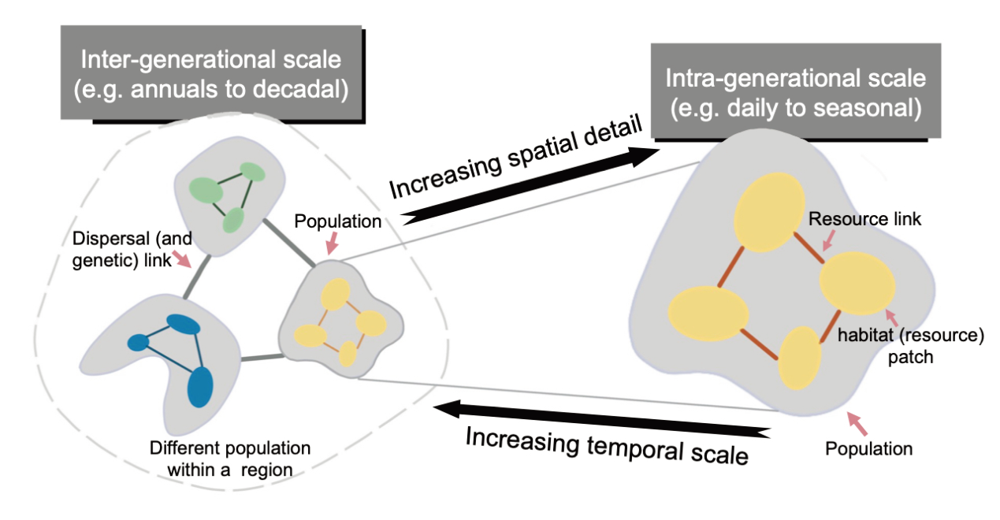

Figure S1 Spatial and temporal scales of ecological processes involved in the concepts of connectivity and meta-patch.

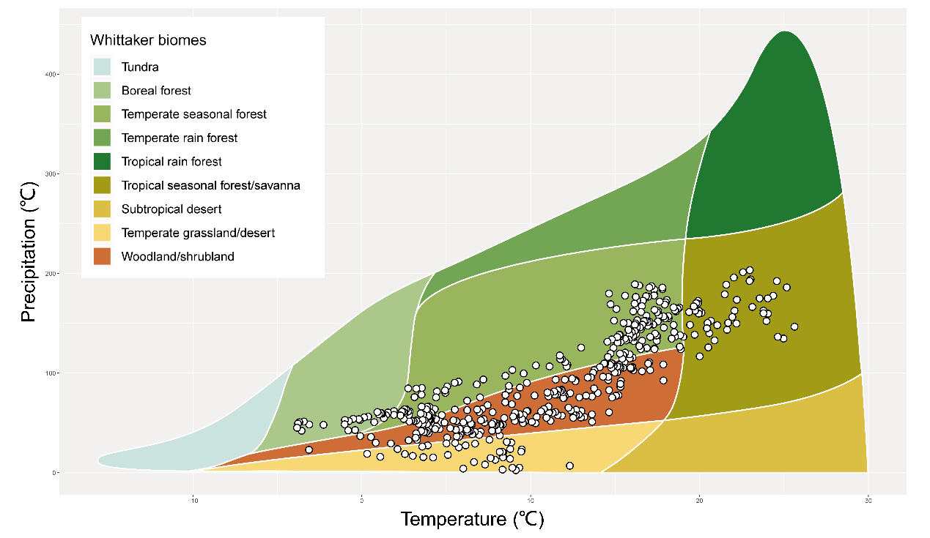

Figure S2 Climatic distributions of each NNRs. The points representing each NNRs are situated on Whittaker's terrestrial biome diagram, and Whittaker's biome depends on the average annual precipitation and temperature as a function.

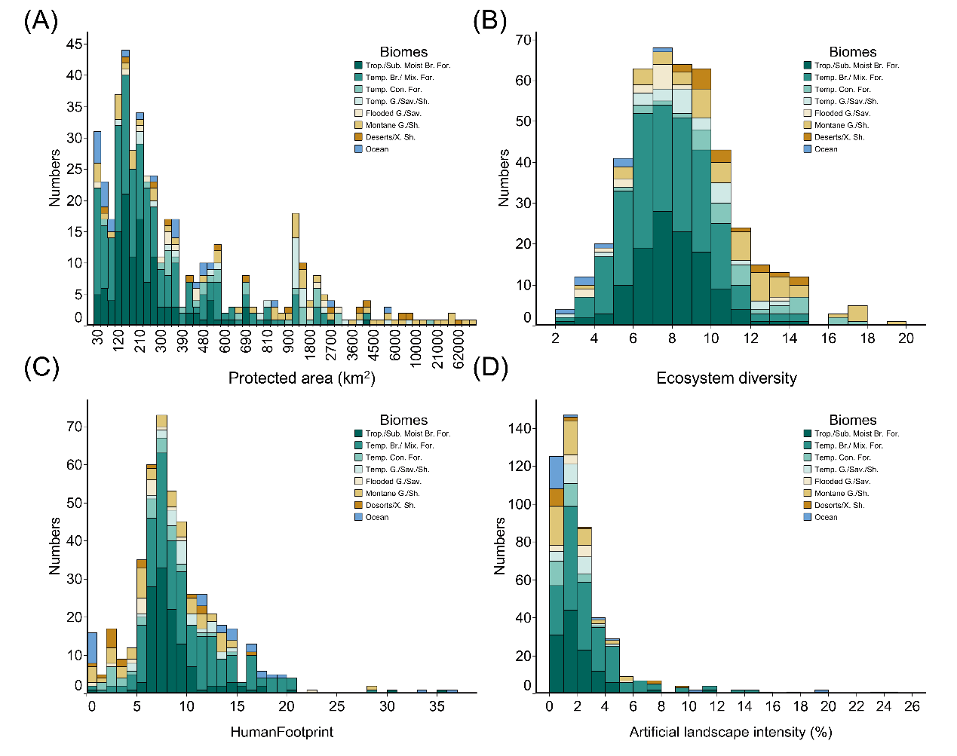

Figure S3 Overview of National Nature Reserves (NNRs). China's NNRs fundamental information on (A) Protected area, (B) Ecosystem diversity, (C) Human footprint, and (D) Artificial landscape intensity. The histogram of frequency distribution is shown, with different colors representing different biomes (see figure legend for details).

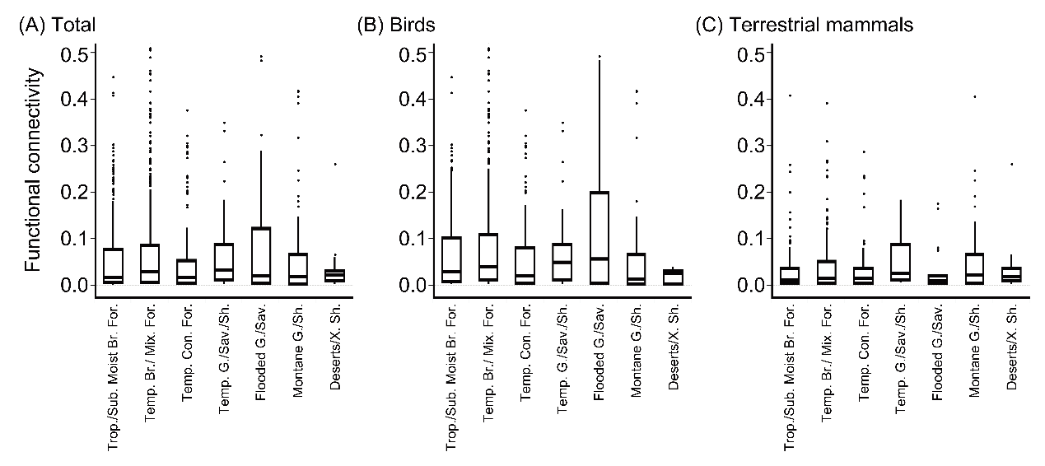

Figure S4 Functional connectivity values for national nature reserves (NNRs) in biomes category. Boxplots of functional connectivity by (A) both birds and terrestrial mammals, (B) birds and (C) terrestrial mammals.

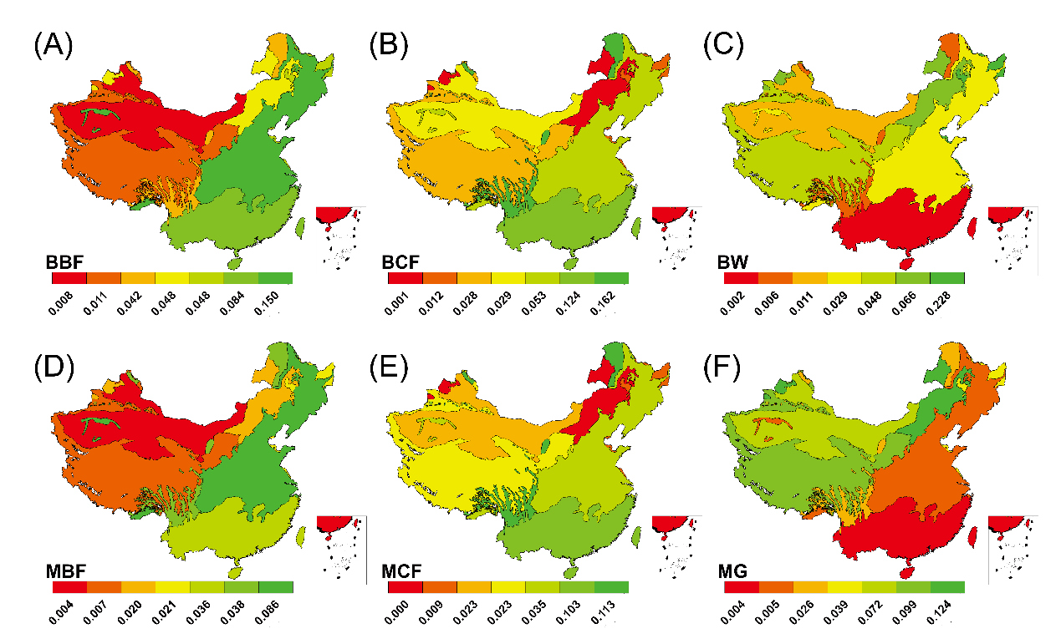

Figure S5 Map of the distribution of functional connectivity values for birds and terrestrial mammal. Represented by the mean value of functional connectivity for all national nature reserves (NNRs) within biomes. Only the connectivity of wildlife with low movement ability is shown here, wildlife with higher movement ability has the same pattern. From Figure A to Figure F, the following virtual species are represented: BBF, Birds living in broadleaf forest habitats; BCF, Birds living in coniferous forest habitats; BW, Birds living in wetland habitats; MBF, Mammals living in broadleaf forest habitats; MCF, Terrestrial mammals living in coniferous forest habitats; MG, Terrestrial mammals in grassland habitats.

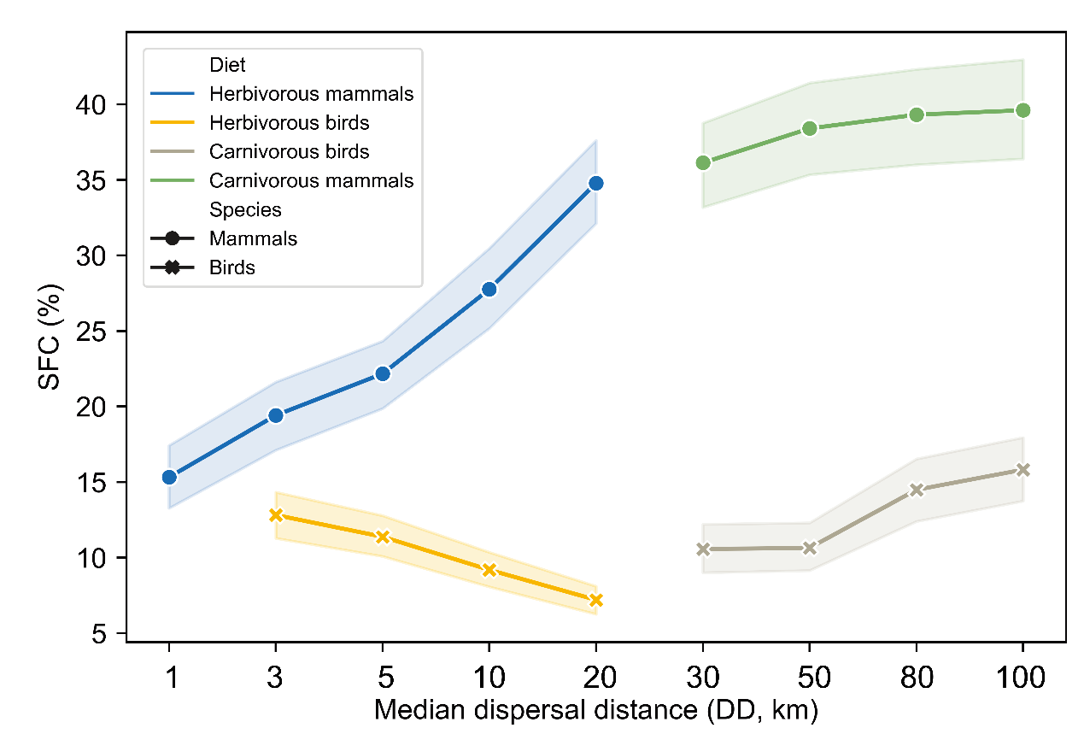

Figure S6 Sensitivity of functional connectivity (SFC) values under varying diet and inter-generational dispersal distance (DD) gradients. The dots represent terrestrial mammals, and the crosses represent birds. The colors of the lines and symbols indicate the different taxa and diet preference. The shaded areas with color indicate the 90% credible intervals.

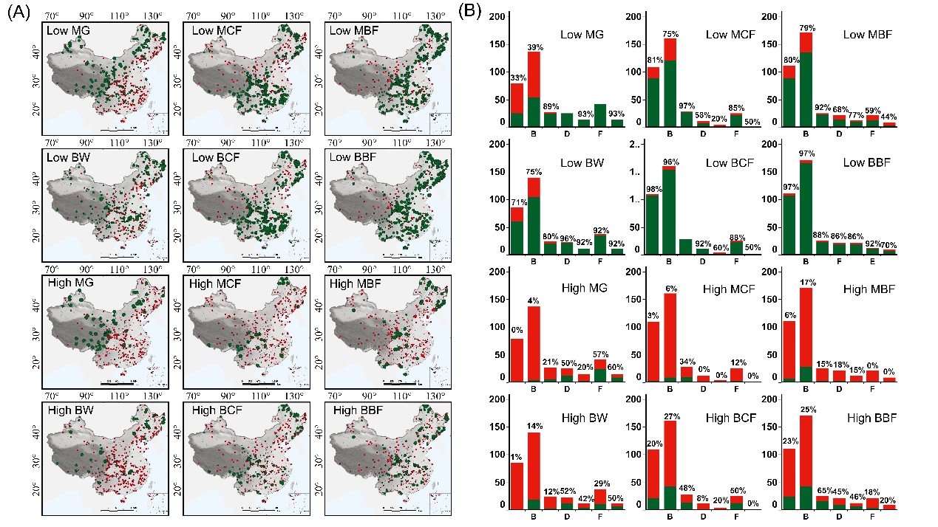

Figure S7 Map of the effectiveness of national nature reserves (NNRs). （A）Distribution is for terrestrial mammals and birds with different habitat preferences. The green points on the map represent effectively protected, while red point represents ineffectively protected. The larger the size of the point, the larger the value of connectivity. (B) The histogram matched with each map is the number and proportion of NNRs within each biome that are effectively protected. The horizontal axis from A to G respectively represent tropical and subtropical moist broadleaf forests, temperate broadleaf and mixed forests, temperate coniferous forests, temperate grasslands, savannas, and shrublands, flooded grasslands and savannas, montane grasslands and shrublands, deserts and xeric shrublands.

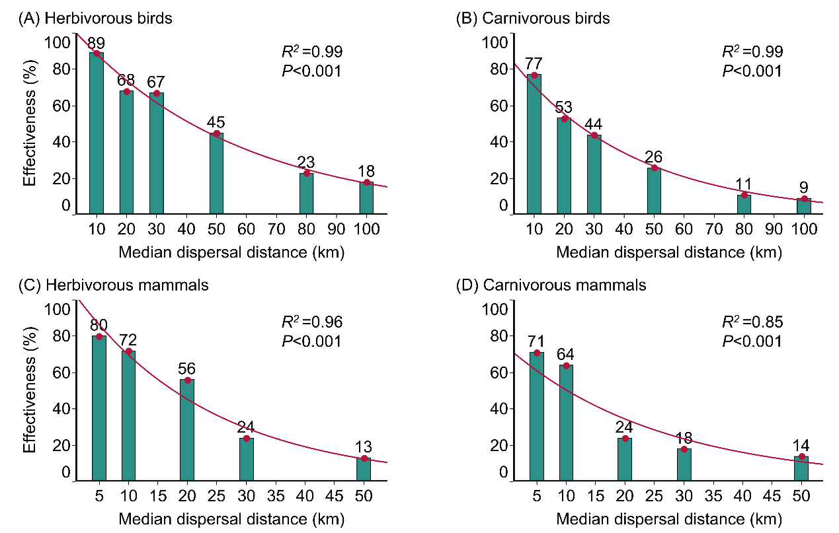

Figure S8 Effectiveness of national nature reserves (NNRs) under varying inter-generational dispersal distance gradients. The proportion of national nature reserves in China that effectively protect (A) herbivorous birds, (B) carnivorous birds, (C) herbivorous terrestrial mammals, and (D) carnivorous terrestrial mammals decreases continuously with increased dispersal distance. Correlations are depicted with Pearson’s R².

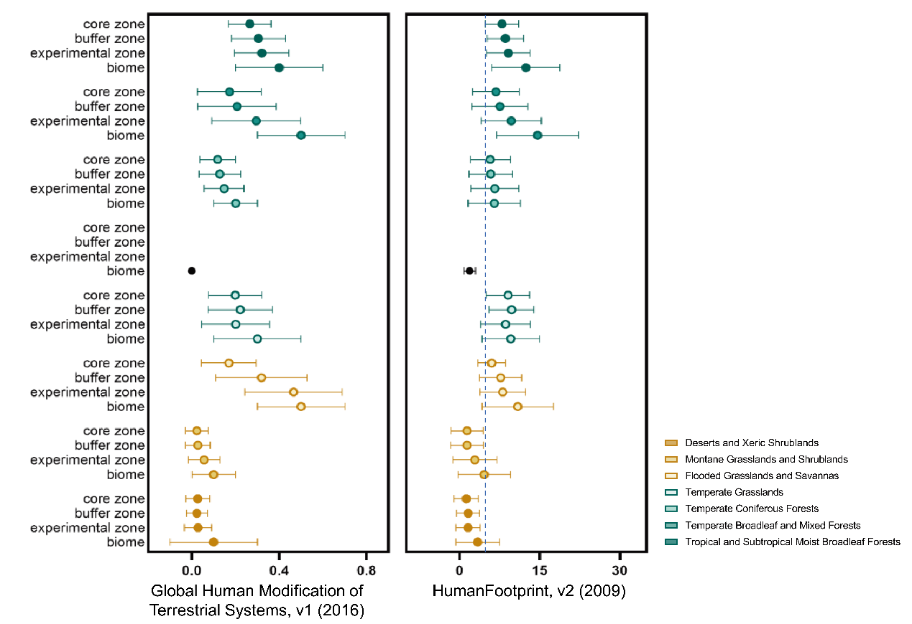

Figure S9 The intensity of human activities outside and inside functional zones of the national nature reserve (NNRs). The functional zones within NNRs include core, buffer and experimental zones, with increasing stringency of protection measures. The intensity of human activities outside the NNRs is represented by the mean value of the biomes in which the NNRs are located. Robustness is guaranteed using two commonly used human footprint dataset. The dashed line in the figure represents human footprint intensity equal to 4. It is generally accepted that HF > 4 is generally used as a threshold to measure whether NNRs is human dominated. Different colored circles representing different biomes (see figure legend for details). The solid black dots represent the biome of boreal forests/ taiga, which is currently without any NNR. Error bars indicate the 95% credible intervals.

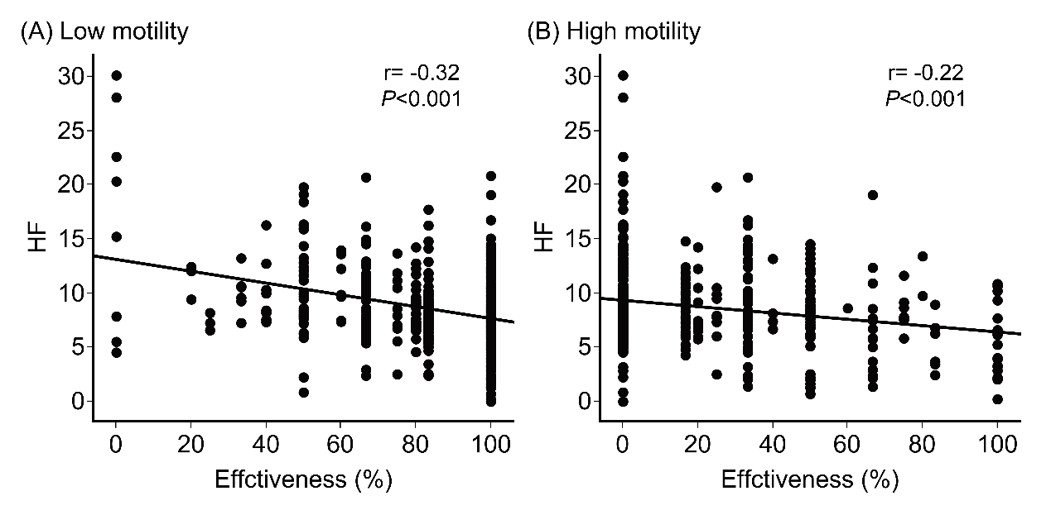

Figure S10 Relationship between the human footprint and the effectiveness for (A) low and (B) high motility species within NNRs. Correlations are depicted with Pearson’s r.

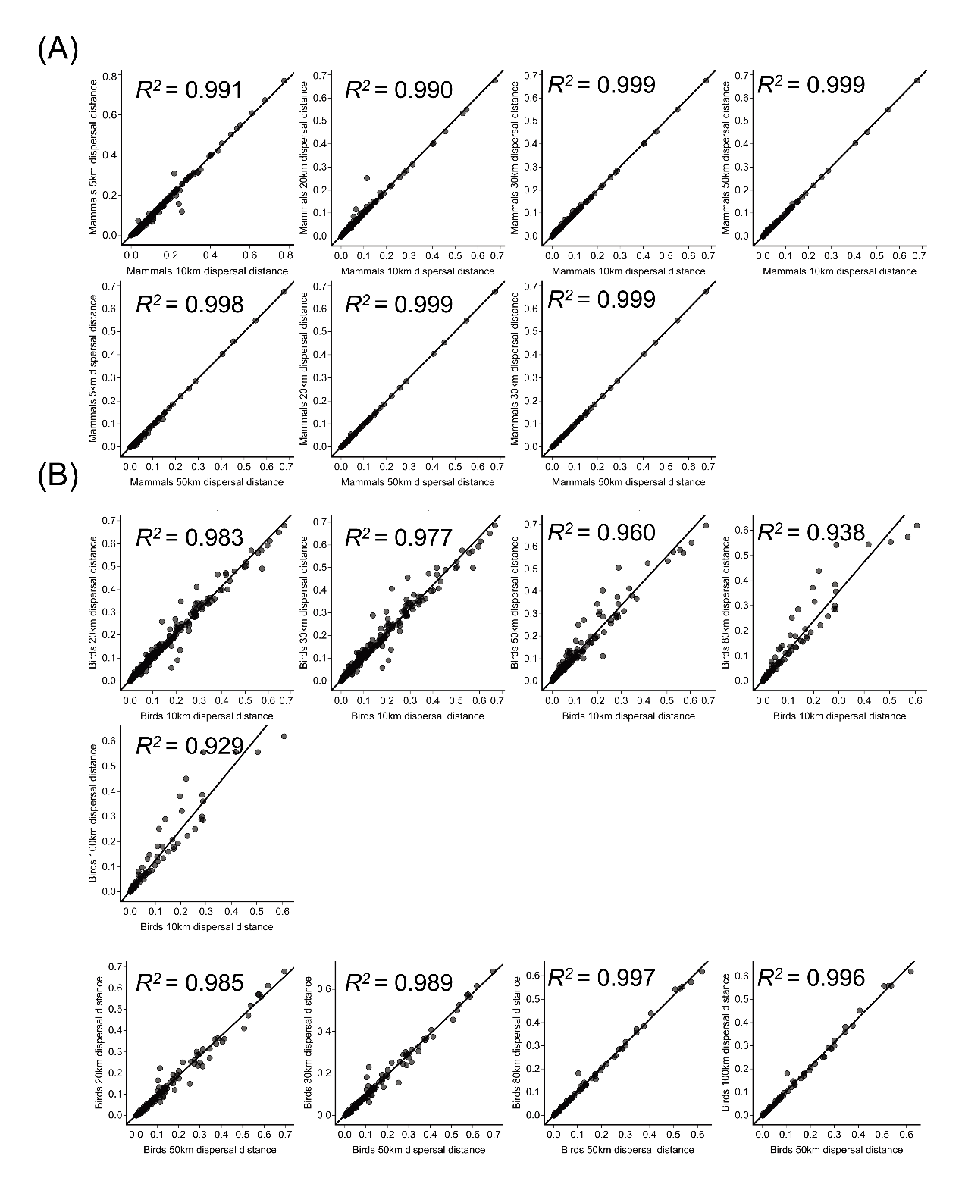

Figure S11 Evaluating the sensitivity of virous dispersal distance within birds and terrestrial mammal. (A) Comparisons of terrestrial mammal and (B) birds. Correlations are depicted with Pearson’s R².

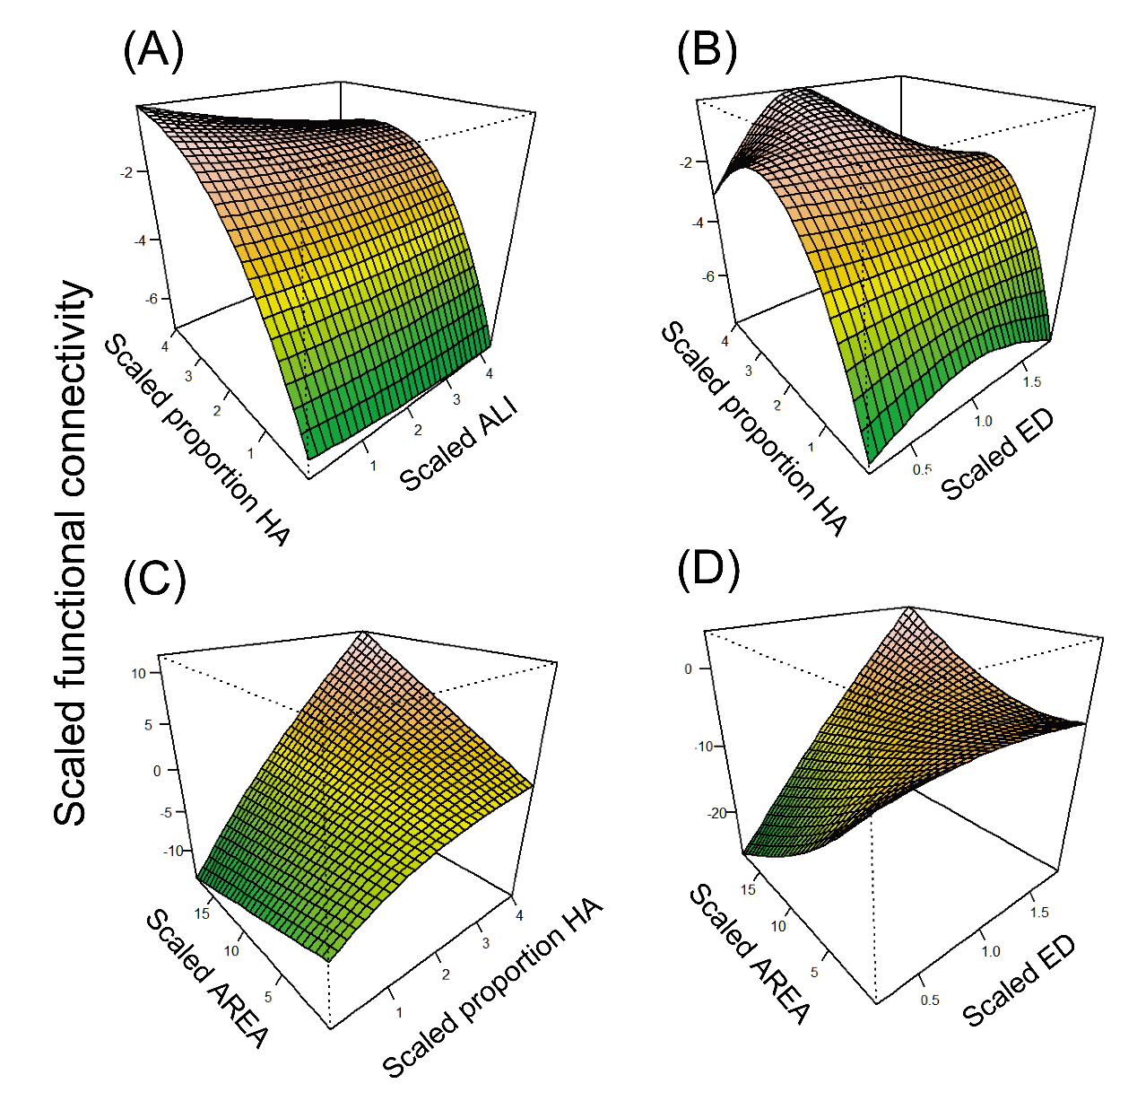

Figure S12 Predictors of functional connectivity. The probability of functional connectivity was generated using the best-fitting GAM, where predictors included proportion of habitat area (Proportion HA), artificial landscape intensity (ALI), ecosystem diversity (ED) and NNRs area (AREA).

