Supporting Information
High-purity monoclinic pyrrhotite derived-from
natural pyrite with excellent removal performance for Cr (VI) and its mechanism
Hao Liu ª, Yuxin Li ^{b}, Guocheng Lv ^{b}, Xin Liu ^{b}, Libing Liao ^{b*}
ª School of Science, China University of Geosciences, Beijing, 100083, China.
^{b} Engineering Research Center of Ministry of Education for Geological Carbon Storage and Low Carbon Utilization of Resources, Beijing Key Laboratory of Materials Utilization of Nonmetallic Minerals and Solid Wastes, National Laboratory of Mineral Materials, School of Material Sciences and Technology, China University of Geosciences, Beijing 100083, China
Corresponding author: Libing Liao, Tel and Fax number: 852-010-82321701, Email: clayl@cugb.edu.cn, Mailing Address: Room 120, Ceshi Building, School of Material Sciences and Technology, China University of Geosciences, Beijing 100083, China.

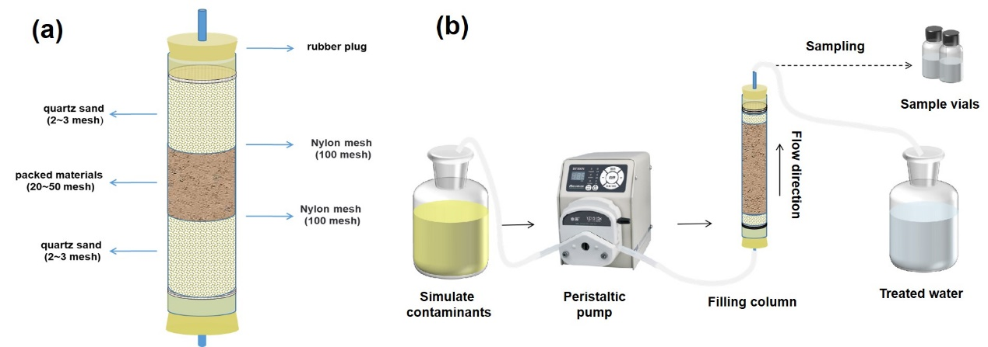
Figure S1 (a) Schematic diagram of the experimental column; (b) Schematic diagram of the dynamic column experimental setup.

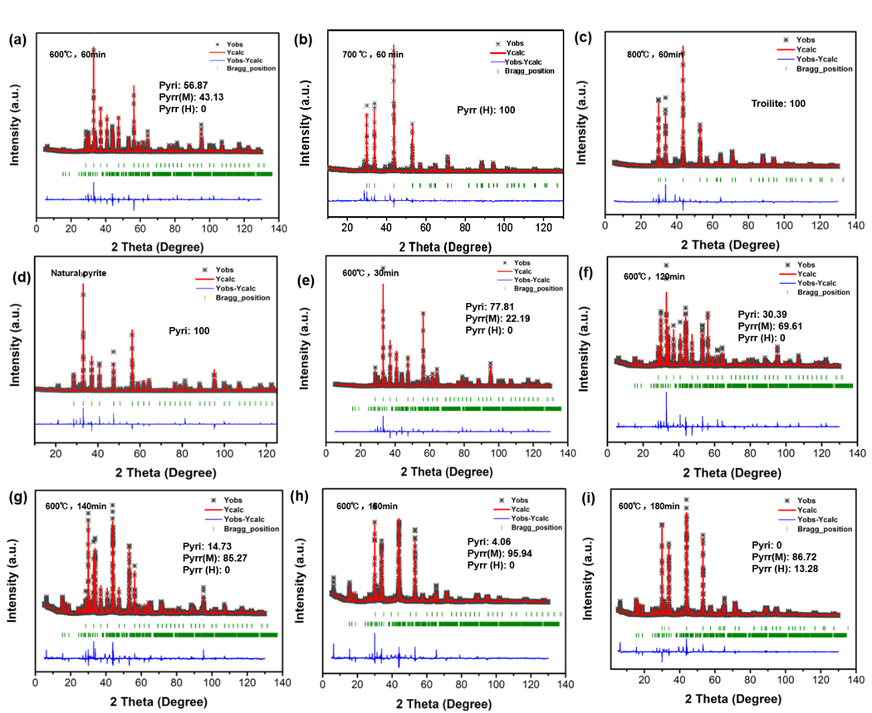
Figure S2. Full XRD spectrum fitting results of the products of heated pyrite in Ar gas held at (a) 600 °C, (b) 700 ° C and (c) 800 ° C for 1 h. (d) pyrite and its calcination at 600 ° C for (e) 30 min, (f) 120 min, (g) 140 min, (h) 160 min and (i) 180 min.

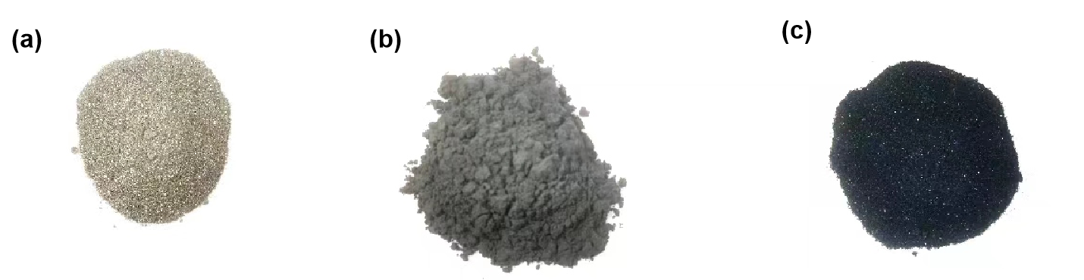
Figure S3 Digital photographs of (a) pyrite, (b) high-purity monoclinic pyrrhotite and (c) hexagonal pyrrhotite.

Table S1. Composition analysis of pyrite and monoclinic pyrrhotite by ICP method
Elements |  | Pyrite | Monoclinic Pyrrhotite | Hexagonal Pyrrhotite
content（mass%） | Fe | 46.67 | 60.51 | 61.17
content（mass%） | S | 53.33 | 39.49 | 38.83

Table S2. Specific surface area and pore parameters of pyrite, monoclinic pyrrhotite and hexagonal pyrrhotite
Sample | Specific surface area（m²/g） | Pore volume  （cc/g） | Pore diameters  （nm）
Pyrite | 0.723 | 0.002 | 1.118
Monoclinic Pyrrhotite | 1.338 | 0.004 | 1.182
Hexagonal Pyrrhotite | 1.042 | 0.003 | 1.185

Table S3. XRD Rietveld refinement parameters of pyrite, monoclinic pyrrhotite and hexagonal pyrrhotite
Samples | Pyrite | Monoclinic pyrrhotite | Hexagonal pyrrhotite
Space groups | Pa-3 | C2/c | P63/mmc
crystal system | Cubic | Monoclinic | Hexagonal
a/b/c (Å) | 5.4190 | 11.9137/ 6.8725/ 12.9056 | 3.4625/ 3.4625/ 5.7718
α/β/γ (°) | 90° | β=118.018° | γ=120°
V (Å³) | 159.133 | 932.833 | 59.926
R_{wp} | 11.50 | 12.50 | 9.38
R_{p} | 7.81 | 9.07 | 6.86

Table S4. Fe and S occupancy in pyrite, monoclinic pyrrhotite and hexagonal pyrrhotite.
Samples | Pyrite | Monoclinic pyrrhotite | Hexagonal pyrrhotite
Fe site occupancy | 1 | 0.870 | 0.887
S site occupancy | 0.997 | 0.956 | 0.977

