Appendix 1 Color Perception Questionnaire
Color Perception Survey on Ancient Chinese Architecture

Thank you for taking time to answer! Color is a part of our life, and for the color of ancient Chinese architecture, our understanding should have various perspectives, including historical changes, craftsmen's skills and color preference inheritage. In order to better understand your color preference for ancient Chinese buildings, we look forward to your participation and help!

Part I Basic Information

Your personal information will only be used for research analysis and not for any other purpose.

1. Your age： [single selection] *
○Under 18 | ○18~25 | ○26~35 | ○36~45
○46~55 | ○56~65 | ○65 Above

2. Your Gender： [single selection] *
○Male | ○ Female | ○Others _________________

3. （Non-required answer）If willing to answer, Your Region: [Type in the blank]
_________________________________

4. （Non-required answer）If willing to answer，Your institutional affiliation [Type in the blank]
_________________________________

5. Your current profession type： [single selection] *
Architecture-related majors: including architecture, planning, landscape architecture and other related disciplines
○Architecture-related student (including undergraduate, master's and doctoral degrees)
○Architecture-related profession (including teachers, designers, etc.)
○Art and design-related students (including undergraduate, master's and doctoral degrees)
○Art and design-related profession (including teachers, designers, etc.)
○Archaeology, Art History-related student (including undergraduate, master's and doctoral degrees)
○Archaeology, Art History-related profession
○Conservation, Museology-related students (including undergraduate, master's and doctoral degrees)
○Conservation, Museology-related profession
○Other _________________

6. Your education level [single selection] *
○Primary and secondary school (acquired or not graduated)
○Bachelor's Degree (acquired or not graduated)
○Master’s Degree（acquired or not graduated）
○Doctor’s Degree（acquired or not graduated）
○Other _________________

7. Do you have any experience in color research related work? [multiple-choice] *
□Yes, engaged in art creation or design
□Yes, specializing in color research
□Yes, specializing in color painting
□Yes, with some color training experience
□Not engaged in color related work
□Other _________________

8. Have you ever been to the Wen Yuan Ge in person? [single selection] *
○Yes
○Never
○Other _________________

Part II Cultural Perception

9. This is the Wen Yuan Ge, the "National Library" in the Forbidden City.
The following is an overall description of the construction history and function of the Wen Yuan Ge.，
“The Wen Yuan Ge of the Qing Dynasty was built in the forty-first year of the Qianlong reign (1776) and functioned to store the Siku Quanshu. (Wen Yuan Ge) to Zhejiang Tianyi Pavilion silhouette openings as a blueprint, in the palace on the basis of the construction of a solemn and luxurious, distinctive style of the two-story building"
"After the completion of the building, it was held in the Wen Yuan Pavilion, after the ceremony, the lecturer and the residence of the official, that is, in the Pavilion to give sitting and give tea."
"Jing Feast: The Jing Feast provided a legitimizing institutional platform for the lecturers of the Jing Feast to teach the Confucian classics centered on the Five Classics and the Four Books to the emperor. As the lecturers who played the role of preachers in the activities of the scripture feast, they hoped to educate the emperors and cultivate the virtue of the kings in order to create Yao, Shun, and Shengwang.。“
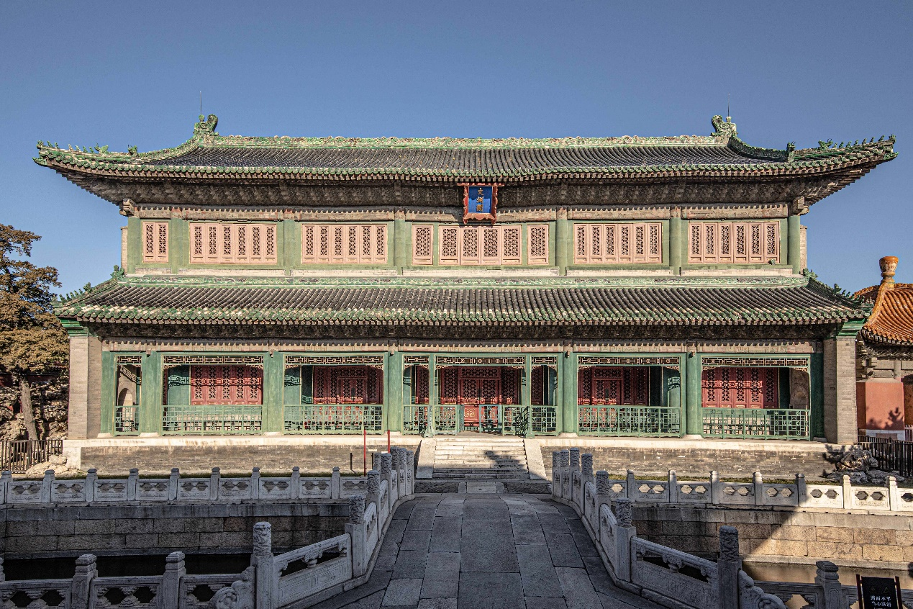
[single selection] *
Do you think the above elevation matches your mental image of a royal library and a place for scriptural ceremonies?
○Least consistent | ○Not very consistent | ○Moderate consistent | ○Very Consistent | ○Most Consistent

10. In the early 20th century, Wen Yuan Ge photos used to be added with different colors, as shown below.
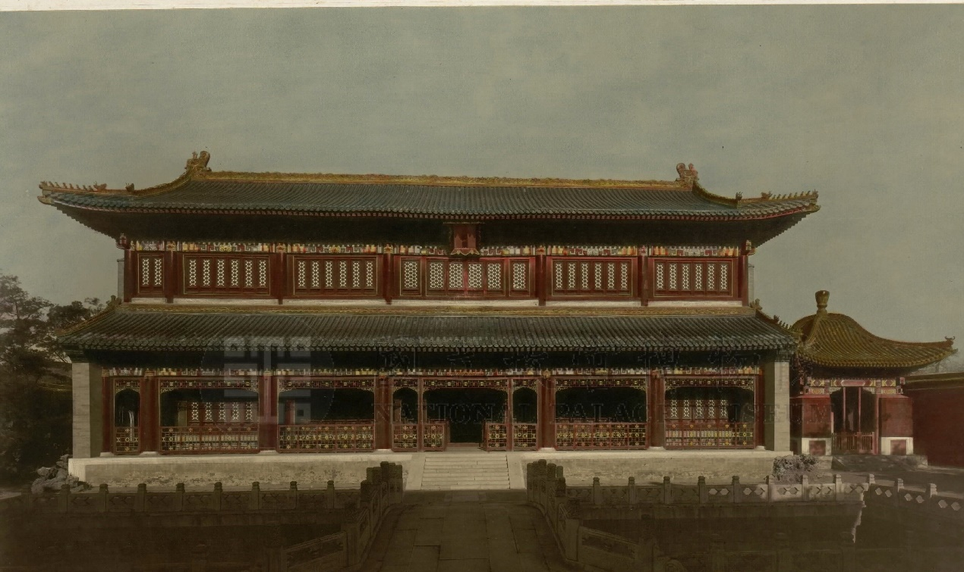[single selection] *
After understanding the architectural function of Wen Yuan Ge, do you think that the above elevation matches the image of "royal library and place of sutra feast" in your mind?
○Least consistent | ○Not very consistent | ○Moderate consistent | ○Very Consistent | ○Most Consistent

Part III Color Perception of Ancient Chinese Building Facades

11. Please observe the color area map of the façade and choose the appropriate descriptor of your feelings (Click on the picture to enlarge it). [Multiple Choice] *
□Gorgeous | □Decorative
□Luxious | □Rich
□Traditional | □Classic
□Quiet | □Delicate
□Cultrual | □Harmonious
□Profound | □Stylish
□Thick | □Elegant;
□Noble | □庄严的
□Other _________________

12. Please look at the photo of the main façade and choose the appropriate descriptor of your feelings (the image can be enlarged by clicking on it).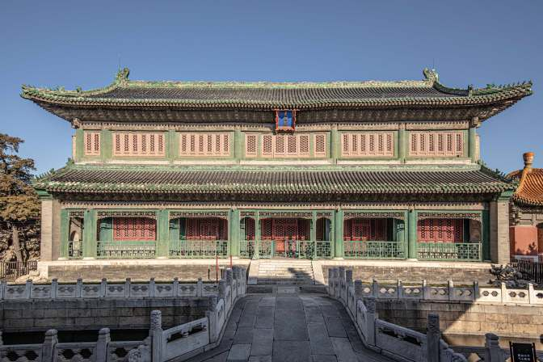 [Multiple Choice] *

□Gorgeous | □Decorative
□Luxious | □Rich
□Traditional | □Classic
□Quiet | □Delicate
□Cultrual | □Harmonious
□Profound | □Stylish
□Thick | □Elegant;
□Noble | □庄严的
□Other _________________

13. Please take a close look at the following "Color Elevation Drawings" and "Photographs of Existing Elevations" and evaluate whether the color elevation drawings are consistent with your overall perception of the existing color of the building elevations: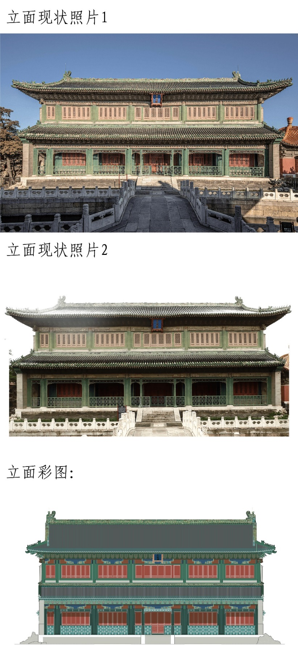
[single selection] *

○Least consistent | ○Not very consistent | ○Moderate consistent | ○Very Consistent | ○Most consistent

14. Please look at the color drawings of the façade and choose the appropriate words to describe your feelings (click on the pictures to enlarge them).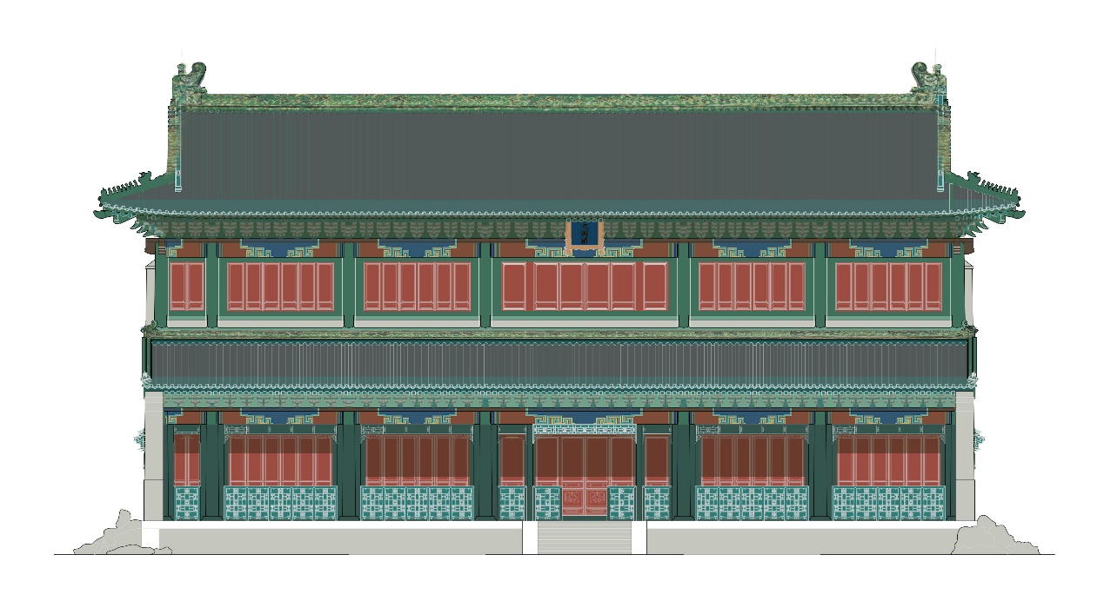 [Multiple Choice] *
□Gorgeous | □Decorative
□Luxious | □Rich
□Traditional | □Classic
□Quiet | □Delicate
□Cultrual | □Harmonious
□Profound | □Stylish
□Thick | □Elegant;
□Noble | □庄严的
□Other _________________

Part IV The ancient building eaves and forehead square color painting color perception

15. Observe the orthophoto of the color painting and choose the appropriate descriptor for your feelings (the image can be enlarged by clicking on it).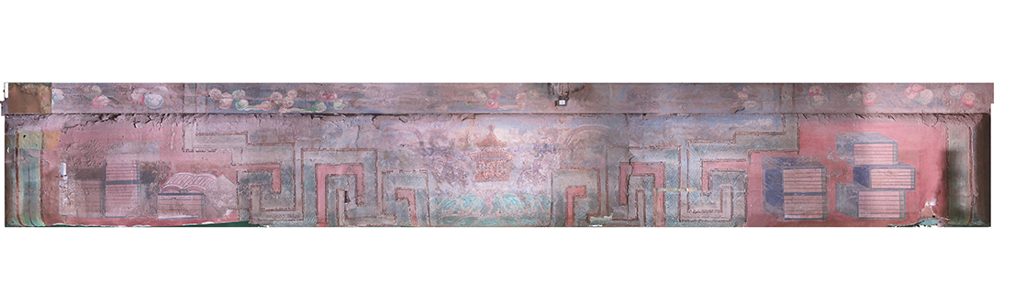 [Multiple Choice] *
□Gorgeous | □Decorative
□Luxious | □Rich
□Traditional | □Classic
□Quiet | □Delicate
□Cultrual | □Harmonious
□Profound | □Stylish
□Thick | □Elegant;
□Noble | □庄严的
□Other _________________

16. Please look carefully at the following pictures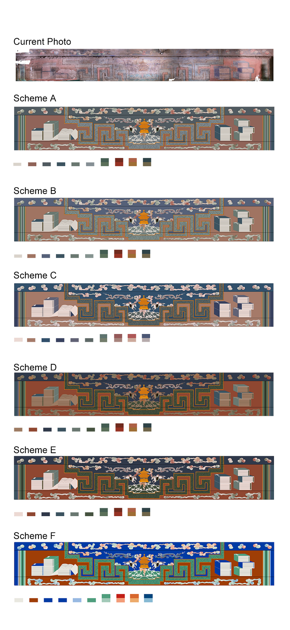[Matrix Scale] *
Please evaluate whether each of the above schemes corresponds to the color perception of the "current photo".
 | Least Consistent | Not Very Consistent | Moderate Consistent | Very Consistnet | Most Consistent
Scheme A | ○ | ○ | ○ | ○ | ○
Scheme B | ○ | ○ | ○ | ○ | ○
Scheme C | ○ | ○ | ○ | ○ | ○
Scheme D | ○ | ○ | ○ | ○ | ○
Scheme E | ○ | ○ | ○ | ○ | ○
Scheme F | ○ | ○ | ○ | ○ | ○

17. Please look carefully at the following pictures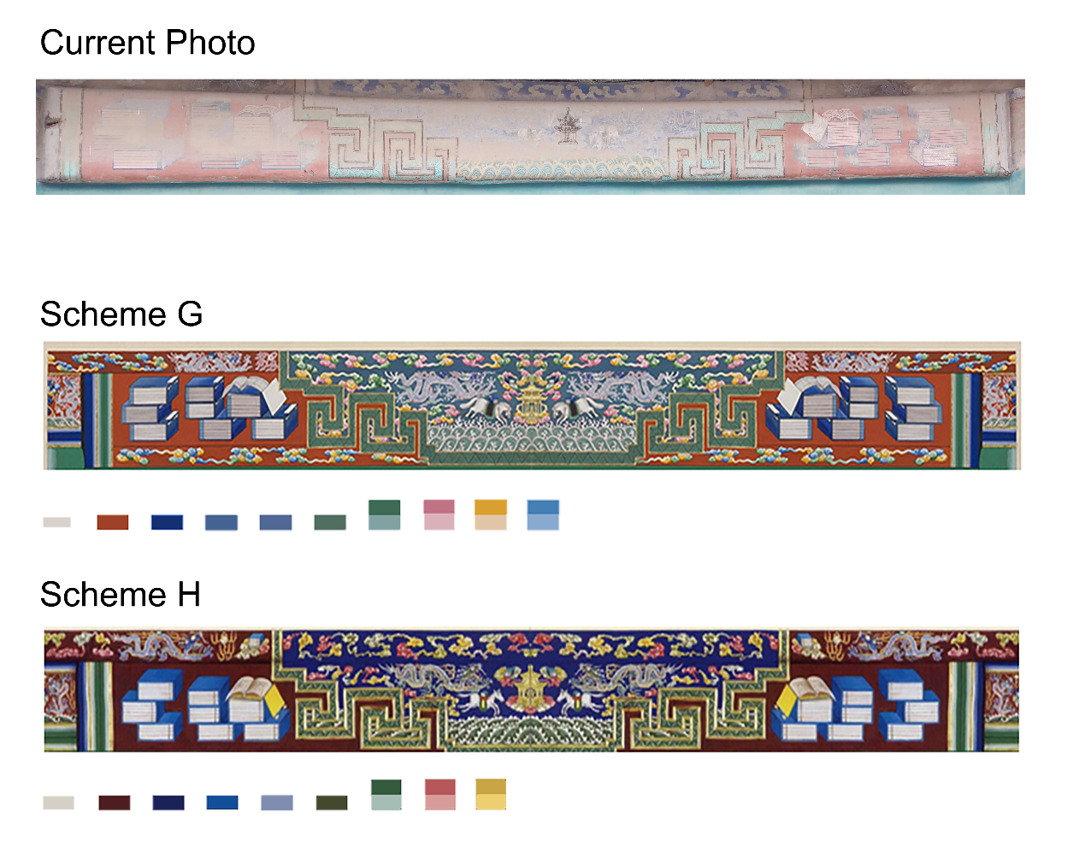[ Matrix Scale Questions] *
Please evaluate whether each of the above diagrams corresponds to the color perception of the "current photo".
 | Least Consistent | Not Very Consistent | Moderate Consistent | Very Consistnet | Most Consistent
Scheme G | ○ | ○ | ○ | ○ | ○
Scheme H | ○ | ○ | ○ | ○ | ○

18. Please observe the same set of pictures[Matrix Scale] *
Please evaluate whether each of the above colorful schematic drawings matches your imagination of the cultural identity of the Wen Yuan Ge (the royal collection of books and the place where the sutra feasts were held).
 | Least Consistent | Not Very Consistent | Moderate Consistent | Very Consistnet | Most Consistent
Scheme A | ○ | ○ | ○ | ○ | ○
Scheme B | ○ | ○ | ○ | ○ | ○
Scheme C | ○ | ○ | ○ | ○ | ○
Scheme D | ○ | ○ | ○ | ○ | ○
Scheme E | ○ | ○ | ○ | ○ | ○
Scheme F | ○ | ○ | ○ | ○ | ○

19. Please observe the same set of pictures [Matrix Scale] *
Please evaluate whether each of the above colorful schematic drawings matches your imagination of the cultural identity of the Wen Yuan Ge (the royal collection of books and the place where the sutra feasts were held).
 | Least Consistent | Not Very Consistent | Moderate Consistent | Very Consistnet | Most Consistent
Scheme G | ○ | ○ | ○ | ○ | ○
Scheme H | ○ | ○ | ○ | ○ | ○

20. Please observe the same set of pictures[Matrix Scale] *
Please evaluate each of the above diagrams to see if they match your aesthetics.
 | Least Consistent | Not Very Consistent | Moderate Consistent | Very Consistnet | Most Consistent
Scheme A | ○ | ○ | ○ | ○ | ○
Scheme B | ○ | ○ | ○ | ○ | ○
Scheme C | ○ | ○ | ○ | ○ | ○
Scheme D | ○ | ○ | ○ | ○ | ○
Scheme E | ○ | ○ | ○ | ○ | ○
Scheme F | ○ | ○ | ○ | ○ | ○

21. Please observe the same set of pictures [Matrix Scale] *
Please evaluate each of the above diagrams to see if they match your aesthetics.
 | Least Consistent | Not Very Consistent | Moderate Consistent | Very Consistnet | Most Consistent
Scheme G | ○ | ○ | ○ | ○ | ○
Scheme H | ○ | ○ | ○ | ○ | ○

22. Please observe the same set of pictures[Matrix Scale] *
Please evaluate whether each of the above diagrams matches your perception of the color of the "scene".
 | Least Consistent | Not Very Consistent | Moderate Consistent | Very Consistnet | Most Consistent
Scheme A | ○ | ○ | ○ | ○ | ○
Scheme B | ○ | ○ | ○ | ○ | ○
Scheme C | ○ | ○ | ○ | ○ | ○
Scheme D | ○ | ○ | ○ | ○ | ○
Scheme E | ○ | ○ | ○ | ○ | ○
Scheme F | ○ | ○ | ○ | ○ | ○

23. Please observe the same set of pictures[Matrix Scale] *
Please evaluate whether each of the above diagrams matches your perception of the color of the "scene".
 | Least Consistent | Not Very Consistent | Moderate Consistent | Very Consistnet | Most Consistent
Scheme G | ○ | ○ | ○ | ○ | ○
Scheme H | ○ | ○ | ○ | ○ | ○

24. 请观察同一组图片
[矩阵量表题] *
Please evaluate whether each of the above schematic diagrams matches the color effect you imagined when it was just drawn (restoration imagery)
 | Least Consistent | Not Very Consistent | Moderate Consistent | Very Consistnet | Most Consistent
Scheme A | ○ | ○ | ○ | ○ | ○
Scheme B | ○ | ○ | ○ | ○ | ○
Scheme C | ○ | ○ | ○ | ○ | ○
Scheme D | ○ | ○ | ○ | ○ | ○
Scheme E | ○ | ○ | ○ | ○ | ○
Scheme F | ○ | ○ | ○ | ○ | ○

25. Please observe the same set of pictures[Matrix Scale] *
请评价以上各个示意图是否符合您想象中刚刚绘制时的色彩效果（复原想象）
 | Least Consistent | Not Very Consistent | Moderate Consistent | Very Consistnet | Most Consistent
Scheme G | ○ | ○ | ○ | ○ | ○
Scheme H | ○ | ○ | ○ | ○ | ○

26. Please observe the same set of pictures[矩阵量表题] *
Please evaluate whether each of the above schematic diagrams meets your expectations for the results of the conservation restoration and dusting of the paintings at this site.
 | Least Consistent | Not Very Consistent | Moderate Consistent | Very Consistnet | Most Consistent
Scheme A | ○ | ○ | ○ | ○ | ○
Scheme B | ○ | ○ | ○ | ○ | ○
Scheme C | ○ | ○ | ○ | ○ | ○
Scheme D | ○ | ○ | ○ | ○ | ○
Scheme E | ○ | ○ | ○ | ○ | ○
Scheme F | ○ | ○ | ○ | ○ | ○

27. Please observe the same set of pictures [Matrix Scale] *
Please evaluate whether each of the above schematic diagrams meets your expectations for the results of the conservation restoration and dusting of the paintings at this site.
 | Least Consistent | Not Very Consistent | Moderate Consistent | Very Consistnet | Most Consistent
Scheme G | ○ | ○ | ○ | ○ | ○
Scheme H | ○ | ○ | ○ | ○ | ○
f
28. (Not required) As professionals, your opinions and feelings are important to us, so please let us know if you have any comments or suggestions about the schematic or option design. [fill in the blank]

