Supplemental Materials

[Supplemental Survey 1]

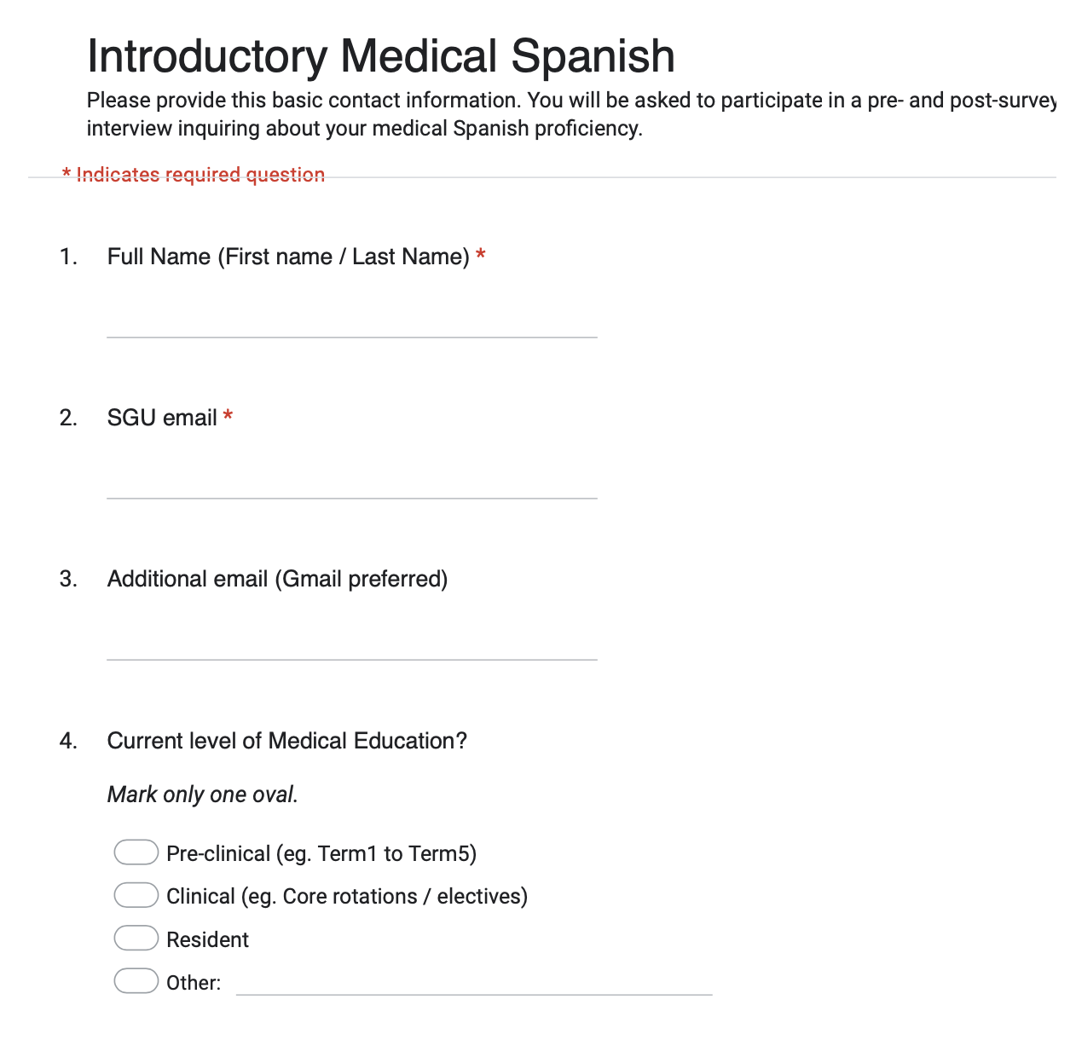

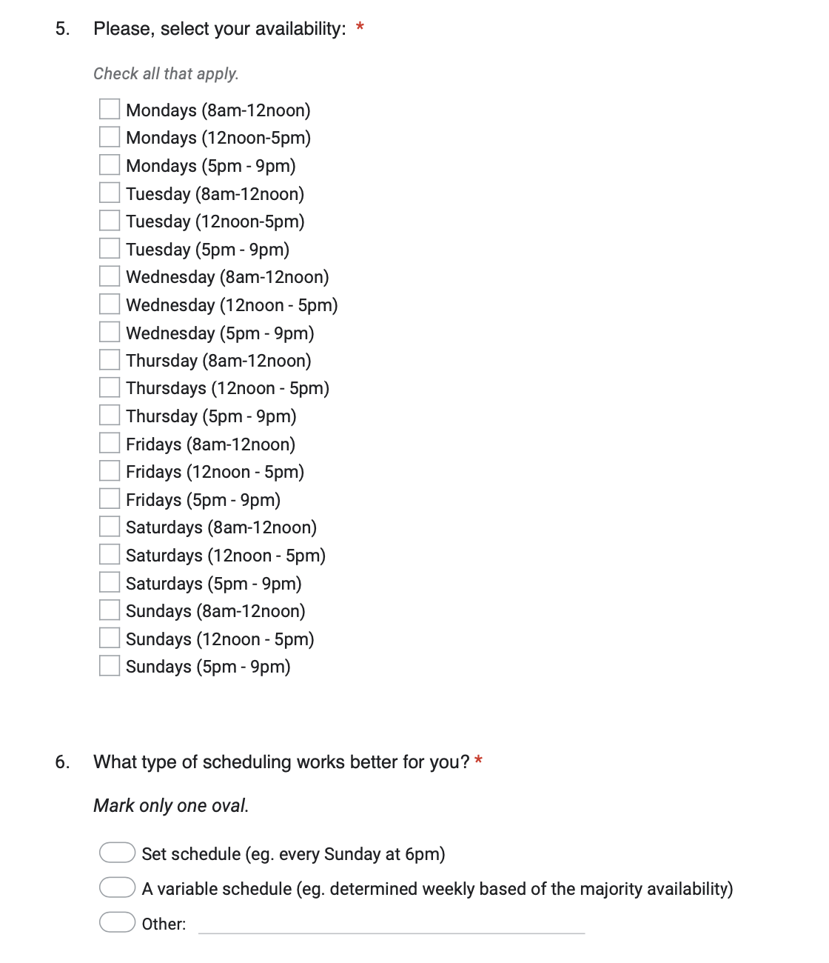

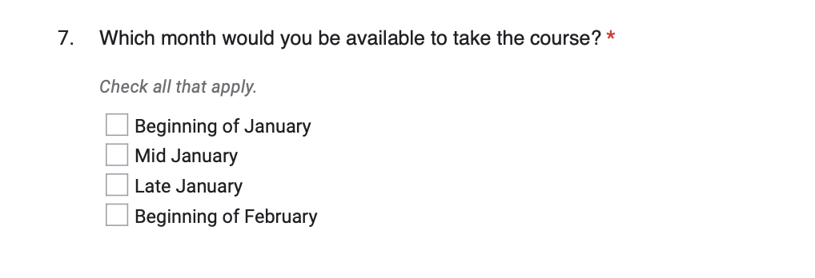

[Supplemental Survey 2] – Pre-course survey

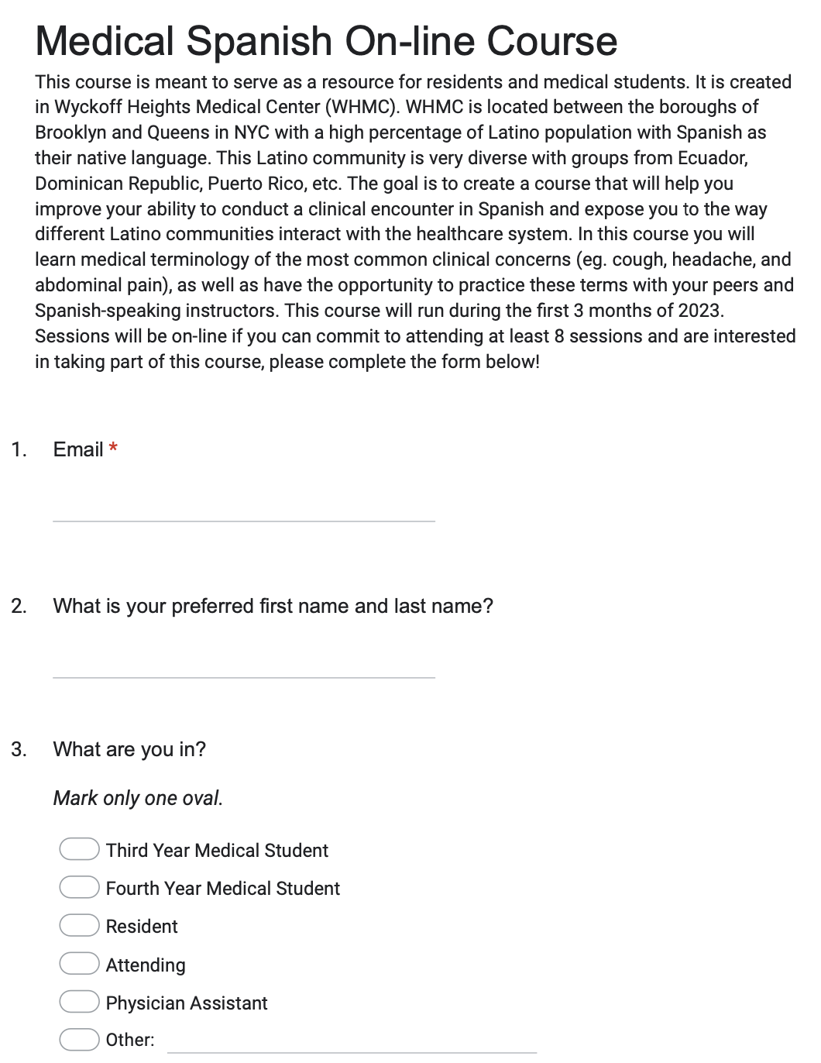
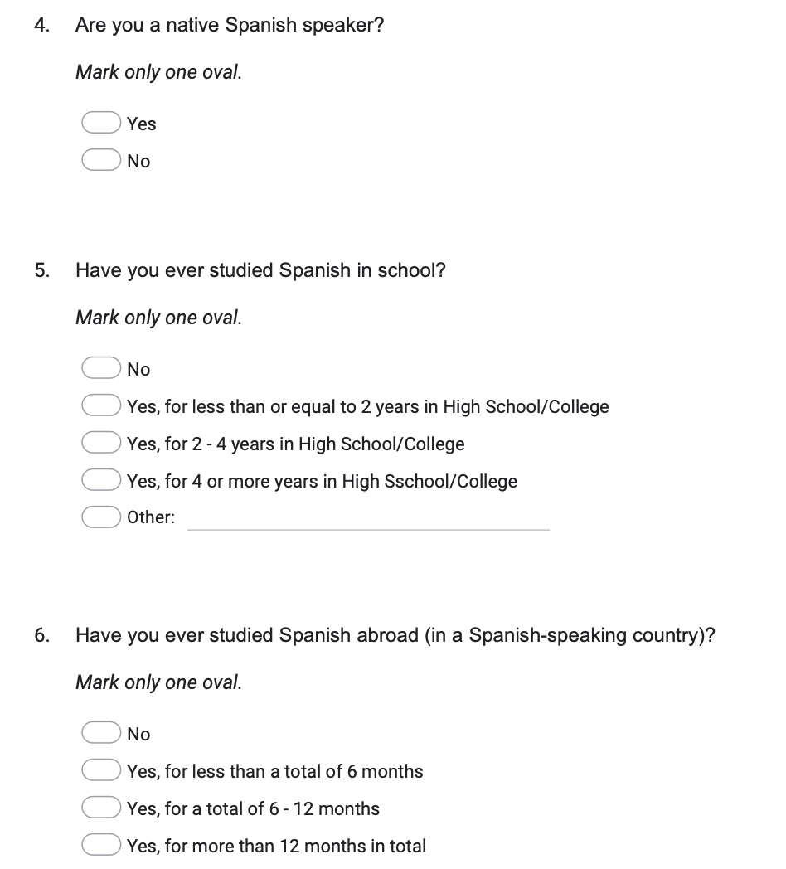

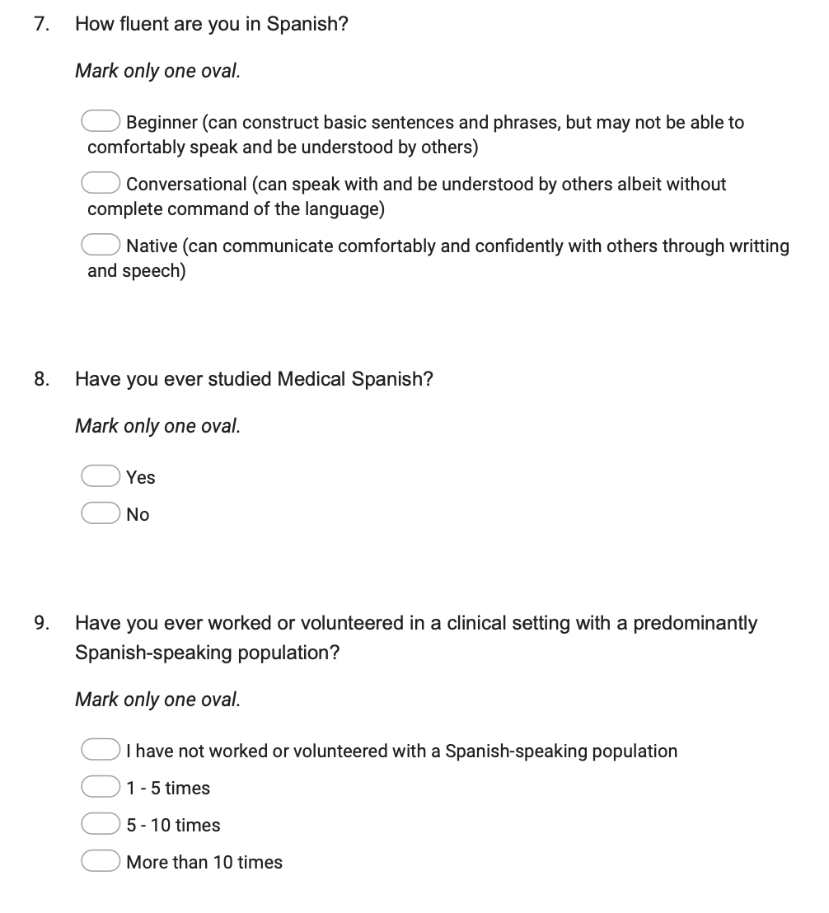

[Supplemental Survey 3] – Post-course survey
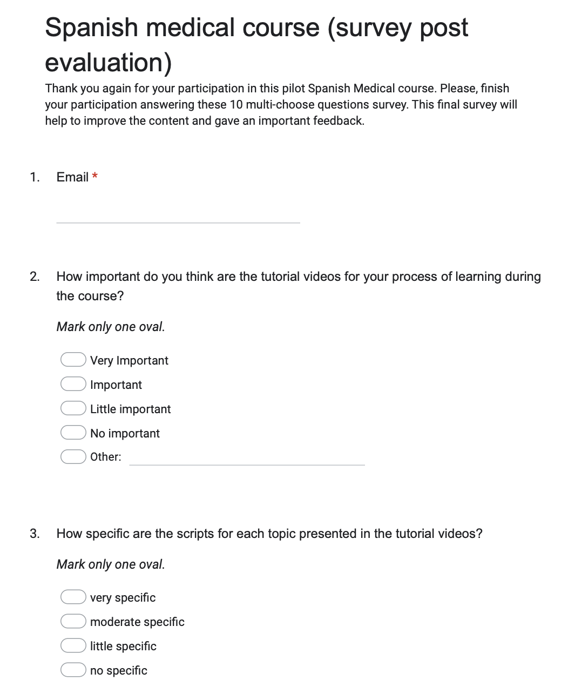

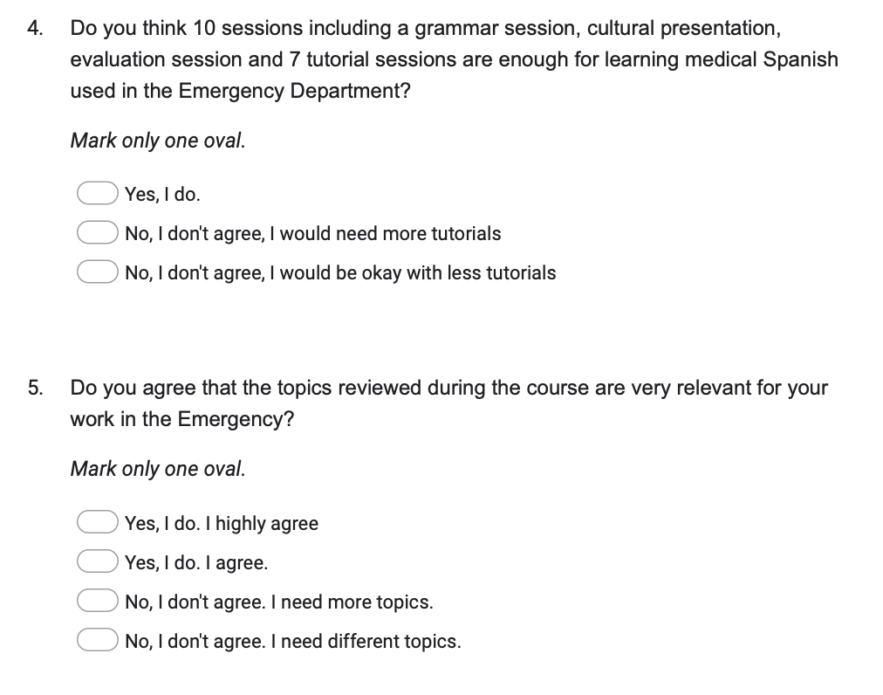

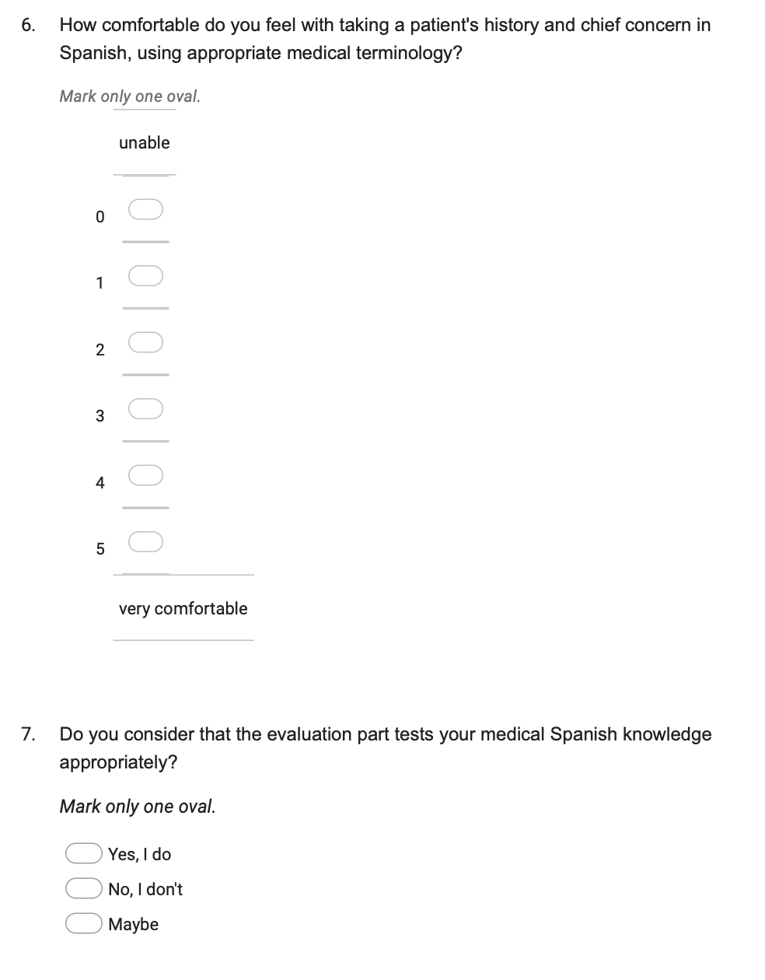

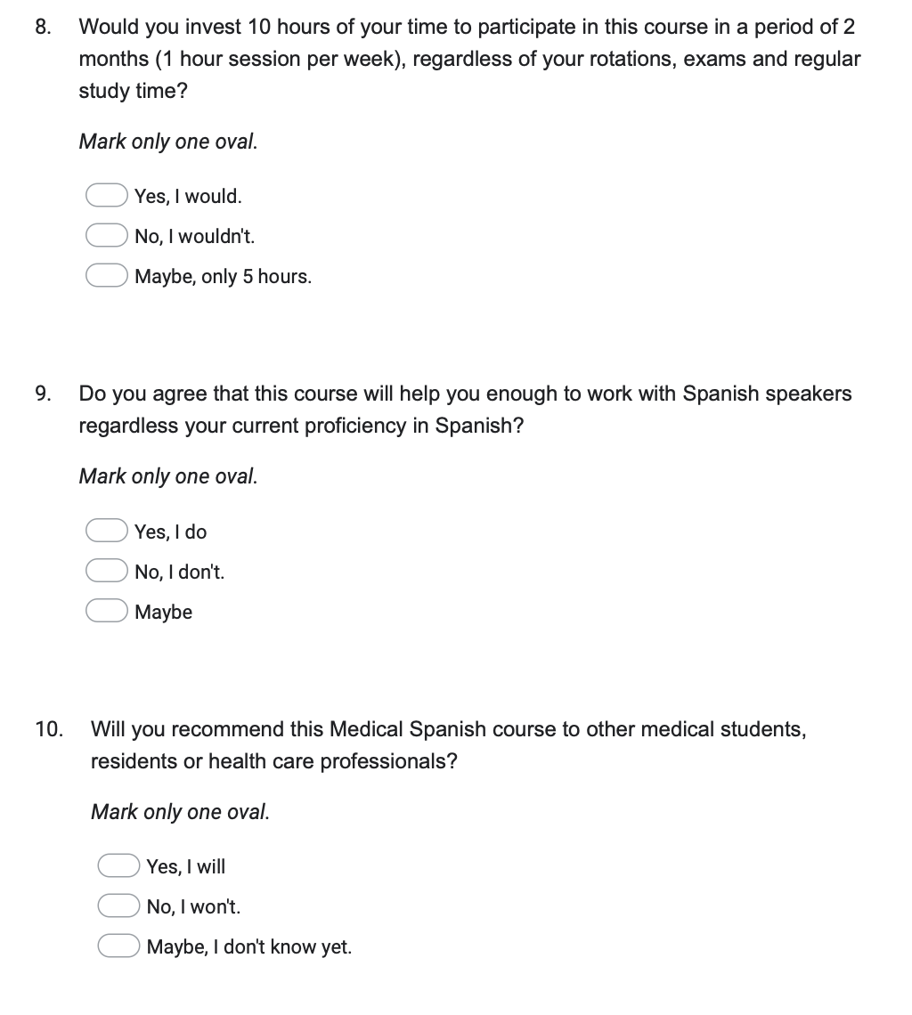

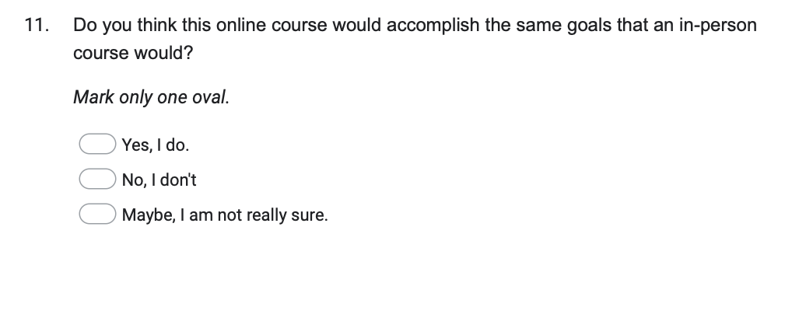

[Supplemental Table 1]

Results of comfort pre- and post-course

_________________________________________________________________________________________
[Supplemental Table 2]
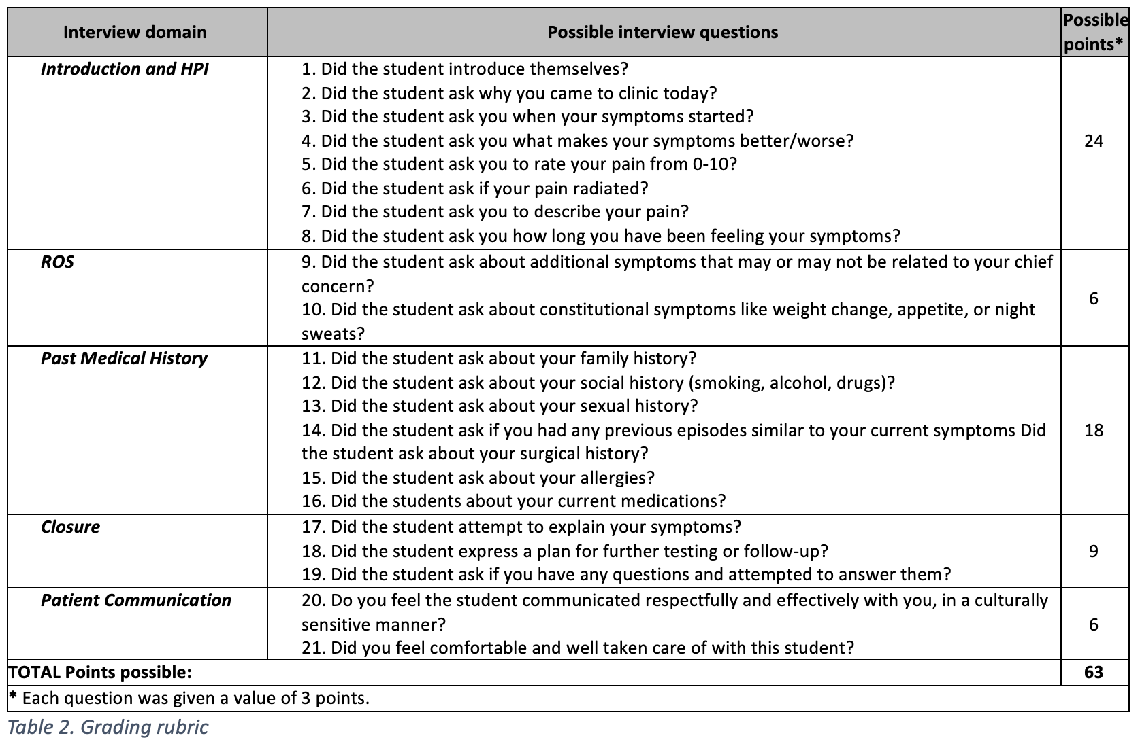

Adapted from:
A Vega T, Contag AG, Urbanowicz E, Sanchez A, Martinez JC, Garcia A, Ortega-Loayza A. Introductory Medical Spanish Elective: Creating and Evaluating a Case-Based Course Compatible with an 18-Month Pre-Clinical Medical Curriculum. Med Sci Educ. 2021 Feb 16;31(2):495-502. doi: 10.1007/s40670-020-01195-6. PMID: 34457907; PMCID: PMC8368887.

[Supplemental Table 3]

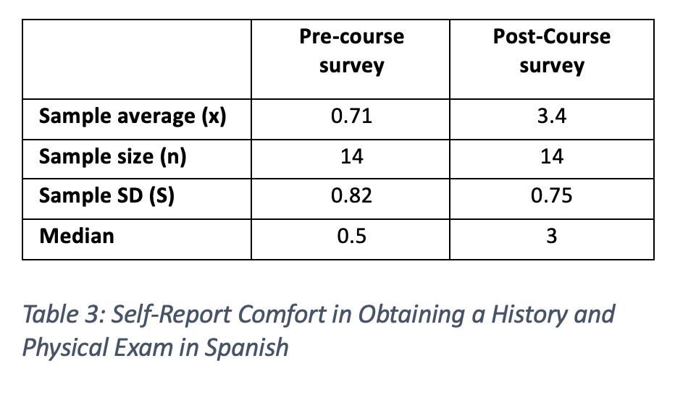

[Supplemental Table 4]

