a) Protein delivered (g/kg/day)
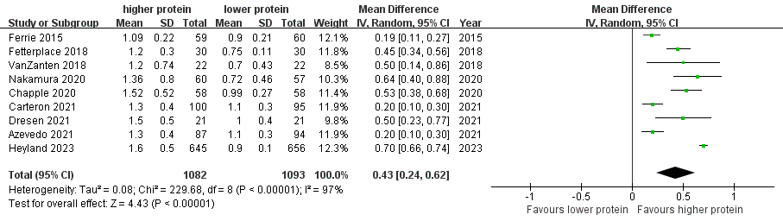
Pooled protein delivered between higher vs lower protein group
b) Energy delivered (kcal/kg/day)
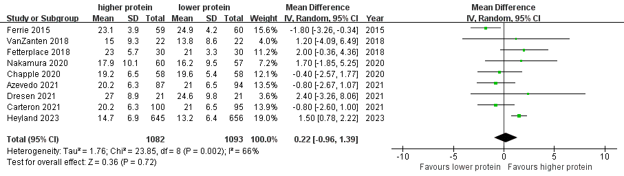
Pooled energy received between higher vs lower protein group
Fig S1 Protein (g/kg/day) and Energy (kcal/kg/day) delivered between higher vs lower protein group

a) Protein delivered (g/day)
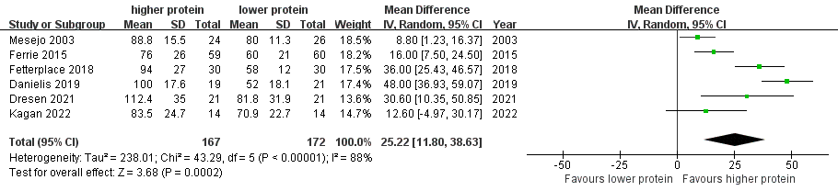
Pooled protein delivered between higher vs lower protein group
b) Energy delivered (kcal/day)
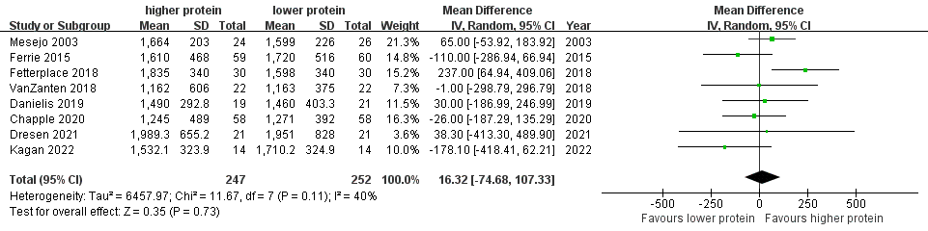
Pooled energy received between higher vs lower protein group
Fig S2 Protein (g/day) and Energy (kcal/day) delivered between higher vs lower protein group

a) Hospital Mortality
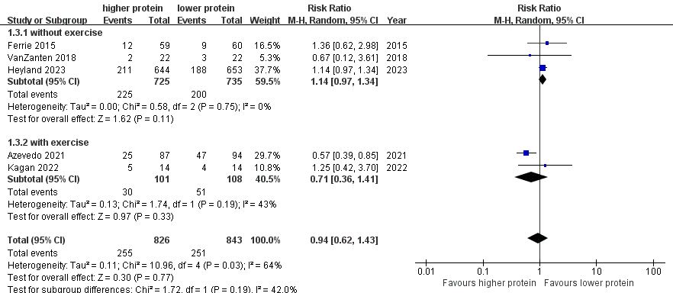

b) 28-day Mortality
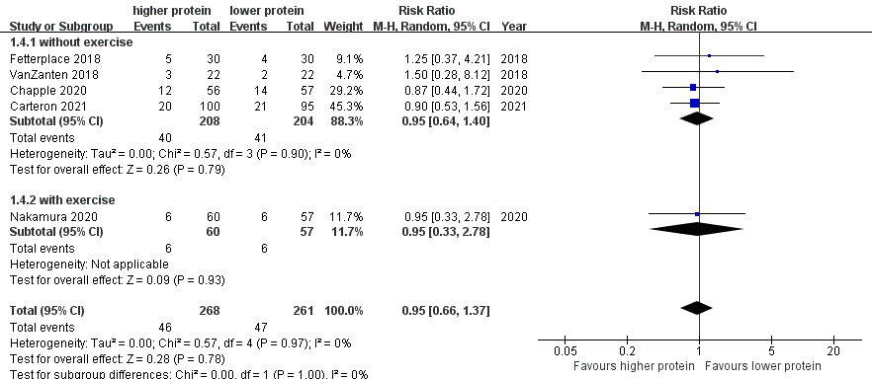

c) ≥60-day Mortality
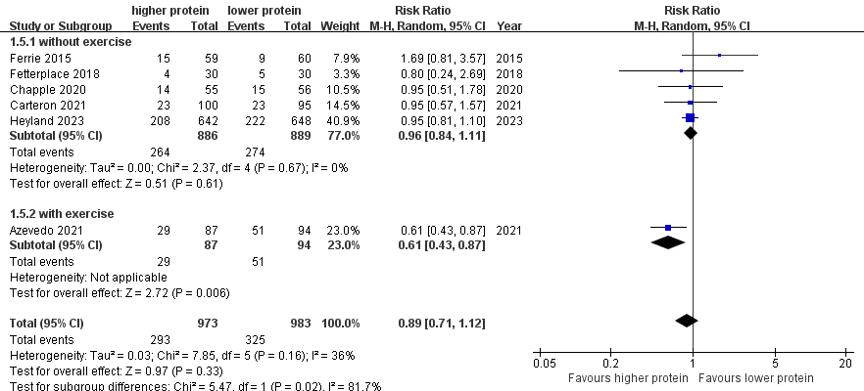
Fig S3 Hospital, 28- and ≥60-day Mortality

- Length of ICU Stay
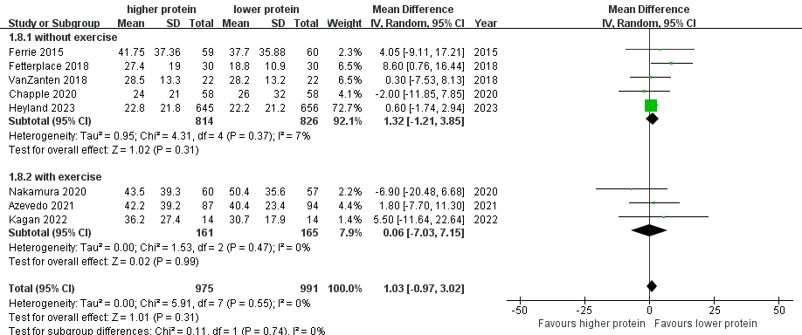

- Length of Hospital Stay
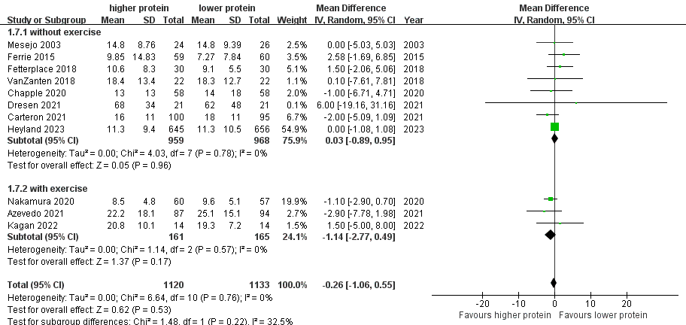
FigS4 Length of Stays. a Length of ICU Stay. b Length of Hospital Stay

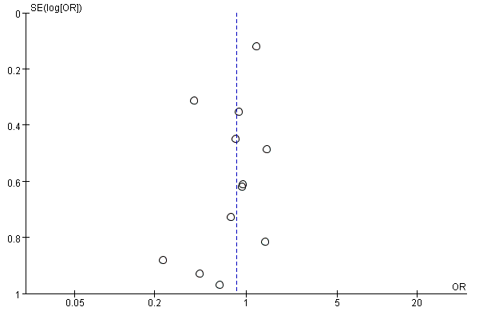
a) Overall mortality (Egger’s test t = -1.83, p = 0.096)
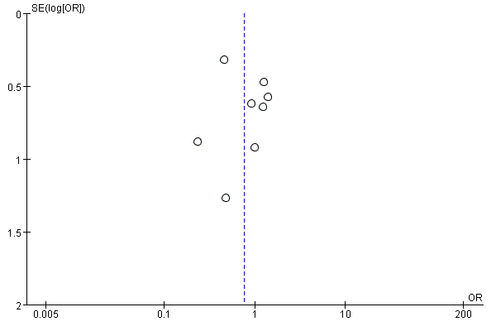
b) ICU mortality
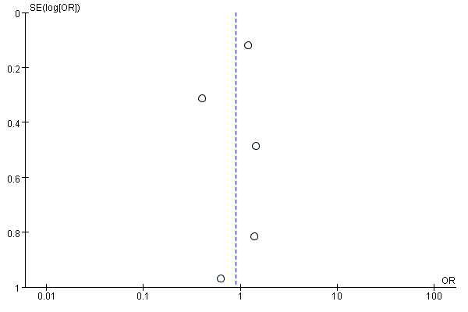c) Hospital mortality
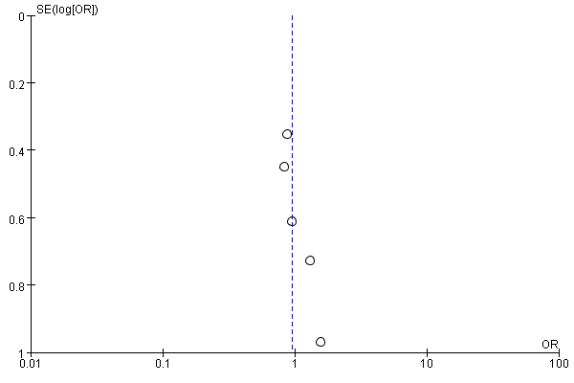
d) 28-day mortality
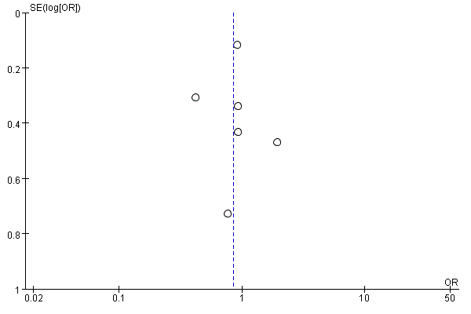
e) ≥60-day mortality
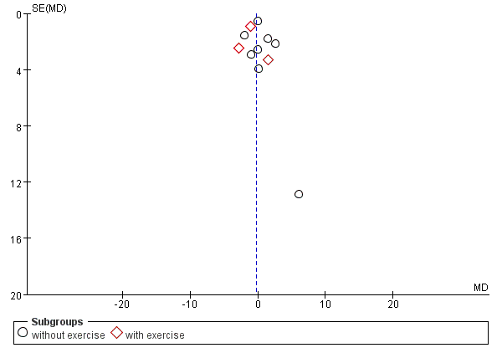
f) Duration of mechanical ventilation (Egger test: t = -0.03, p = 0.975)
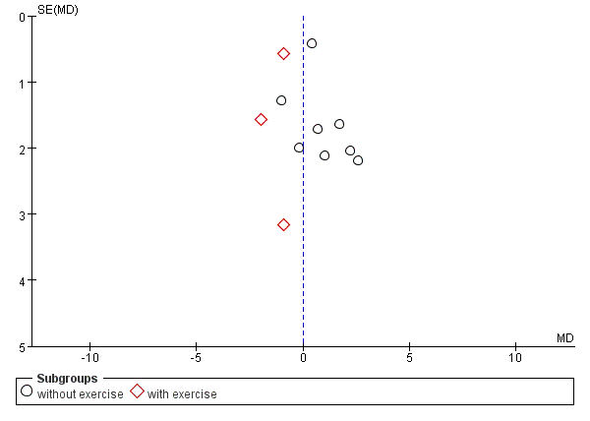
g) Length of ICU Stay (Egger test: t = -0.21, p = 0.836)
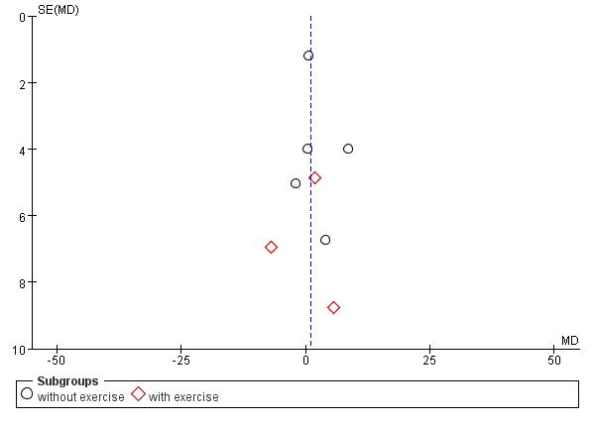
h)Length of Hospital Stay
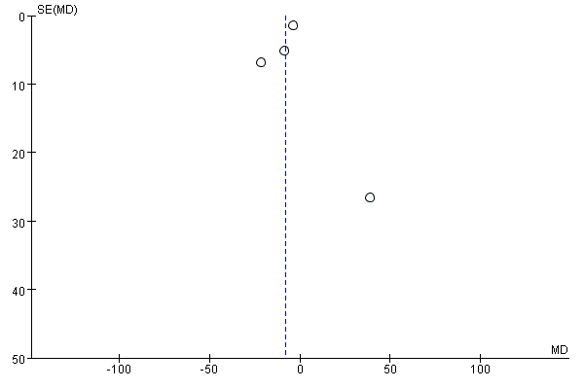
i)Muscale change
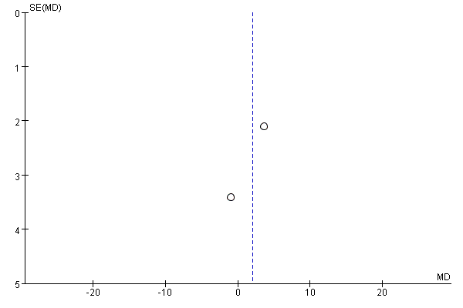
j) Handgrip strength

Fig S5 Funnel plots

