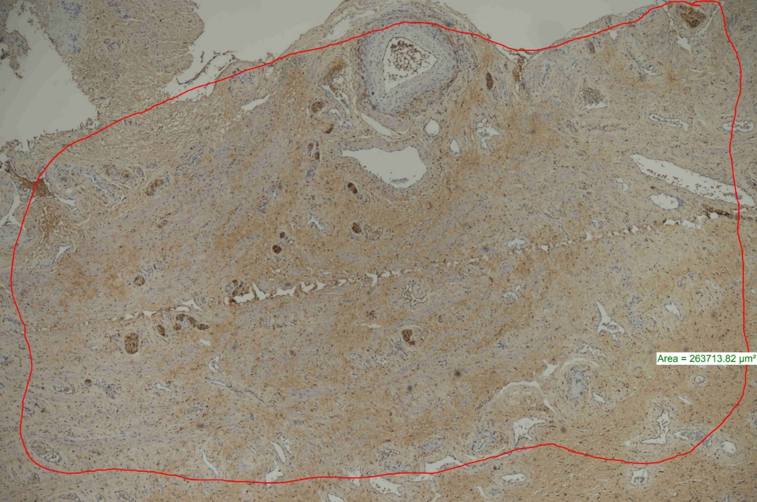

Figure 2s. The area with the highest number of nerve cross-sections was measured and proportioned to mm2. (PGP 9.5 x40).

