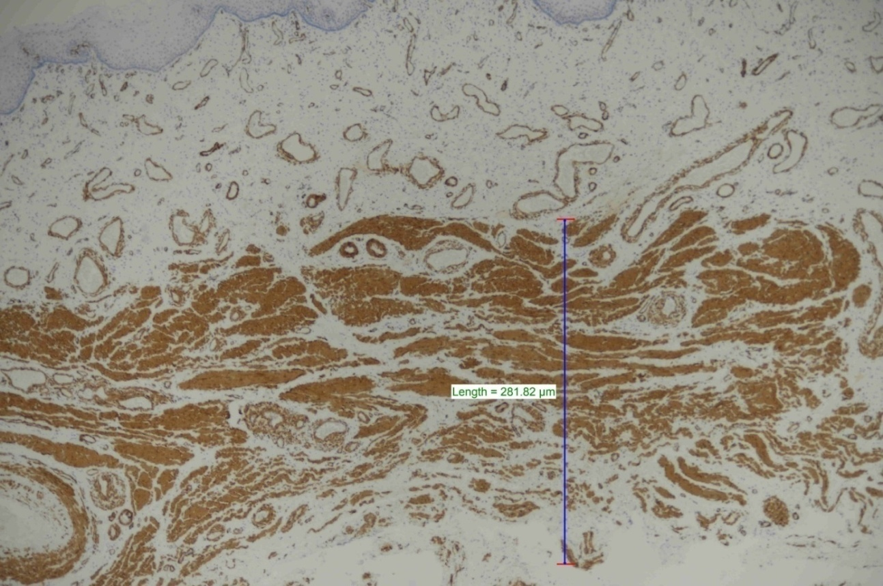

Figure 1s. Measurement was made with the NIS elements program from the place where the muscle thickness was the highest. (SMA x40).

