Rat fibroblast-like synovial cells (RA-FLS)
Repeat 1 Repeat 2 Repeat 3
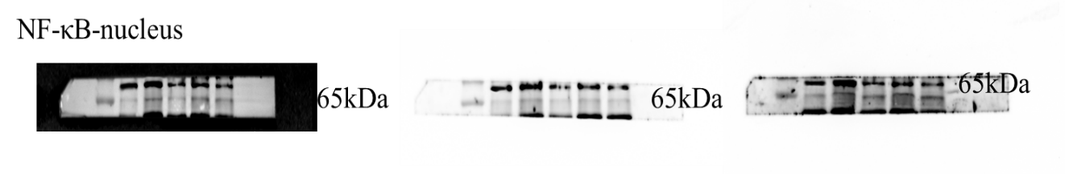
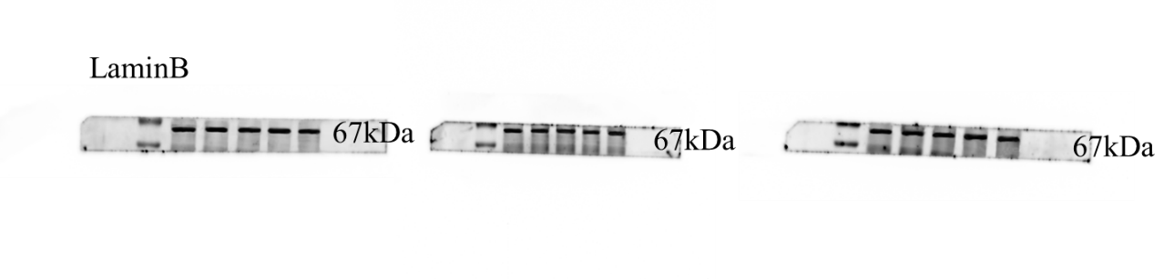
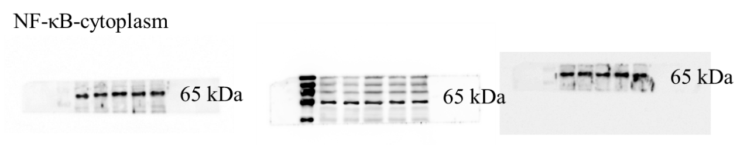
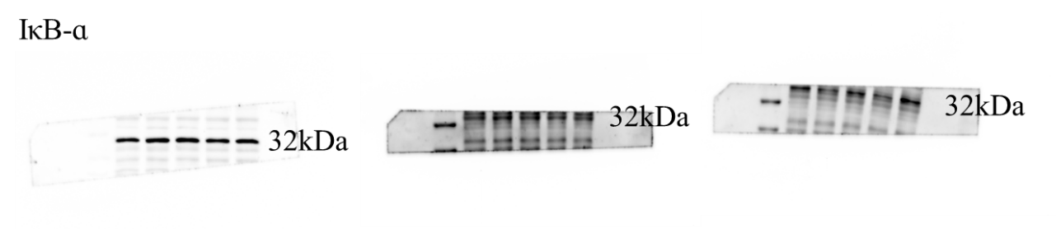
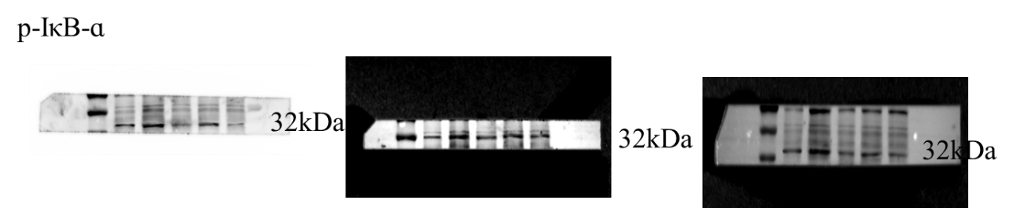
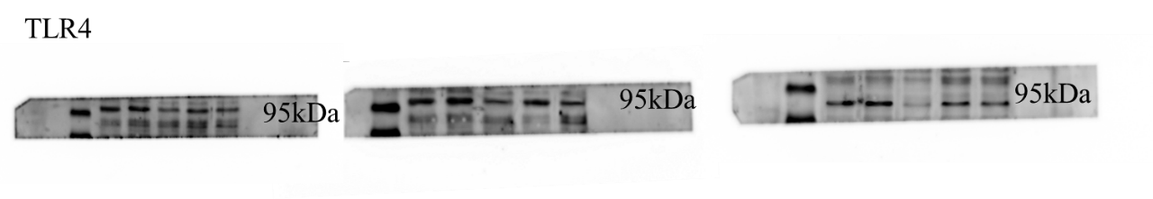
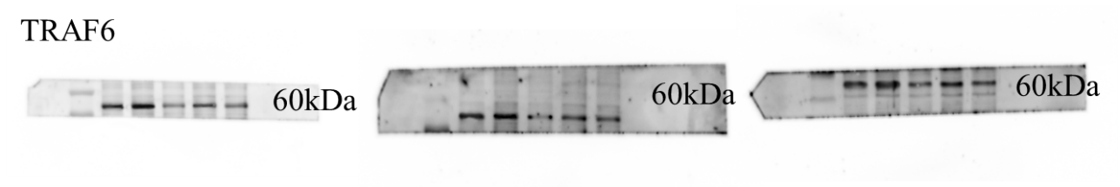
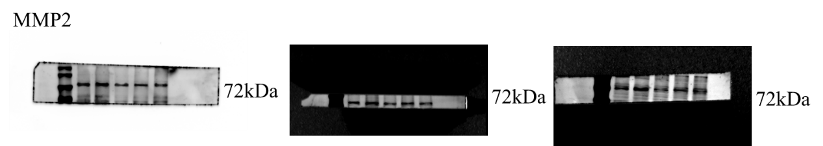
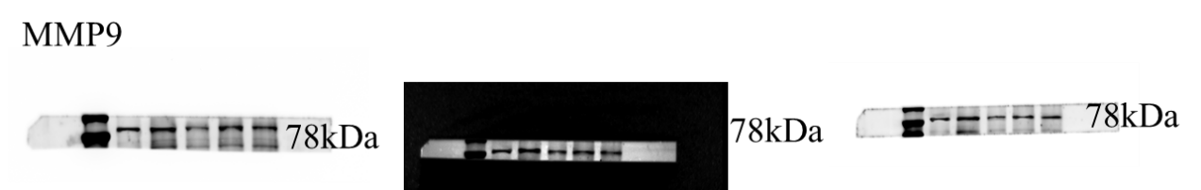
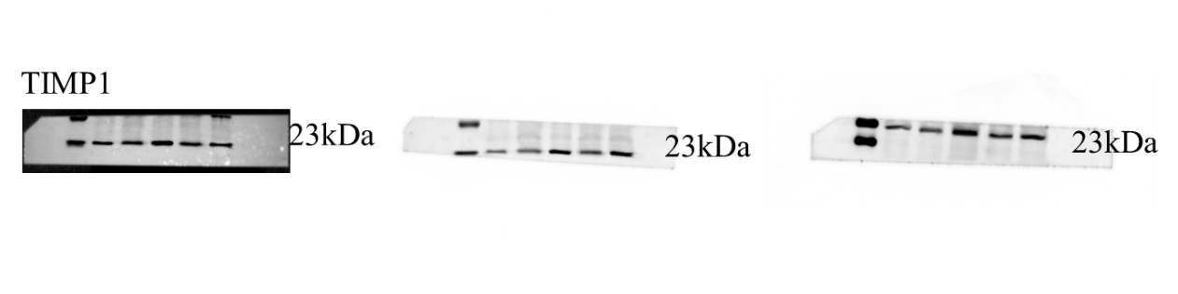
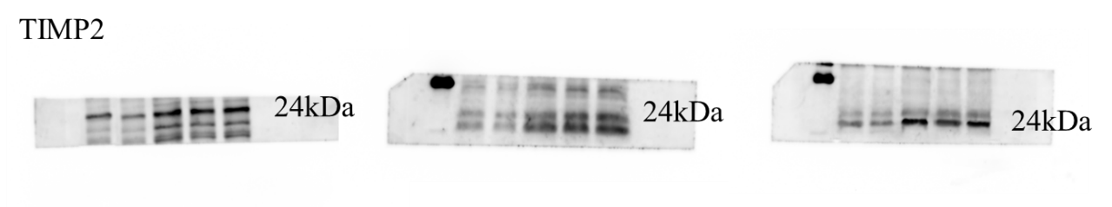
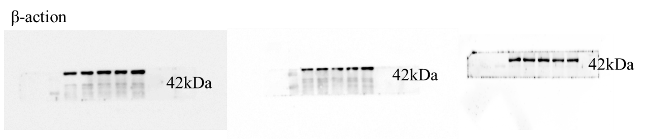

Rat synovial tissue
Repeat 1 Repeat 2 Repeat 3
