We performed UPLC-MS for WMP, and the marker compounds in each of the herbal medicines composing WMP were similarly examined. Comparative analyses were also performed.
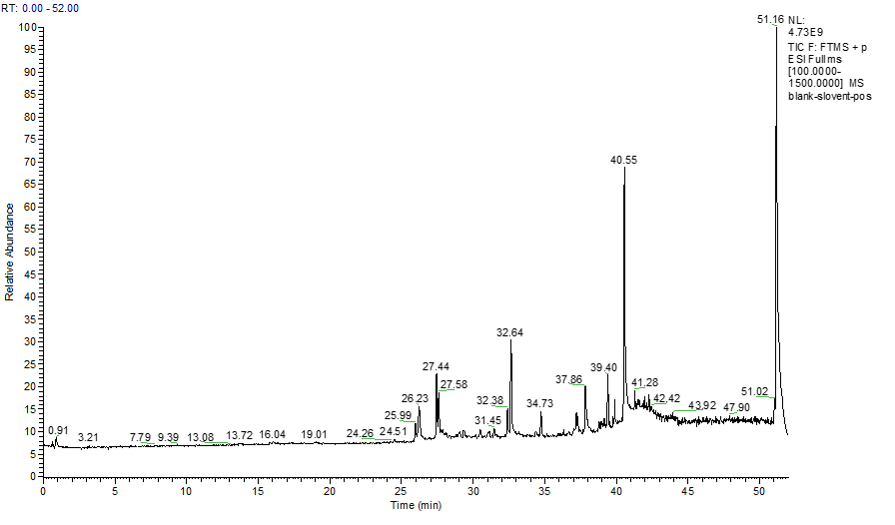
Fig.1. TIC diagram of solvent cation
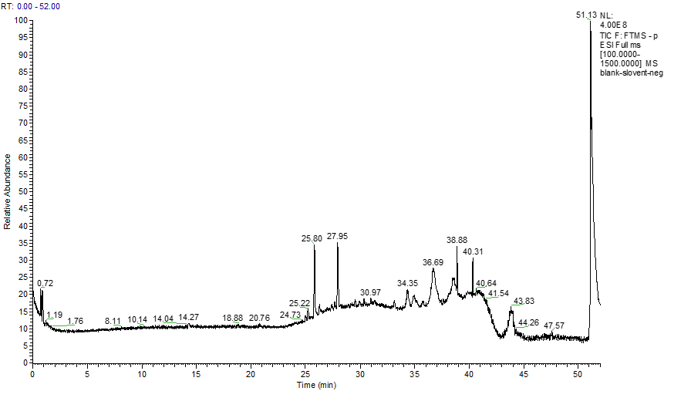
Fig.2. TIC diagram of negative ion
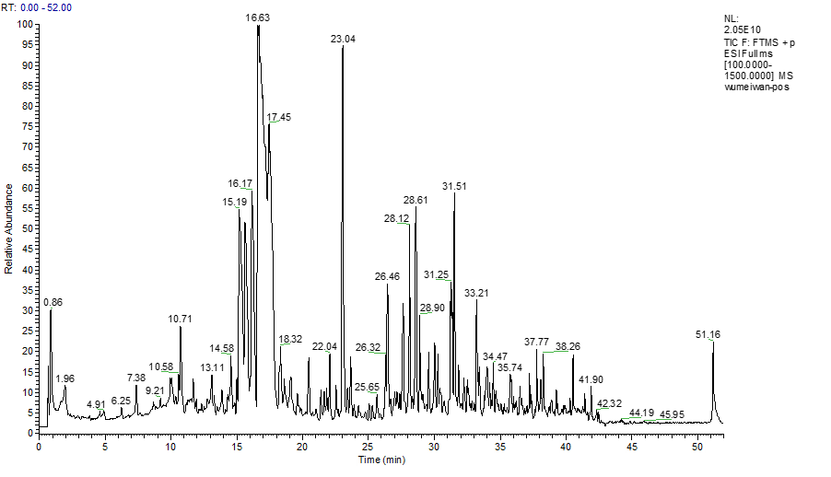
Fig.3.WMP cation TIC plots
Fig.4.WMP negative ion TIC diagram.
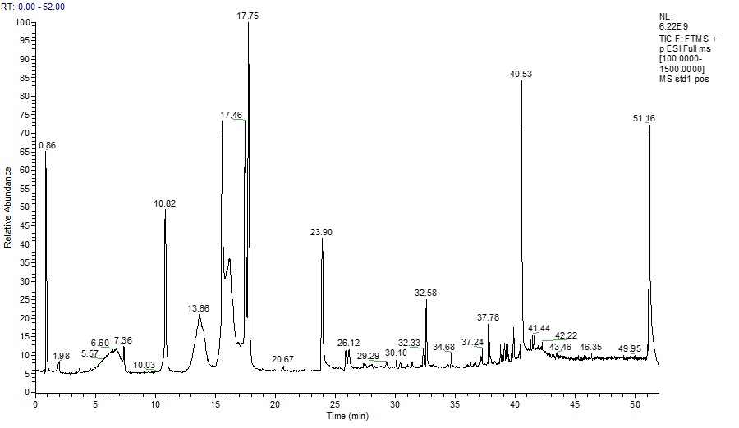
Fig.5.Standard 1 positive ion TIC diagram
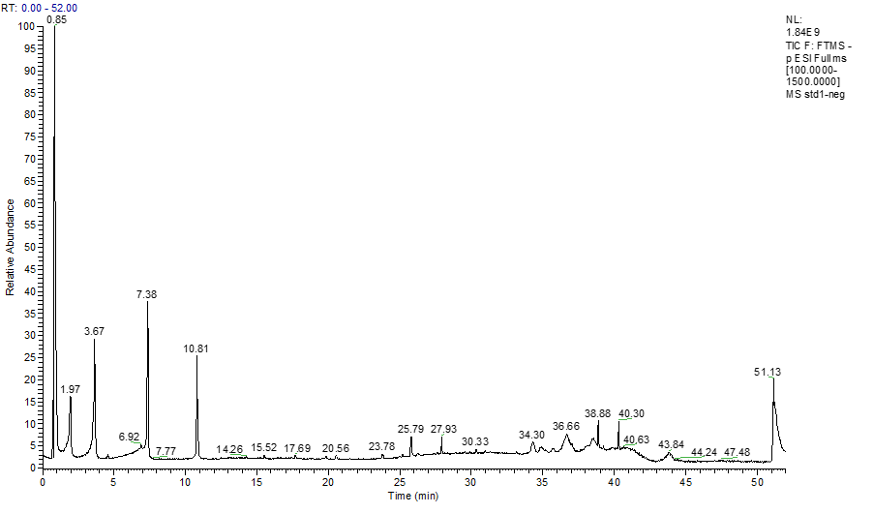
Fig.6.Standard 1 Negative Ion TIC Chart
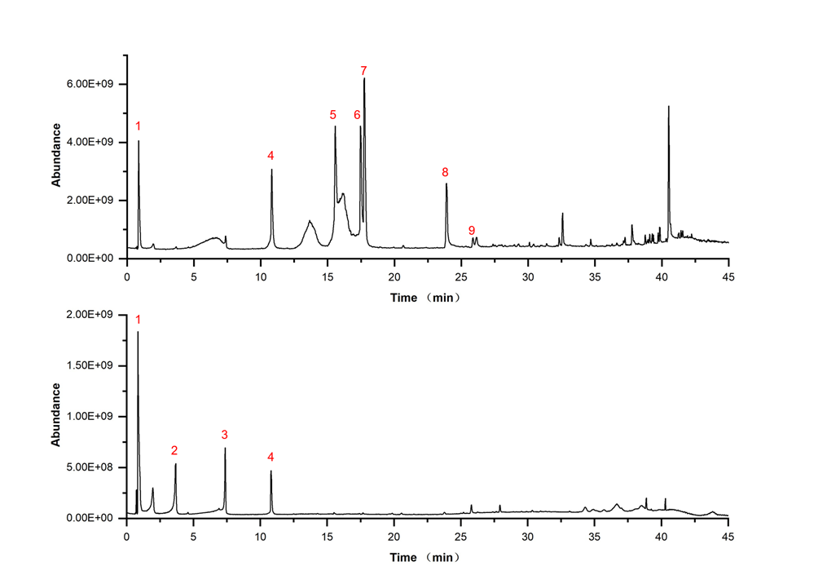
Fig.7. Compositional designation of Reference Standard 1 (1. citric acid 2. gallic acid 3. neochlorogenic acid 4. magnoflorine 5. xanthophylline 6. berberine 7. palmatine 8. cacodyl alcohol 9. methyl eugenol)
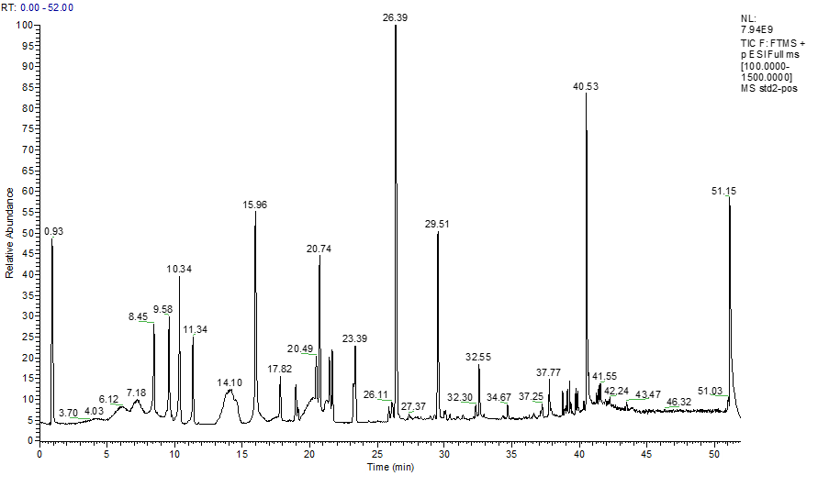
Fig.8.Positive ion TIC diagram of standard 2
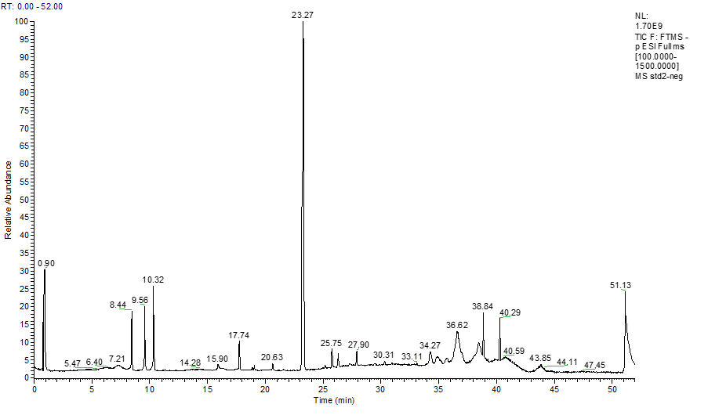
Fig.9.Negative ion TIC diagram of standard 2
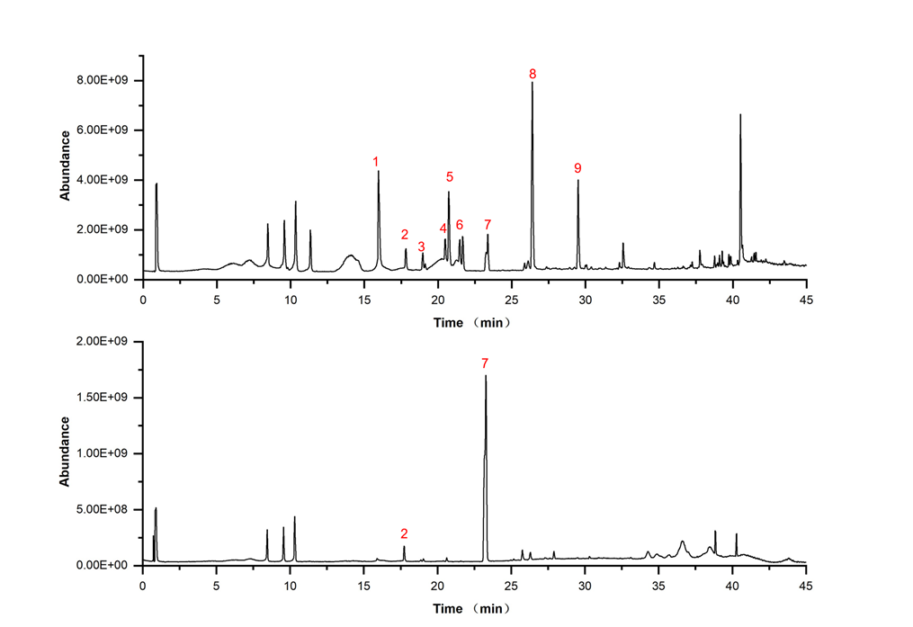
Fig.10. Component identification of standard 2 (1. epiberberine 2. benzoyl neoaconitine 3. benzoyl hypaconitine 4. benzoylaconitine 5. neoaconitine 6. hypaconitine 7. ginsenoside Re 8. 6-gingerol 9. sphingolipids)
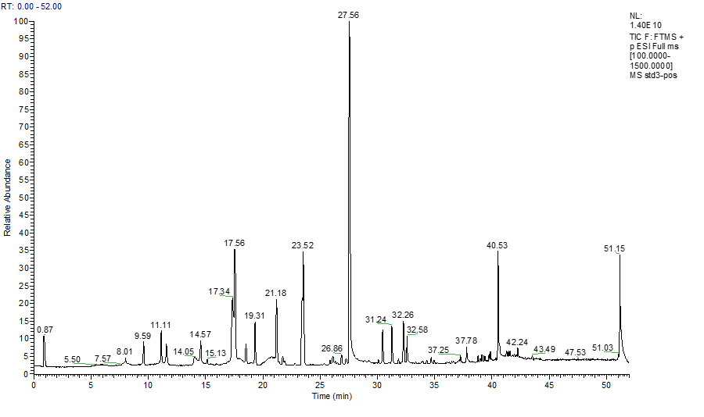
Fig.10. Standard 3 positive ion TIC diagram
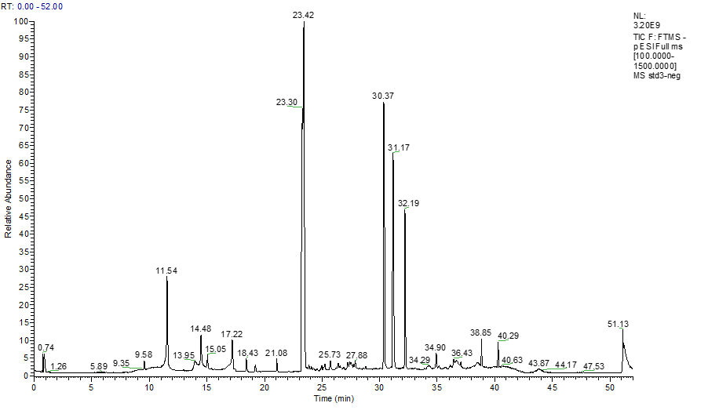
Fig.11. Standard 3 Negative Ion TIC Chart
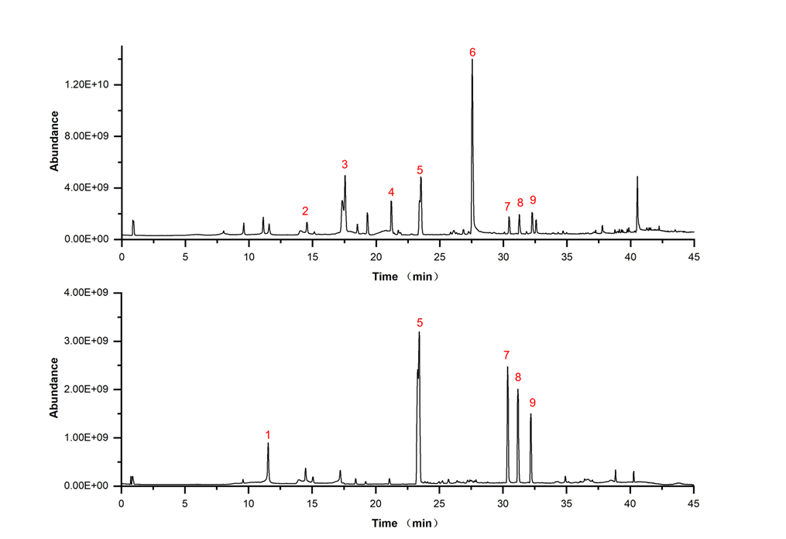
Fig.12. Component identification of Reference Standard 3 (1. Paeonia lactone glycoside 2. ferulic acid 3. rhizoma ligusticum lactone I 4. aconitine 5. ginsenoside Rg1 6. gibberellin 7. ginsenoside Rb1 8. ginsenoside Rb2 9. ginsenoside Rd)
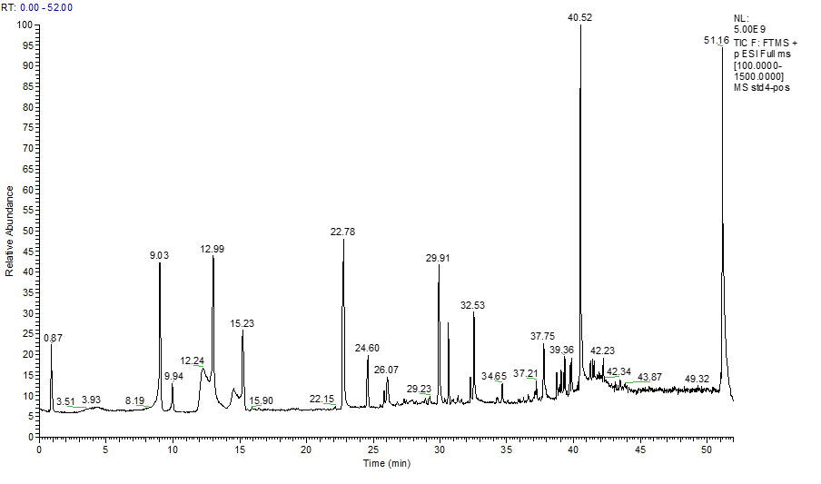
Fig.13. Standard 4 positive ion TIC diagram
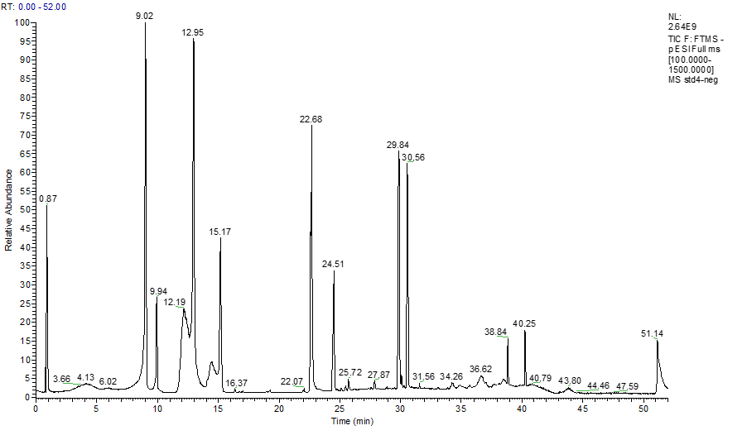
Fig.14.Standard 4 Negative Ion TIC Chart
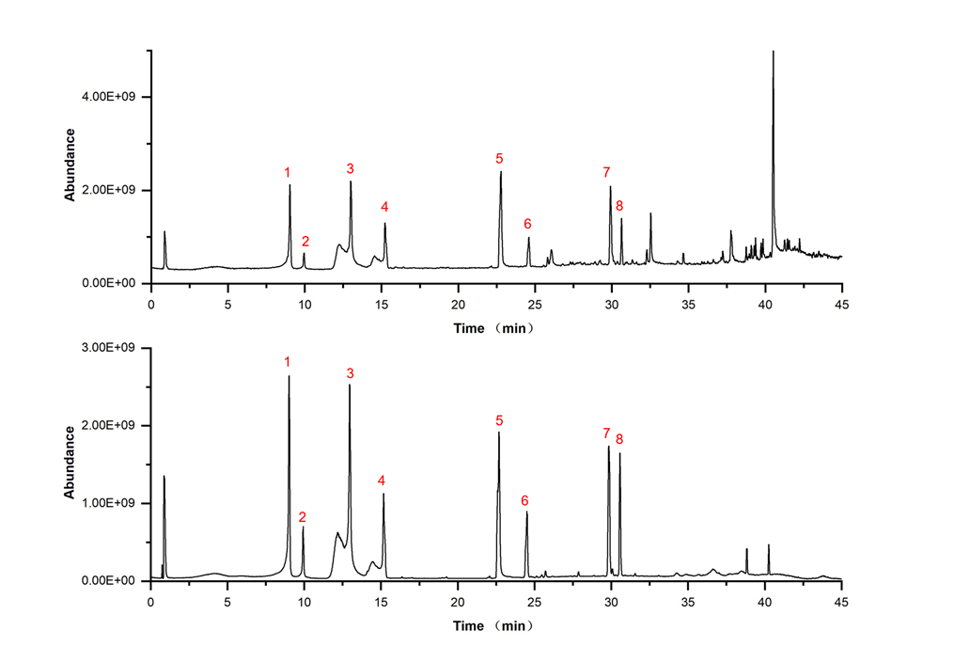
Fig.15. Component identification of Reference Standard 4 (1. catechin 2. paeoniflorin oxide 3. paeoniflorin 4. glycyrrhizin 5. benzoylpaeoniflorin 6. platycodin D 7. glycyrrhizic acid 8. ginsenoside Rc)

