Graphical Abstract
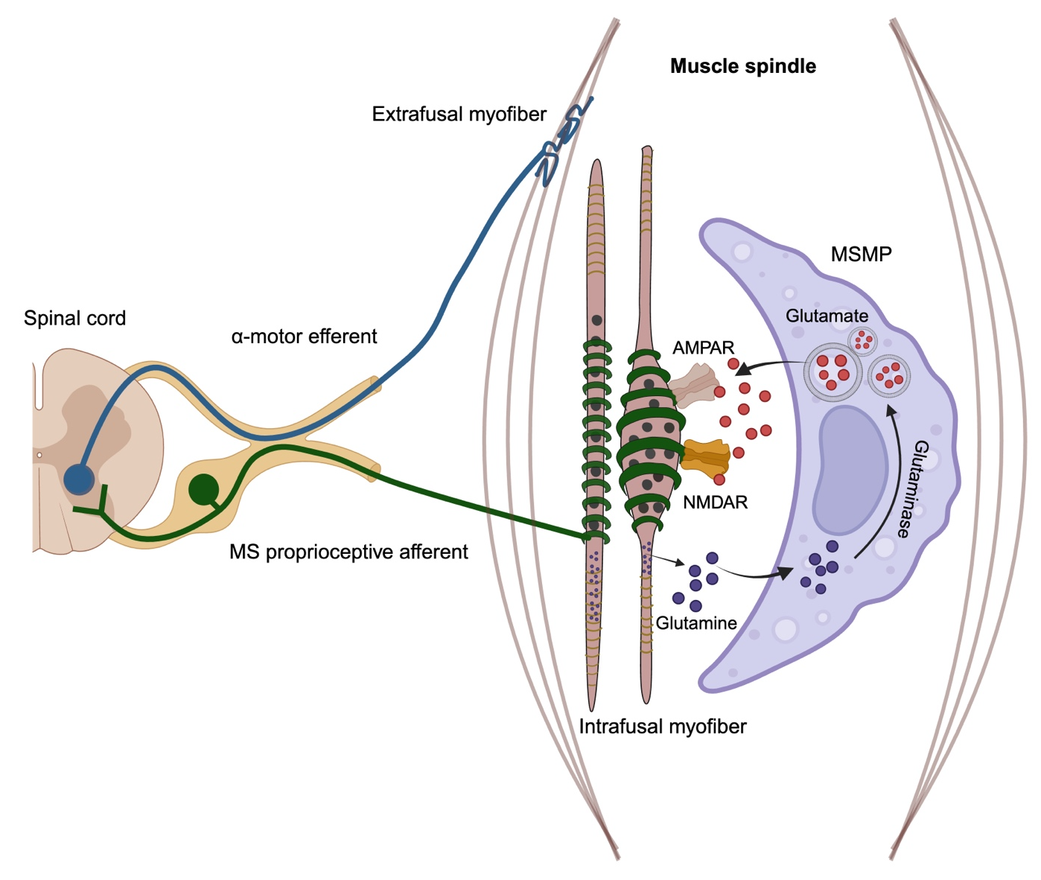

MS: muscle spindle
MSMP: muscle spindle macrophages

