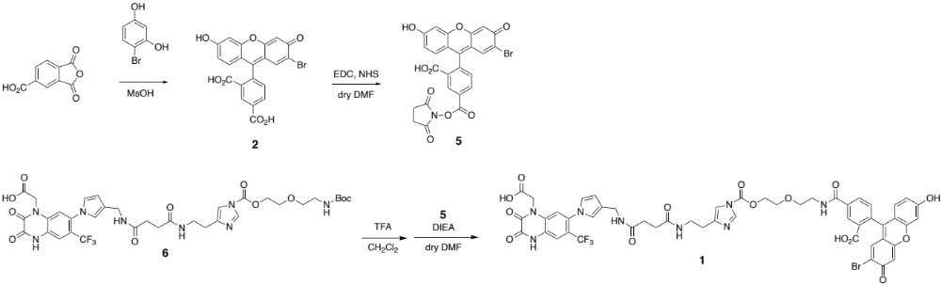
Scheme 1 Synthetic scheme of 1

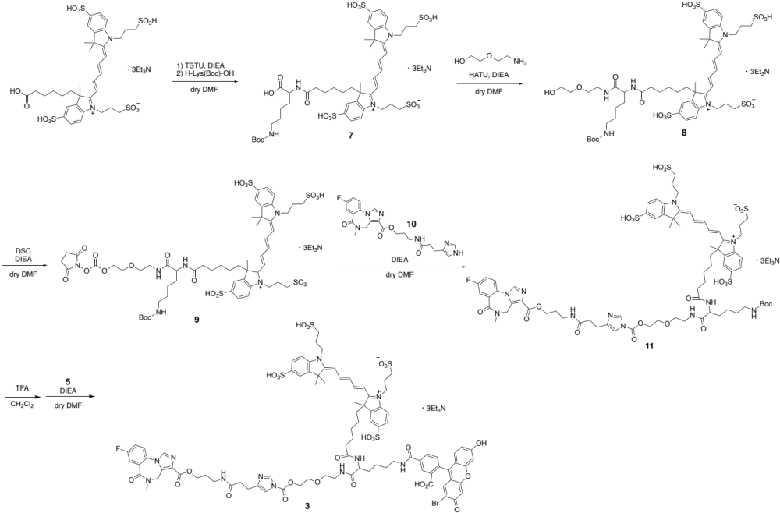
Scheme 2 Synthetic scheme of 3

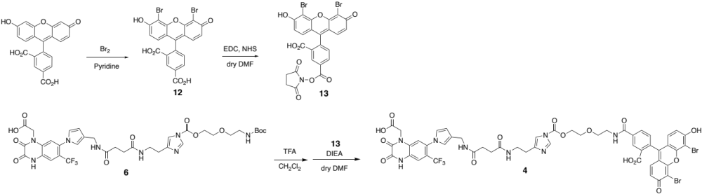
Scheme 3 Synthetic scheme of 4

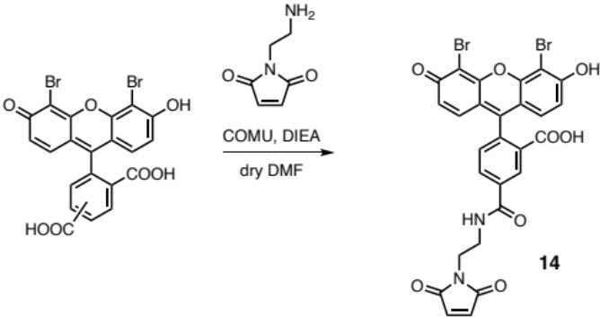
Scheme 4 Synthetic scheme of 14

