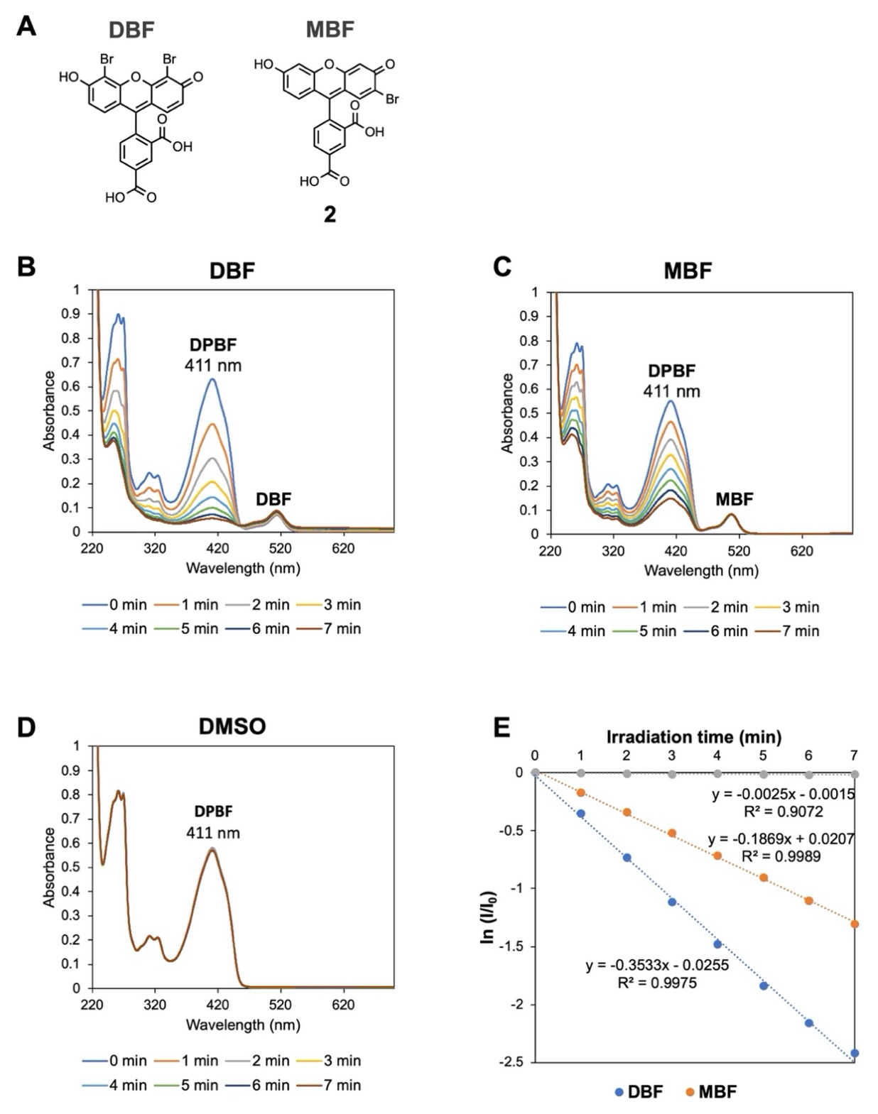

Extended Data Fig. 1 | Estimation of the ¹O₂ quantum yield (Φ_{Δ}) of MBF. The Φ_{Δ} of MBF was estimated by a relative spectrophotometric method using 1,3-diphenylisobenzofuran (DPBF) as the chemical trap for ¹O₂ and DBF as the reference photosensitizer. (A) Chemical structures of the DBF and MBF derivatives used. (B–D) Raw absorption spectra showing the photoirradiation-dependent decrease in absorbance of DPBF in the presence of DBF and MBF but not DMSO. (E) Logarithm of DBPF concentration in the presence of MBF or DBF plotted against irradiation time. Φ_{Δ} of MBF was calculated from the slopes in this plot (see Methods).

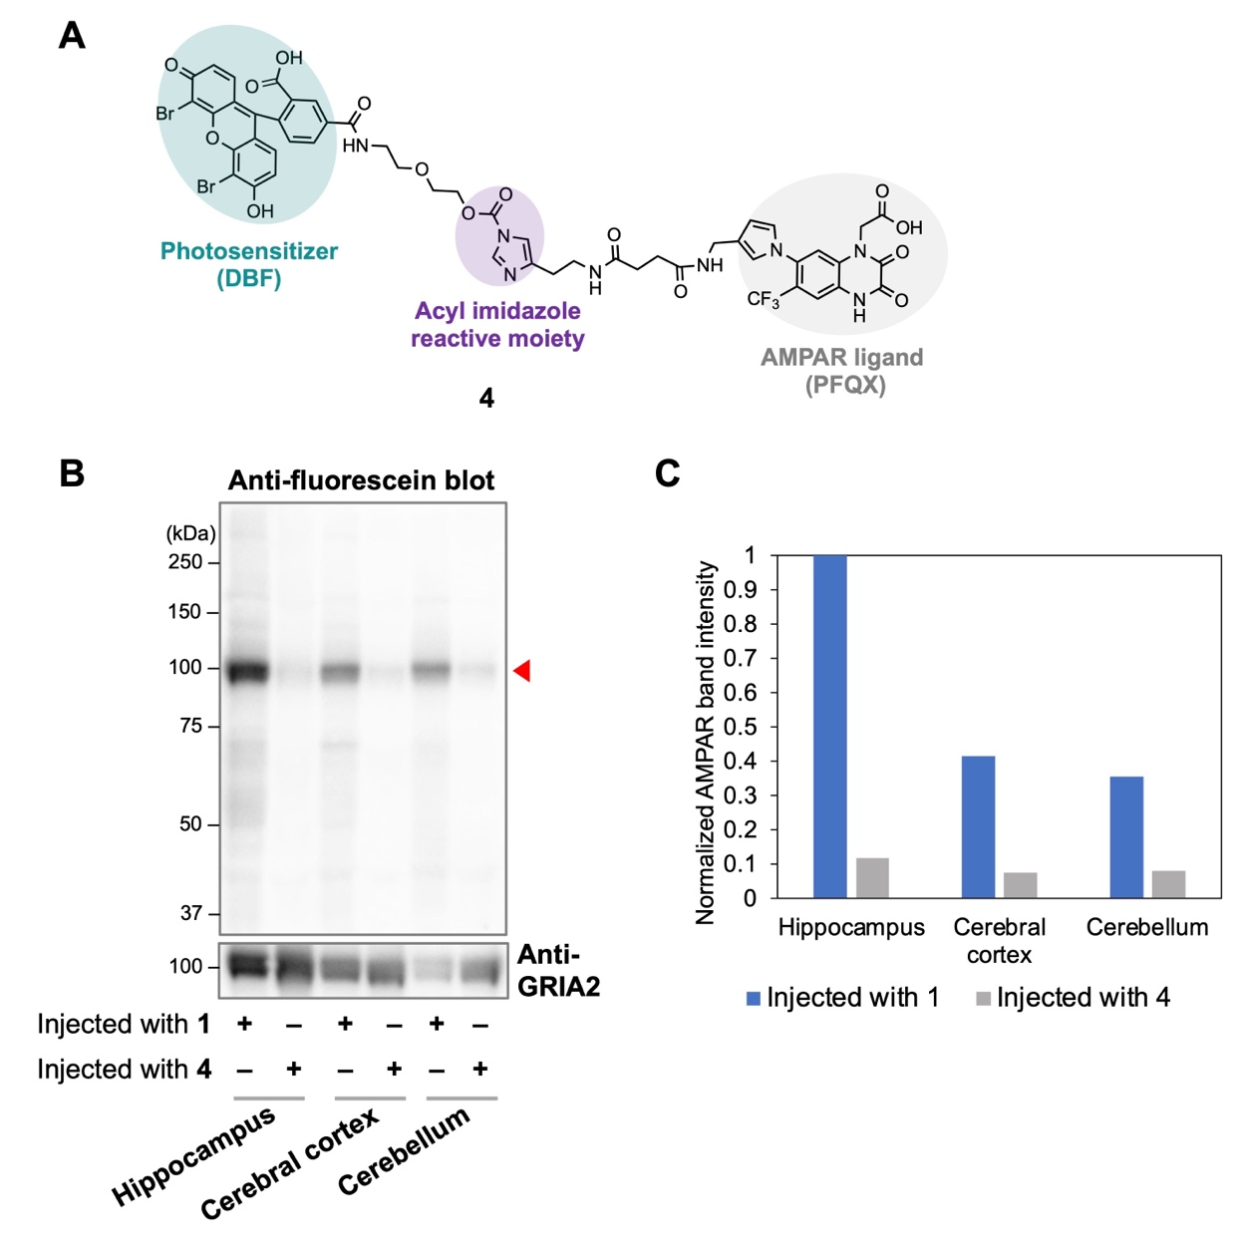

Extended Data Fig. 2 | Comparison of the in vivo anchoring efficiency of targeted photosensitizers. (A) Chemical structure of 4 designed to install the photosensitizer DBF onto AMPARs. (B) Western blot analysis of MBF and DBF anchoring onto AMPARs in brain tissue isolated from mice injected to the lateral ventricles with 1 or 4. Red triangle points to the band corresponding to MBF- or DBF-modified AMPAR subunits. (C) Quantification of the ~100 kDa band (red triangle) in (B).

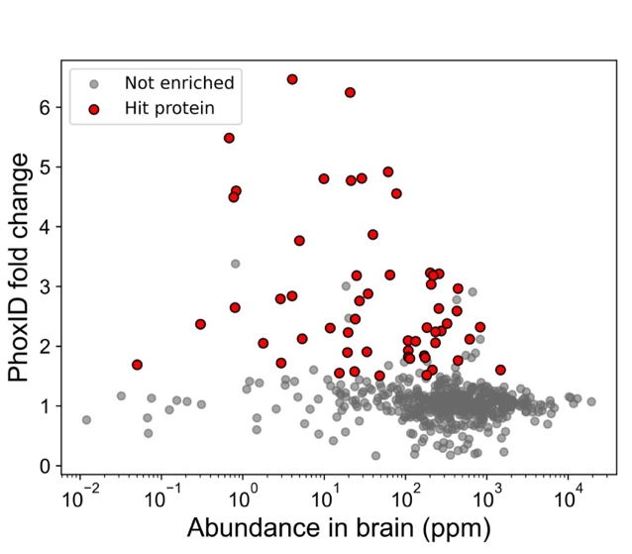

Extended Data Fig. 3 | PhoxID is not biased towards highly abundant proteins. The PhoxID fold change of the hippocampal AMPAR-proximal hits is plotted against their abundance in the brain as reported in PAXdb 4.2 to show that PhoxID fold changes do not correlate with protein expression levels.

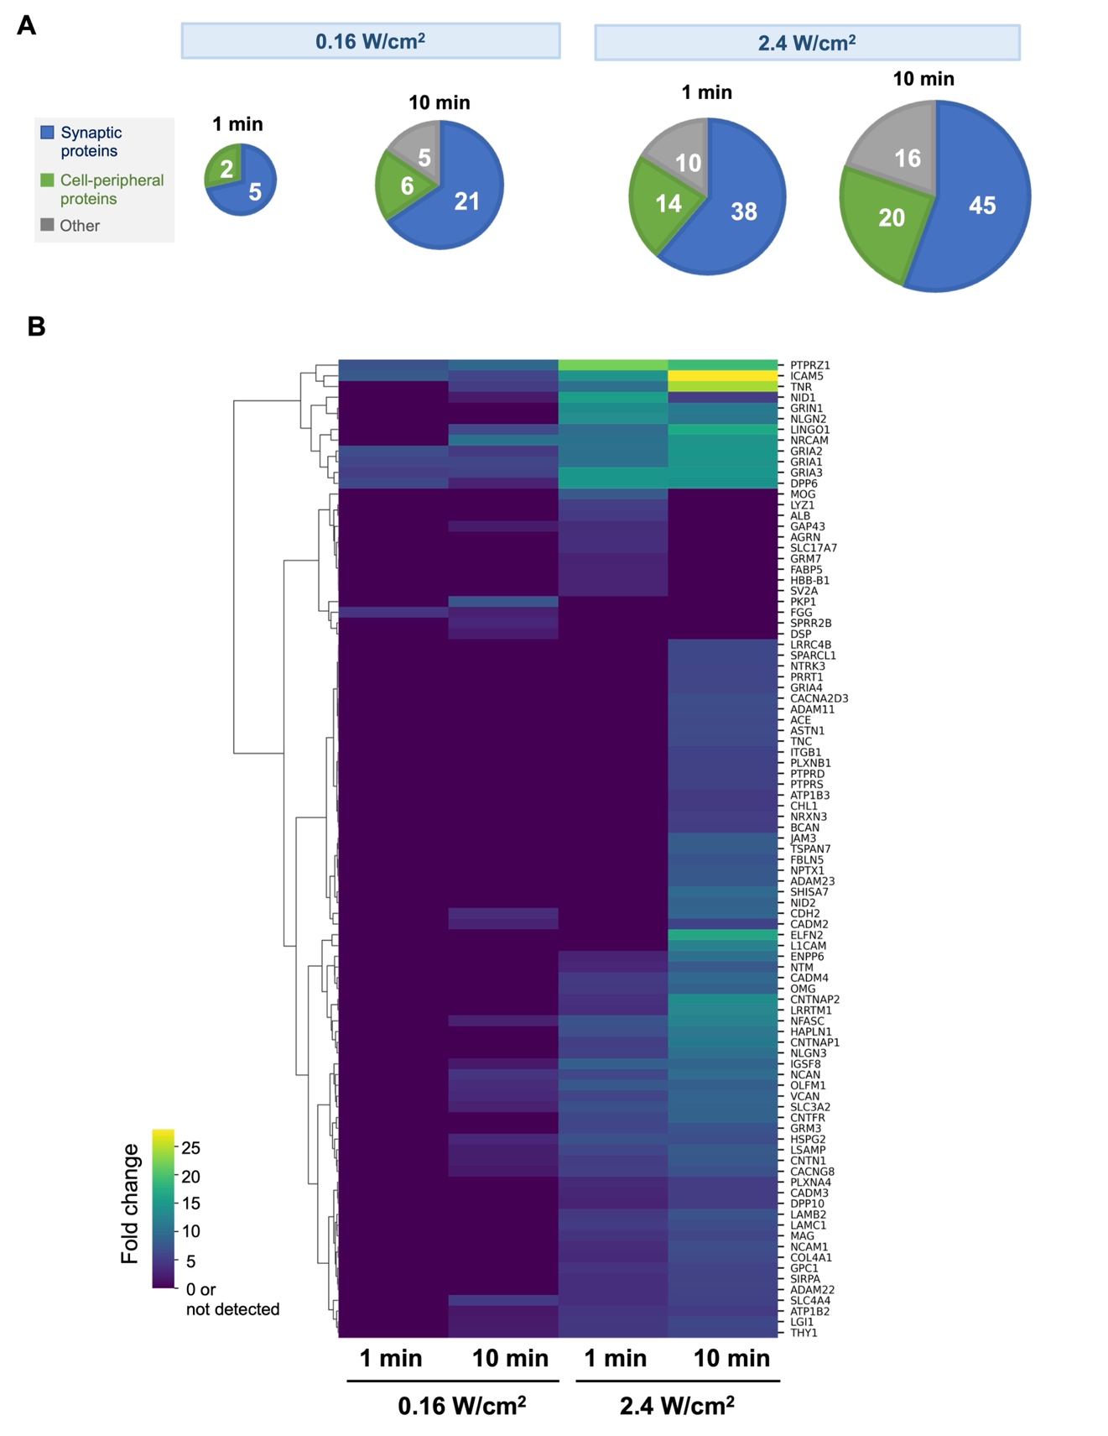
Extended Data Fig. 4 | Data in support of Fig. 2H. (A) Fraction of hit proteins detected in each photoirradiation condition that are annotated to synaptic and cell-peripheral GOCC terms. Proteins that were annotated to both synaptic terms and the cell periphery were classified here as synaptic proteins. (B) Heatmap showing the fold change of proteins under various photoirradiation conditions. Data only shown for proteins that met the hit protein criteria in at least one of the conditions. Mitochondrial/nuclear contaminant proteins were omitted.
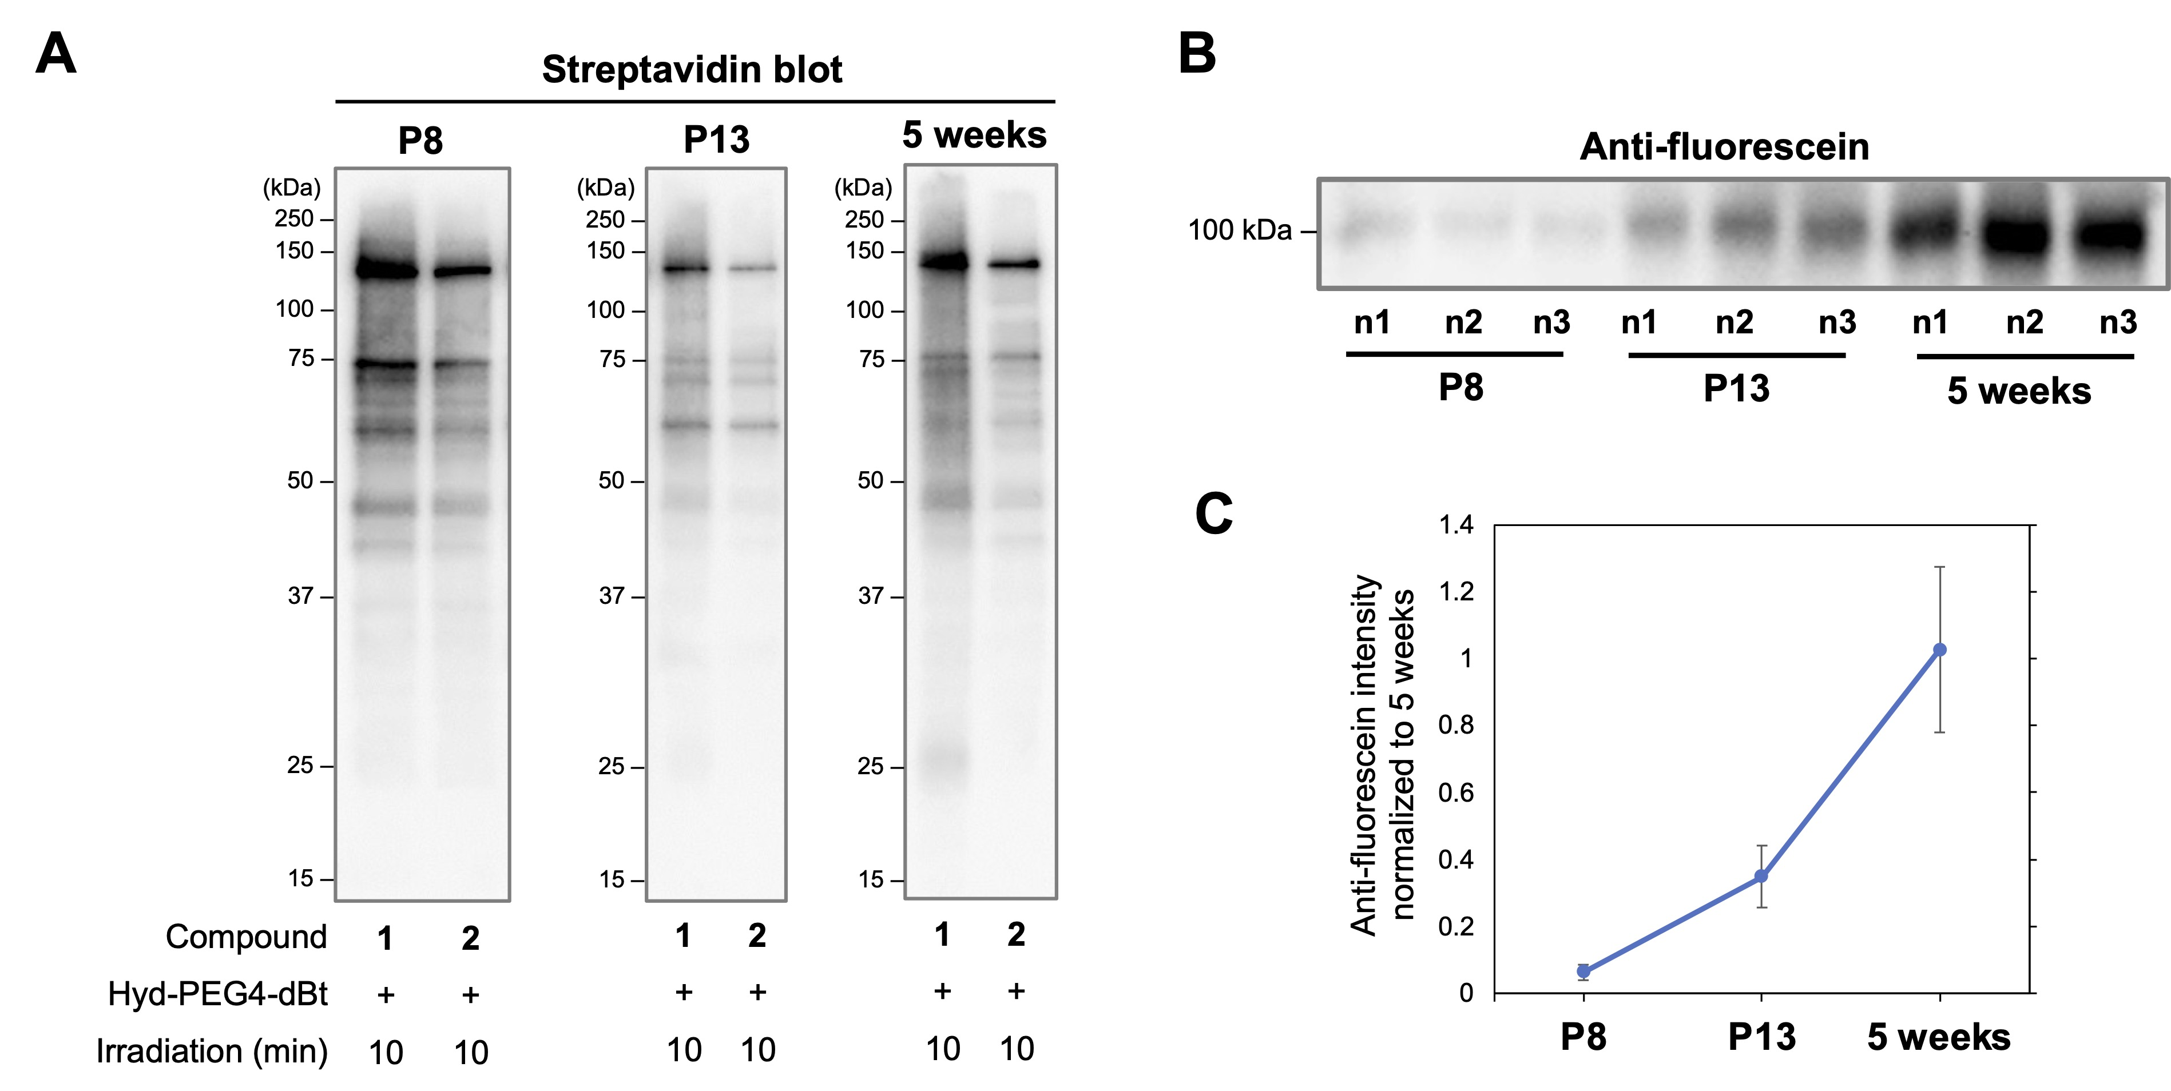
Extended Data Fig. 5 | Western blot analysis of AMPAR-proximal PhoxID in the postnatal cerebellum. (A) Streptavidin blots of proteins labeled by PhoxID in the P8, P13, and 5-week-old cerebellum. Western blotting was performed after neutravidin enrichment. (B) Western blot analysis of MBF anchoring in the mouse cerebellum isolated from P8, P13, and 5-week-old mice injected with 1. n1, n2, and n3 denote biological replicates. (C) Mean intensity of the bands in (B). Data are normalized to the mean band intensity in 5-week-old mice. Error bars represent s.d.
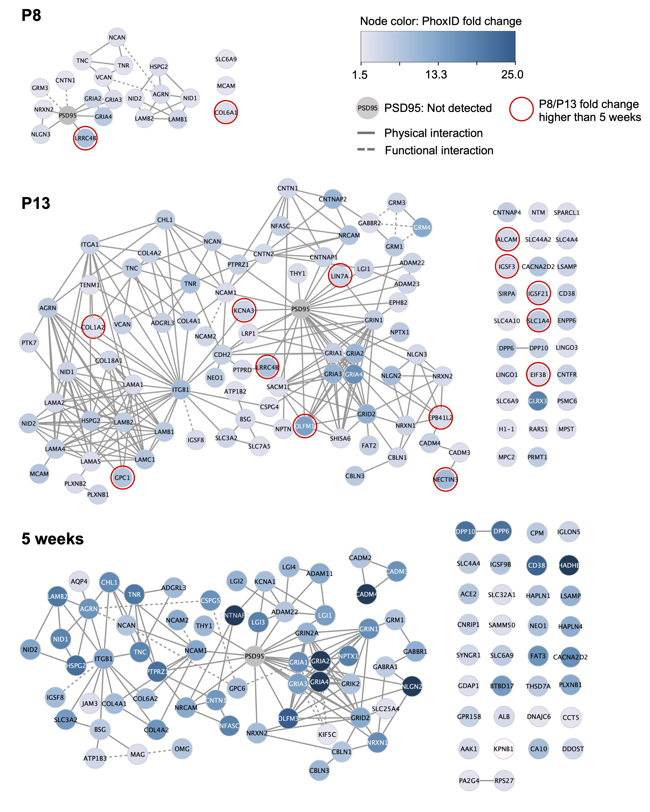
Extended Data Fig. 6 | Network diagrams of known and predicted interactions between the AMPAR-proximal PhoxID hit proteins at each postnatal age studied. Interaction information was obtained from STRING 11.5 (text mining and co-expression excluded) and several manual annotations.
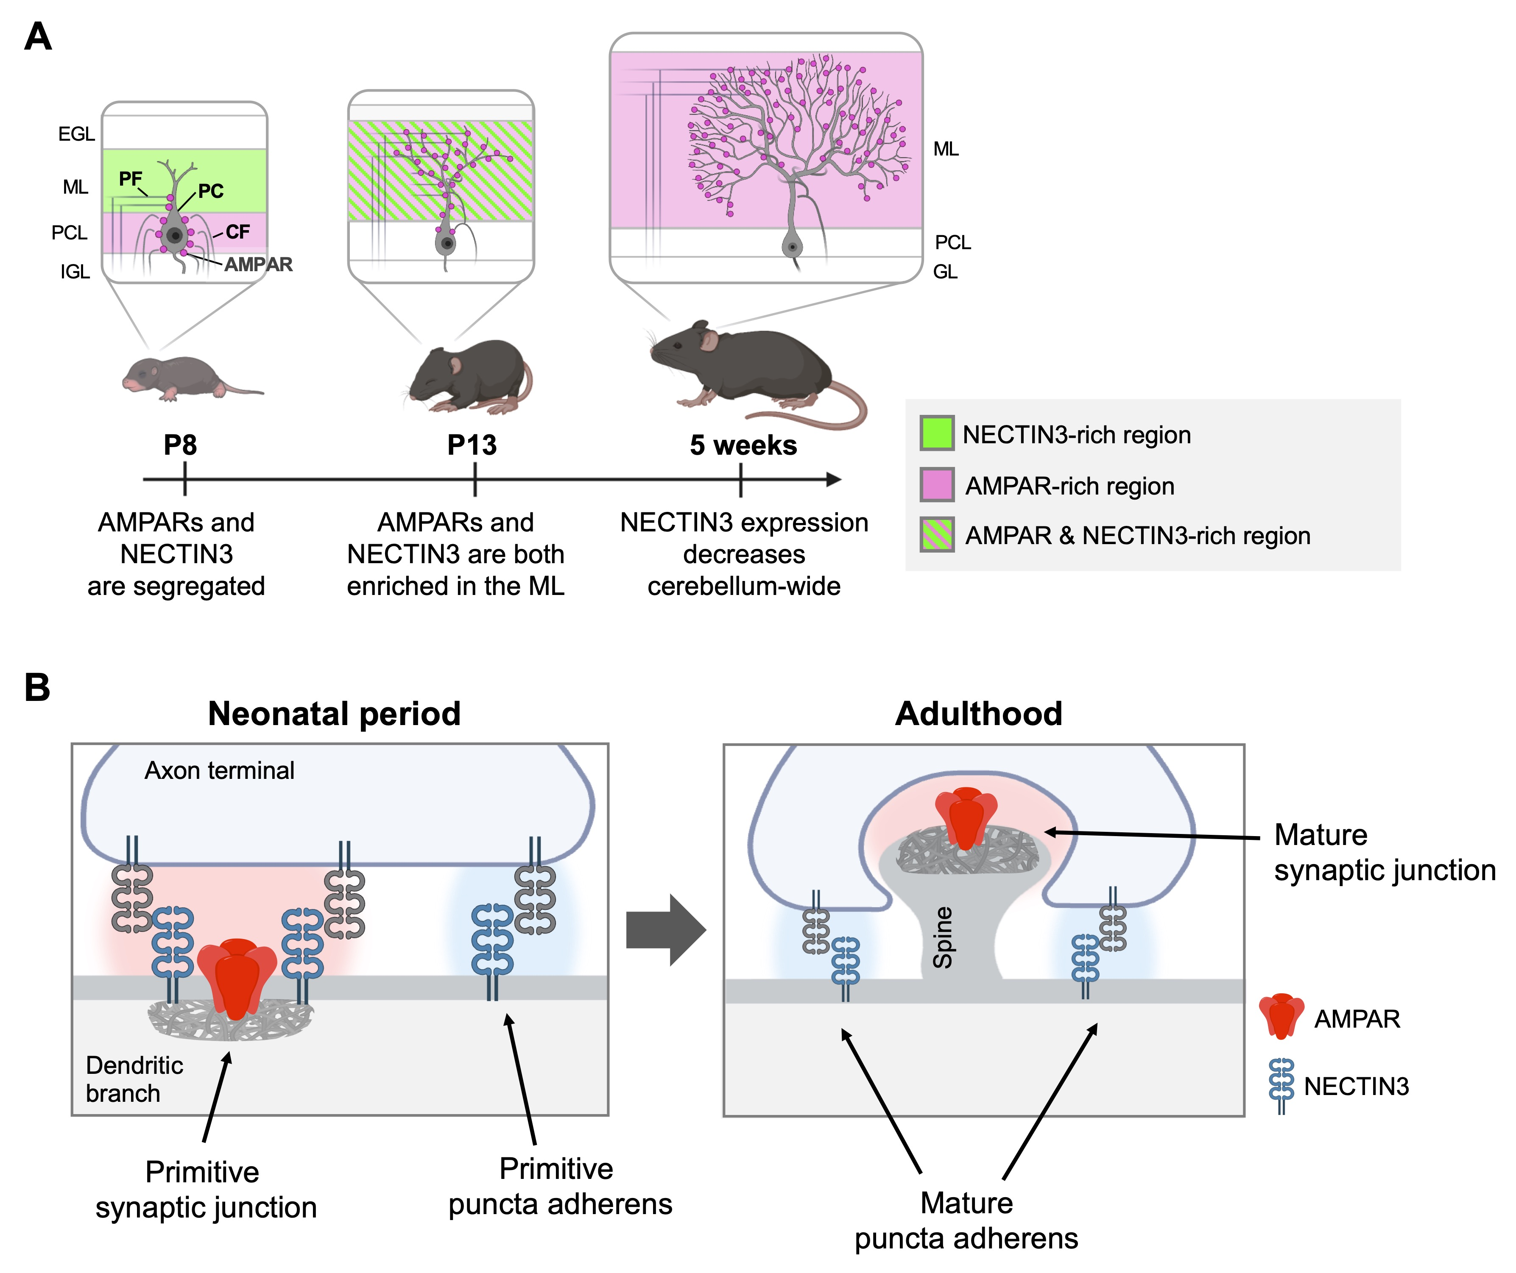
Extended Data Fig. 7 | Cartoon depictions of AMPARs and NECTIN3 in the developing cerebellum. (A) Changes in the regional distribution of AMPARs and NECTIN3 in the cerebellum as revealed by immunostaining. PC, Purkinje cell. PF, parallel fiber. CF, climbing fiber. EGL, external granular layer. ML, molecular layer. PCL, Purkinje cell layer. IGL, internal granular layer. GL, granular layer. (B) Hypothesis regarding the spatial dynamics of AMPARs and NECTIN3 in the cerebellum. We postulate that NECTIN3 populates both synaptic junctions and puncta adherens in the neonatal period but are depleted and/or sequestered to puncta adherens by adulthood.
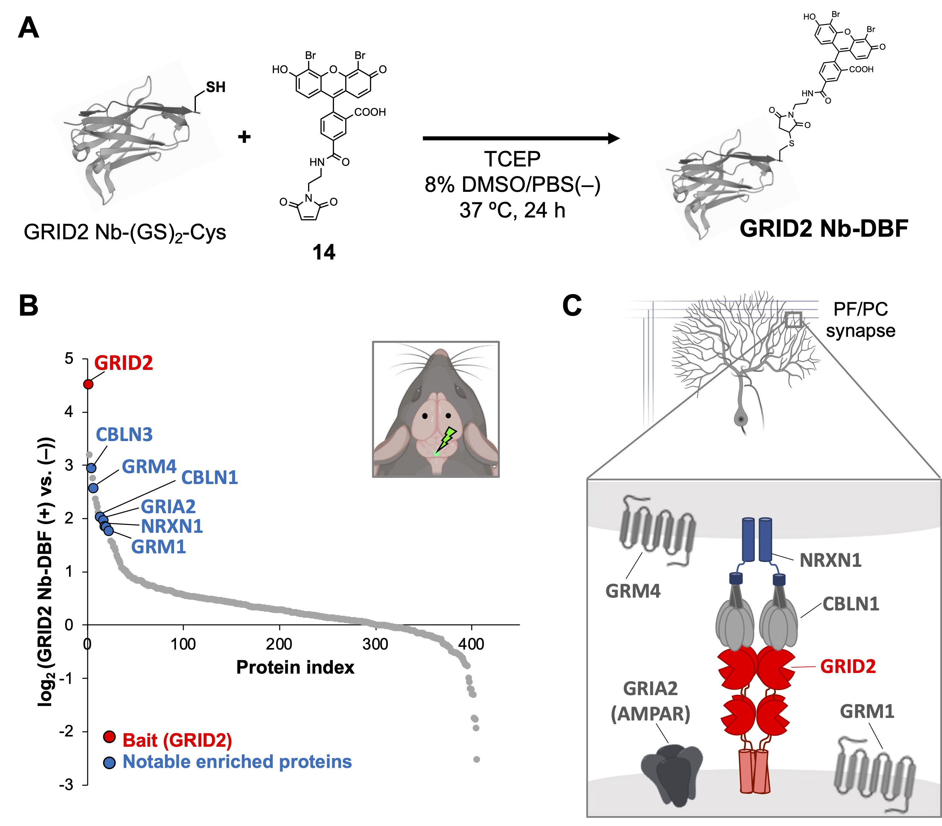
Extended Data Fig. 8 | PhoxID with a photosensitizer-nanobody conjugate. (A) Schematic of the conjugation reaction between DBF and a nanobody for ionotropic glutamate receptor delta-2 (GRID2) modified with a tandem GS linker and Cys residue at the C-terminus. The target specificity of GRID2 Nb-DBF has been confirmed in our previous work.⁵³ (B) Fold change plot of the proteins identified by PhoxID in the cerebellum with GRID2 Nb-DBF and Hyd-PEG4-dBt. Upper-right panel, schematic diagram of the brain injection and photoirradiation sites. Black dots represent the injection sites of GRID2 Nb-DBF and the green dot represents the site of Hyd-PEG4-dBt injection and photoirradiation. (C) Cartoon depiction of the localization and topology of representative enriched proteins. All components of the GRID2-CBLN1-NRXN1 transsynaptic complex⁵⁷ were successfully labeled.
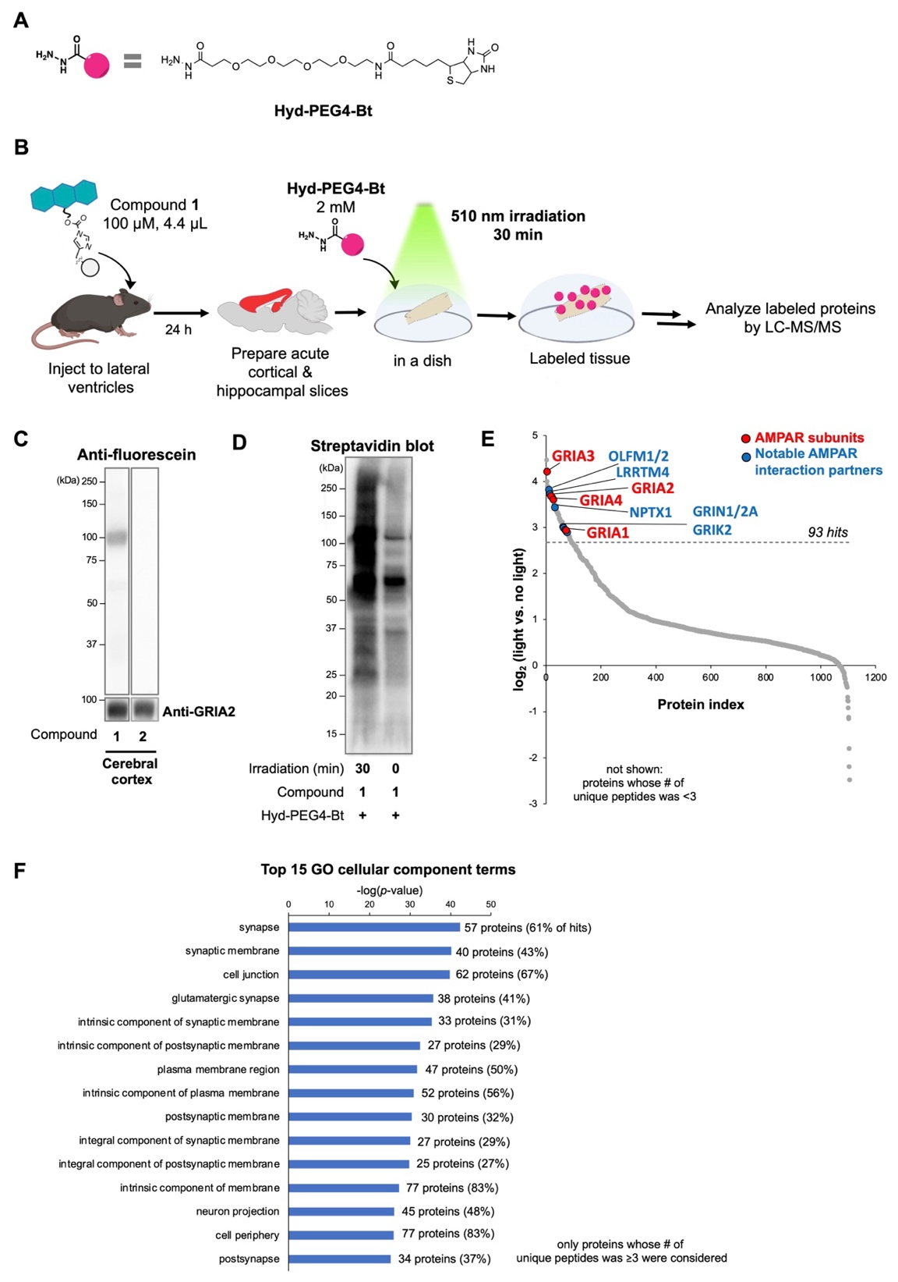
Extended Data Fig. 9 | PhoxID can be performed in acute brain slices. (A) Chemical structure of Hyd-PEG4-Bt bearing biotin as the enrichment handle. (B) Experimental workflow for PhoxID in acute brain slices. (C) Western blot analysis of MBF anchoring onto AMPARs in the cerebral cortex. (D) Streptavidin blot of the proteins labeled by PhoxID in acute cortical and hippocampal slices. Western blotting was performed after neutravidin enrichment. (E) Fold change plot of the proteins identified by LC-MS/MS in a single biological replicate. (F) GOCC (complete) enrichment analysis of the PhoxID hits. The top 15 terms with the smallest raw p-value are shown. Percentages represent the fraction of hit proteins that are annotated to each GOCC term.

