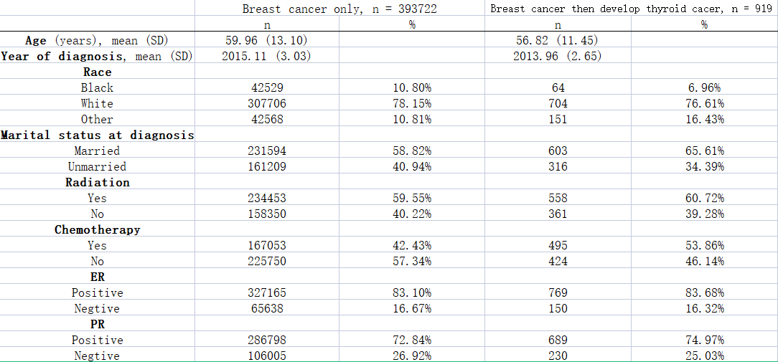
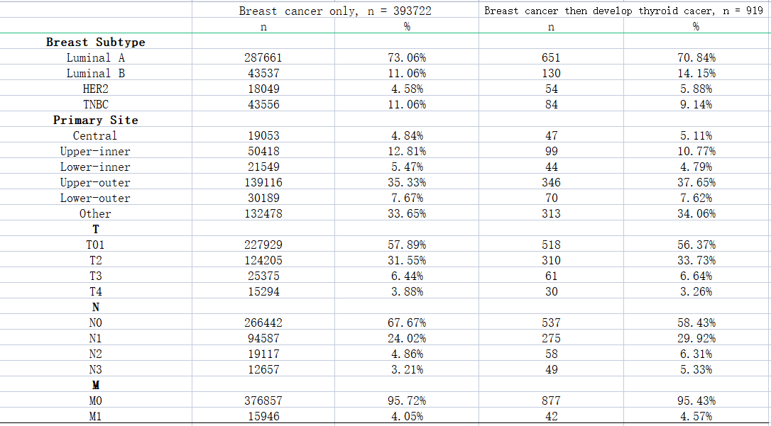
Table I. Baseline data of breast cancer patients with solitary breast cancer and secondary thyroid cancer.

Table II. Case and control groups before and after matching according to the PSM method.
Comparison of baseline characteristics

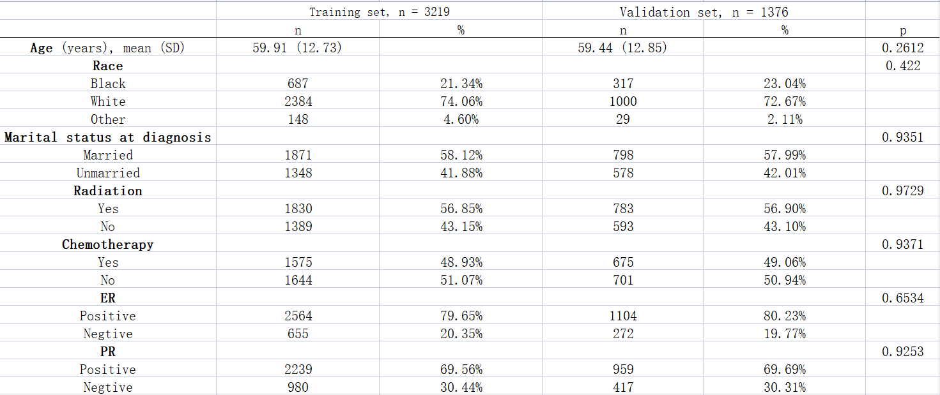
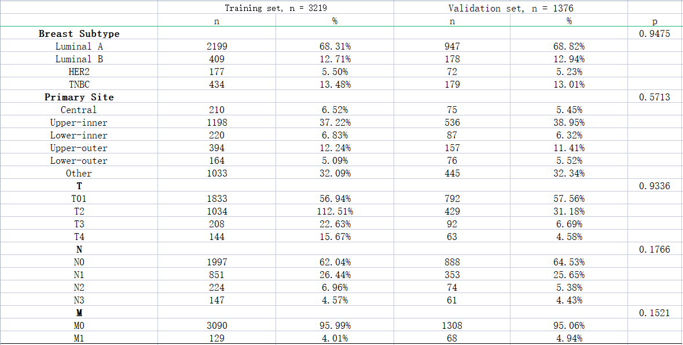
Table III. General information about the training and validation sets

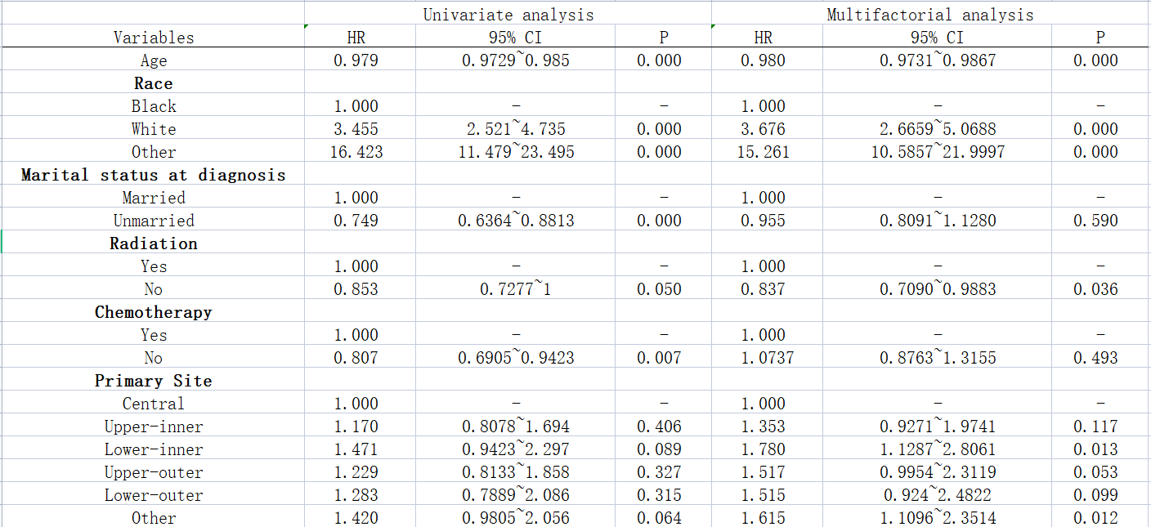
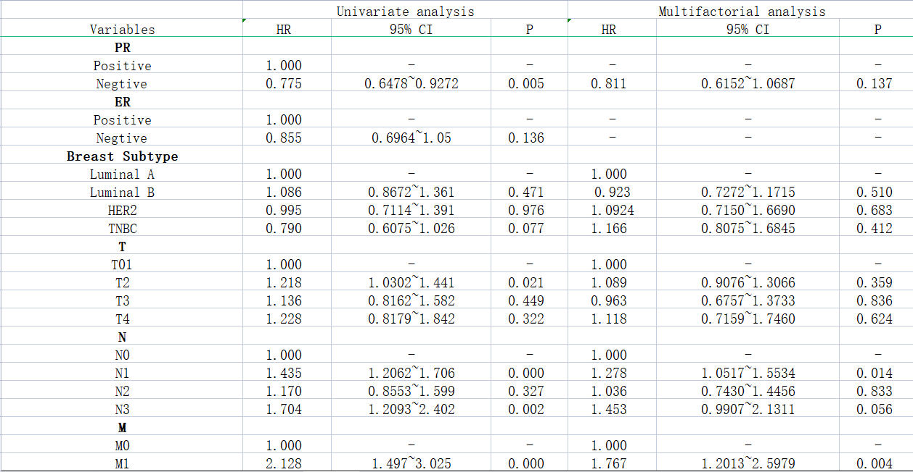
Table IV. Results of single-factor and multifactor cox regression analyses.

