Appendix 1. Compounds detected in n-hexane A. fertilis (collected from nature) extract
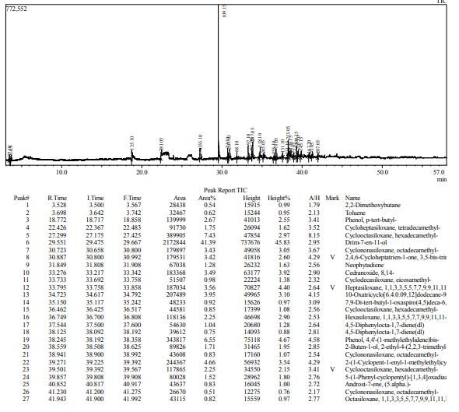

Appendix 2. Compounds detected in n-hexane A. fertilis (in vitro) extract
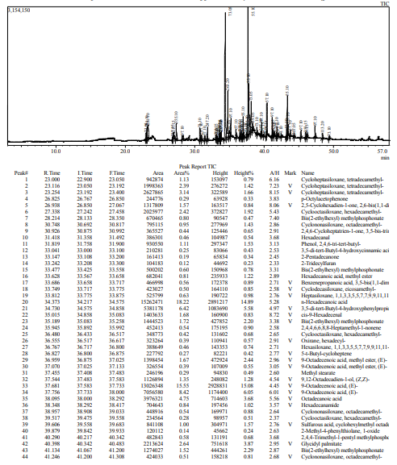
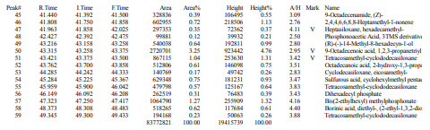
Appendix 3. Compounds detected in methanol fraction A. fertilis (collected from nature) extract
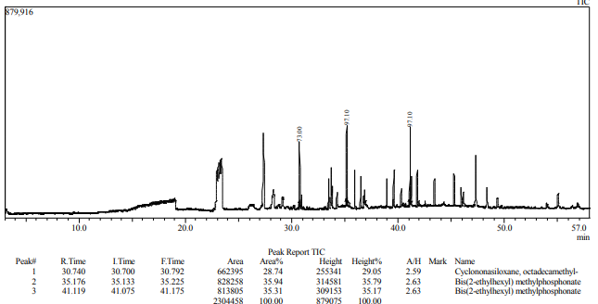

Appendix 4. Compounds detected in methanol fraction A. fertilis Depok (in vitro) extract
