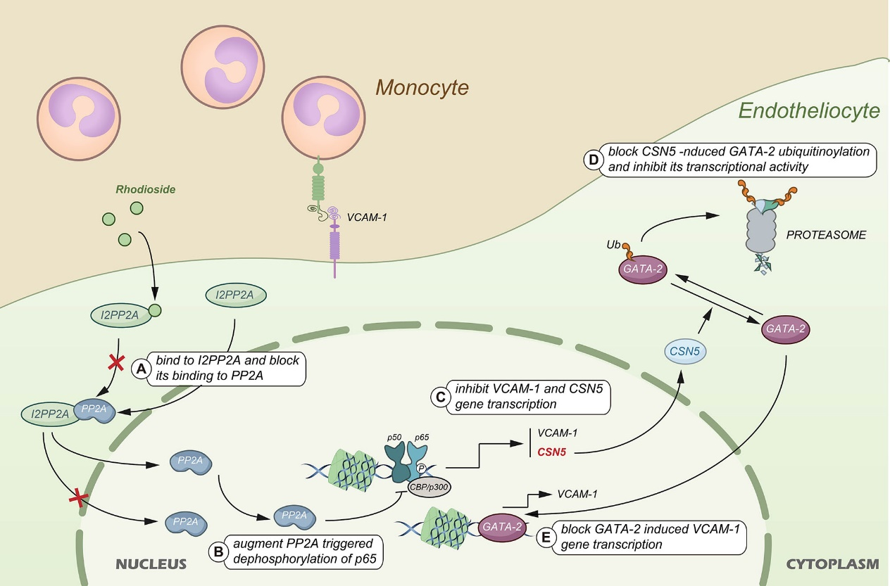
Diagram of the mechanism of monocyte-endothelial cell adhesion inhibition by rhodiroside

