Supplementary Materials

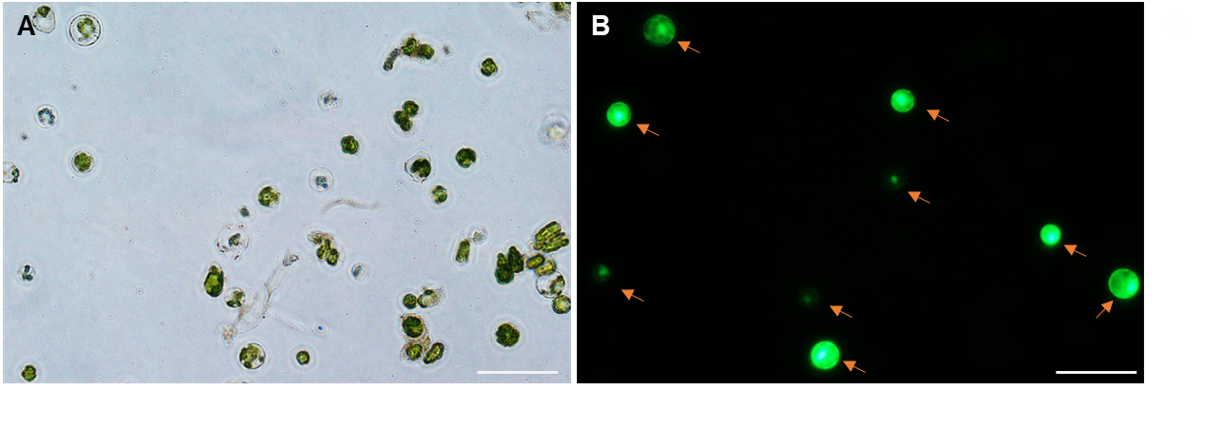
Figure S1. Transient EGFP expression in mesophyll-derived protoplasts in mulberry. Bright-field (A) and EGFP (B) images of protoplasts transformed with vector pAN580 after 2 days’ incubation in the PIM medium. Scale bar, 20 µm.

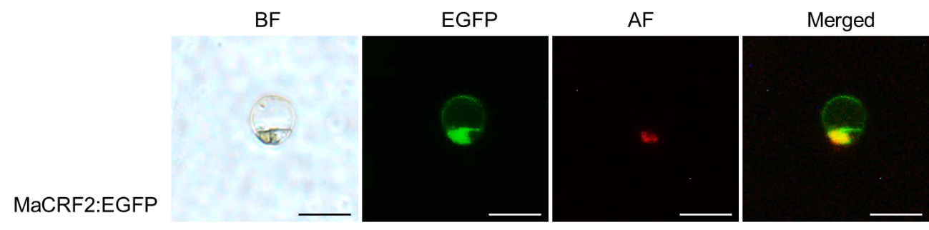

Figure S2. Subcellular localization of MaCRF2:GFP protein in mulberry protoplasts in PIM without cytokinin. BF, bright-field image; AF, autofluorescence image (chloroplasts); Merged, merged image. Scale bar, 20 µm.

Table S1. General information of the four MaCRF proteins identified in mulberry
Name | ID | Chromosome | Transcripts  (bp) | Amino acids | AP2 Domain  (PF00847)
MaCRF1 | malb00022611-R1 | 12 | 999 | 332 | 122-185
MaCRF2 | malb00014260-R1 | 11 | 1110 | 369 | 124-180
MaCRF3 | malb00017653-R1 | 9 | 888 | 295 | 108-164
MaCRF4 | malb00003994-R1 | 6 | 738 | 245 | 101-158

Table S2. List of primers used in this paper
Primer name | Sequence (5’-3’) | Length (bp) | Tm (℃)
MaHTR6-ORF-F | TAAGTCCGGAGCTAGCTCTAGAATGGCCCGTACGAAGCAAAC | 42 | 67.99
MaHTR6-ORF-R | GCCCTTGCTCACCATGGATCCAGCACGCTCACCCCTGATC | 40 | 67.85
MaCRF1-qPCR-F | CTCTAAATCCACCGCTTCGC | 20 | 65.75
MaCRF1-qPCR-R | CGTCGCTTTCTCTGGAACAC | 20 | 64.87
MaCRF2-qPCR-F | AGGTGAGGAAACAGTCGAGG | 20 | 63.22
MaCRF2-qPCR-R | GACGTATCTCTTCACCCGCT | 20 | 63.13
MaCRF3-qPCR-F | TCGACAATGAGGGTGGTGAA | 20 | 66.59
MaCRF3-qPCR-R | CGAACTCCGCGAAACTTCTT | 20 | 65.41
MaACT1-qPCR-F | CATTCAACACCCCGGCTATG | 20 | 67.24
MaACT1-qPCR-R | CAAACGGAGGATGGCATGTG | 20 | 68.44
MaCRF1-ORF-F | CAACTAGTCTTAAGTCCGGAGCTAGCATGAATCGAAGTGGTCAAGTG | 47 | 61.53
MaCRF1-ORF-R | ACAGCTCCTCGCCCTTGCTCACCATAAGAGCGACGAGAGGATCT | 44 | 60.68
MaCRF2-ORF-F | CAACTAGTCTTAAGTCCGGAGCTAGCATGATGGAGCAGAGTATTCTATG | 49 | 58.74
MaCRF2-ORF-R | ACAGCTCCTCGCCCTTGCTCACCATGAGGACCACAAGAGGATC | 43 | 56.82
MaCRF3-ORF-F | CAACTAGTCTTAAGTCCGGAGCTAGCATGGGTTCGGTAAAGCTAAC | 46 | 59.47
MaCRF3-ORF-R | ACAGCTCCTCGCCCTTGCTCACCATAGATAATTCTTCAATGCCCAATG | 48 | 62.69

