Supplementary Figure 1. Daily reported number of domestic cases and death before and after large-scale community-acquired outbreaks of Omicron infection in Taiwan
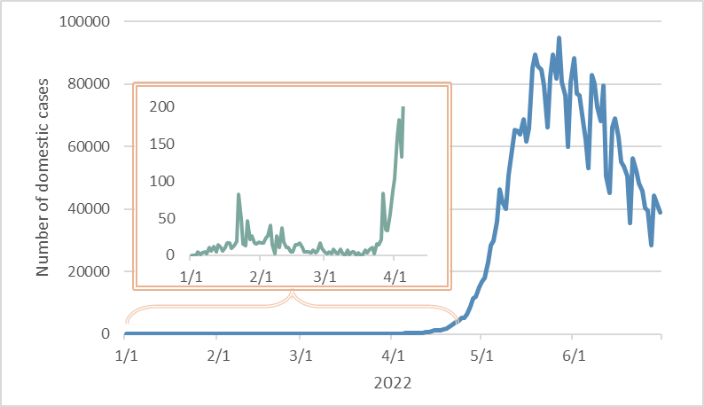
Supplementary Figure 2. Time trend of proportion of aged 70 years and above from 1993 to 2021 in Taiwan.

Supplementary Figure 3. Estimated excess deaths for COVID-19 pandemic of Asian and Oceania countries
- Countries with baby-boom effect
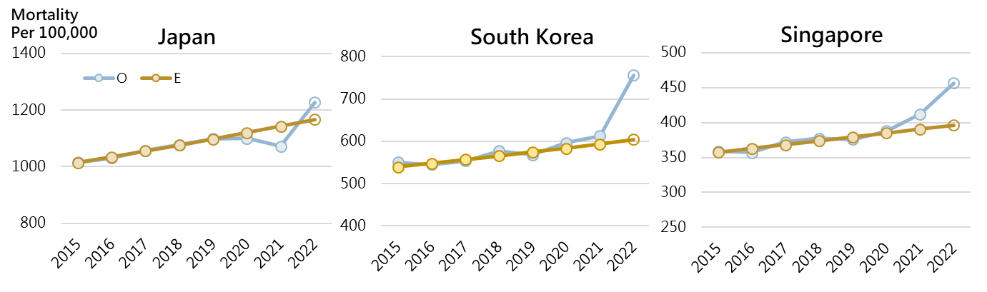
- Countries without baby-boom effect
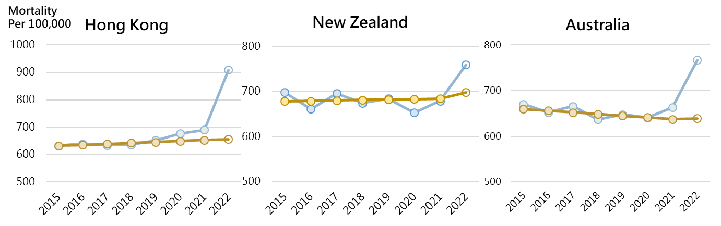

Supplementary Table 1. Estimated regression coefficients of Poisson time series regression model of background mortality
 | Coefficient | Standard Error | 95%CI |  | P-value
Intercept | -7.4768 | 0.0034 | -7.4835 | -7.4701 | <.0001
Trend
Per month | -0.0003 | 0.0001 | -0.0004 | -0.0001 | 0.0006
Season |  |  |  |  | <.0001
(vs. Oct-Dec)
Jan-Mar | 0.1011 | 0.0031 | 0.0951 | 0.1071
Apr-Jun | 0.0001 | 0.0031 | -0.006 | 0.0062
Jul-Sep | -0.0046 | 0.0031 | -0.0107 | 0.0015
Baby boomers vs. Non-baby boomers | 0.0379 | 0.005 | 0.0281 | 0.0476 | <.0001
Baby-boomer*Trend | 0.0051 | 0.0001 | 0.0049 | 0.0054 | <.0001

Supplementary Table 2. Rate ratio of expected mortality by baby-boomers and non-baby boomers
 | Baby boomers |  | Non-baby boomers |  | Ratio (Baby boomers vs. Non-baby boomers)
 | Number | Expected  mortality* | Number | Expected  mortality* | Ratio (Baby boomers vs. Non-baby boomers)
2015 | 5,735,026 | 746.49 | 17,757,048 | 695.45 | 1.07 (1.06-1.08)
2016 | 5,691,951 | 791.57 | 17,847,865 | 693.31 | 1.14 (1.14-1.15)
2017 | 5,647,807 | 839.37 | 17,923,420 | 691.18 | 1.21 (1.21-1.22)
2018 | 5,600,697 | 890.05 | 17,988,235 | 689.05 | 1.29 (1.29-1.30)
2019 | 5,553,130 | 943.79 | 18,049,991 | 686.93 | 1.37 (1.36-1.38)
2020 | 5,487,530 | 1000.78 | 18,073,706 | 684.82 | 1.46 (1.45-1.48)
2021 | 5,382,096 | 1061.21 | 17,993,218 | 682.71 | 1.56 (1.54-1.57)
2022 | 5,307,761 | 1113.49 | 17,878,517 | 683.46 | 1.63 (1.60-1.65)
*Per 100,000

