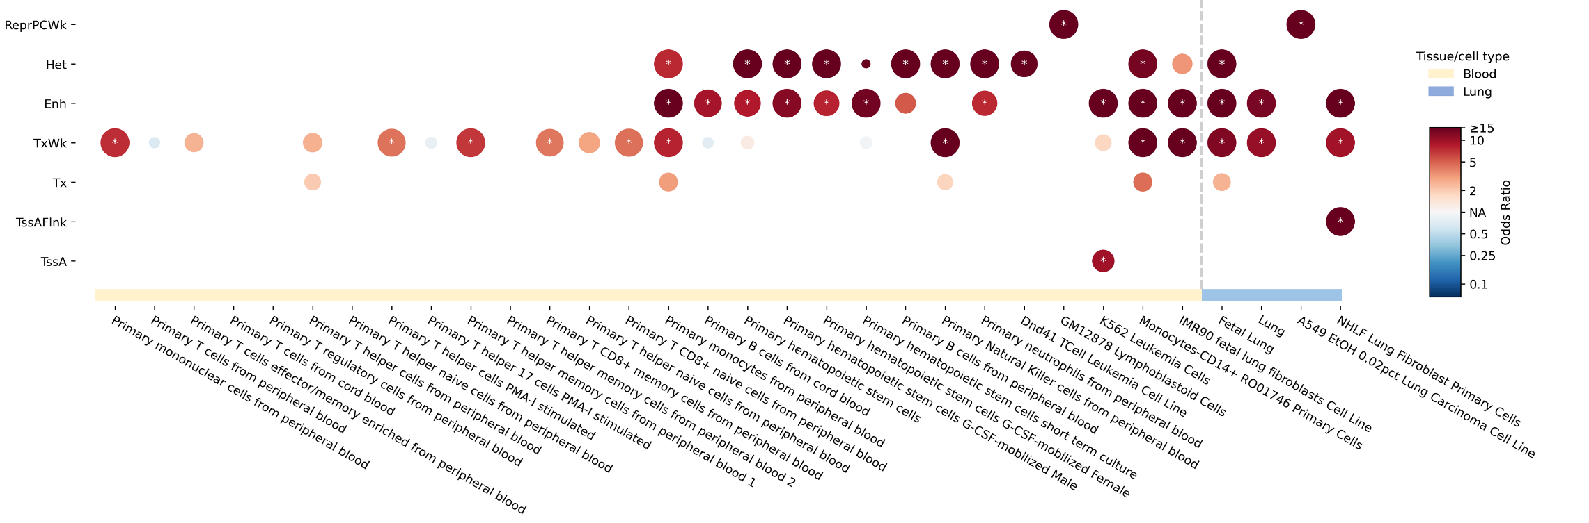
Supplementary Figure 1. Enrichment of the genome-wide significant SNPs in chromatin states. Dot plot displayed enrichments results for all the significant SNPs within the identified risk locus across 15 distinct chromatin states in blood and lung tissues/cells data using hypergeometric distribution test. Blue, negative association (odds ratio [OR]<1); red, positive association (OR>1); white, null association (OR=NA). Larger circles correspond to smaller adjusted P-value. Chromatin states showing enrichment with a false discovery rate adjusted P-value <0.05 were marked with asterisks. These states include weak repressed PolyComb (ReprPCWk), heterochromatin (Het), enhancers (Enh), weak transcription (TxWk), strong transcription (Tx), flanking active transcription start site (TssAFlnk), active transcription start site (TssA) (not shown in this figure as none of the enrichment results were valid for this chromatin state).

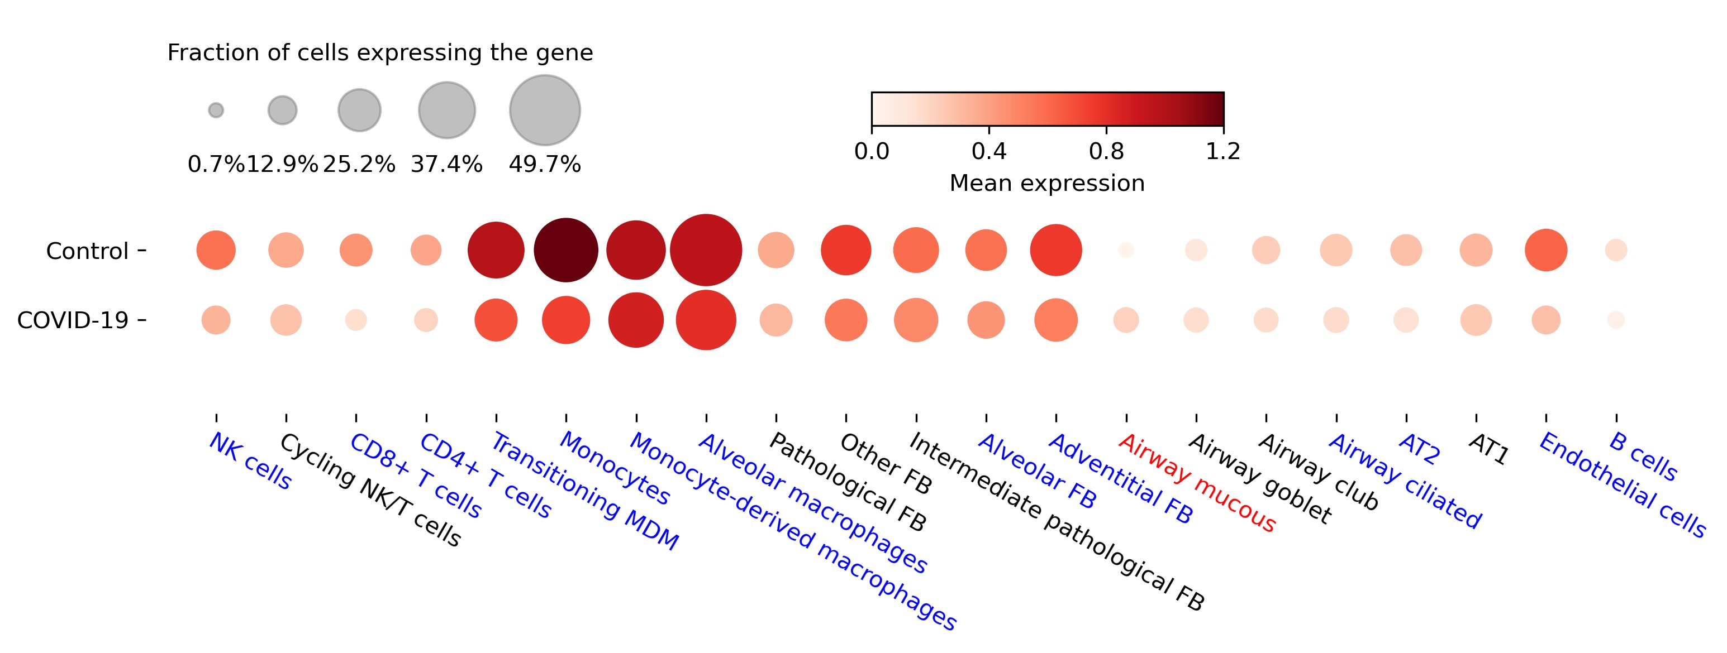
Supplementary Figure 2. CPQ expression for lung tissues in severe COVID-19 patients compared to healthy controls. Dot plot displaying the expression levels of the CPQ gene across 21 different cell types within the lung scRNA-seq data. Cell types exhibiting lower CPQ expression levels in severe COVID-19 patients compared to healthy controls are highlighted in blue, while higher CPQ expression levels are in red.

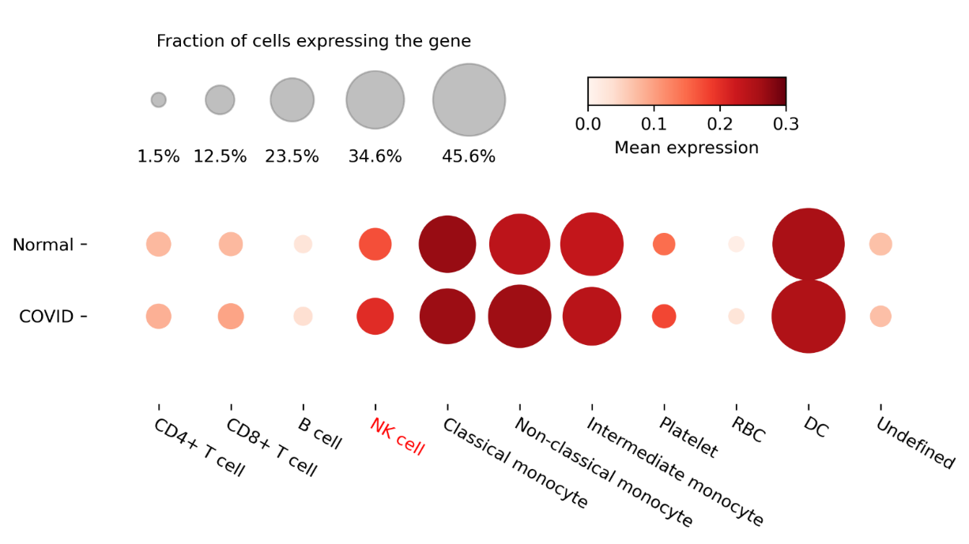
Supplementary Figure 3. CPQ expression for peripheral blood mononuclear (PBMCs) cells in severe COVID-19 patients compared to healthy controls. Dot plot displaying the expression levels of the CPQ gene across 11 cell types within the PBMCs scRNA-seq data. Cell types exhibiting higher CPQ expression levels in severe COVID-19 patients compared to healthy controls are highlighted in red.

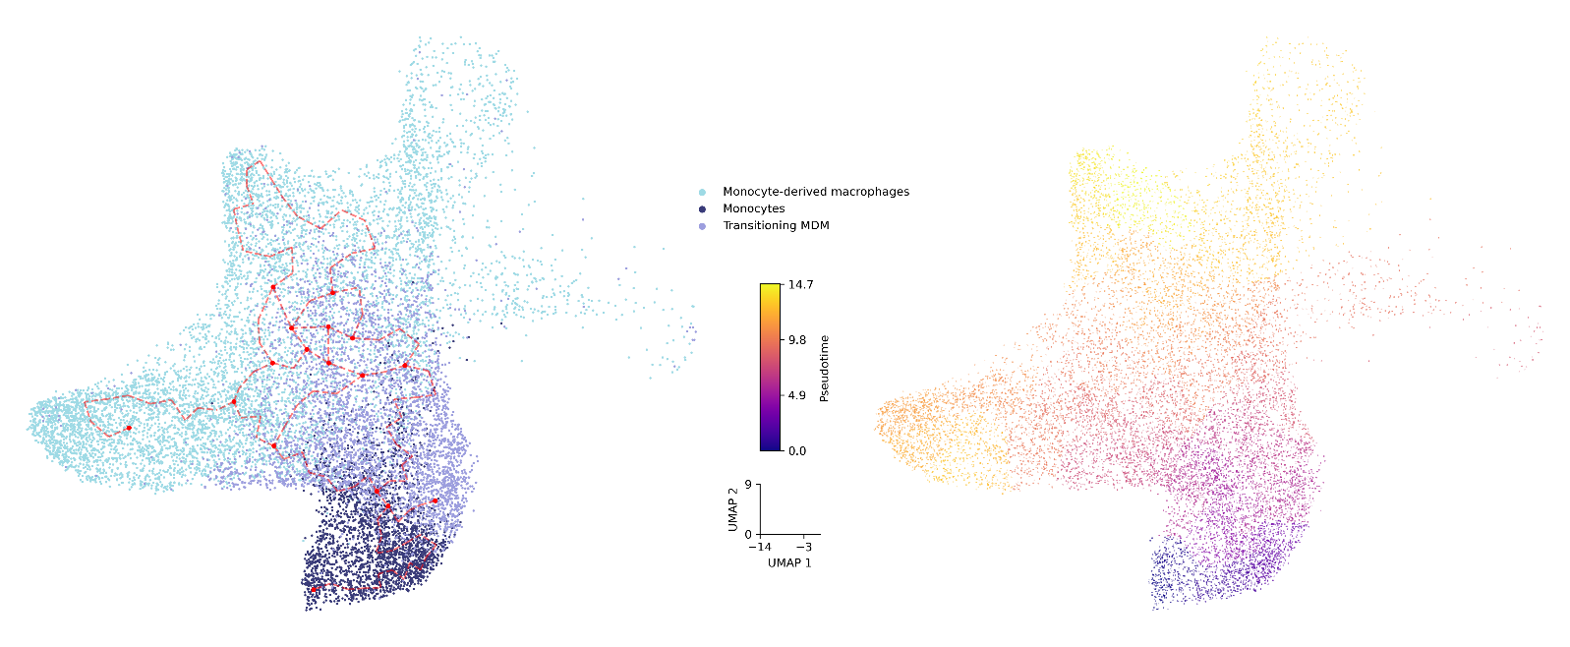
Supplementary Figure 4. Pseudotime trajectory for monocyte-derived macrophages (MDM) and its precursor cells, monocytes and transitioning MDM. Each cell was assigned a pseudotime value, where 0 indicated no progress in the transition from monocyte to MDM, and the maximum value of 100 represented 100% progress. The red curve indicated the trajectory for the relative progression in the transition process.


Supplementary Figure 5. Protein-protein interaction network of the ubiquitination-related genes using STRING. Analysis was based on protein-protein interactions that were backed by high-throughput experiments and possessed association scores exceeding the median score (i.e., 0.04). Protein-protein interaction network analysis of these six ubiquitination-related genes revealed functional connections among USP48 (formerly known as USP31), GSK3B, and FBXW11 (connected by lines).

