Supplementary Information

Anti-inflammatory, Antioxidant, and Chelating Activities of Nor-triterpenes from Galphimia spp. (Malpighiaceae)
Eleazar León-Álvarez ¹, César Millán Pacheco ², Renier Gesto-Borroto ¹, María de Lourdes Acosta-Urdapilleta³, Maura Téllez-Téllez³, Rita Barreto González⁴, Pablo Noé Núñez-Arangón⁵, María Luisa Villarreal¹, Alexandre Toshirrico Cardoso Taketa¹

Affiliation
¹ Centro de Investigación en Biotecnología, Universidad Autónoma del Estado de Morelos, Cuernavaca, Morelos, Mexico
² Facultad de Farmacia, Universidad Autónoma del Estado de Morelos, Cuernavaca, Morelos, Mexico
³ Centro de Investigaciones Biológicas, Universidad Autónoma del Estado de Morelos, Cuernavaca, Morelos, Mexico
⁴ Facultad de Ciencias Biológicas, Universidad Autónoma del Estado de Morelos, Cuernavaca, Morelos, Mexico
⁵ Centro de Estudios Profesionales, Colegio Superior Agropecuario del Estado de Guerrero, Cocula, Guerrero, Mexico

Correspondence
Dr. Alexandre Toshirrico Cardoso Taketa
Dr. María Luisa Villarreal
Centro de Investigación en Biotecnología
Universidad Autónoma del Estado de Morelos
62209 Cuernavaca, Morelos
Mexico
Phone: +52 777 3297057
Fax: +52 777 3297030
ataketa@uaem.mx (ATCT)
luisav@uaem.mx (MLV)

Contents

Physicochemical, specific rotation and NMR data of compounds 1 and 2.
Fig. S1. ¹H NMR spectrum of compound 1 (CDCl₃, 500 MHz).
Fig. S2. ¹³C spectrum of compound 1 (CDCl₃, 125 MHz).
Fig. S3. HSQC spectrum of compound 1 (CDCl₃, 500 MHz).
Fig. S4. HSBC spectrum of compound 1 (CDCl₃, 500 MHz).
Fig. S5. ¹H NMR spectrum of compound 2 (CDCl₃, 500 MHz).
Fig. S6. NMR spectra at 125 MHz of 2. (A) DEPT 90, (B) DEPT 135, (C) Decoupled ¹³C spectrum. The boxes indicate information about the type of some carbons.
Fig. S7. HH COSY spectrum of compound 2 (CDCl₃, 500 MHz).
Fig. S8. HSQC spectrum of compound 2 (CDCl₃, 500 MHz).
Fig. S9. HMBC spectrum of compound 2 (CDCl₃, 500 MHz).
Fig. S10. Concentration-response curves of the anti-inflammatory inhibitory activity of Galphimia spp. methanolic extract, compounds 1 and 2, and indomethacin on TPA-induced inflammation in mice ear.
Fig. S11. Percentage of inhibition of the DPPH radical by isoquercetin (Iso) and rutin as standards, the methanolic extract (Ext), and triterpenes 1 and 2 at 1 mg/mL. Different letters indicate differences between the means that are statistically significant at p < 0.05 ANOVA followed by Dunnett's test.
Fig. S12. Percentage of inhibition of the ABTS radical by isoquercetin (Iso) and rutin as standards, methanolic extract (Ext), and triterpenes 1 and 2 at 1 mg/mL. Different letters indicate differences between the means that are statistically significant at p < 0.05 ANOVA followed by Dunnett's test.
Fig. S13. Percentage of chelating activity by ethylenediaminetetraacetic acid (EDTA), methanolic extract (Ext), and triterpenes 1 and 2 at 1 mg/mL. Different letters indicate differences between the means that are statistically significant at p < 0.05 ANOVA followed by Dunnett's test.

Physicochemical, specific rotation and NMR data of compounds 1 and 2.

Galphimidin (1): white amorphous powder; mp 148-150 °C; [α]²⁵_{D} −38° (c 0.4, CHCl₃); ¹H NMR (CDCl₃, 500 MHz): δ 4.93 (1H,brs, H-3), 4.78 (1H, brs, H-29b), 4.78 (1H, brs, H-29a), 4.74 (1H, d, 12 Hz, H-24a), 4.47 (1H, d, 12 Hz, H-24b), 3.94 (1H, brt, 8 Hz, H-7), 3.65 (1H, m, H-15), 3.64 (3H, s, OCH₃-26), 3.27 (1H, d, 8 Hz, H-6), 3.12 (1H, m, H-12b), 2.70 (1H, m, H-22), 2.65 (1H, d, 13 Hz, H-19a), 2.51 (1H, m, H-21b), 2.33 (1H, d, 13 Hz, H-19b), 2.31 (1H, m, H-21a), 2.12 (1H, m, H-12a), 1.93 (1H, m, H-2), 1.82 (1H, m, H-16b), 1.55 (1H, m, H-15), 1.53 (1H, m, H-1a), 1.52 (1H, m, H-11b), 1.50 (1H, m, H-11a), 1.36 (1H, m, H-16a), 1.32 (1H, d, 7 Hz, H-23), 1.31 (1H, m, H-11a), 1.25 (3H, s, CH₃-28), 1.16 (3H, s, CH₃-26), 0.99 (3H, s, CH₃-25); ¹³C NMR (CDCl₃, 125 MHz): δ 174.70 (CH₃, C-27), 144.01 (C, C-20), 110.71 (CH₂, C-29), 86.51 (CH, C-6), 80.05 (C, C-13), 79.52 (C, C-18), 72.82 (CH, C-7), 74.72 (CH, C-3), 65.56 (CH2, C-24), 59.39 (CH, C-10), 53.35 (CH, C-22), 49.1 (CH, C-4), 45.36 (CH₂, C-19), 49.98 (CH, C-8), 45.82 (C, C-5), 43.59 (C, C-14), 41.50 (C, C-17), 40.07 (CH₂, C-11), 37.20 (C, C-9), 34.37 (CH₂, C-21), 33.81 (CH₂, C-12), 31.71 (CH₂, C-2), 30.52 (CH₂, C-15), 25.46 (CH₂, C-16), 23.21 (CH₃, C-26), 22.97 (CH₃, C-28), 19.73 (CH₃, C-25), 16.94 (CH₂, C-23), 170.77 (OAc), 170.25 (OAc).
Galphimidin B (2): white amorphous powder; mp 148-150 °C; [α]²⁵_{D} −38° (c 0.4, CHCl₃); ¹H NMR (CDCl₃, 500 MHz) δ 4.79 (1H, s, H-29b), 4.77 (1H, s, H-29a), 4.19 (1H, d, 12.3 Hz, H-24a), 4.08 (1H, d, 12.3 Hz, H-24b), 3.97 (1H, dd, 9.4 Hz, H-7), 3.86 (1H, dd, 6.0, 2.5 Hz, H-3), 3.64 (3H, s, -OCH₃), 3.27(1H, d, 8.7 Hz, H-6), 3.12 (1H, d, 14.6 Hz, H-15a), 2.85 (1H, s, -OH-18), 2.72 (1H, dd, 13.8, 3.7 Hz, H-22), 0.98 (1H, d, 10.6 Hz, H-10), 2.64 (1H, d, 13.3 Hz, H-19a), 2.52 (1H, dd, 13.3 Hz, H-21a), 2.18 (1H, dd, 13.3, 2.5 Hz, H-21b), 2.23 (1H, s, -OH-13), 2.36 (1H, d, 13.3 Hz, H-19b), 2.12 (1H, dd, 12.0 Hz, H-12a), 1.93 (1H, d, 13.6 Hz, H-2), 1.80 (1H, dd, 14.4 Hz, H-16a), 1.81 (1H, ddd, 14.0, 13.3, 3.8 Hz, H-1b), 1.66 (1H, m, H-4), 1.36 (1H, m, H-11b), 1.62 (1H, d, 13.6 Hz, H-2), 1.60 (1H, d, 10.6 Hz, H-8), 1.57 (1H, d, 14.6 Hz, H-15b), 1.54 (1H, m, H-1a), 1.50 (1H, m, H-11a), 1.48 (3H, d, 7.2 Hz, H-23), 1.48 (3H, d, 7.2 Hz, H-23), 1.37 (1H, m, 12.0 Hz, H-12b), 1.01 (3H, s, CH₃-25), 1.26 (3H, s, CH₃-26), 1.17 (3H, s, CH₃-26), 1.01 (3H, s, CH₃-25); ¹³C NMR (CDCl₃, 125 MHz): δ 174.93 (CH₃, C-27), 144.35 (C, C-20), 110.61 (CH₂, C-29), 86.51 (CH, C-6), 79.90 (C, C-13), 74.96 (C, C-18), 73.50 (CH, C-7), 73.02 (CH, C-3), 65.37 (CH₂, C-16), 53.06 (CH, C-10), 51.64 (CH, C-22), 50.71 (CH, C-4), 49.90 (CH, C-9), 46.22 (C, C-5), 45.35 (CH₂, C-19), 43.64 (C, C-14), 41.51 (C, C-17), 39.84 (CH₂, C-11), 37.71 (C, C-9), 34.90 (CH₂, C-2), 33.56 (CH₂, C-21), 30.01 (CH₂, C-12), 25.37 (CH₂, C-15), 23.03 (CH₃, C-26), 23.12 (CH₃, C-28), 19.57 (CH₃, C-25), 18.54 (CH₃, C-18), 16.44 (CH₂, C-1).

Fig. S1. ¹H NMR spectrum of compound 1 (CDCl₃, 500 MHz).

Fig. S2. ¹³C spectrum of compound 1 (CDCl₃, 125 MHz).

Fig. S3. HSQC spectrum of compound 1 (CDCl₃, 500 MHz).

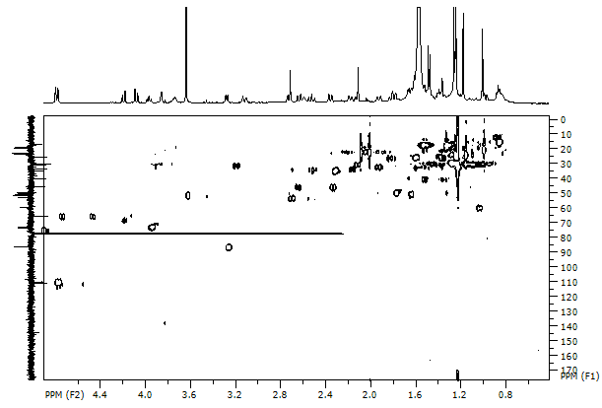

Fig. S4. HSBC spectrum of compound 1 (CDCl₃, 500 MHz).

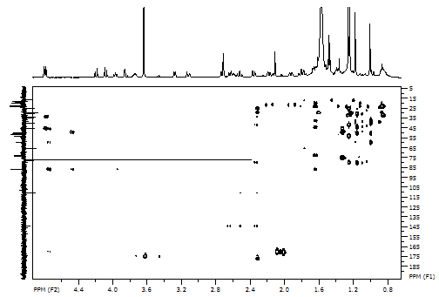

Fig. S5. ¹H NMR spectrum of compound 2 (CDCl₃, 500 MHz).
CH₃O-
CH₃
CH₃
CH₃
CH₃

Fig. S6. NMR spectra at 125 MHz of 2. (A) DEPT 90, (B) DEPT 135, (C) Decoupled ¹³C spectrum. The boxes indicate information about the type of some carbons.

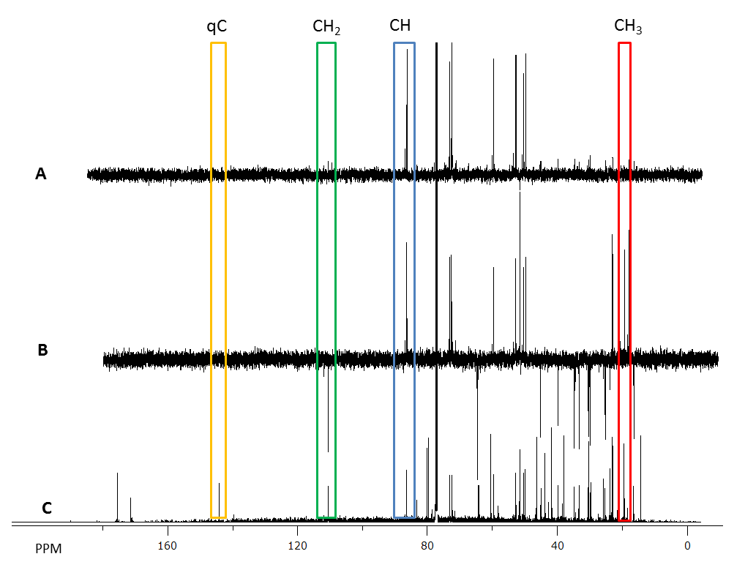
Fig. S7. HH COSY spectrum of compound 2 (CDCl₃, 500 MHz).

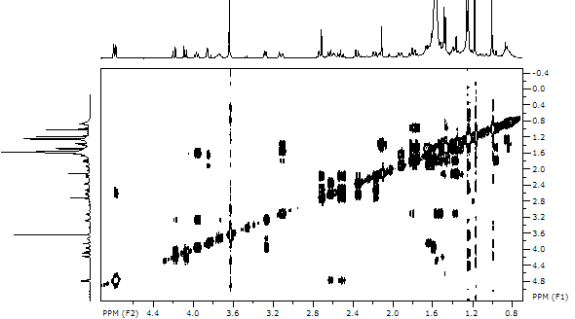

Fig. S8. HSQC spectrum of compound 2 (CDCl₃, 500 MHz).

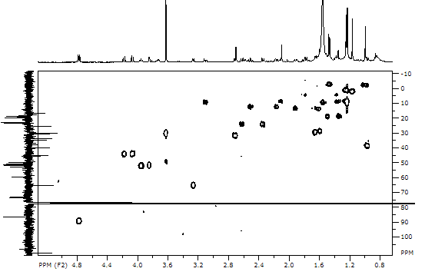

Fig. S9. HMBC spectrum of compound 2 (CDCl₃, 500 MHz).

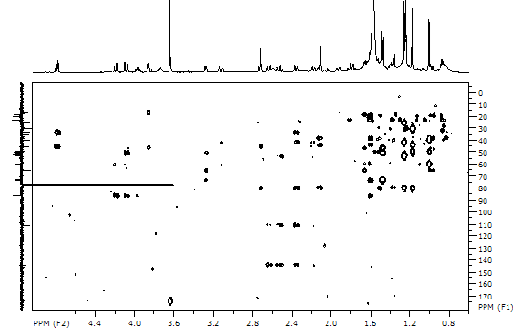

Fig. S10. Concentration-response curves of the anti-inflammatory inhibitory activity of Galphimia spp. methanolic extract, compounds 1 and 2, and indomethacin on TPA-induced inflammation in mice ear.

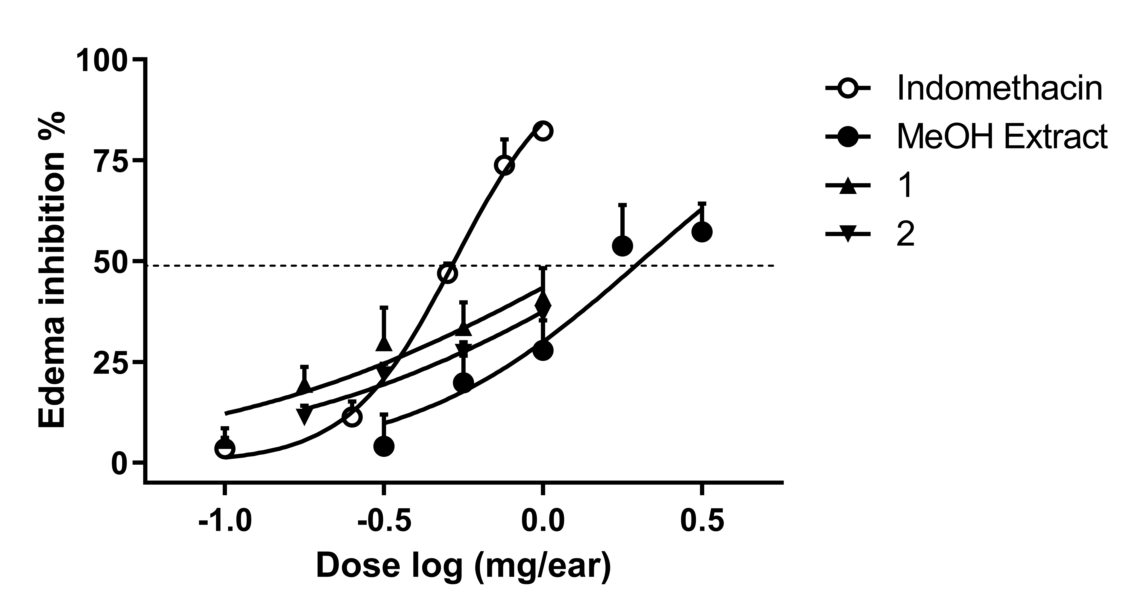

Fig. S11. Percentage of inhibition of the DPPH radical by isoquercetin (Iso) and rutin as standards, the methanolic extract (Ext), and triterpenes 1 and 2 at 1 mg/mL. Different letters indicate differences between the means that are statistically significant at p < 0.05 ANOVA followed by Dunnett's test.
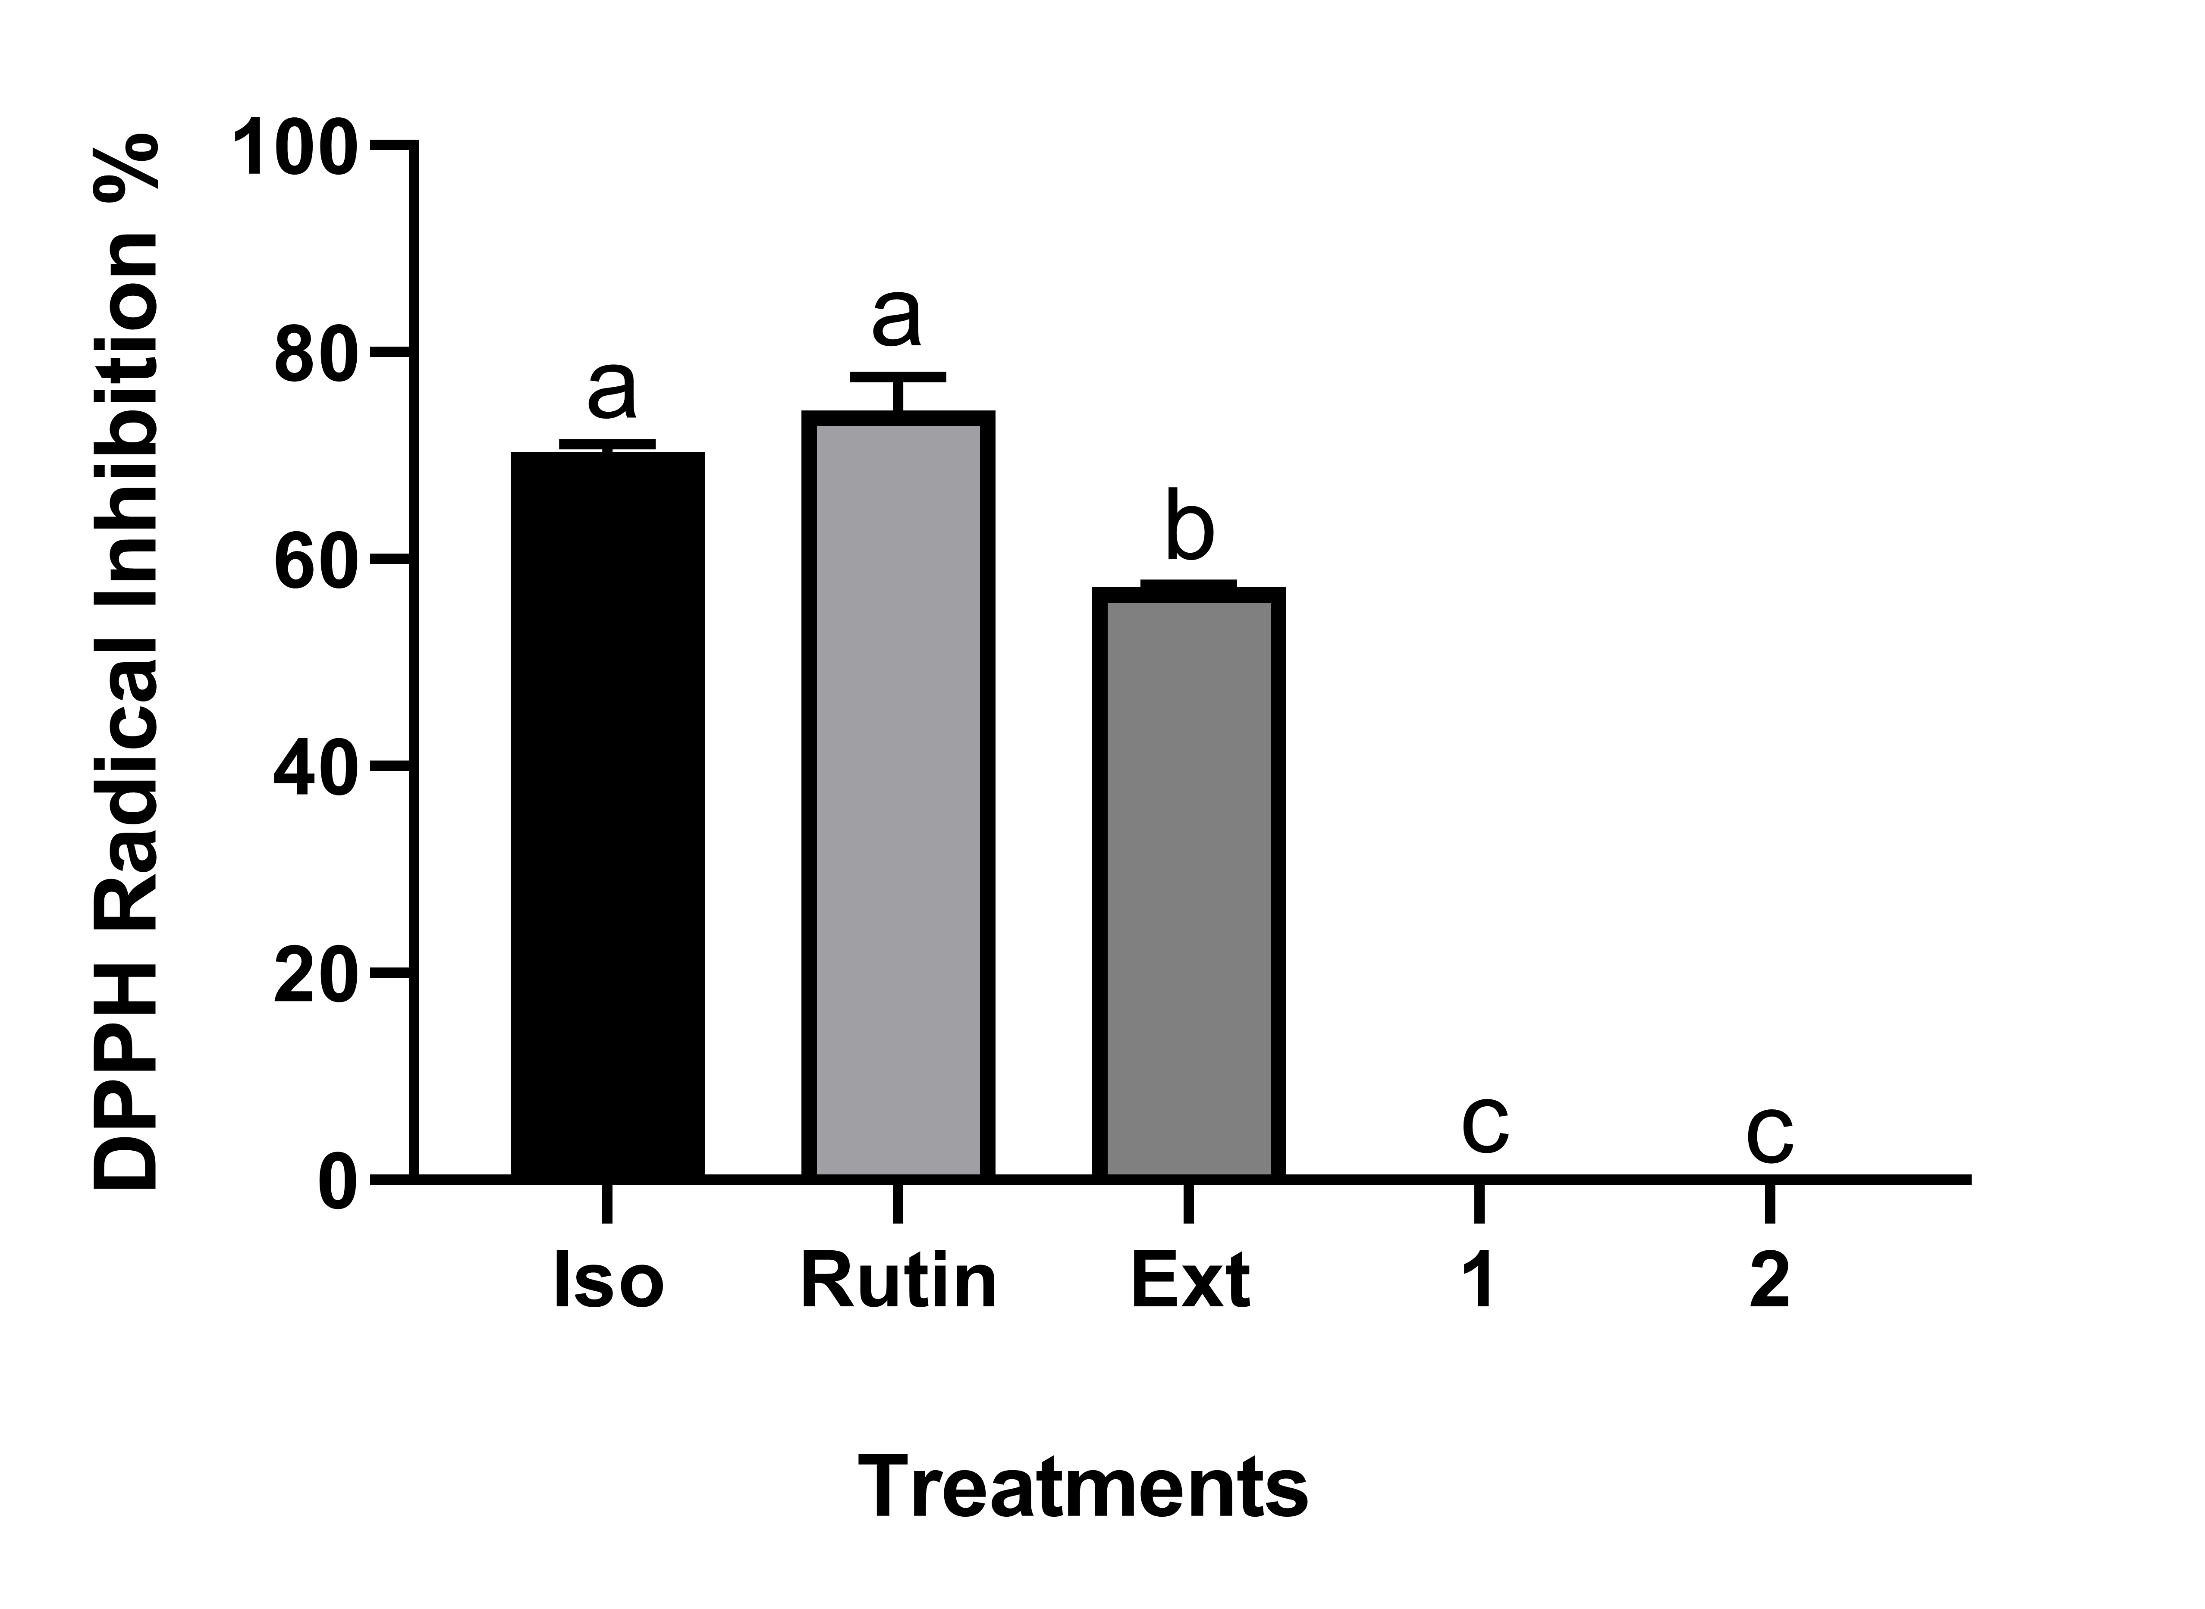

Fig. S12. Percentage of inhibition of the ABTS radical by isoquercetin (Iso) and rutin as standards, methanolic extract (Ext), and triterpenes 1 and 2 at 1 mg/mL. Different letters indicate differences between the means that are statistically significant at p < 0.05 ANOVA followed by Dunnett's test.

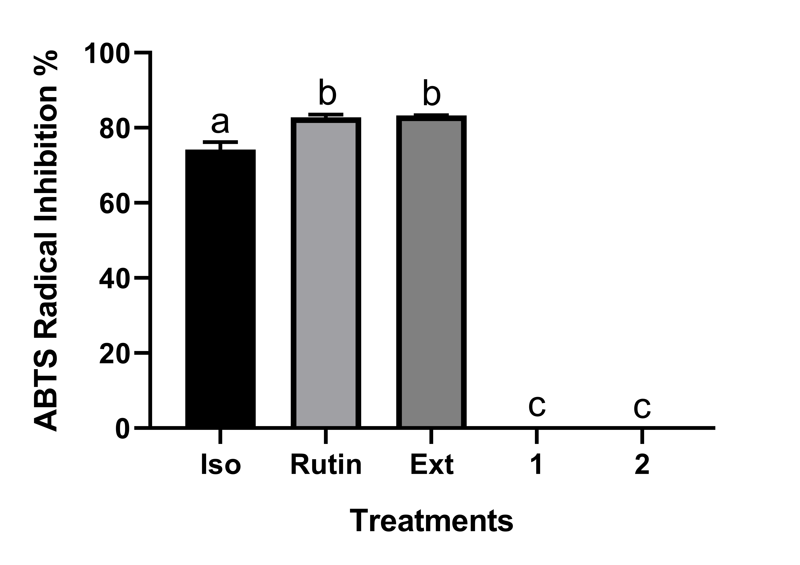

Fig. S13. Percentage of chelating activity by ethylenediaminetetraacetic acid (EDTA), methanolic extract (Ext), and triterpenes 1 and 2 at 1 mg/mL. Different letters indicate differences between the means that are statistically significant at p < 0.05 ANOVA followed by Dunnett's test.

