Chilling and Heat Requirement Manual
- Software introduction
The function of the software includes the calculation of the chilling and heat requirements, the maximum and minimum temperature of the day, drawing, and analysis of the change trend of each chilling model with time.
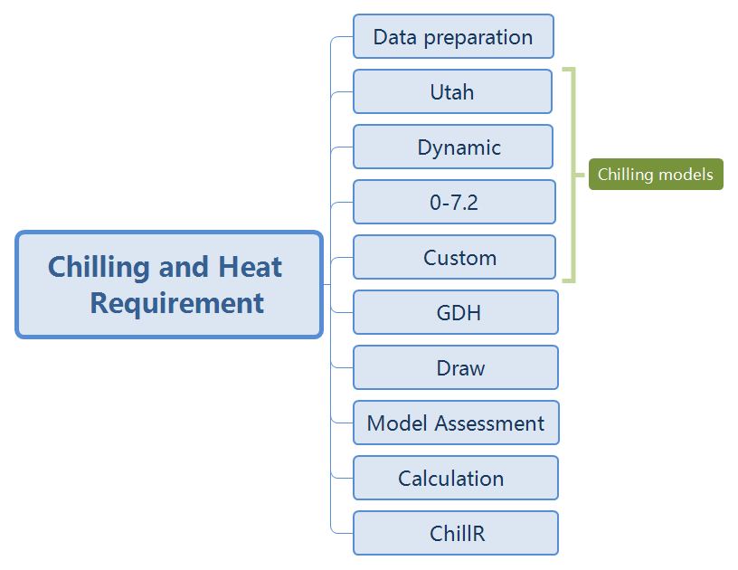
Software function
- Software Installation
This software does not need to be installed; it can be operated as stand-alone by double-clicking directly.
- Main interface
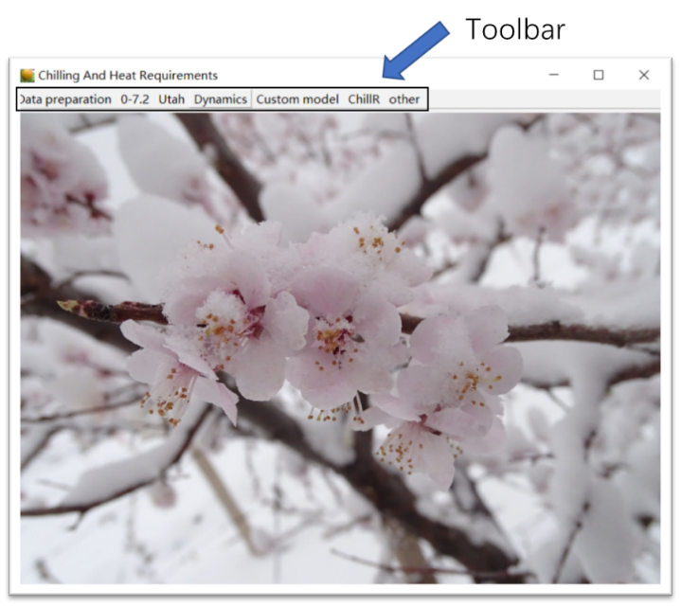
- Input and output of files
（1）The file types used by this tool have a .txt format
（2）It is recommended to create a new folder for the input and output of a file
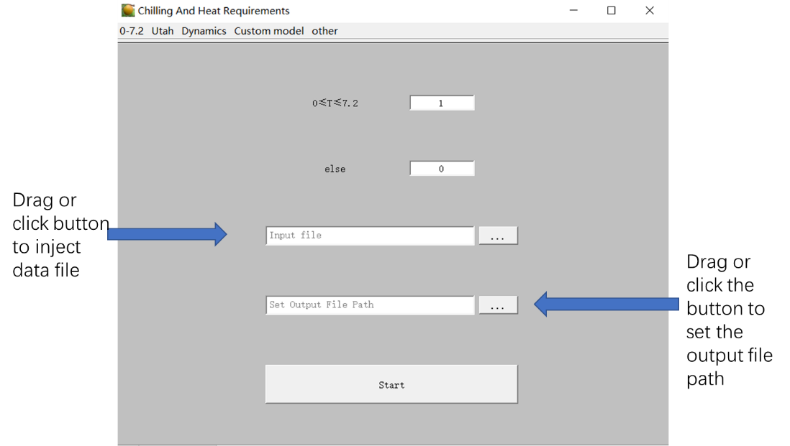
- Data preparation
Generally, the temperature recorder will record the change of temperature at any time. However, the chilling calculation is based on temperature per hour. The data preparation function helps in converting the recorded temperature into hourly units.
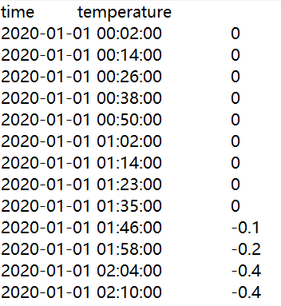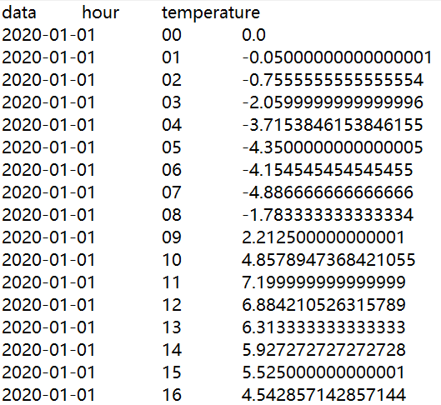
Recorded data Transformed data
- Calculation of chilling requirements
Includes 0–7.2, Utah, dynamics, and custom analysis tools
- Input data format
Hourly temperature
- 0–7.2 model
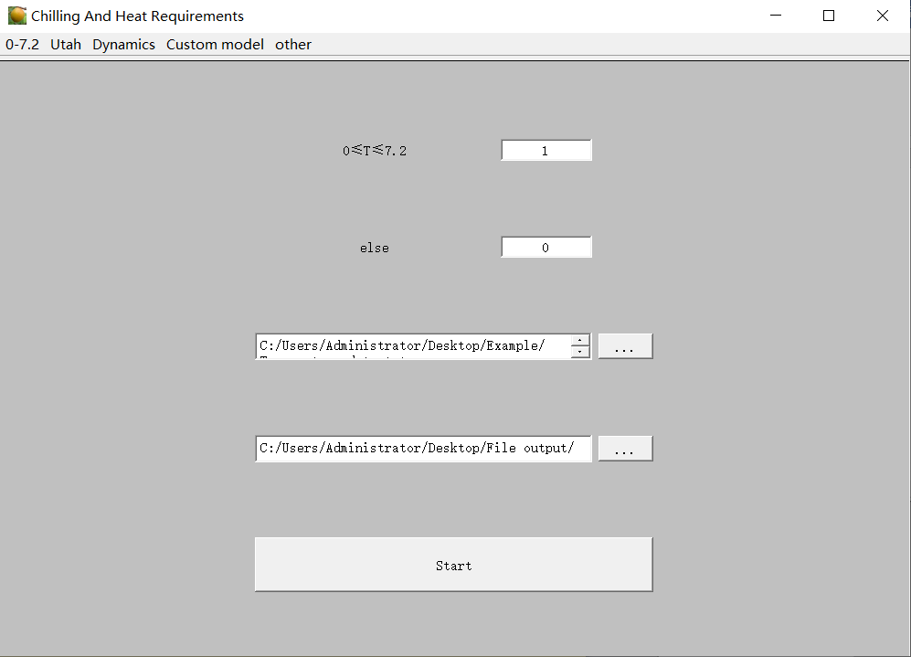
- Utah model

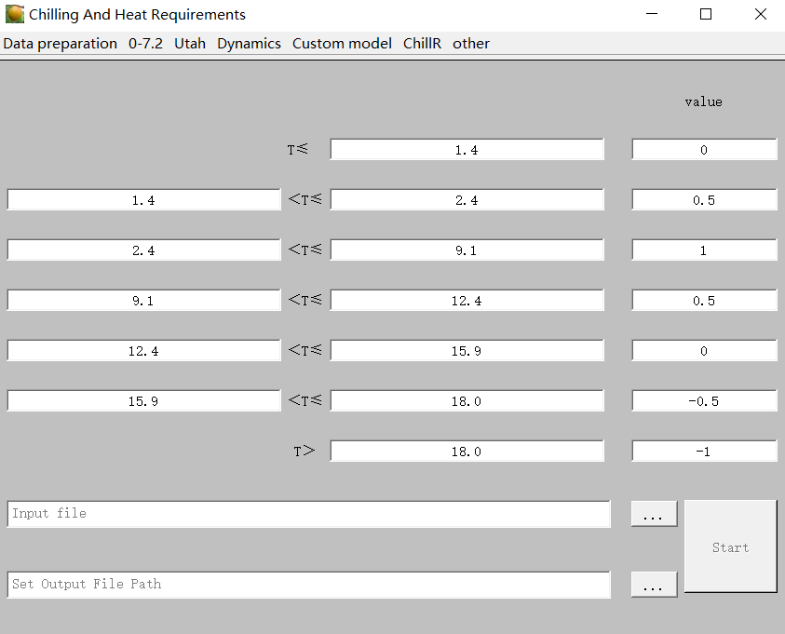
- Dynamics model
Note: Set the parameters of the chilling model according to the default format. For example, if the parameter a0 is changed to 139000, it must be written as 1.39 * 10 ^ 5.
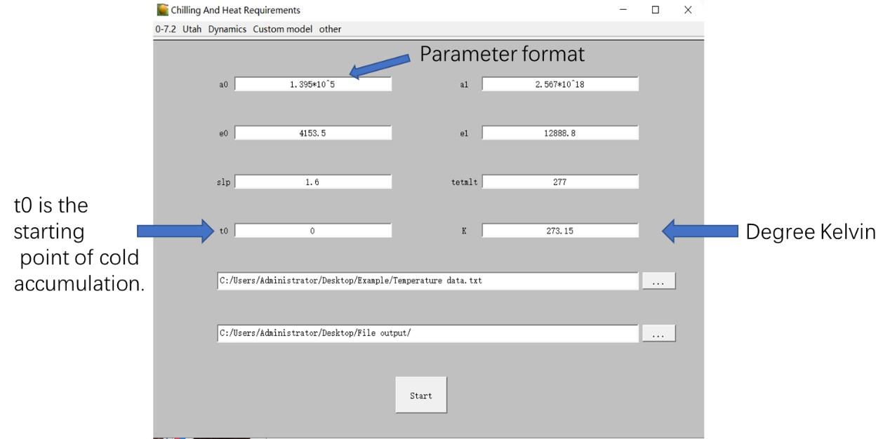
- Custom function
It not only can realize 0–7.2, Utah, but can also realize the functions of models such as low temperature, the Positive Utah Model, and the North Carolina Model. At the same time, researchers can also design according to their own needs.
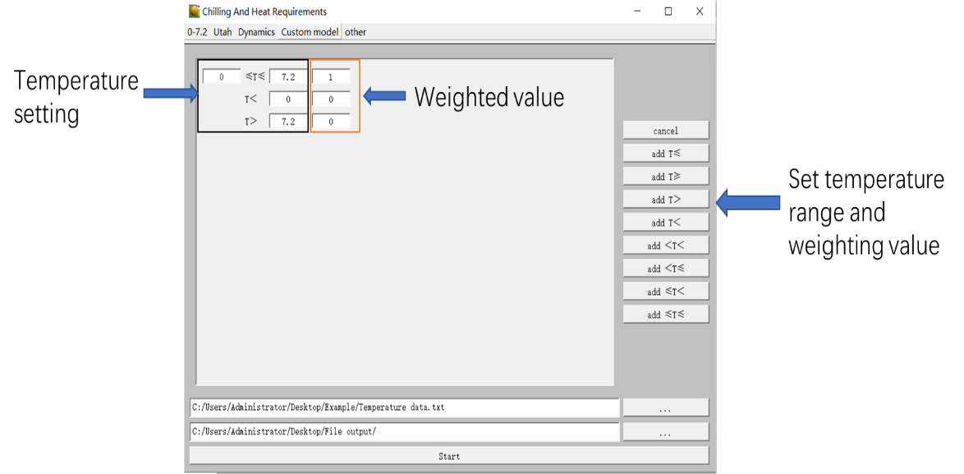
- Calculation of heat requirements (GDH)
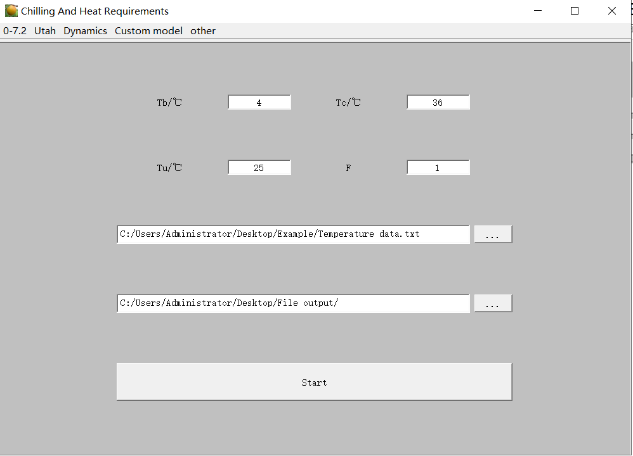
- DL：daylength
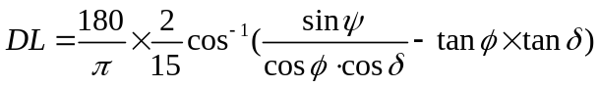
This equation can be modified if one includes the different daylength definitions (Table 1). The different definitions depend on the position of the Sun with respect to the horizon (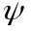solar elevation angle at sunset).
Table1 Daylength definitions defined by the solar elevation angle Ψ with respect to the horizon
Daylength definition | Ψ (degrees)
Sunrise/sunset is when:
The centre of the Sun is even with the horizon | 0
The top of the Sun is even with the horizon | -0.2667
The top of the Sun is apparently even with horizon | -0.8333
With twilight:
Cocklebur | -4
Civil | -6

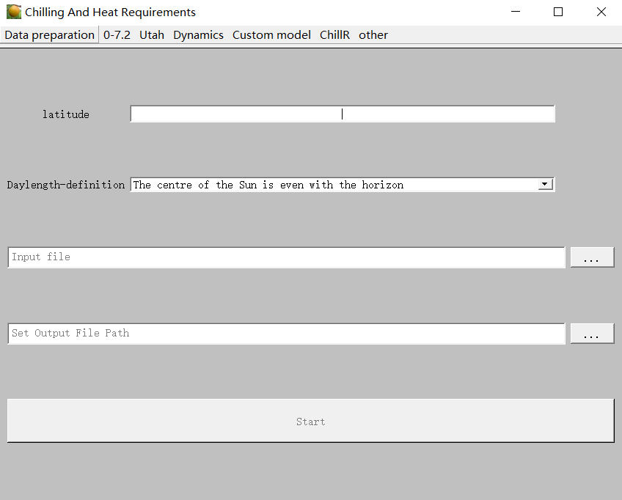
Daylength interface
- Calculation
It is employed to calculate the maximum, minimum, and average temperature of the day. The format of input data is the same as that of chilling requirements
- Tool interface
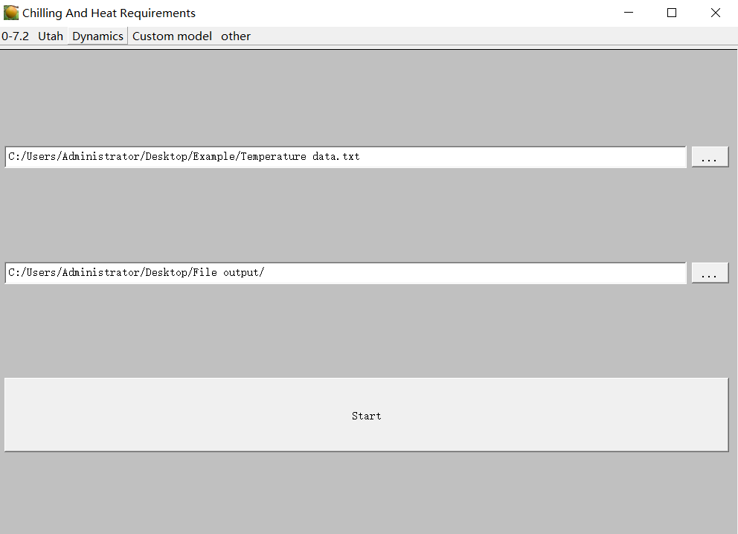
- Output data
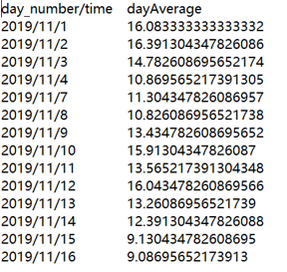
Average temperature
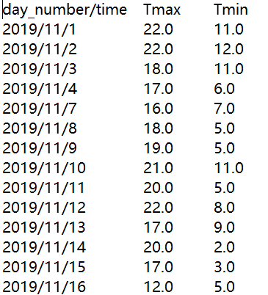
Maximum and minimum temperatures
- Drawing
Researchers can plot the average temperature, the highest and lowest temperatures, the chilling and heat requirement calculated by the model according to the number of days, and the results accumulated by the days to observe the changes.
- Chilling requirement changes with time
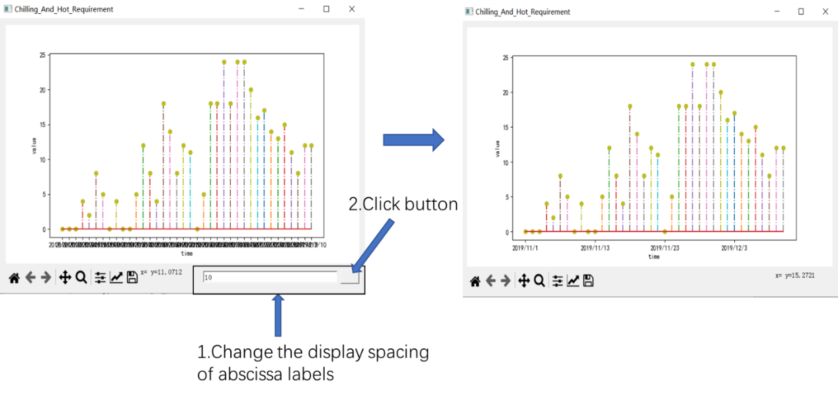
- Change of the maximum and minimum temperatures with time
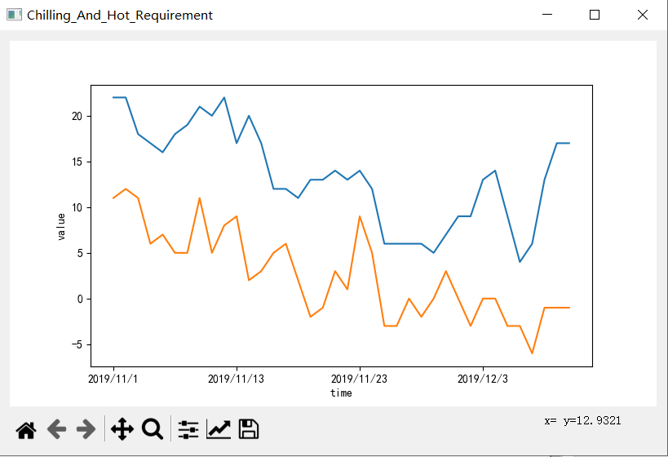
- Model assessment
This function is used to analyze the change trend of the calculation results of chilling requirement by the calculation model. Draw fitting line and 95% confidence interval.
