Supplementary methods

Data used

Characterization of pasture systems
Table S1 shows the average data used for semi-nature pasture (low-yield pasture) and high-yield pasture (sown biodiverse pasture) of aboveground grass productivity, stocking rate, grazing time, soil organic matter (SOM) concentration and air temperature¹. These were the only measured variables used in the present paper.

Table S1. Averages of parameters both pasture systems. Minima and maxima for all farms and years are also indicated. DM – Dry Matter; LU – Livestock Units; SOM – Soil Organic Matter.
Parameter | Unit | High-yield pasture | Low-yield pasture
Aboveground productivity | kg DM/ha.yr | 6,770 | 3,690
Stocking rate | LU/ha | 0.91 | 0.39
Average SOM concentration | % | 2.17 | 1.77
Annual SOM increment¹ | Percentage point per year | 0.30 | 0.11
Air temperature | ºC | 18 | 18
¹ Annual SOM increments were calculated as the difference between average SOM concentrations in two consecutive years.

Characterization of animal weight
For animal weights, we used data of one native breed in the Alentejo region, Alentejana, and three of the most common imported breeds, Angus, Charolais and Limousin². The animal growth curves for all breeds were obtained from Marques et al.³. This paper performed a literature review in order to obtain the animal growth and adult weight for all breeds at ad libitum, i.e. animals receive the exact amount of feed in order to reach the maximum weight. The animal weight at age t, or $W$ (kg per head), was calculated using
 | $W=WB+\frac{MW∙A}{MW+A}$, | (1)
where $WB$ is the weight at birth (kg per head), $MW$ is the adult animal weight (kg per head) and $A$ is age of the animal (in days). The animal growth curves for all breeds are presented in Figure S1.
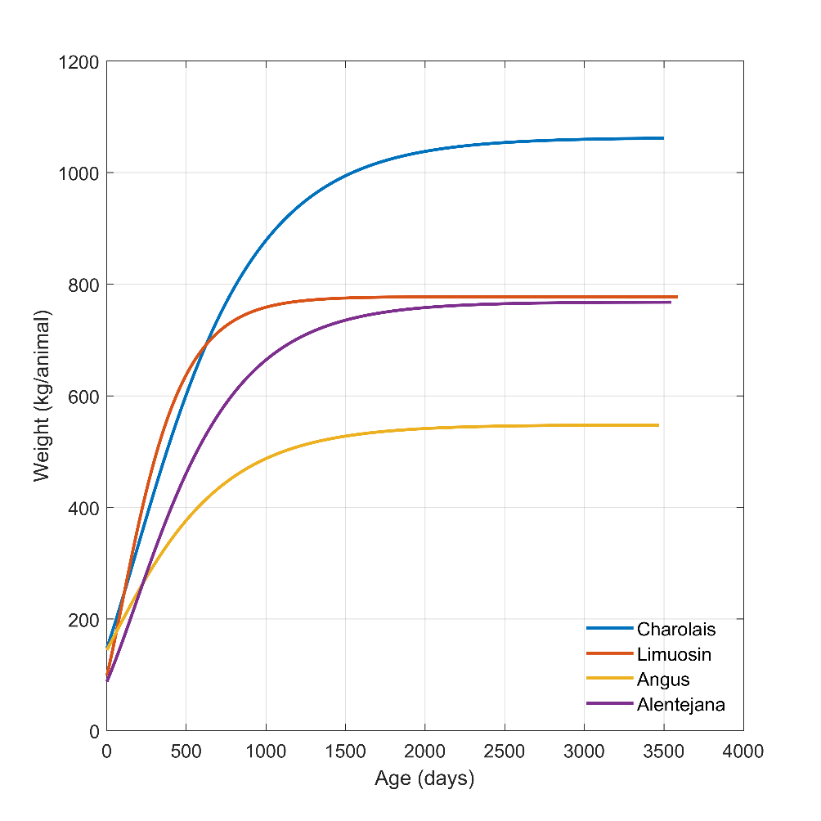
Figure S1. Growth curves for the different breeds without feeding precision reduction.

The effect of feed intake adequacy reduction on animal weight
As illustrative of the calculation procedure of reduced feed intake adequacy (FIA), Figure S2 presents the effect of feeding precision reduction at 100% feeding precision (blue curve on Figure S2) and 3 reduction levels (80%, 70% and 50%) considering the high-yield pasture. Between birthday and weaning, steers have no limitation of feed so all the curves are equal. Feeding reduction only occurs between 6 months (weaning) and 12 months old (confinement). The feeding reduction occurs only on the required supplemental feed of the steer during grazing. Adult cows are always assumed to be optimally fed. During this period, animal growth reduction is proportional to the feeding reduction, i.e. animal growth with a supplement reduction of 50% is lower than the animal growth with a supplement reduction of 30%. When the animal is confined the feeding reduction disappears and the growth starts to increase again. Since feeding limitations disappears, animal weight recovers as an adult it reaches the same weight as steers fed without limitation. This is visible in Figure S2, as for ages higher than 12 months all the curves start to converge.
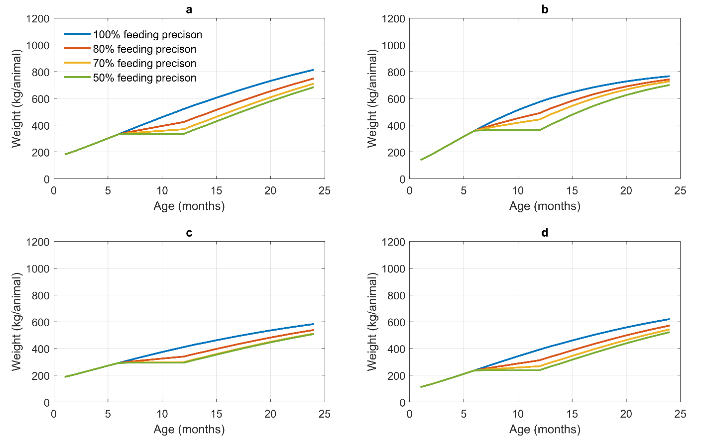
Figure S2. Effect of feed intake adequacy at 3 levels of reduction of animal growth considering grazing on high-yield pastures. a) Charolais, b) Limousin, c) Angus, and d) Alentejana.

Calculation of emissions from animals

Methane from enteric fermentation
Using IPCC’s Tier 2 approach we calculated enteric CH₄ and N excretion of steers on a daily basis since its birth until adulthood. Enteric CH₄ (${ECH}_{4}$) depends on gross energy intake ($GE$, unit: MJ/hd/day) and a methane conversion factor ($Y_{m}$), which is the percentage of gross energy in feed that is converted to methane), according to
 | ${ECH}_{4}= \frac{GE∙\frac{Y_{m}}{100}∙365}{55.65}$. | (1)
where, the factor 55.65 (MJ/kg CH₄) is the energy content of methane. We considered that $Y_{m}$ is 6.3% according Portuguese National Inventory Report (NIR ²).
$GE$ depends on the net energies required for maintenance (${NE}_{m}$), animal activity (${NE}_{a}$), lactation (${NE}_{l}$), pregnancy (${NE}_{p}$) and growth (${NE}_{g}$) (here, we excluded energy for work because animals are not used for muscle work and wool production because it is only considered in sheep), ratio of net energy available in a diet for maintenance to digestible energy consumed ($REM$), ratio of net energy available for growth in a diet to digestible energy consumed ($REG$), and digestible energy expressed as a percentage of gross energy ($\%DE$). We considered a $\%DE$ of 80% for commercial feed (according to the IPCC it ranges between 75-85%), 65% for high-yield pasture (55% for low quality pasture and 75% for high quality pasture, according to the IPCC) and 55% for low-yield pasture. Thus, $GE$ was calculated according to
 | $GE = \frac{\frac{{NE}_{m}+{NE}_{a}+{NE}_{l}+{NE}_{p}}{REM}+\frac{{NE}_{g}}{REG}}{\frac{DE\%}{100}}$. | (3)
${NE}_{m}$ depends on the animal weight ($W$) and $Cf$ factor. The $Cf$ is 0.386 for lactating cows and 0.322 for non-lactating cows according to the IPCC ⁴. It was calculated as
 | ${NE}_{m}=Cf∙W^{0.75}$. | (4)
${NE}_{a}$ depends on the ${NE}_{m}$ and an activity coefficient ($C_{a}$). We considered a value of 0.36 for the coefficient, which according to the IPCC corresponds to the factor for animals that graze on large areas. This variable was therefore calculated as
 | ${NE}_{a}=C_{a}∙{NE}_{m}$. | (5)
${NE}_{g}$ depends on the animal weight ($W$), animal mature weight ($MW$), daily weight gain ($WG$) and a coefficient $C$. For the coefficient $C$, we considered a value of 1 (average between 0.8 for females and 1.2 for males) for calves and 0.8 for adult cows, and used
 | ${NE}_{g}=22.02∙{\left(\frac{W}{C∙MW}\right)}^{0.75}∙{WG}^{0.75}$. | (6)
${NE}_{l}$ was only considered in adult lactating cows for 6 months. It depends on the milk production ($Milk$, we considered 8 kg/day according to the Portuguese NIR ² and fat content of milk ($Fat$, we considered 4% according to the Portuguese NIR ²), as
 | ${NE}_{l}=Milk∙(1.47+0.40∙Fat)$. | (7)
Despite the fact that the pregnancy period of the adult cow was not explicitly involved in the analysis, we considered the extra energy requirements for that period. This is due to the fact that, while pregnant, cows also emit methane, and it could be assigned to the beef production system assessed. ${NE}_{p}$ depends on the ${NE}_{m}$ and a pregnancy coefficient ($C_{p}$, we considered 0.10 according IPCC).
Both $REM$ and $REG$ depend only on the $\%DE$, according the following equations, respectively
 | $$REM=1.123-\left(\%DE∙4.092∙{10}^{-3}\right)+\left[{\left(\%DE\right)}^{2}∙1.126∙{10}^{-5}\right]-\frac{24.5}{\%DE}$$ | (8)
 | $$REG=1.164-\left(\%DE∙5.160∙{10}^{-3}\right)+\left[{\left(\%DE\right)}^{2}∙1.308∙{10}^{-5}\right]-\frac{37.4}{\%DE}$$ | (9)

Figure S3 presents the accumulated enteric CH₄ emissions for all the considered cattle breads (Charolais, Limousin, Angus and Alentejana) and 4 different levels of precision feeding (100%, 80%, 70% and 50%) in pasture-based production system with high-yield pastures. We only considered feeding precision reduction after weaning and until animals leave the pasture (i.e. between 6 and 12 months).
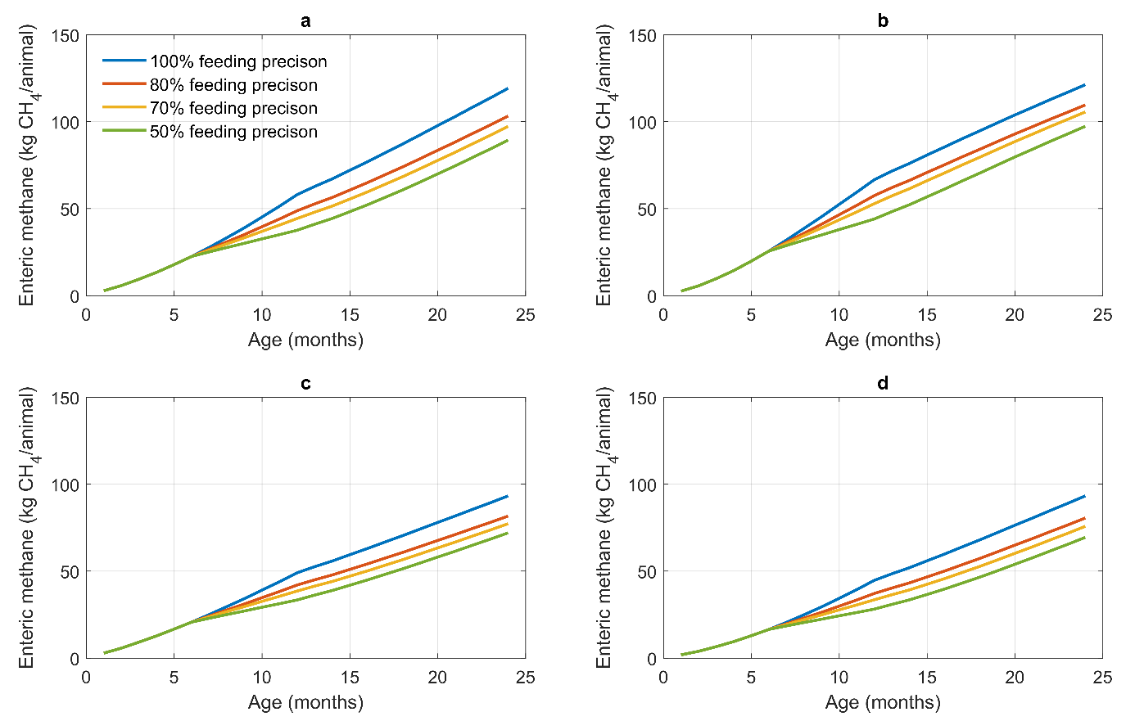
Figure S3. Enteric methane emissions for the considered breeds with different feeding precision levels (100%, 80%, 70% and 50%) and in pasture-based production system with high-yield pastures. a) Charolais, b) Limousin, c) Angus, and d) Alentejana.

Animal nitrogen excretion
In the IPCC’s Tier 2 method, N excretion ($N_{exc}$ – kg N/head.day) depends on the total annual N intake ($N_{intake}$) and total annual N retention ($N_{retention}$) of the animal, according to
 | $N_{exc} = N_{intake}∙\left(1-N_{retention}\right)$. | (10)
$N_{intake}$ depends on the $GE$ and crude protein content in the diet ($\%CP$ – calculated basedin the N intake from the N balance of BalSim), according to
 | $N_{intake}=\frac{GE}{18.45}∙\frac{\%CP}{6.25∙100}$. | (11)
$N_{retention}$ depends on the $Milk$, $Fat$, ${NE}_{g}$ and $WG$ according to
 | $N_{retention} =\frac{Milk∙\left(1.47+0.40∙Fat\right)}{6.38}+WG∙\left(268-\frac{7.03∙{NE}_{g}}{WG}\right)∙\frac{1}{6.25}$. | (12)
According to equation (12), for adult cows $N_{retention}$ depends only on $Milk$ and $Fat$ since $WG$ is zero. For a calf, $N_{retention}$ only depends on $WG$.
Figure S4 presents the accumulated N excretion for all the cattle breads used (Charolais, Limousin, Angus and Alentejana) and 4 different levels of precision feeding (100%, 80%, 70% and 50%) in pasture-based production system with high-yield pastures.
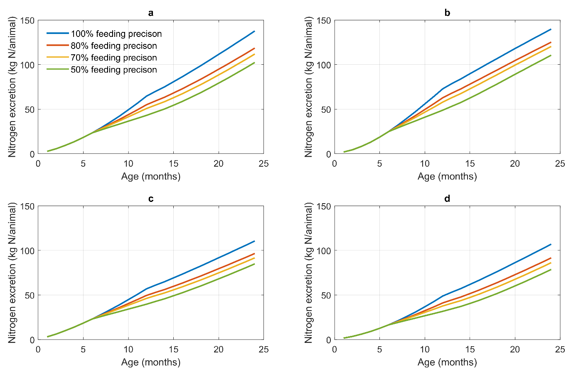
Figure S4. Nitrogen excretion for the considered breeds with different feeding precision levels (100%, 80%, 70% and 50%) and in pasture-based production system with high-yield pastures. a) Charolais, b) Limousin, c) Angus, and d) Alentejana.

Carbon and nitrogen balances during confinement
In order to quantify C and N inflows, outflows and accumulation during confinement, we considered two new C and N sub-balances in relation to the previously available version of BalSim: (i) the animal sub-balance and (ii) the manure management sub-balance. All flows included in the BalSim model during housing are presented in Table 3. The two sub-balance equations are described in Table 4 and explained in detail in the ensuing sub-sections of this paper.

Table S2. Description of all new variables used in this paper to depict BalSim flows additionally to the previous version of the model ⁵. All variables are measured in kg (of carbon or nitrogen) per hectare and year.
Designation in this paper | Description
$$C_{ani_feed}$$ | Carbon uptake by animals through feed supplementation
$$C_{ani_CO2_hous}$$ | Carbon emitted as CO₂ from animal respiration during confinement
$$C_{ani_CH4_hous}$$ | Carbon emitted as CH₄ from animal enteric fermentation during confinement
$$C_{ani_exc_hous}$$ | Carbon excreted by animals as manure during confinement
$$C_{man_exp}$$ | Carbon exported after manure management
$$C_{man_CH4}$$ | Carbon emitted as CH₄ through anaerobic mineralization of manure
$$C_{man_CO2}$$ | Carbon emitted as CO₂ through aerobic mineralization of manure
$$N_{ani_feed}$$ | Nitrogen uptake by animals through feed supplementation
$$N_{ani_exc_hous}$$ | Nitrogen excreted by animals as manure during confinement
$$N_{man_exp}$$ | Nitrogen exported after manure management
$$N_{man_N2O}$$ | Nitrogen emitted as N₂O through direct emissions of manure
$$N_{man_NH3}$$ | Nitrogen emitted as NH₃ through indirect emissions of manure
$$N_{man_leach}$$ | Nitrogen loss through leaching during manure management

Table S3. Carbon (C) and nitrogen (N) balance equations for BalSim during housing. The variables indicated in black were estimated using a combination of measured data and parameters collected from the literature, and variables in blue are unknown in each equation. The variables are explained in Table 1.${∆C}/{∆t}$ and ${∆N}/{∆t}$ the annual C and N accumulation in the animal, respectively.
Balance | Balance equation for C | Balance equation for N
Animal | $$C_{ani_feed}={\left({∆C}/{∆t}\right)}_{ani_hous}+C_{ani_CO2_hous}+C_{ani_CH4_hous}+C_{ani_exc_hous}$$  (13) | $$N_{ani_feed}={\left({∆N}/{∆t}\right)}_{ani_hous}+N_{ani_exc_hous}$$  (14)
Manure | $$C_{ani_exc_hous}=C_{man_exp}+C_{man_CH4}+C_{man_CO2}$$  (15) | $$N_{ani_exc_hous}=N_{man_exp}+N_{man_N2O}+N_{man_NH3}+N_{man_leach}$$  (16)

Animal sub-balance
During confinement, the only source of C and N flowing into the animal is feed (${C/N}_{ani_feed}$). C and N either accumulate in body tissues of animals ${\left(∆C/N⁄∆t\right)}_{ani_hous}$) or are lost in excretions ${C/N}_{ani_exc_stab}$), through breathing ($C_{ani_CO2_hous}$) and CH₄ emissions from enteric fermentation ($C_{ani_CH4_hous}$).
The amount of N in the feed ($N_{ani_feed}$) was calculated using the animal N balance as shown in Table S3. After determining this parameter, we converted it into $C_{ani_feed}$ using the C:N ratio of the supplemental feed, which is approximately 22.5⁶. Accumulation in live tissue was estimated using animal growth. The C and N accumulation was calculated according to the animal growth curves and C and N contents of live tissues, which were 0.487 kg C/kg LW and 0.114 kg N/kg LW ⁷, respectively. We also considered a 60% of water content in cattle bodies⁸, which means that only 40% of weight increases are dry matter. Accumulation was therefore calculated as
 | ${\left(\frac{∆C/N}{∆t}\right)}_{ani_hous}=\left(P_{ani_growth}×0.35\right)×{C/N}_{animal}×P_{stock_calf}$, | (17)
where the stocking rate for calves ($P_{stock_calf}$) was obtained from Teixeira et al.⁵, i.e. 0.27 LU/ha for high-yield pasture and 0.11 LU/ha for low-yield pasture. Only calves are confined and fattened.
As for the outputs, we considered that the total amount of N excreted by the animal ($N_{ani_exc_annual}$) was 60 kg N/head.year ². This value takes into account the number of months that the calf is housed ($M_{hous}$). For example, if the animal is slaughtered at 18 months, $M_{hous}$ is 6 months if we assume that the animal spent the first 12 months in the pasture, and consequently N excreted is 30 kg N/head, which must then be multiplied by the stocking rate considered in each case ($P_{stock_calf}$). Therefore, this N excretion was calculated using
 | $N_{ani_exc_hous}=N_{ani_exc_annual}×M_{hous}×P_{stock_calf}$. | (18)
Carbon excretion ($C_{ani_exc_hous}$) was then obtained assuming a C:N ratio of the manure of 19.1 ^{5,9}. In the C balance there are two additional outflows as atmospheric emissions from CO₂ released during respiration ($C_{ani_CO2_hous}$) and CH₄ from enteric fermentation ($C_{ani_CH4_hous}$). $C_{ani_CH4_hous}$ was calculated using country specific emission factors for calves from Portuguese National Inventory Report (NIR - the average of 67.3 and 45.9 kg CH₄/head.year ²), considering $M_{hous}$ and $P_{stock_calf}$, according to
 | $C_{ani_CH4_hous}=C_{ani_CH4_annual}×M_{hous}×P_{stock_calf}$. | (19)
Finally, $C_{ani_CO2_hous}$ is the only unknown of the C balance for the animal, as can therefore be calculated using
 | $C_{ani_CO2_hous}=C_{ani_feed}-\left[C_{ani_CH4_hous}+C_{ani_exc_hous}+{\left({∆C}/{∆t}\right)}_{ani_hous}\right]$. | (20)

Manure sub-balance
This sub-balance receives C and N from manure excreted during housing (${C/N}_{ani_exc_hous}$) and quantified in the animal sub-balance. There are direct CH₄ emissions ($C_{man_CH4}$), N₂O emissions ($N_{man_N2O_dir}$) and NH₃ emissions ($N_{man_NH3_ind}$), and N losses due the leaching ($N_{man_leach}$) during the management process. We assume no accumulation at the end of the period, so the remainder of the C and N are exported from the farm for latter application to the soil. Emissions during application were considered outside the boundary for this analysis and were omitted.
N₂O emissions and N leached during manure management were calculated using the IPCC method ⁴. According to the NIR ², almost all manure from beef cattle in Portugal are classified as “solid storage”. NH₃ emissions were calculated using the management-specific factors (${EF}_{NH3}$) proposed by the Portuguese NIR ². The direct emission factor (${EF}_{NH3}$) is 0.3 kg N-NH₃/kg N. Thus, the total NH₃ emissions were calculated as
 | $N_{man_NH3}=N_{ani_exc_hous}×{EF}_{NH3}$. | (22)
As for N₂O emissions, N losses due to leaching during manure management are independent of the system according to the emission factors (${EF}_{leach}$) in the Portuguese NIR ² and are 0.1 kg N leached/kg N. Thus, these emissions were calculated as
 | $$N_{man_leach}=N_{ani_exc_hous}×{EF}_{leach}.$$ | (23)
The direct N₂O emission factor (${EF}_{N2O_dir}$) is 0.005 kg N-N₂O/kg N managed ² and the indirect N₂O emission factor (${EF}_{N2O_ind}$) is 0.0075 kg N-N₂O/kg N ². Thus, the total emissions were calculated using
 | $$N_{man_N2O}=N_{ani_exc_hous}×{EF}_{N2O_dir}+(N_{man_NH3}+N_{man_leach})×{EF}_{N2O_ind}.$$ | (21)
Manure exported after manure management is the only unknown variable of N balance, and can therefore be calculated as
 | $$N_{man_exp}=N_{ani_exc_hous}-\left[N_{man_N2O}+N_{man_NH3}+N_{man_leach}\right].$$ | (24)
To obtained $C_{man_exp}$, we used a different C:N ratio than the ratio used by Teixeira et al. ⁵ for the urine and dung excreted during grazing because the C:N ratio of manure changes significantly during management and strongly depends on the management system. To assess how this ratio is affected by management, and in the absence of data from confined systems in Portugal, we performed a literature review. We used the search engine Google Scholar and the keywords “carbon” + “nitrogen” + “cattle” + “manure management”. The search was conducted on August 13, 2019. We obtained about 127,531 records. We then selected only peer-reviewed studies published in books and journals with impact factor according to the 2018 InCites “Journal Citation Reports” from Clarivate Analytics, excluding reports, Master and PhD dissertations and other grey literature sources. As the goal was not to perform a comprehensive meta-analysis, we considered only the first 10 Google Scholar pages, i.e. 100 papers. We only used studies that explicitly report initial and final C:N ratio or C and N content. In the end, only 10 papers fulfilled all the criteria. In these papers, the final C:N ratio is 29% lower than initial C:N ratio (i.e. the management process accumulates nitrogen). Since the initial C:N ratio is 19.1 kg C/kg N, the final C:N ratio used here was therefore 13.4 kg C/kg N.
CH₄ emissions from manure management were calculated using IPCC Tier 2 method ⁴ adapted for Portugal in the NIR ². The first step was to calculate volatile solids excreted ($VS$) according to
 | $$VS=\left[GE×\left(1-\frac{\%DE}{100}\right)+\left(UE×GE\right)\right]×\left(\frac{1-Ash}{18.45}\right)×365,$$ | (25)
where, $GE$ is daily average gross energy intake (167.7 MJ/kg.head), $\%DE$ is digestibility of the feed (60%), $\left(UE×GE\right)$ is urinary energy expressed as fraction of GE (40% of $GE$ for cattle – 67.08 MJ/kg.head), $Ash$ is ash content of manure calculated as a fraction of the dry matter feed intake and 18.45 MJ/kg is the conversion factor for dietary GE per kg of dry matter. Then, $C_{man_CH4}$ was calculated using
 | $C_{man_CH4}=P_{stock_calf}×M_{hous}×VS×B_{o}×0.67×{EF}_{man_CH4}$, | (26)
where $B_{o}$ is maximum methane production capacity from manure (m³/kg VS), ${EF}_{man_CH4}$ is the methane conversion factor (4%) and 0.67 is conversion factor of m³ into kg.
Finally, the last unknown in the manure sub-balance are the CO₂ emissions during management ($C_{man_CO2}$), which can therefore be calculated as
 | ${C_{man_CO2}=C}_{ani_exc_hous}-\left(C_{man_exp}+C_{man_CH4}\right)$. | (27)

Environmental indicators calculated using the balances
The non-CO₂ GHG balance was calculated as
 | $GHG \left[kg\frac{{CO}_{2}e}{ha}.yr\right]=N_{{litter}_{N2O}}∙\frac{M_{N2O}}{M_{N}}∙{GWP}_{N2O}+C_{{animal}_{CH4}}∙\frac{M_{CH4}}{M_{C}}∙{GWP}_{CH4}+C_{dun_{CH4}}∙\frac{M_{CH4}}{M_{C}}∙{GWP}_{CH4}+N_{dun_{N2O}}∙\frac{M_{CO2}}{M_{N}}∙{GWP}_{N2O}+N_{soil_{N2O}}∙\frac{M_{N2O}}{M_{N}}∙{GWP}_{N2O}+N_{{legume}_{N2O}}∙\frac{M_{N2o}}{M_{N}}∙{GWP}_{N2O}+C_{{man}_{CH4}}∙\frac{M_{CH4}}{M_{C}}∙{GWP}_{CH4}+N_{{man}_{N2O}}∙\frac{M_{N2O}}{M_{N}}∙{GWP}_{N2O}+C_{feed}∙\frac{1}{M_{C}}∙{EF}_{feed}+{GHG}_{{pasture}_{insallation}}+{GHG}_{{pasture}_{maintenance}}-N_{man_exp}∙{EF}_{man_exp}$, | (17)
where the C and N fluxes were converted into emissions using the respective molecular/atomic weights and converted into CO₂e using the IPCC global warming potentials (GWP) without climate feedbacks¹⁰ (GWP_{CO2}=1, GWP_{CH4}=28, GWP_{N2O}=298). We discounted the GHG emissions of inorganic N fertilizer production correspondent to the manure exported ($N_{man_exp}$), and the emissions factor (${EF}_{man_exp}$) is 4 kg CO2e/kg N¹¹$. {GHG}_{pasture_installation}$ are the emissions of the pasture installation, which is only associated with the high-yield system, as the low-yield pasture system is semi-natural without any major agricultural operations except frequent tillage for shrub control. The high-yield pasture system was inspired by the grass-legume sown biodiverse pasture systems in Portugal, which is self-reseeding and can be maintained for at least 10 years (in some cases 25 years). We therefore allocated GHG emissions of installation equally between the 10 years. The GHG emissions were calculated according
 | ${GHG}_{pasture_installation} =\left({SC}_{lime_ins}∙{EF}_{lime}+{EF}_{{SC}_{transport}}+{EF}_{{SC}_{application}}+{EF}_{{SP}_{Tillage}}+{EF}_{{SP}_{Scrolling}}+{SowC}_{seeds}∙{EF}_{seeds}+{EF}_{application}+{FC}_{Super_ins}∙{EF}_{Super}+{FC}_{Borax}∙{EF}_{Borax}+{FC}_{Zinc}∙{EF}_{Zinc}+{EF}_{{FC}_{transport}}+{EF}_{{FC}_{application}}\right)∙\frac{1}{10}$. | (17)
All variables are defined in Table S1. ${GHG}_{pasture_maintenance}$ are the GHG emissions of maintaining the pastures. For low-yield pasture, tillage operation was the only source of emissions, and therefore
 | ${GHG}_{pasture_maintenance} ={EF}_{{SP}_{Tillage}}$. | (17)
For the high-yield pasture, GHG emissions were calculated using
 | ${GHG}_{pasture_maintenance} ={SC}_{lime_main}∙{EF}_{lime}+{EF}_{{SC}_{transport}}+{EF}_{{SC}_{application}}+{FC}_{Super_main}∙{EF}_{Super_main}+{FC}_{Borax}∙{EF}_{Borax}+{FC}_{Zinc}∙{EF}_{Zinc}+{EF}_{{FC}_{transport}}+{EF}_{{FC}_{application}}$. | (17)

References used in this file
1. Teixeira, R. F. M., Proença, V., Crespo, D., Valada, T. & Domingos, T. A conceptual framework for the analysis of engineered biodiverse pastures. Ecol. Eng. 77, 85–97 (2015).
2. APA. Portuguese National Inventory Report on Greenhouse Gases, 1990 - 2018. (2018).
3. Marques, G. M. et al. Minimizing direct greenhouse gas emissions in livestock production: The need for a metabolic theory. Ecol. Modell. 434, 109259 (2020).
4. IPCC. 2006 IPCC Guidelines for National Greenhouse Gas Inventories. Institute for Global Environmental Strategies (IGES) for the Intergovernmental Panel on Climate Change. (2006).
5. Teixeira, R. F. M., Barão, L., Morais, T. G. & Domingos, T. ‘BalSim’: A carbon, nitrogen and greenhouse gas mass balance model for pastures. Sustainability 11, 53 (2019).
6. Costa, P. et al. Effect of low- and high-forage diets on meat quality and fatty acid composition of Alentejana and Barrosã beef breeds. Animal 6, 1187–97 (2012).
7. Kooijman, S. a. L. M. Dynamic Energy Budget theory for metabolic organisation : Summary of concepts of the third edition. Water (2010). doi:10.1098/rstb.2010.0167.
8. Bonilha, E. F. M. et al. Body chemical composition, tissue deposition rates and gain composition of young Nellore cattle selected for postweaning weight. Rev. Bras. Zootec. 43, 175–182 (2014).
9. Aguilera, E. et al. A historical perspective on soil organic carbon in Mediterranean cropland (Spain, 1900–2008). Sci. Total Environ. 621, 634–648 (2018).
10. IPCC. Climate Change 2013 - The Physical Science Basis. Climate Change 2013 - The Physical Science Basis (2014). doi:10.1017/cbo9781107415324.
11. Köhl, M., Möllmann, C., Fromm, J., Kraus, G. & Mues, V. Land- und Forstwirtschaft, Fischerei. in Hamburger Klimabericht – Wissen über Klima, Klimawandel und Auswirkungen in Hamburg und Norddeutschland (2017). doi:10.1007/978-3-662-55379-4_7.

