Supplementary information

Photo-luminochromism of organic crystals arising from subtle molecular rearrangement

Zihao Zhao¹, Yusong Cai¹, Qiang Zhang¹, Anze Li¹, Tianwen Zhu¹, Xiaohong Chen¹ & Wang Zhang Yuan¹*

¹School of Chemistry and Chemical Engineering, Frontiers Science Center for Transformative Molecules, Shanghai Jiao Tong University, No. 800 Dongchuan Rd., Minhang District, Shanghai 200240, China
✉e-mail: wzhyuan@sjtu.edu.cn

Table of contents

Experimental

Supplementary Figures and Tables

References

Experimental
Synthesis of dimethyl terephthalate (DMTPA). 1.7 mL of triethylamine (Et₃N), 0.49 mL of methanol and 10 mL of dichloromethane (DCM) were separately added into a 50 mL round-bottom flask. Afterwards, 2.03 g of terephthaloyl chloride dissolved in 5 mL of DCM was added dropwise into the flask under N₂ through a syringe under vigorous stirring, when the system was cooled to 0 ºC by ice-water bath. The mixture was then heated to room temperature and reacted for 2 h, monitored by TLC. After quenched by 10 mL of pure water, the organic phase was separated, washed with brine three times and dried by anhydrous magnesium sulfate overnight. After the removal of the solvent with a rotary evaporator under reduced pressure, the crude product was purified by column chromatography with n-hexane/ethyl acetate (EA) (v/v = 6/1) as eluent. A withe solid was obtained in 93.8% yield (1.82 g) after being dried in vacuum at 40 ºC overnight. Single crystals for further characterization were obtained by slowly cooling its hot and saturated EA solution. ¹H NMR (500 MHz, CDCl₃) δ (ppm) 8.10 (s, 4H), 3.94 (s, 6H) (Supplementary Fig. 1). ¹³C NMR (125 MHz, CDCl₃) δ (ppm) 166.42, 134.04, 129.69, 52.57 (Supplementary Fig. 2). The purity of DMTPA is proved by HPLC analysis (Supplementary Fig. 16).
Synthesis of diethyl terephthalate (DETPA). DETPA was synthesized via the similar procedures to those of DMTPA described above. A white solid was obtained in 92.7% yield. Single crystals for further characterization were obtained by slowly cooling its hot and saturated EA solution. ¹H NMR (500 MHz, CDCl₃) δ (ppm) 8.10 (s, 4H), 4.40 (q, J = 7.1 Hz, 4H), 1.41 (t, J = 7.1 Hz, 6H) (Supplementary Fig. 3). ¹³C NMR (125 MHz, CDCl₃) δ (ppm) 165.98, 134.30, 129.59, 61.53, 14.41 (Supplementary Fig. 4). The purity of DETPA is proved by HPLC analysis (Supplementary Fig. 32).
Synthesis of diisopropyl terephthalate (DiPTPA). DiPTPA was synthesized via the similar procedures to those of DMTPA described above. A white solid was obtained in 95.2% yield. Single crystals of DiPTPA for further characterization were obtained by slowly cooling its hot and saturated EA solution. ¹H NMR (500 MHz, DMSO-d₆) δ (ppm) 8.05 (s, 4H), 5.16 (sep, J = 6.2 Hz, 2H), 1.33 (d, J = 6.3 Hz, 12H) (Supplementary Fig. 5). ¹³C NMR (125 MHz, DMSO-d₆) δ (ppm) 164.48, 133.98, 129.31, 68.77, 21.56 (Supplementary Fig. 6). The purity of DiPTPA is proved by HPLC analysis (Supplementary Fig. 33).
Purification of dimethyl 2,6-naphthalenedicarboxylate. Commercially available dimethyl 2,6-naphthalenedicarboxylate was firstly purified by column chromatography with n-hexane/EA (v/v = 6/1) as eluent and dried in vacuum at 40 ºC overnight. The obtained solid was further purified by recrystallization through slowly cooling its hot and saturated EA solution. The resulting crystals were collected through filtration and then dissolved in EA for further purification and single crystal cultivation. Single crystals were obtained by slowly evaporating its dilute EA solution at room temperature. ¹H NMR (500 MHz, CDCl₃) δ (ppm) 8.63 (s, 2H), 8.12 (d, J = 8.5 Hz, 2H), 8.00 (d, J = 8.6 Hz, 2H), 4.00 (s, J = 1.2 Hz, 6H) (Supplementary Fig. 7). ¹³C NMR (125 MHz, CDCl₃) δ (ppm) 167.00, 134.73, 130.80, 129.73, 129.66, 126.16, 52.58 (Supplementary Fig. 8).
Purification of monomethyl terephthalate (MMTPA). Commercially available MMTPA was firstly purified by column chromatography with DCM/EA (v/v = 1/1) as eluent and dried in vacuum at 40 ºC overnight. The obtained MMTPA was further purified by recrystallization performed through slowly cooling its hot and saturated EA/methanol solution. The resulting crystals were collected through filtration and then dissolved in EA for further purification and single crystal cultivation. Single crystals of MMTPA were obtained by slowly evaporating its dilute EA solution at room temperature. ¹H NMR (500 MHz, DMSO-d₆) δ (ppm) 13.34 (s, 1H), 8.05 (d, J = 2.4 Hz, 4H), 3.88 (s, 3H) (Supplementary Fig. 9). ¹³C NMR (125 MHz, DMSO-d₆) δ (ppm) 166.57, 165.62, 134.82, 133.17, 129.61, 129.36, 52.46 (Supplementary Fig. 10). The purity of MMTPA is proved by HPLC analysis (Supplementary Fig. 55).
Purification of terephthalic acid (TPA). Commercially available TPA was firstly purified by RP-C18 column chromatography and dried in vacuum at 40 ºC overnight. The obtained TPA was further purified by slowly evaporating its dilute dimethyl sulfoxide (DMSO) solution at 30 ºC. Unfortunately, we failed to acquire TPA single crystals due to the excessively strong interactions among the molecules. The powder crystals were obtained instead, whose crystalline nature is verified by the sharp and intense peaks in XRD patterns. ¹H NMR (500 MHz, DMSO-d₆) δ (ppm) 13.29 (s, 2H), 8.04 (s, 4H) (Supplementary Fig. 11). ¹³C NMR (125 MHz, DMSO-d₆) δ (ppm) 167.14, 134.90, 129.92 (Supplementary Fig. 12).
Purification of methyl 4-(aminocarbonyl)benzoate. Commercially available methyl 4-(aminocarbonyl)benzoate was purified by recrystallization performed through slowly cooling its hot and saturated EA solution. The resulting crystals were collected through filtration and then dissolved in EA for further purification and single crystal cultivation. Single crystals were obtained by slowly evaporating its dilute EA solution at room temperature. ¹H NMR (500 MHz, DMSO-d₆) δ (ppm) 8.14 (s, 1H), 8.05 – 7.95 (m, 4H), 7.56 (s, 1H), 3.88 (s, 3H) (Supplementary Fig. 13). ¹³C NMR (125 MHz, DMSO-d₆) δ (ppm) 167.03, 165.75, 138.44, 131.80, 129.07, 127.83, 52.37 (Supplementary Fig. 14).
Supplementary Figures and Tables
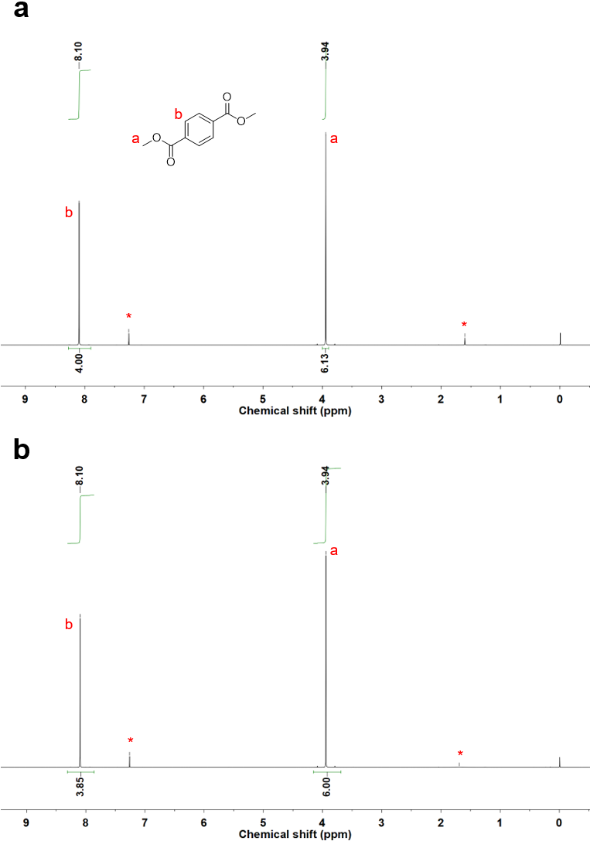
Supplementary Fig. 1. ¹H NMR spectra of DMTPA (a) before and (b) after 12 h of 312 nm UV irradiation.
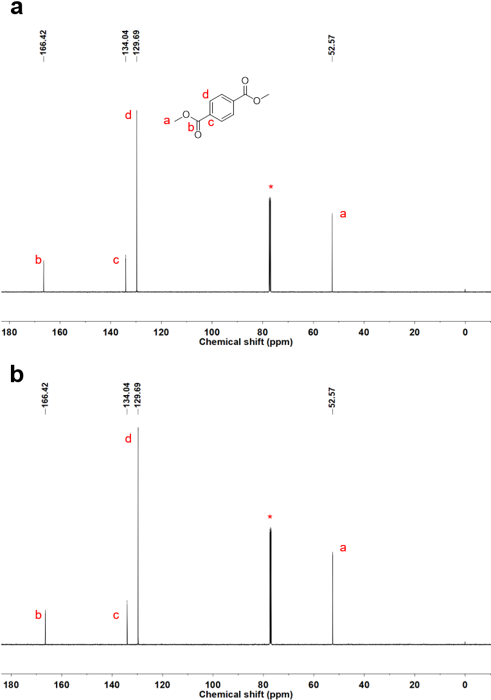
Supplementary Fig. 2. ¹³C NMR spectra of DMTPA (a) before and (b) after 12 h of 312 nm UV irradiation.
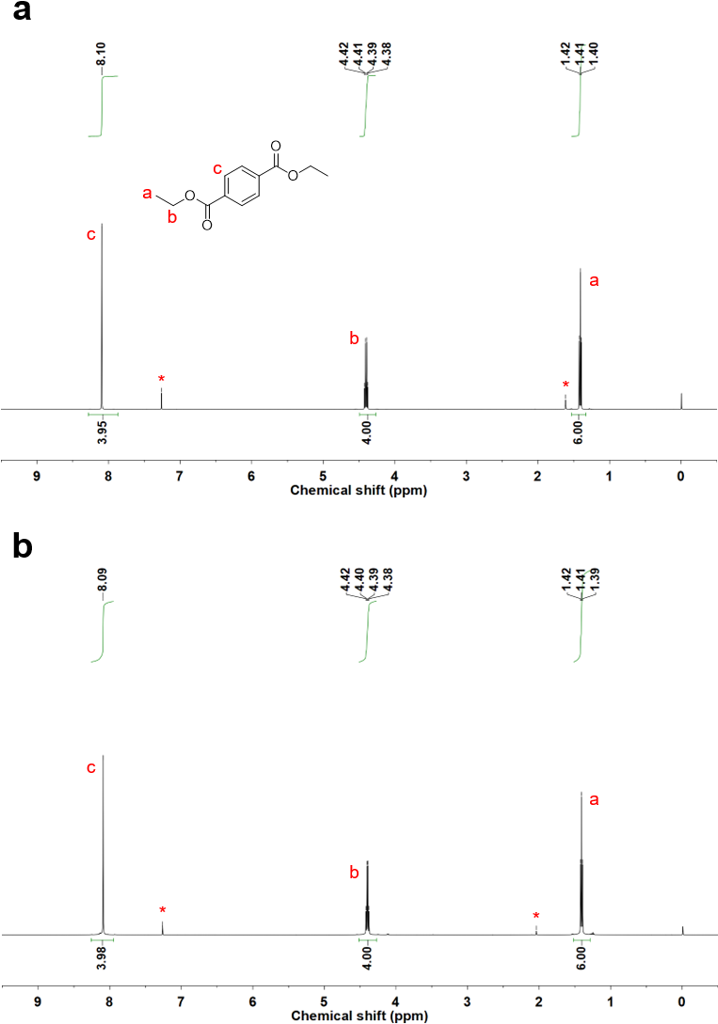
Supplementary Fig. 3. ¹H NMR spectra of DETPA (a) before and (b) after 12 h of 312 nm UV irradiation.
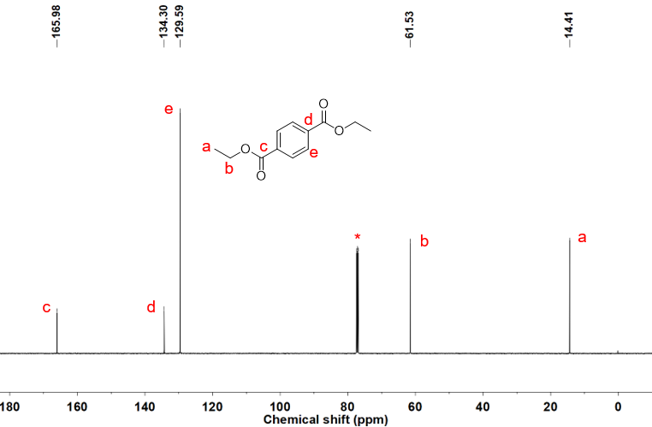
Supplementary Fig. 4. ¹³C NMR spectra of DETPA.
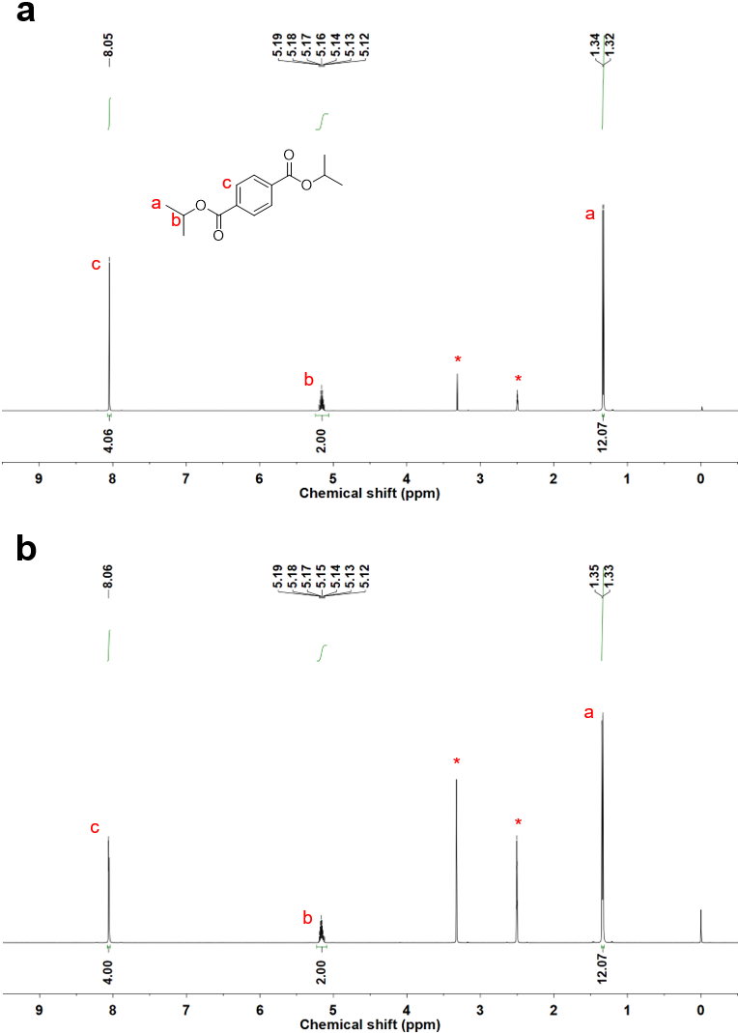
Supplementary Fig. 5. ¹H NMR spectra of DiPTPA (a) before and (b) after 12 h of 312 nm UV irradiation.
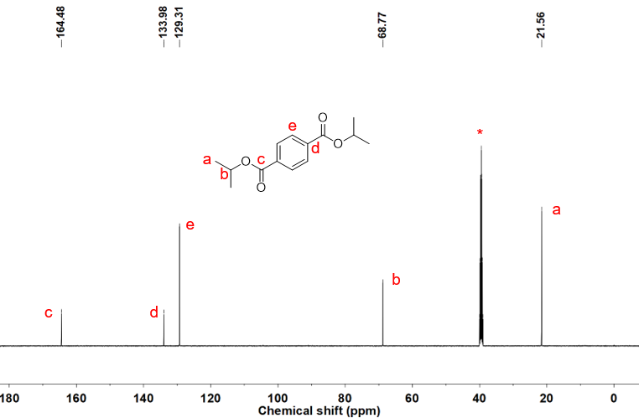
Supplementary Fig. 6. ¹³C NMR spectra of DiPTPA.
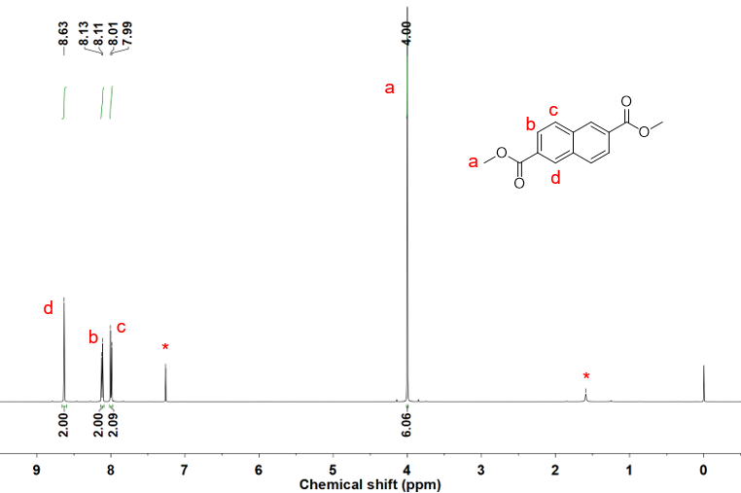
Supplementary Fig. 7. ¹H NMR spectra of dimethyl 2,6-naphthalenedicarboxylate.
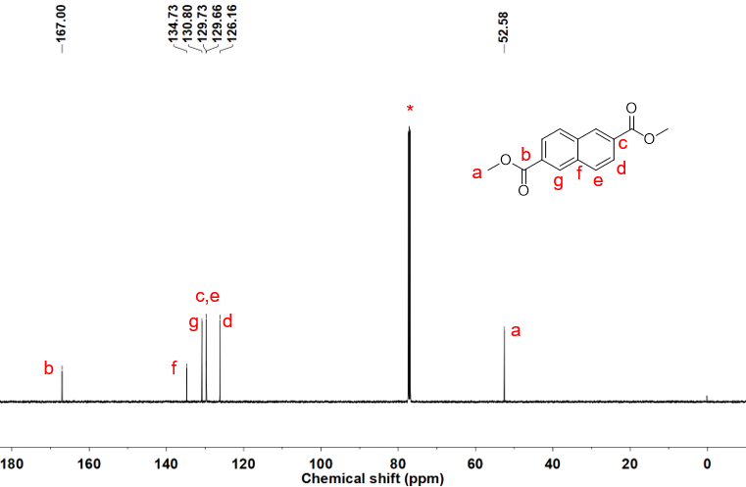
Supplementary Fig. 8. ¹³C NMR spectra of dimethyl 2,6-naphthalenedicarboxylate.
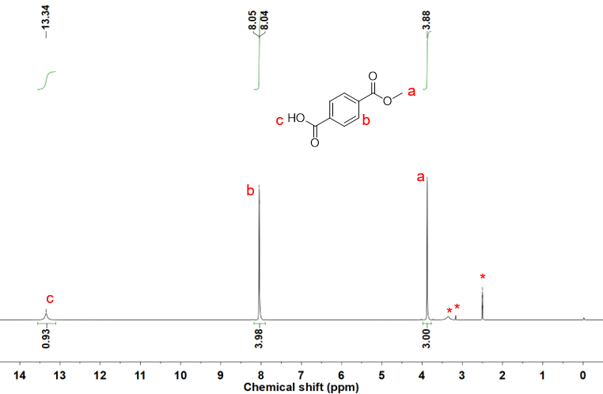
Supplementary Fig. 9. ¹H NMR spectra of MMTPA.
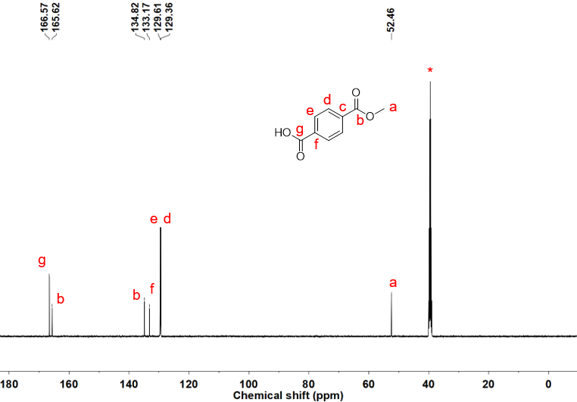
Supplementary Fig. 10. ¹³C NMR spectra of MMTPA.
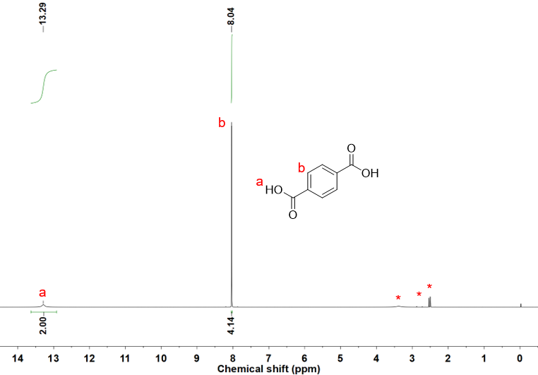
Supplementary Fig. 11. ¹H NMR spectra of TPA.
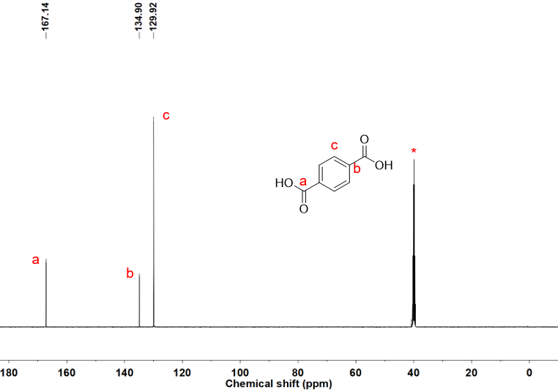
Supplementary Fig. 12. ¹³C NMR spectra of TPA.
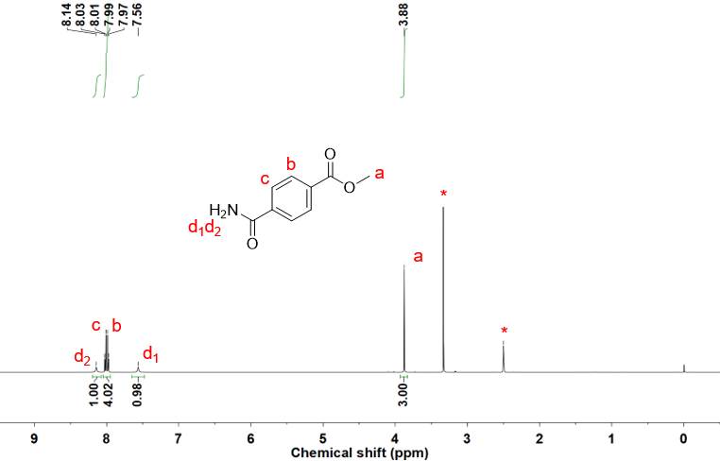
Supplementary Fig. 13. ¹H NMR spectra of methyl 4-(aminocarbonyl)benzoate.
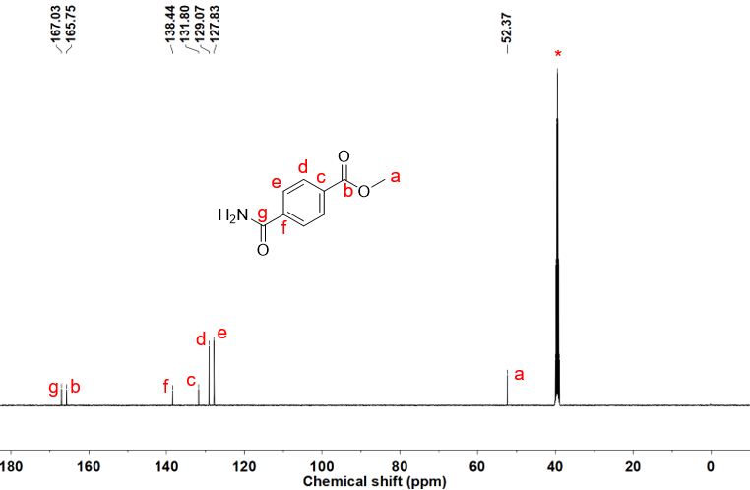
Supplementary Fig. 14. ¹³C NMR spectra of methyl 4-(aminocarbonyl)benzoate.
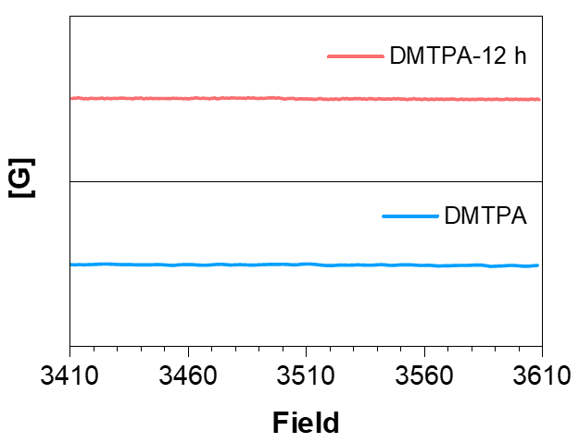
Supplementary Fig. 15. EPR spectra of DMTPA crystals before and after 12 h of 312 nm UV irradiation.
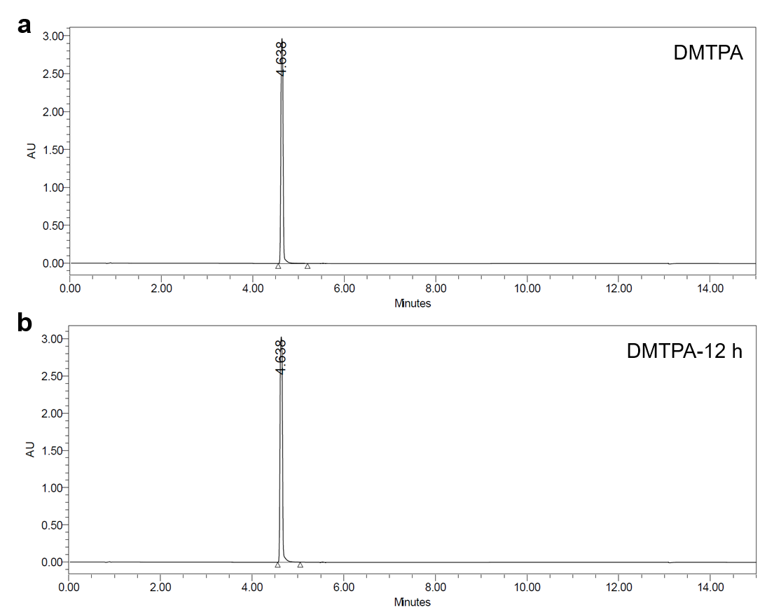
Supplementary Fig. 16. HPLC results for DMTPA crystals (a) before and (b) after 12 h of 312 nm UV irradiation.
Supplementary Note 1. To accumulate the products of the possible photochemical reactions, DMTPA crystals were irradiated by 312 nm UV light for 12 h before corresponding NMR, EPR and HPLC analyses, whose results show no difference from those of unstimulated DMTPA crystals, suggesting the PL transformation is not caused by photochemical changes on DMTPA molecules.
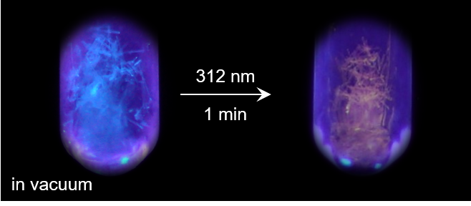
Supplementary Fig. 17. The luminescent photographs of PL colour transformation process of DMTPA crystals in a vacuum under 312 nm UV irradiation.
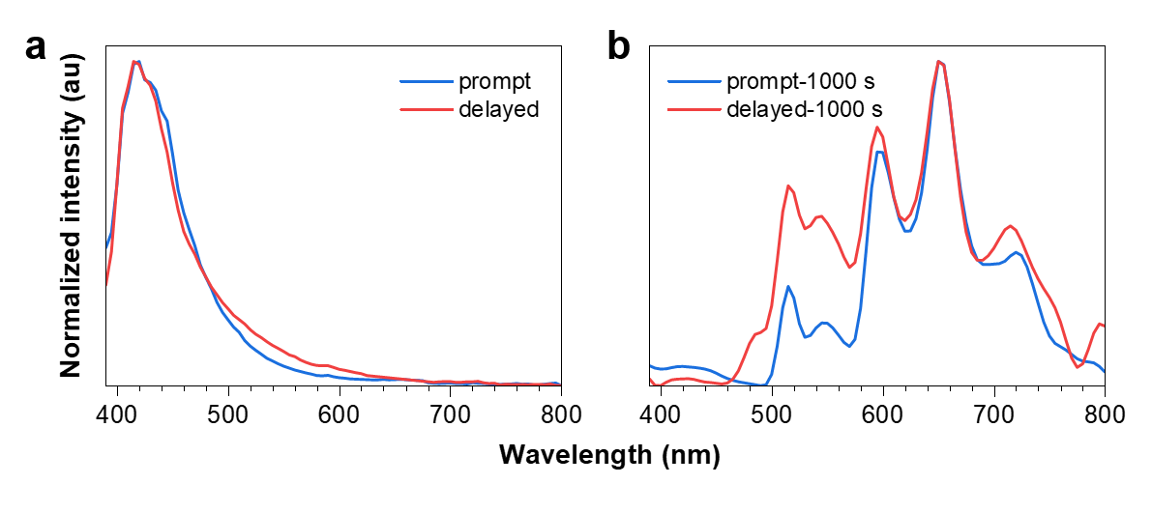
Supplementary Fig. 18. Prompt and delayed (t_{d} = 1 ms) emission spectra of DMTPA crystals (a) before and (b) after 1000 s of 312 nm UV irradiation (λ_{ex} = 312 nm).
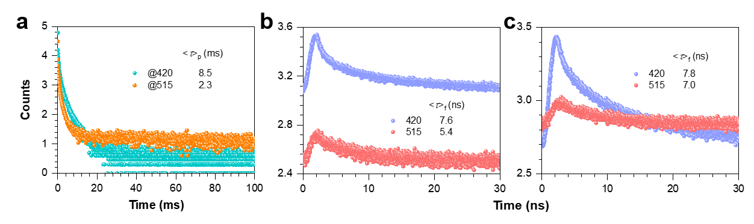
Supplementary Fig. 19. (a) Millisecond scale lifetimes for DMTPA crystals before UV irradiation (λ_{ex} = 312 nm). Nanosecond scale lifetimes for DMTPA crystals (b) before and (c) after 312 nm UV irradiation (λ_{ex} = 312 nm). Except those at 420 and 515 nm, no nanosecond scale lifetimes can be detected at other peaks in emission spectra of DMTPA crystals.
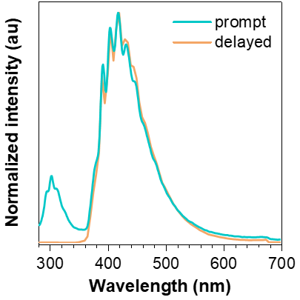
Supplementary Fig. 20. Prompt and delayed emission spectra of 10⁻⁵ M DMTPA/2-MTHF solution at 77 K.
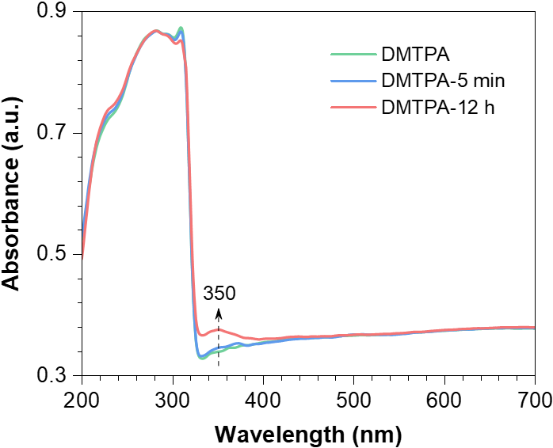
Supplementary Fig. 21. Absorption of DMTPA crystals before and after 5 min and 12 h of 312 nm UV irradiation.
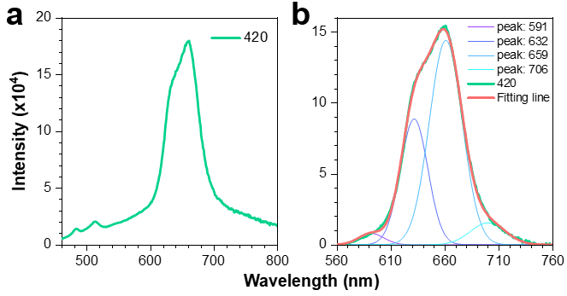
Supplementary Fig. 22. (a) Emission spectrum and (b) corresponding multi-peaks Gaussian fitting of DMTPA crystals after 1000 s of 312 nm UV irradiation (λ_{ex} = 420 nm).
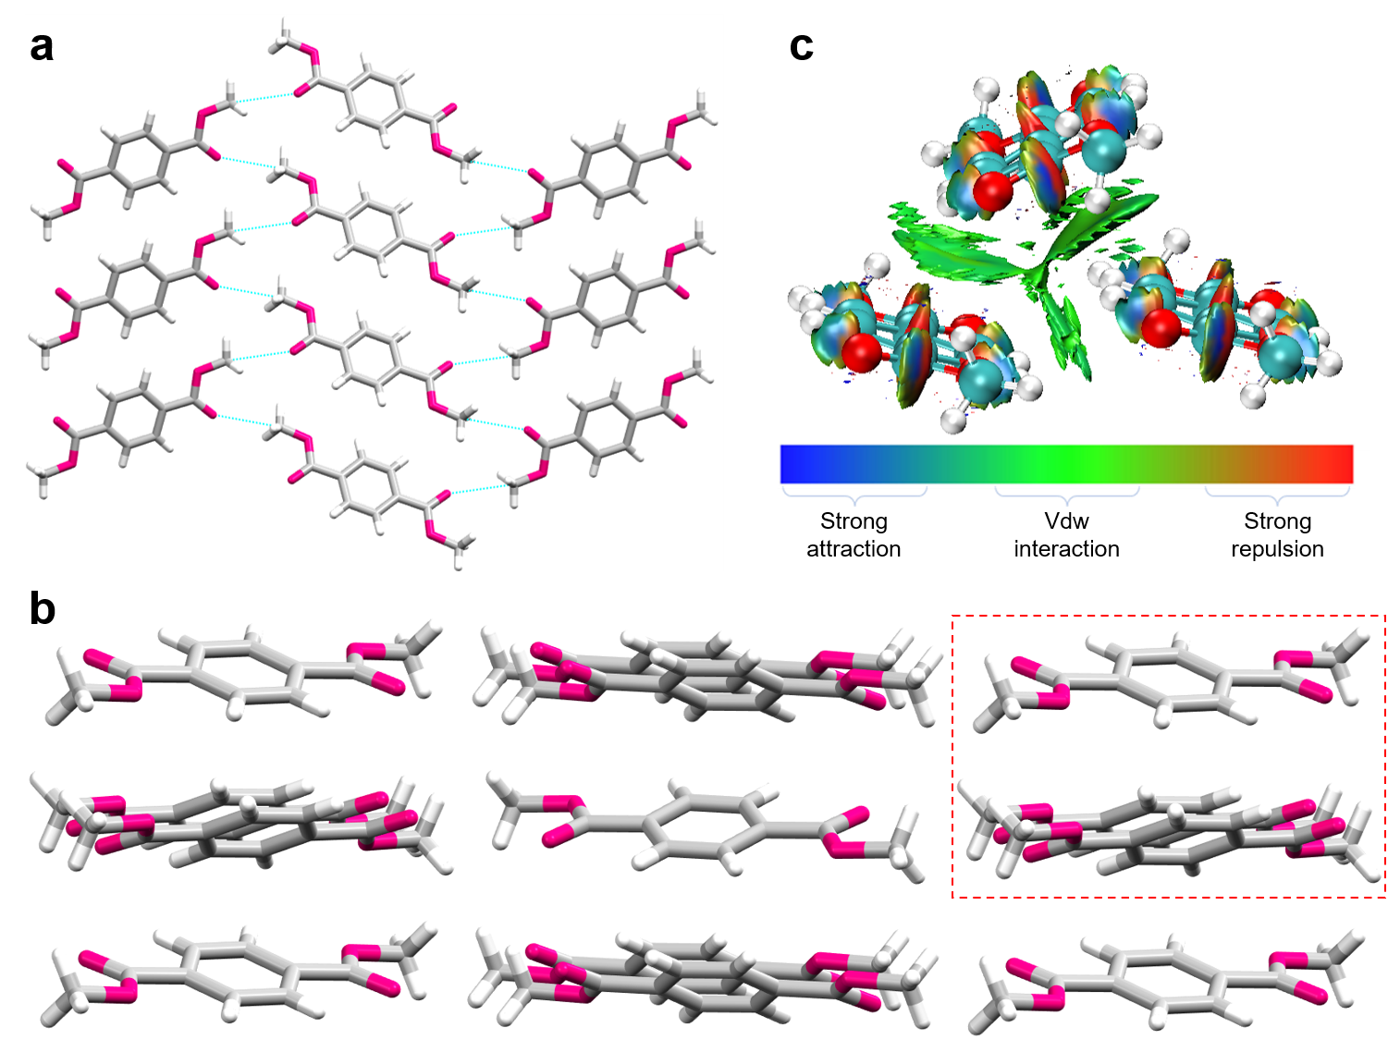
Supplementary Fig. 23. (a, b) Single crystal structure and fragmental molecular packing of DMTPA. (c) The noncovalent interactions (NCI) plot of DMTPA trimer marked by dashed box in (b). The green area among DMTPA molecules implies the widespread edge-to-face π-π interactions.
Supplementary Note 2. Noncovalent interactions (NCI) analysis can be used to visualize secondary bonds, such as hydrogen bonds and van der Waals (VDW) interactions^{1,2}. Labelled in different colours, the strong repulsion, VDW interactions and strong attractions are identified clearly in NCI plots. Therefore, the green area in Supplementary Fig. 10c indicates obvious edge-to-face π-π interactions among the DMTPA trimer, which can construct a widespread through-space conjugation (TSC) network throughout the crystal lattice.
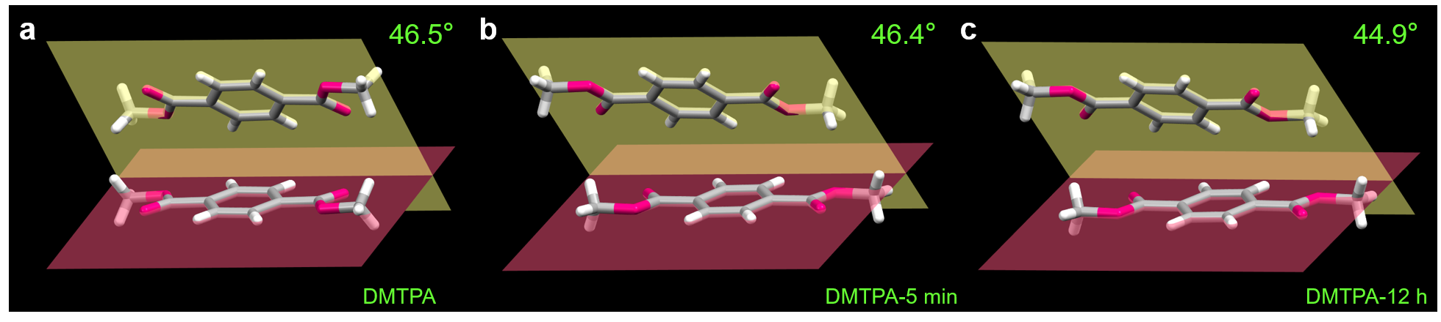
Supplementary Fig. 24. The transformation of dihedral angle between two DMTPA molecules in crystal (a) before and after (b) 5 min and (c) 12 h of 312 nm UV irradiation.
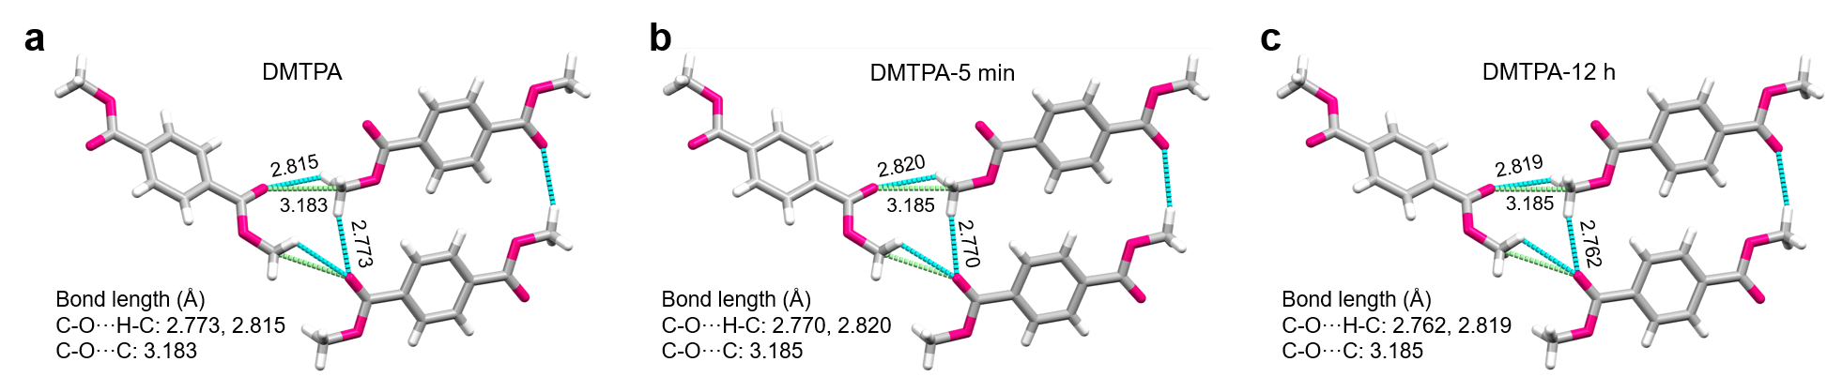
Supplementary Fig. 25. The transformation of bond lengths of denoted intermolecular interactions in DMTPA crystal (a) before and after (b) 5 min and (c) 12 h of 312 nm UV irradiation.
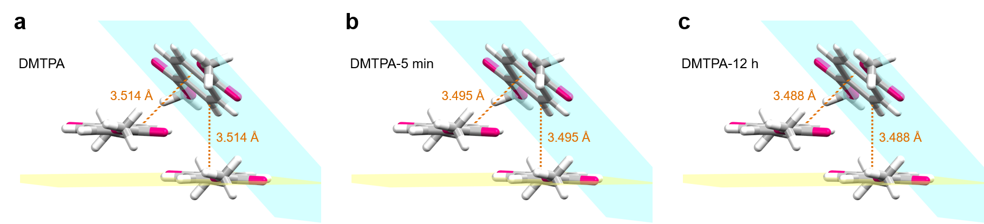
Supplementary Fig. 26. The transformation of distances between DMTPA molecules with edge-to-face π-π interactions in crystal (a) before and after (b) 5 min and (c) 12 h of 312 nm UV irradiation.
Supplementary Table 1. Single crystal data of DMTPA before and after 12 h of 312 nm UV irradiation.
 | DMTPA | DMTPA-12 h
Formula | C₁₀H₁₀O₄ | C₁₀H₁₀O₄
Formula Weight | 194.18 | 194.18
Wavelength (Å) | 1.54178 | 0.70173
Space Group | Pbca | Pbca
Cell Length (Å) | a=7.1191 (7)  b=6.0236 (5)  c=21.9995 (15) | a=7.1131 (6)  b=6.0159 (5)  c=21.9960 (17)
Cell Angle (°) | α=90  β=90  γ=90 | α=90  β=90  γ=90
Cell Volume (Å³) | 943.40 (14) | 941.25 (13)
Z | 4 | 4
Density (g/cm³) | 1.367 | 1.370
F (000) | 408.0 | 408.0
h_{max}, k_{max}, l_{max} | 8, 7, 26 | 8, 7, 26
T_{min}, T_{max} | 0.806, 0.835 | 0.881, 0.914
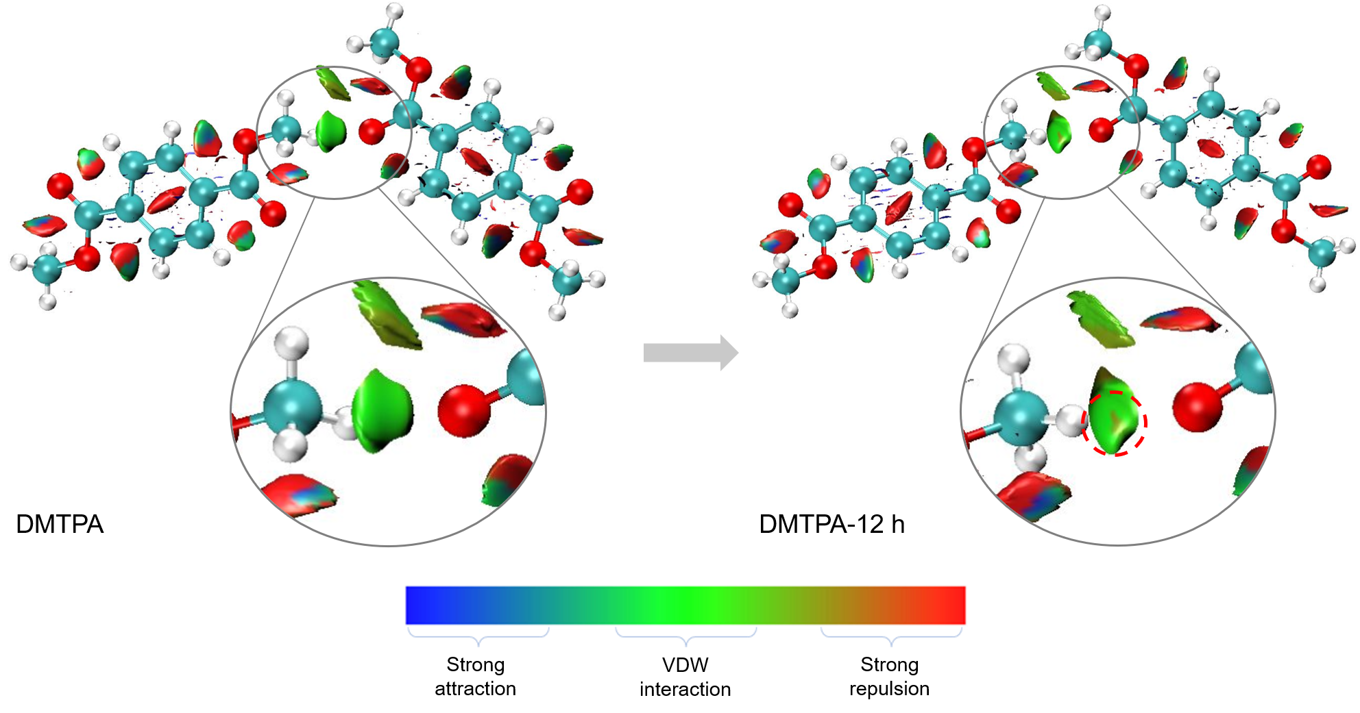
Supplementary Fig. 27. The NCI plot of transversely arranged DMTPA molecules before and after 12 h of 312 nm UV irradiation. The small red area labelled by the dashed circle in DMTPA-12 h suggests the presence of repulsion between these two molecules after UV stimulus, which leads to the impairing of corresponding short contacts. The theoretically calculated result shows superior consistence with the above experimental results.
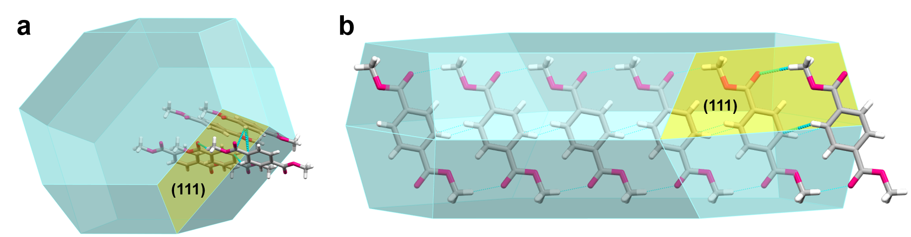
Supplementary Fig. 28. Predicted crystal morphology and intermolecular interactions corresponding to crystal face (111).
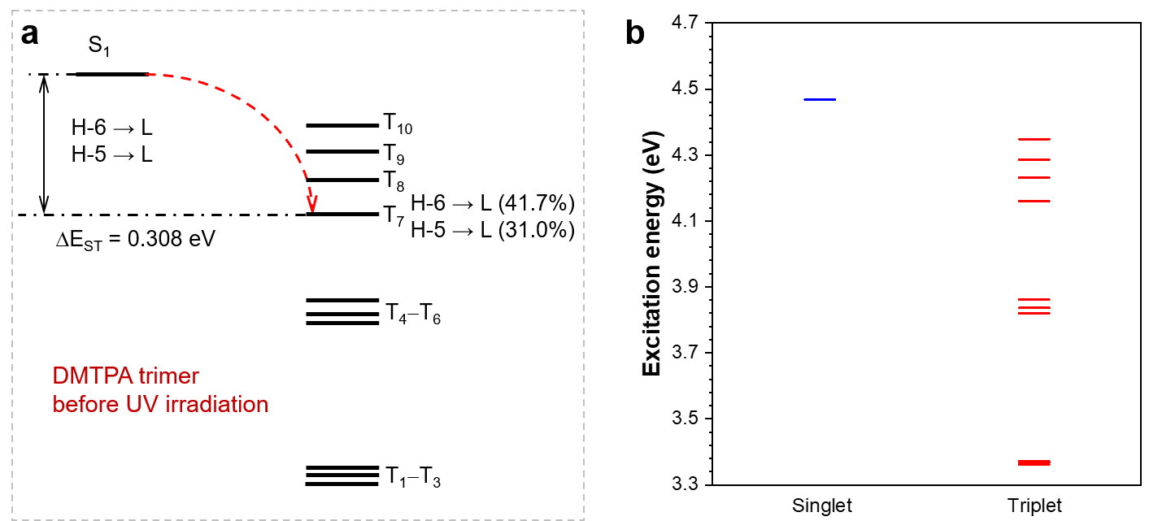
Supplementary Fig. 29. (a) The ISC channels and (b) excitation energy diagram of DMTPA trimer before exposed to 312 nm UV irradiation.
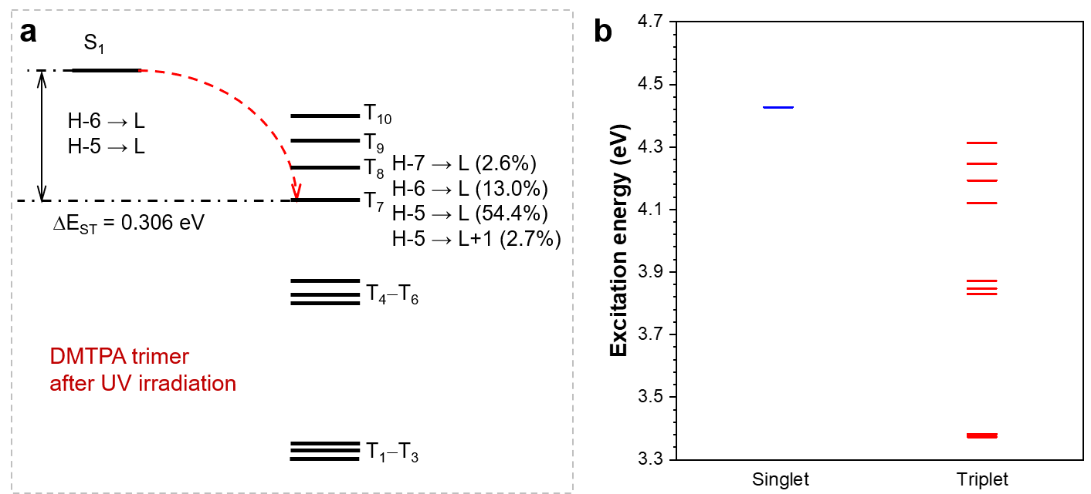
Supplementary Fig. 30. (a) The ISC channels and (b) excitation energy diagram of DMTPA trimer after 12 h of 312 nm UV irradiation.
Supplementary Fig. 31. (a) Luminescent photographs of liquid nitrogen quenched DMTPA solid and its ground powder under 312 nm UV irradiation with different exposure time. (b) XRD patterns of the crystals, liquid nitrogen quenched solid and ground powder of DMTPA.
Supplementary Note 3. To verify the necessity of crystal structure for the PLC property of these compounds, the liquid nitrogen quenched DMTPA solid and its ground powder were investigated. As Supplementary Fig. 31a shows, although the liquid nitrogen quenched DMTPA solid still exhibit PLC emission from blue to magenta under 312 nm UV irradiation, the range of PL variation becomes narrower compared with that of DMTPA crystals, together with slower response time. As the quenched solid is further ground into powders, the PLC phenomenon becomes inconspicuous. Notably, no obvious PLC behaviors can be noticed even when the solid is placed in vacuum. The XRD patterns of these samples reveal a gradual decrease in crystallization degree (Supplementary Fig. 31b), demonstrating the high consistency between PLC and the crystallinity of DMTPA.
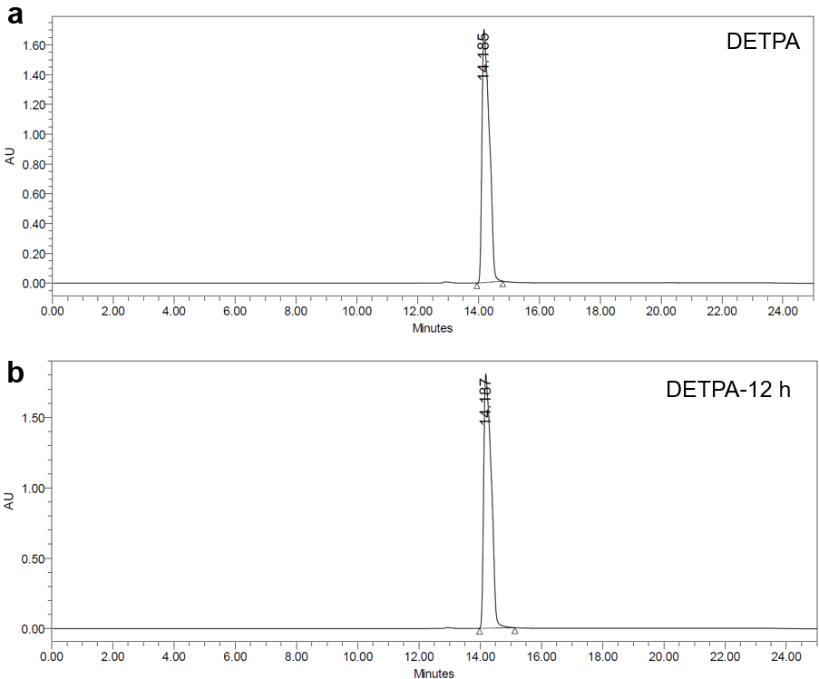
Supplementary Fig. 32. HPLC results for DETPA crystals (a) before and (b) after 12 h of 312 nm UV irradiation.
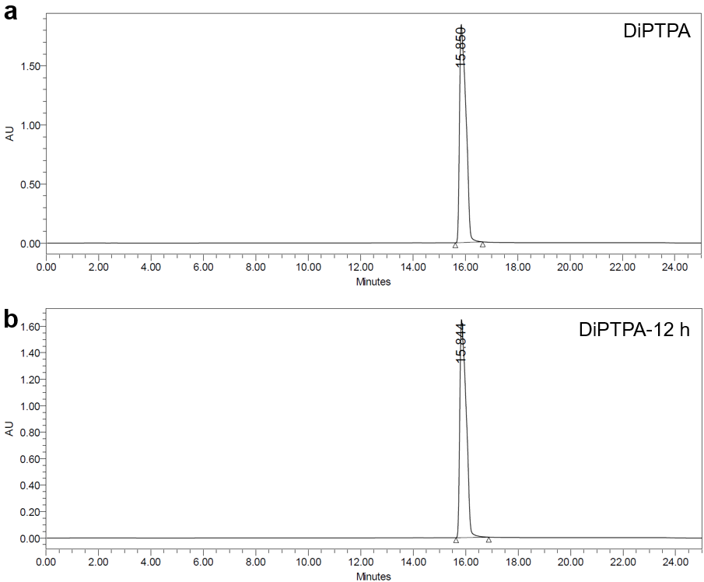
Supplementary Fig. 33. HPLC results for DiPTPA crystals (a) before and (b) after 12 h of 312 nm UV irradiation.
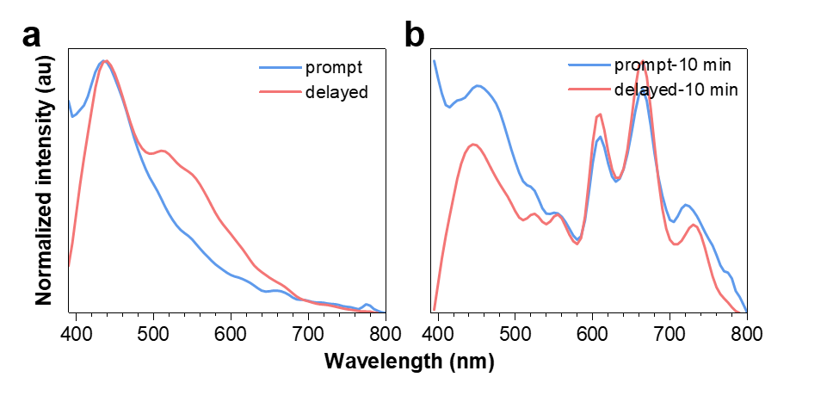
Supplementary Fig. 34. Prompt and delayed (t_{d} = 1 ms) emission spectra of DETPA crystals (a) before and (b) after 10 min of 312 nm UV irradiation (λ_{ex} = 312 nm).
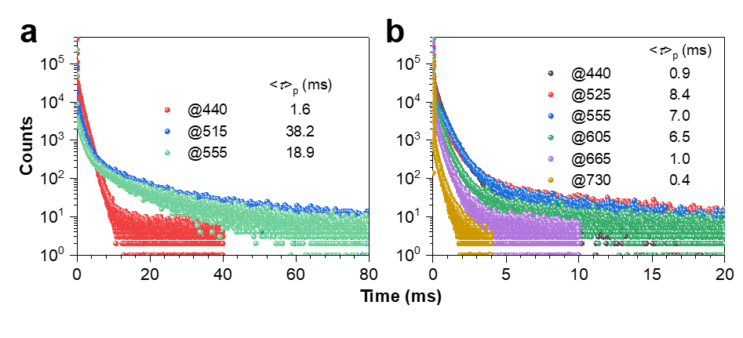
Supplementary Fig. 35. Millisecond-scale lifetimes for DETPA crystals (a) before and (b) after 312 nm UV irradiation (λ_{ex} = 312 nm).
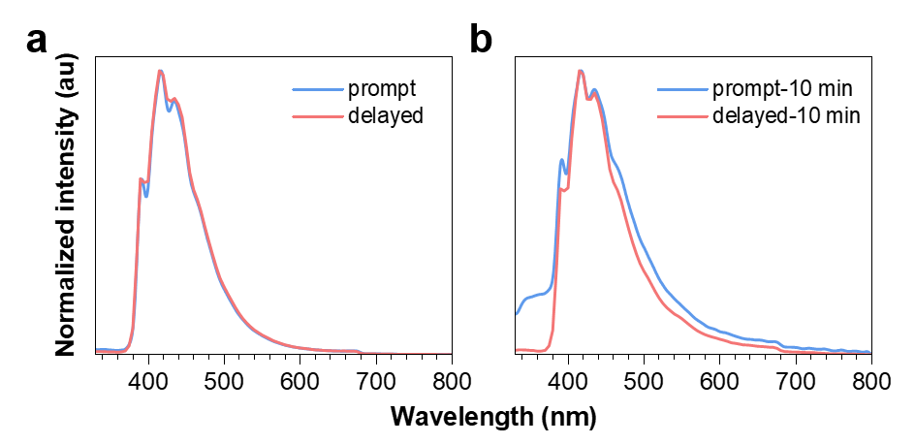
Supplementary Fig. 36. Prompt and delayed (t_{d} = 1 ms) emission spectra of DiPTPA crystals (a) before and (b) after 10 min of 312 nm UV irradiation (λ_{ex} = 312 nm).
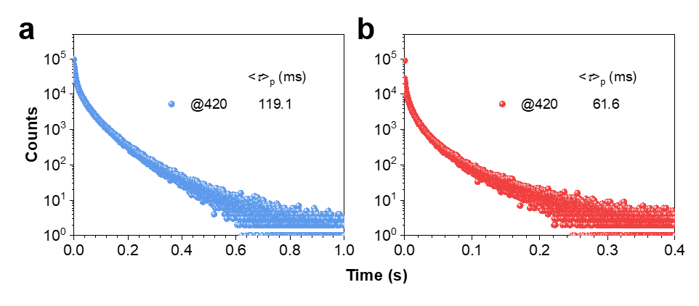
Supplementary Fig. 37. Millisecond-scale lifetimes for DiPTPA crystals (a) before and (b) after 312 nm UV irradiation (λ_{ex} = 312 nm).
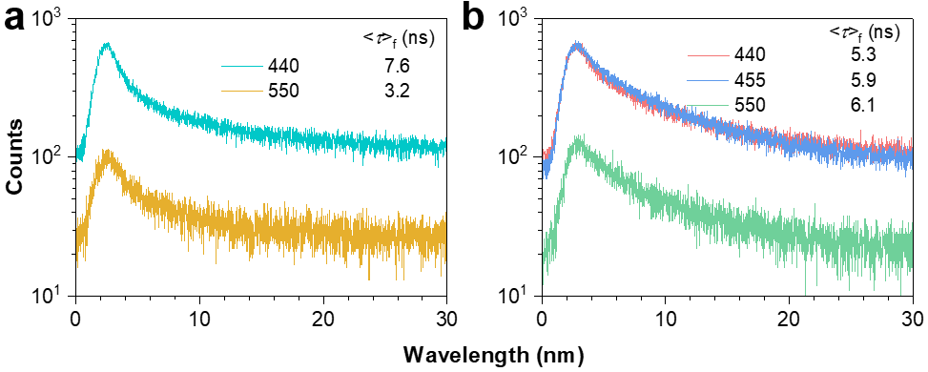
Supplementary Fig. 38. Nanosecond scale lifetime for DETPA crystals (a) before and (b) after 10 min of 312 nm UV irradiation (λ_{ex} = 312 nm). No nanosecond scale lifetimes can be detected at other peaks in emission spectra of DETPA crystals. And no nanosecond scale lifetimes can be measured at peaks shown in emission spectra of DiPTPA crystals.
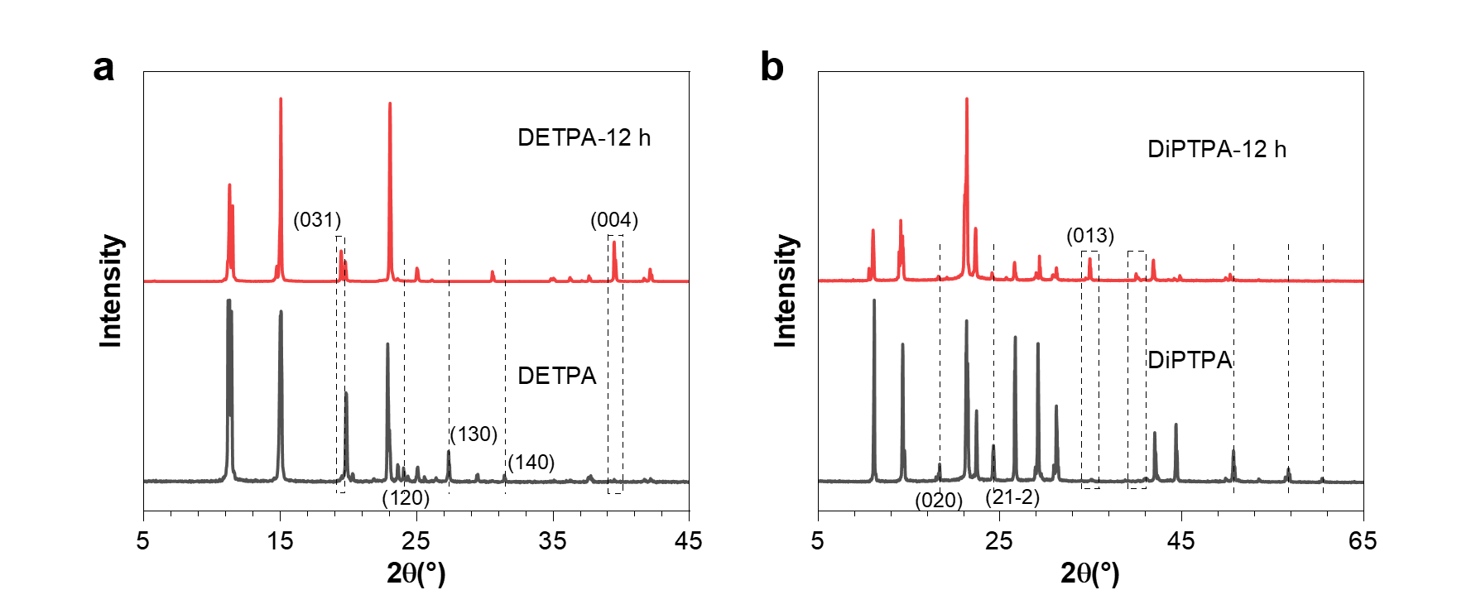
Supplementary Fig. 39. XRD patterns of (a) DETPA and (b) DiPTPA crystals before and after 12 h of 312 nm UV irradiation.
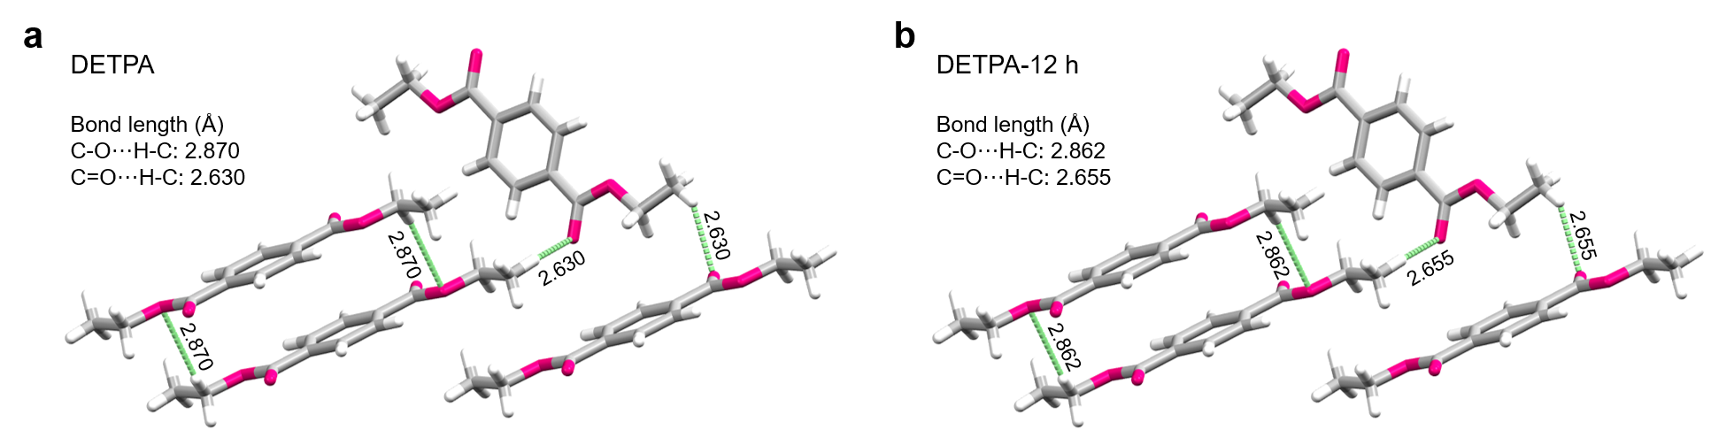
Supplementary Fig. 40. The transformation of bond lengths of denoted intermolecular interactions in DETPA crystal (a) before and (b) after 12 h of 312 nm UV irradiation.
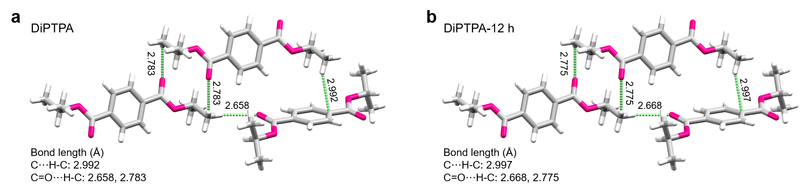
Supplementary Fig. 41. The transformation of bond lengths of denoted intermolecular interactions in DiPTPA crystal (a) before and (b) after 12 h of 312 nm UV irradiation.

Supplementary Table 2. Single crystal data of DETPA before and after 12 h of 312 nm UV irradiation.
 | DETPA | DETPA-12 h
Formula | C₁₂H₁₄O₄ | C₁₂H₁₄O₄
Formula Weight | 222.23 | 222.23
Wavelength (Å) | 1.54178 | 1.54178
Space Group | P21/n | P21/n
Cell Length (Å) | a=4.2243 (5)  b=15.4519 (15)  c=9.1426 (11) | a=4.2253 (7)  b=15.441 (3)  c=9.1422 (14)
Cell Angle (°) | α=90  β=92.902 (8)  γ=90 | α=90  β=92.968 (10)  γ=90
Cell Volume (Å³) | 596.00 (12) | 595.68 (17)
Z | 2 | 2
Density (g/cm³) | 1.238 | 1.239
F (000) | 236.0 | 236.0
h_{max}, k_{max}, l_{max} | 5, 18, 10 | 5, 18, 11
T_{min}, T_{max} | 0.597, 0.753 | 0.533, 0.753
Supplementary Table 3. Single crystal data of DiPTPA before and after 12 h of 312 nm UV irradiation.
 | DiPTPA | DiPTPA-12 h
Formula | C₁₄H₁₈O₄ | C₁₄H₁₈O₄
Formula Weight | 250.28 | 250.28
Wavelength (Å) | 1.54178 | 1.54178
Space Group | P21/c | P21/n
Cell Length (Å) | a= 9.0928 (8)  b= 9.6861 (9)  c= 9.2091 (10) | a= 9.1032 (6)  b= 9.6809 (6)  c= 9.2082 (7)
Cell Angle (°) | α=90  β=119.578 (4)  γ=90 | α=90  β=119.607 (3)  γ=90
Cell Volume (Å³) | 705.38 (12) | 705.54 (9)
Z | 2 | 2
Density (g/cm³) | 1.178 | 1.178
F (000) | 268.0 | 268.0
h_{max}, k_{max}, l_{max} | 10, 11, 10 | 10, 11, 11
T_{min}, T_{max} | 0.609, 0.753 | 0.632, 0.753
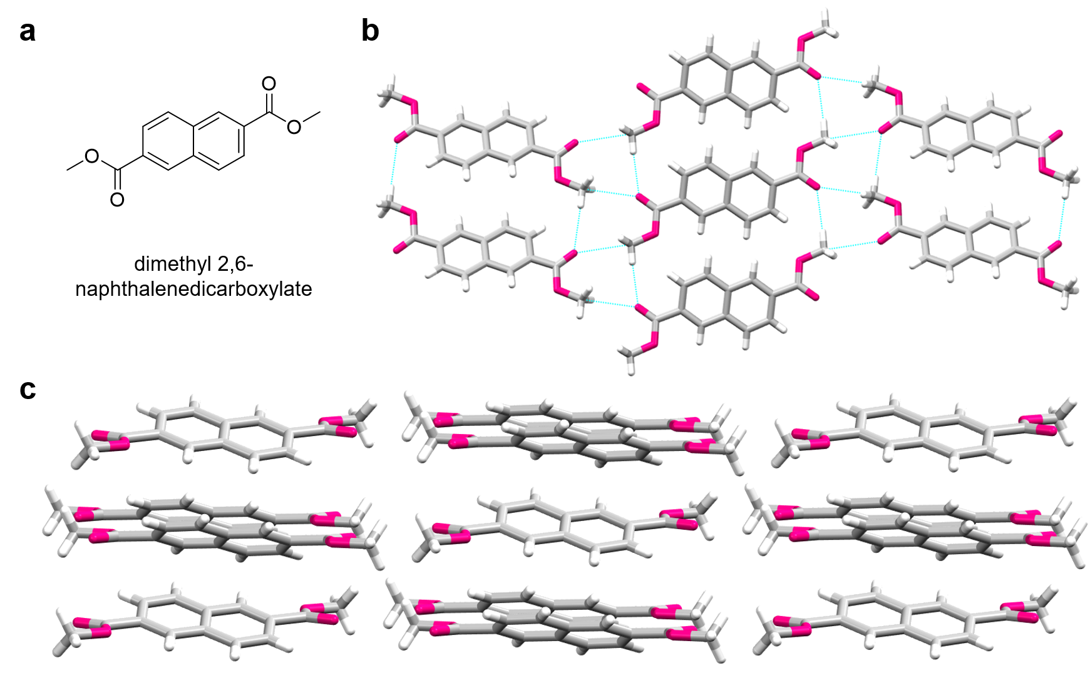
Supplementary Fig. 42. (a) The structural formula of dimethyl 2,6-naphthalenedicarboxylate. (b, c) Single crystal structure and fragmental molecular packing of dimethyl 2,6-naphthalenedicarboxylate.
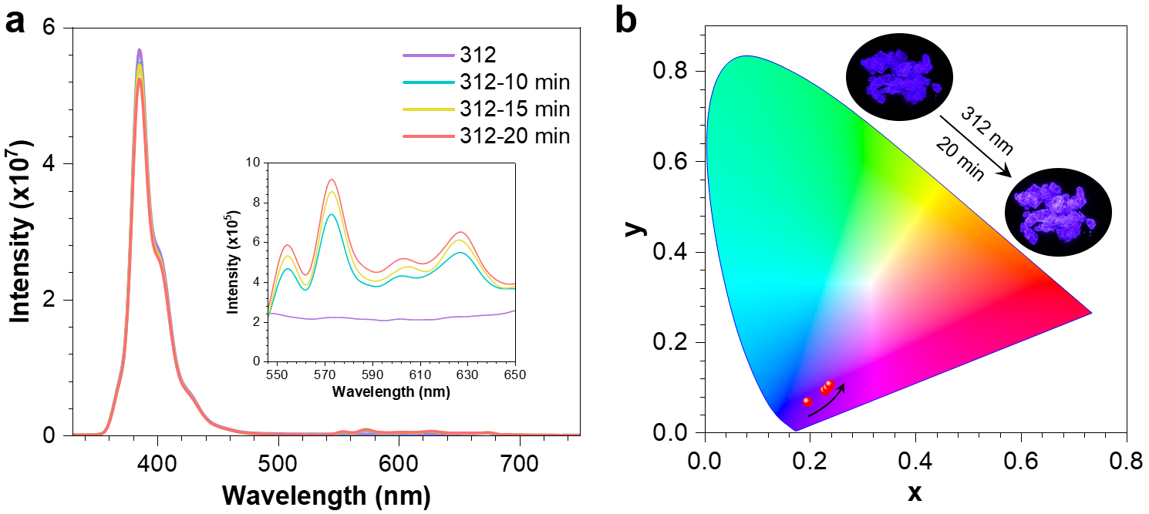
Supplementary Fig. 43. (a) Prompt emission spectra, (b) CIE coordinate diagram and (b, inset) luminescent photographs of PL colour transforming process of dimethyl 2,6-naphthalenedicarboxylate crystals under 312 nm UV irradiation with different exposure times. The inset in (a) is a larger version of the spectra from 545 to 650 nm.
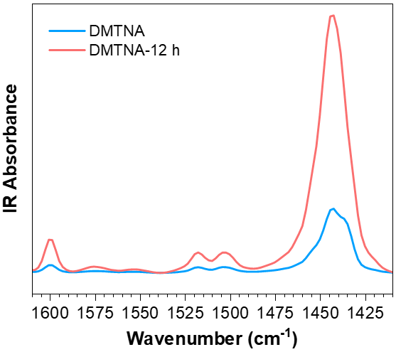
Supplementary Fig. 44. FTIR spectra of dimethyl 2,6-naphthalenedicarboxylate crystals before and after 12 h of 312 nm UV irradiation.
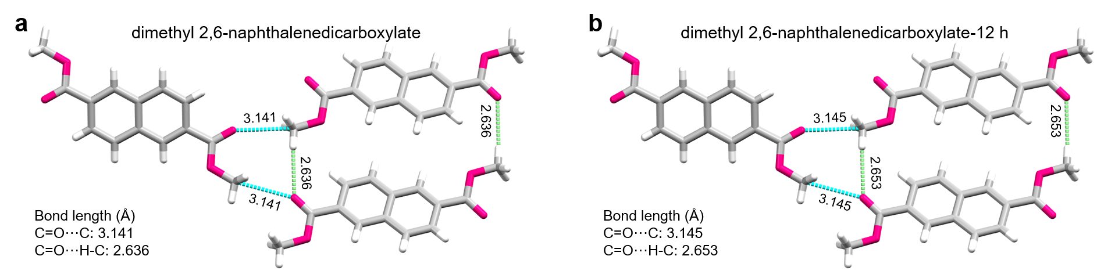
Supplementary Fig. 45. The transformation of bond lengths of denoted intermolecular interactions in dimethyl 2,6-naphthalenedicarboxylate crystal (a) before and (b) after 12 h of 312 nm UV irradiation.
Supplementary Table 4. Single crystal data of dimethyl 2,6-naphthalenedicarboxylate before and after 12 h of 312 nm UV irradiation.
 | dimethyl 2,6-naphthalenedicarboxylate | dimethyl 2,6-naphthalenedicarboxylate -12 h
Formula | C₁₄H₁₂O₄ | C₁₄H₁₂O₄
Formula Weight | 244.24 | 244.24
Wavelength (Å) | 1.54178 | 1.54178
Space Group | P21/c | P21/n
Cell Length (Å) | a= 13.4344 (7)  b= 6.1512 (3)  c= 7.1638 (4) | a= 13.4478 (7)  b= 6.1584 (3)  c= 7.1669 (4)
Cell Angle (°) | α=90  β= 100.415 (2)  γ=90 | α=90  β= 100.366 (4)  γ=90
Cell Volume (Å³) | 582.25 (5) | 583.85 (5)
Z | 2 | 2
Density (g/cm³) | 1.393 | 1.389
F (000) | 256.0 | 256.0
h_{max}, k_{max}, l_{max} | 16, 7, 8 | 16, 7, 8
T_{min}, T_{max} | 0.596, 0.753 | 0.603, 0.753
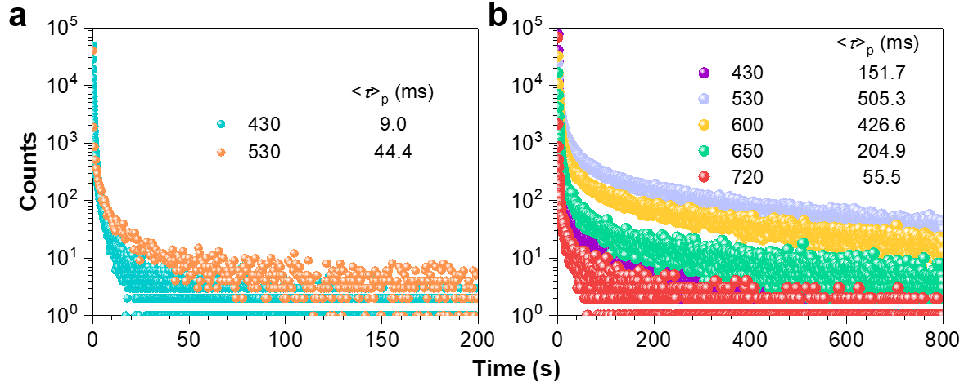
Supplementary Fig. 46. Millisecond scale lifetimes for MMTPA crystals (a) before and (b) after 312 nm UV irradiation. (λ_{ex} = 312 nm).
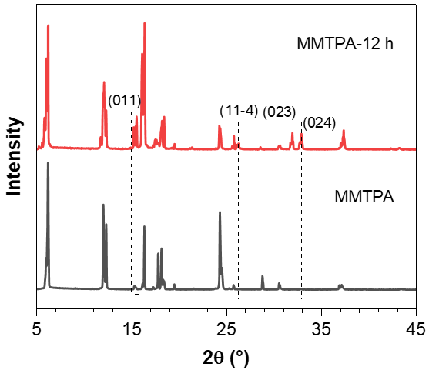
Supplementary Fig. 47. XRD patterns of MMTPA crystals before and after 12 h of 312 nm UV irradiation.
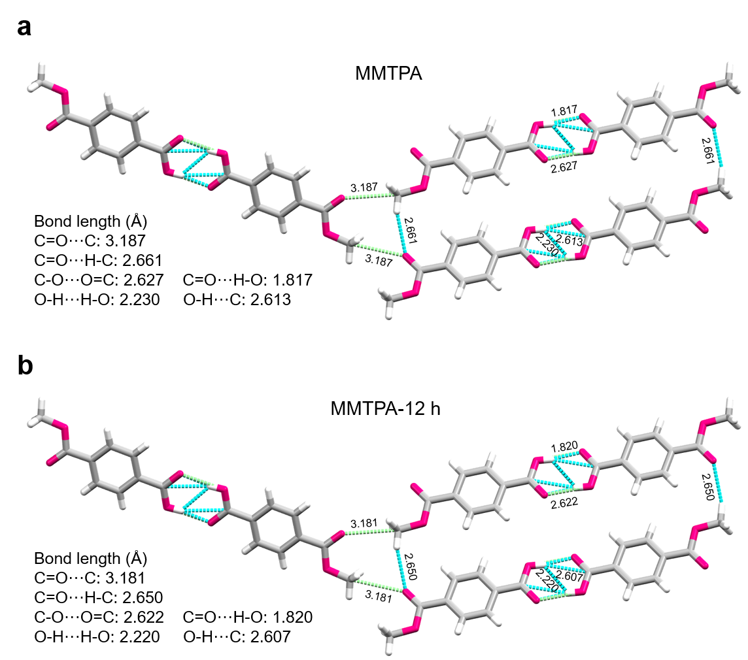
Supplementary Fig. 48. The transformation of bond lengths of denoted intermolecular interactions in MMTPA crystal (a) before and (b) after 12 h of 312 nm UV irradiation.

Supplementary Table 5. Single crystal data of MMTPA before and after 12 h of 312 nm UV irradiation.
 | MMTPA | MMTPA-12 h
Formula | C₉H₈O₄ | C₉H₈O₄
Formula Weight | 180.15 | 180.15
Wavelength (Å) | 1.54178 | 1.54178
Space Group | P21/c | P21/n
Cell Length (Å) | a= 4.8531 (11)  b= 5.8842 (11)  c= 29.172 (6) | a= 4.840 (2)  b= 5.8675 (18)  c=29.145 (8)
Cell Angle (°) | α=90  β= 91.557 (10)  γ=90 | α=90  β= 91.52 (2)  γ=90
Cell Volume (Å³) | 832.8 (3) | 827.4 (5)
Z | 4 | 4
Density (g/cm³) | 1.437 | 1.446
F (000) | 376.0 | 376.0
h_{max}, k_{max}, l_{max} | 5, 7, 35 | 5, 7, 35
T_{min}, T_{max} | 0.715, 0.753 | 0.566, 0.753
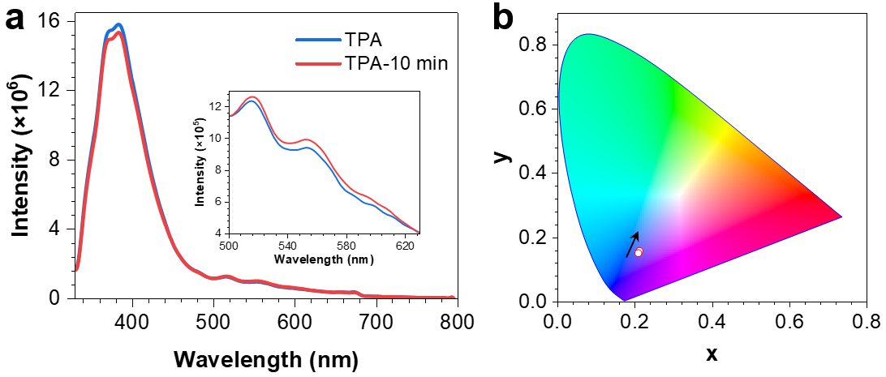
Supplementary Fig. 49. (a) Prompt emission spectra and (b) CIE coordinate diagram of PL colour transforming process of TPA powder crystals before and after 10 min of 312 nm UV irradiation. The inset in (a) is a larger version of the spectra from 500 to 630 nm.
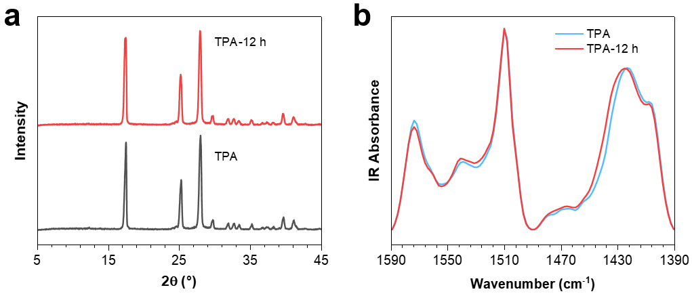
Supplementary Fig. 50. (a) XRD patterns and (b) FTIR spectra of TPA crystals before and after 12 h of 312 nm UV irradiation.
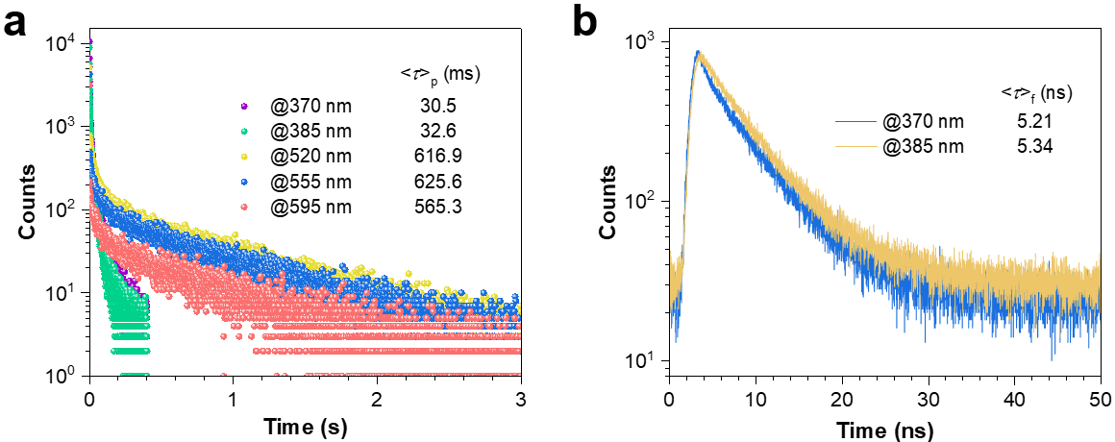
Supplementary Fig. 51. (a) Millisecond and (b) nanosecond scale lifetimes for TPA powder crystals (λ_{ex} = 312 nm).
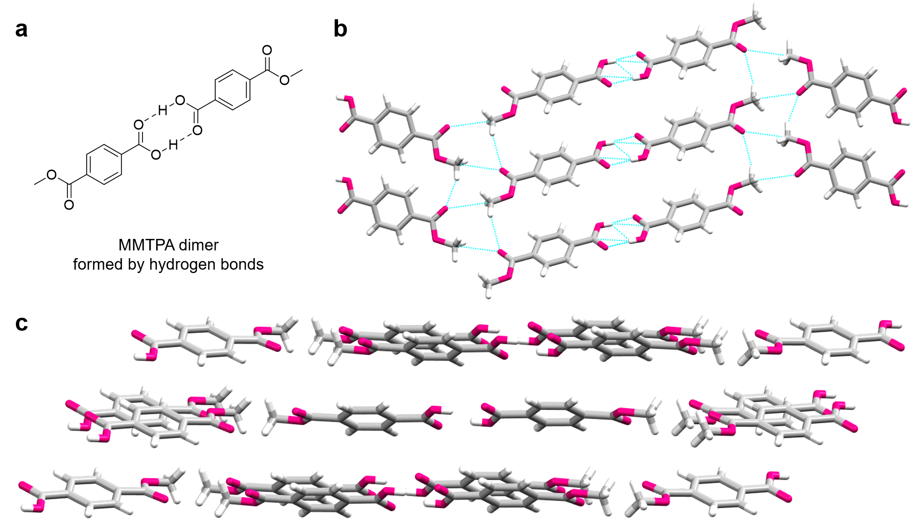
Supplementary Fig. 52. (a) The structural formula of MMTPA dimer connected by hydrogen bonds. (b, c) Single crystal structure and fragmental molecular packing of MMTPA.
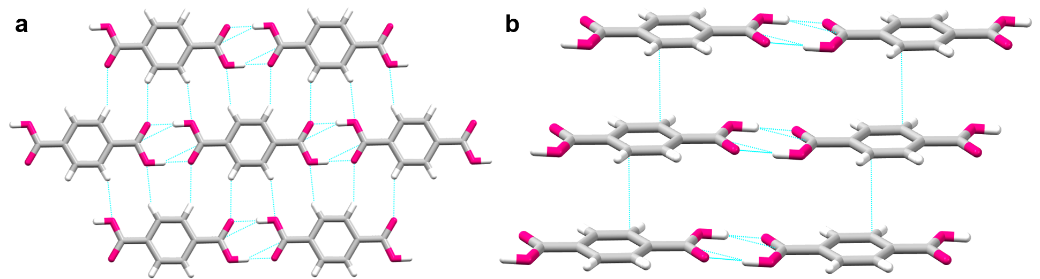
Supplementary Fig. 53. Single crystal structure and fragmental molecular packing of TPA³.
Supplementary Fig. 54. (a) The structural formula of methyl 4-(aminocarbonyl)benzoate. (b) Prompt emission spectra, (c) CIE coordinate diagram and (c, inset) luminescent photographs of PL colour transforming process of methyl 4-(aminocarbonyl)benzoate crystals under 312 nm UV irradiation with different exposure times. (d) The structural formula and luminescent photographs of terephthalamide. The PL colour of its crystals seldom transforms after 20 min of 312 nm UV irradiation.
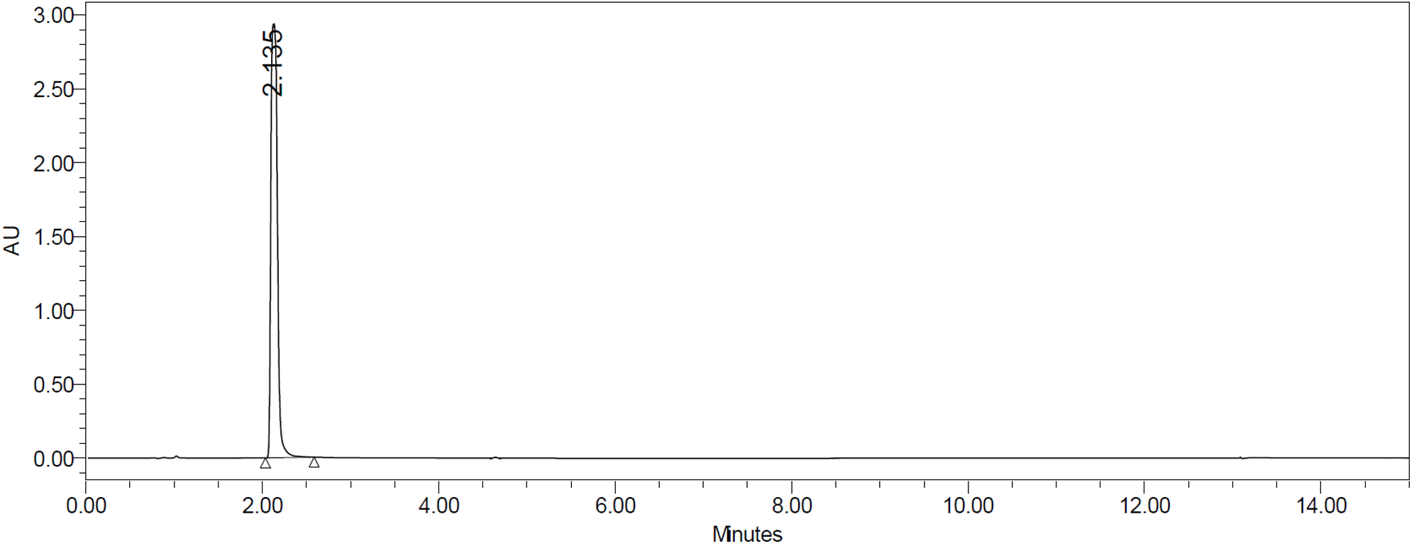
Supplementary Fig. 55. HPLC results for MMTPA crystals.

References
1. Yang, G.-W., Zhang, Y.-Y. Xie, R. & Wu, G.-P. Scalable bifunctional organoboron catalysts for copolymerization of CO₂ and epoxides with unprecedented efficiency. J. Am. Chem. Soc. 142, 12245 (2020).
2. Johnson, E. R., Keinan, S., Mori-Sánchez, P., Contreras-García, J., Cohen, A. J. & Yang, W. Revealing noncovalent interactions. J. Am. Chem. Soc. 132, 6498 (2010).
3. Ahmed, E., Karothu, D. P., Warren, M. & Naumov, P. Shape-memory effects in molecular crystals. Nat. Commun. 10, 3723 (2019).

