Supplemental Figure 1.
 |  |  | Day1 |  |  |  |  |  |  |  |  |  |  |  | Day2 |  |  |  |  |  |  |  |  |  | Day3
 | Blood |  |  |  |  |  |  |  |  |  |  | CSF  CSF |  |  | Blood |  |  |  |  |  |  |  | CSF |  | Blood |  |  |  |  |  |  |  |  | CSF
Rat | H (relative to dose) |  |  |  |  |  |  |  |  |  |  | H |  | H | H (relative to dose) |  |  |  |  |  |  |  | H | H | H (relative to dose) |  |  |  |  |  |  |  |  | H | H
1 | 1 | 4.5 |  | 5.5 | 6 | 21.5 |  | NA | NA | NA | NA | 5 |  | 21.5 | 0.5 | 1 | 2 | 7 | 21 | NA | NA | NA | 7 | NA | 0.5 | 1 |  | 2 | 4 |  | 5 | 6 | 8 | NA | NA
2  3 | 1 | 2.5 |  | 4 | 8 | 22 |  | NA | NA | NA | NA | 8 |  | NA | 1 | 4 | 8 | 21 | NA | NA | NA | NA | 8 | *23 | 1 | 4 |  | 7 | 22 |  | NA | NA | NA | 1 | 7
3 | 0.5 | 1 |  | 3 | 5 | 7 |  | 7.5 | 8 | 9 | 11 | 7 |  | NA | 1 | 2 | 5 | 6 | 7.5 | 8 | 9.5 | 13 | 0.5 | 7 | 1 | 2 |  | 5.5 | 7 |  | 7.5 | 9 | 11 | 8 | NA
4 | 0.5 | 2 |  | 4 | 6 | 8 |  | 9 | 11 | 13 | 15 | 8 |  | NA | 26 | 1 | 2 | 6 | 8 | 10 | 12 | 15 | 26 | 8 | 27 | 0.5 |  | 2.5 | 6 |  | 8 | 10 | 12 | 27 | 8
5 | 0.5 | 1 |  | 3 | 5 | 5.5 |  | 6 | 8 | 9 | 11 | 6 |  | NA | 33 | 0.5 | 2 | 5 | 7 | 9 | 11 | 13 | *33 | 8 | 35 | 0.5 |  | 1 | 6 |  | 8 | 9 | 11 | 35 | 8
6 | 1 | 2 |  | 6 | 9 | 11 |  | 13 | 14 | 16 | NA | 2 |  | 14 | 1 | 3 | 6 | 10 | 15 | NA | NA | NA | 3 | NA | 1 | 2 |  | 6 | 8 |  | 10 | 12 | 16 | 2 | 12
7 | 2 | 4 |  | 6 | 8 | 9 |  | 12 | 13 | 15 | NA | NA |  | NA | NA | NA | NA | NA | NA | NA | NA | NA | NA | NA | NA | NA |  | NA | NA |  | NA | NA | NA | NA | NA
8 | 5 | 2 |  | 5 | 8 | 9 |  | 10 | 11 | 13 | NA | 2 |  | 11 | 1 | 3 | 6 | 8 | 10 | 11 | 12 | NA | 3 | NA | 1 | 2 |  | 5 | 8 |  | 10 | 12 | 15 | 2 | 12
9 | 1 | 2 |  | 5 | 8 | 9 |  | 10 | 12 | 16 | NA | 2 |  | NA | 1 | 2 | 6 | 8 | 11 | 12 | 14 | 18 | 2 | 14 | 1 | 3 |  | 6 | 8 |  | 10 | 12 | 15 | 3 | NA
10 | 1 | 3 |  | 5 | 9 | 10 |  | 12 | 13 | 15 | NA | 3 |  | 13 | 1 | 3 | 5.5 | 8 | 10 | 14 | 16 | NA | 3 | NA | 1 | 3 |  | 5 | 8 |  | 10 | 13 | 16 | 3 | 13
 |  |  | Day4 |  |  |  |  |  |  |  |  |  |  |  |  | Day5 |  |  |  |  |  |  |  |  |  |  | Day6
 | Blood |  |  |  |  |  |  |  |  |  |  |  | CSF |  |  | Blood |  |  |  |  |  |  |  | CSF |  |  | Terminal Draws
Rat | H (relative to dose) |  |  |  |  |  |  |  |  |  |  |  | H |  | H | H (relative to dose) |  |  |  |  |  |  |  | H | H
1 | 0.5 | 1 |  | 2 | 3.5 | 8 |  | NA | NA | NA | NA |  | 21.5 |  | NA | 0.2 | 1 | 2 | 3 | 4 | 6 | 8 | NA | NA | NA |  | T
2  3 | 1.5 | 5 |  | 8 | 23 | NA |  | NA | NA | NA | NA |  | 21.5 |  | 32 | 1 | 2 | 6 | NA | NA | NA | NA | NA | *37 | 45 |  | T
3 | 0.5 | 1 |  | 5 | 7 | 8 |  | 10 | 13 | 25 | NA |  | 27 |  | 35 | 0.5 | 1.5 | 4 | 7 | 9 | 11 | 13 | 14 | 9 | NA |  | T
4 | 25 | 0.5 |  | 1 | 4 | 6 |  | 8 | 10 | 14 | 15 |  | 25 |  | 6 | 0.5 | 1.5 | 5.5 | 7 | 9 | 11 | 13 | 14 | 7 | 25 |  | T
5 | 0.5 | 2 |  | 5 | 7 | 8 |  | 9 | 14 | NA | NA |  | 1 |  | 8 | 25 | 0.5 | 1.5 | 5 | 8 | 9 | 10 | 13 | 8 | 25 |  | T
6 | 1 | 3 |  | 5 | 8 | 10 |  | 14 | 15 | NA | NA |  | 3 |  | 10 | 1 | 3 | 6 | 8 | 10 | 12 | 15 | NA | 3 | 10 |  | T
7 | NA | NA |  | NA | NA | NA |  | NA | NA | NA | NA |  | NA |  | NA | NA | NA | NA | NA | NA | NA | NA | NA | NA | NA |  | T
8 | 1 | 2 |  | 4 | 7 | 9 |  | 11 | 13 | NA | NA |  | 2 |  | 9 | 1 | 2 | 4 | 7 | 9 | 11 | 15 | NA | 2 | 9 |  | T
9 | 1 | 2 |  | 3 | 6 | 9 |  | 11 | 14 | NA | NA |  | 2 |  | 10 | 1 | 2 | 6 | 7 | 9 | 10 | 13 | NA | 2 | 9 |  | T
10 | 1 | 2 |  | 3 | 7 | 9 |  | 11 | 14 | NA | NA |  | NA |  | NA | 1 | 4 | 6 | 8 | 11 | 13 | 16 | NA | 4 | 11 |  | T

Legend: Example of staggering sampling schematic utilized for study protocol. Each animal received NMR/RTV dose twice daily for 5-days. Time depicted in the figure is relative to previous day 1st dose.
Abbreviations: CSF=cerebrospinal fluid, N/A=not applicable, H=hour, T=terminal, NMR=nirmatrelvir, RTV=ritonavir

Supplemental Figure 2.
X₃
V_{CSF}
CSF Compartment
X₂
V_{C}
Central Compartment
K_{el}
K₂₃
Ka
K₃₀
Differential Equations
dx₁(t)/dt = -Ka*X₁
dx₂(t)/dt = Ka*X₁ – (K_{el} + K₂₃)X₂
dx₃(t)/dt = K₂₃*X₂ - K₃₀*X₃
X₁
Oral Compartment

Legend: Schematic and differential equations of base three-compartmental PK model. There was an oral compartment (X₁), central compartment (X₂), and CSF compartment (X₃). Drug transit into and out the CSF was depicted with a one-way rate constant (K₂₃) and a CSF elimination rate constant (K₃₀).

Abbreviations: PK=pharmacokinetic, CSF= cerebrospinal fluid, Kel=elimination rate constant, V_{c}=volume central compartment, V_{csf}=volume cerebral spinal fluid compartment, Ka=rate constant for absorption, K₂₃=rate constant to cerebral spinal fluid from central compartment, K₃₀=elimination rate constant from CSF compartment, X₁= amount in the oral compartment, X₂=amount in the central compartment, X₃= amount in the CSF compartment

Supplemental Figure 3.
(a). (b).
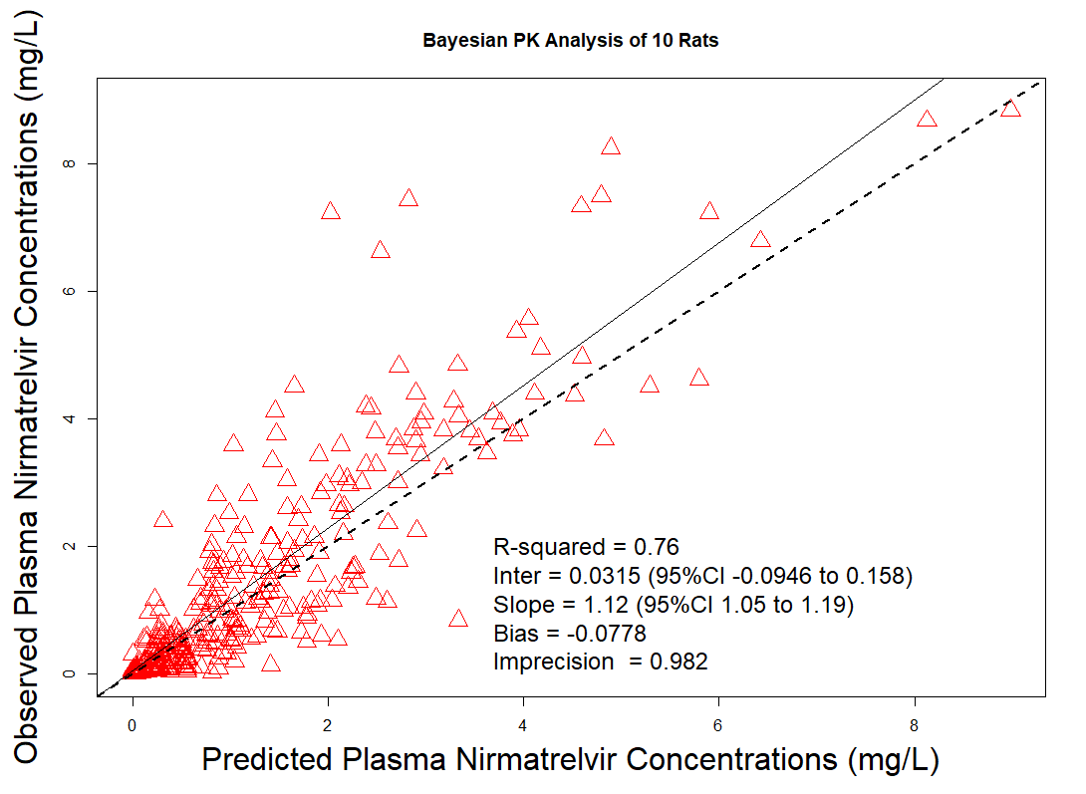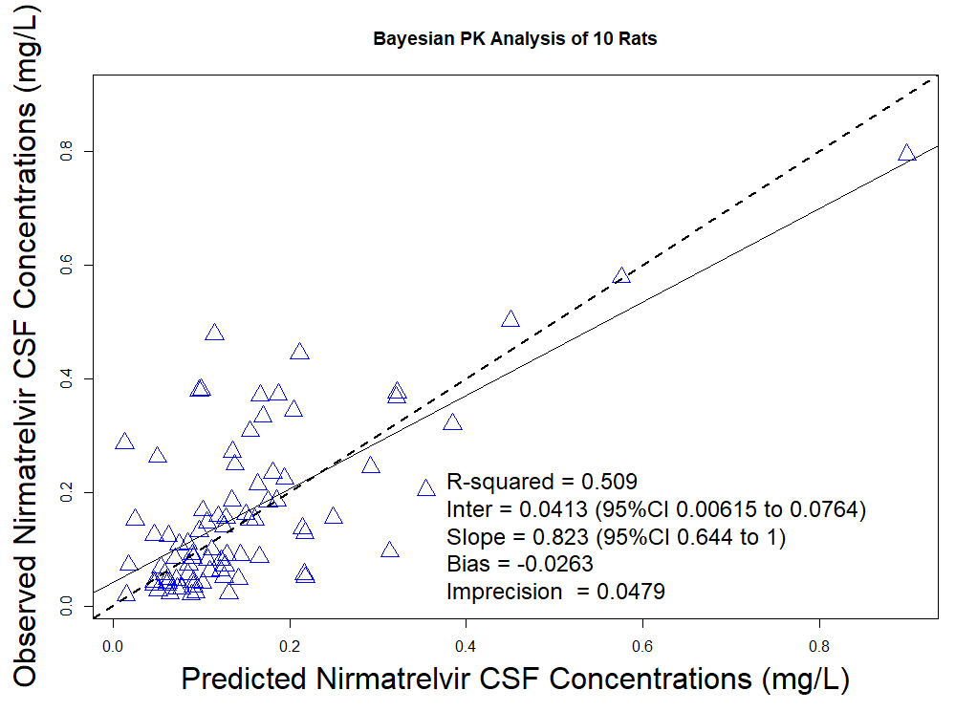
Legend: Observed vs. predicted Bayesian plots from the final model for plasma (a) and CSF (b). Overall, the model fits showed minimal bias and imprecision for both plasma and CSF. The observation variance was proportional with an additive (lambda) model (error = SD² + lamda²)^{0.5} where SD for each matrix= C₀ + C₁Y (with inputs of C₀ = 0.1 mg/L and C₁ = 0.15 in plasma and inputs of C₀ = 0.01 mg/L, C₁ = 0.15 in CSF where; Y was = the observed concentration).
Abbreviations: PK=pharmacokinetic, CSF=cerebrospinal fluid

Supplemental Figure 4.
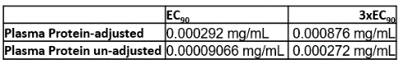
Rat | Liver (mg/g) | Brain (mg/g) | Lung (mg/g) | Kidney (mg/g) | Heart (mg/g) | PBMC** (mg/mL)
1 | 0.00001153 | BLOQ | - | 0.0000481 | - | 0.000014985
2 | 0.0001079 | 0.00005137 | - | 0.0004664 | - | 0.000674325
3 | 0.000106 | 0.000004167 | 0.00008067 | 0.00002882 | 0.00005394 | 0.000031968
4 | 0.00003856 | BLOQ | 0.00001871 | 0.00009447 | 0.00001007 | 0.00018981
5 | 0.00002691 | 0.00003202 | 0.00001356 | 0.00001688 | 0.00001501 | 0.000500499
6 | 0.00010872 | 0.00001095 | 0.00005505 | 0.00012633 | 0.00008927 | 0.0000314685
7* | 0.00385004 | 0.00009838 | 0.00144259 | 0.00082259 | 0.00064773 | -
8 | 0.0001338 | 0.00003327 | 0.00004391 | 0.00005163 | 0.0000695 | 0.00006.14385
9 | 0.00028553 | 0.00001563 | 0.00012496 | 0.00024089 | 0.00011895 | 0.00011039
10 | 0.0008204 | 0.00001093 | 0.00006953 | 0.00010121 | 0.00005273 | 0.000056943
Median (IQR) | 0.00011  (0.00003565-0.0004195) | 0.00002383  (0.00001094-0.00004685) | 0.00006786  (0.00002501-0.0001113) | 0.00009784  (0.00004328-0.0002973) | 0.00006172  (0.00002444-0.0001115) | 0.00006144  (0.0000317-0.0003452)

Legend: Tissue and PBMC Concentrations of NMR. Compared to all the tissues, the brain had the lowest median NMR concentrations which were all <3xEC₉₀ regardless of adjustment for plasma protein binding. Figure depicts EC_{90adjusted} (black dotted line) values for reference. Tissues quantified in grams, mg/g of drug in tissue is equivalent to a concentration of mg/mL. Values left unrounded given the low concentrations.
*Rat 7 only completed 1 day of treatment, no PMBC levels available, rats 1 and 2 did not have lung or heart NMR concentrations due to tissue processing complications.
**PBMC levels converted to mg/mL
Abbreviations: BLOQ=below level of quantification, IQR=interquartile range, EC₉₀= 90% maximal effective concentration.
Supplemental Figure 5.
(a)
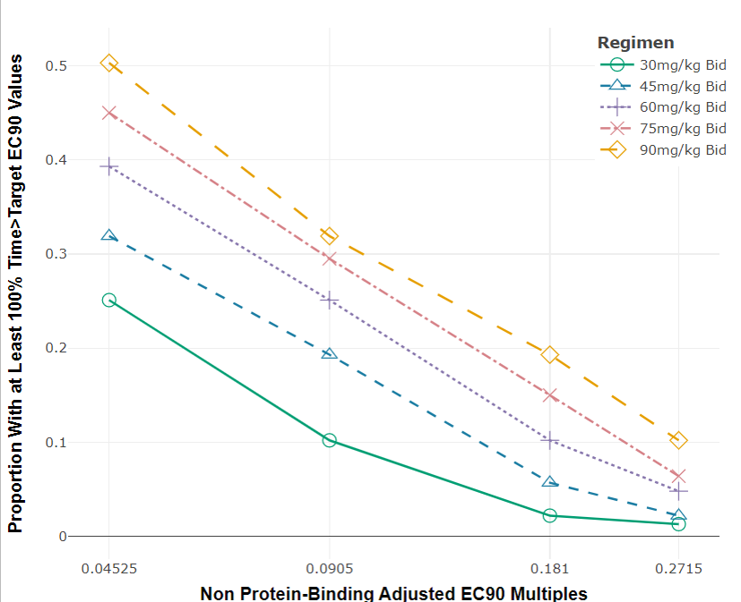
(b)
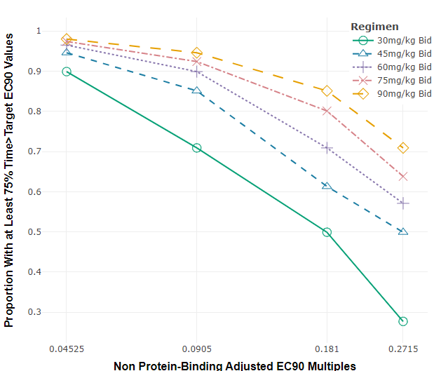
(c)
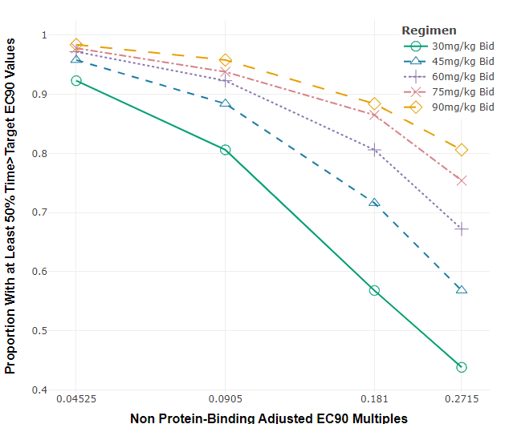
Legend: Monte Carlo simulations (n=1000, assuming a 300g rat) showing different proportions of target attainment in CSF at 100% (a), 75% (b) and 50% (c) of time>EC_{90Un_adjusted} at various doses of NMR (mg/kg/BID). Doses>90mg/kg BID would be needed in rats to achieve 100% of time>3X EC_{90Un_adjusted} in CSF.
Abbreviations: CSF=cerebrospinal fluid, EC₉₀= 90% maximal effective concentration
Supplemental Figure 6.
(a)
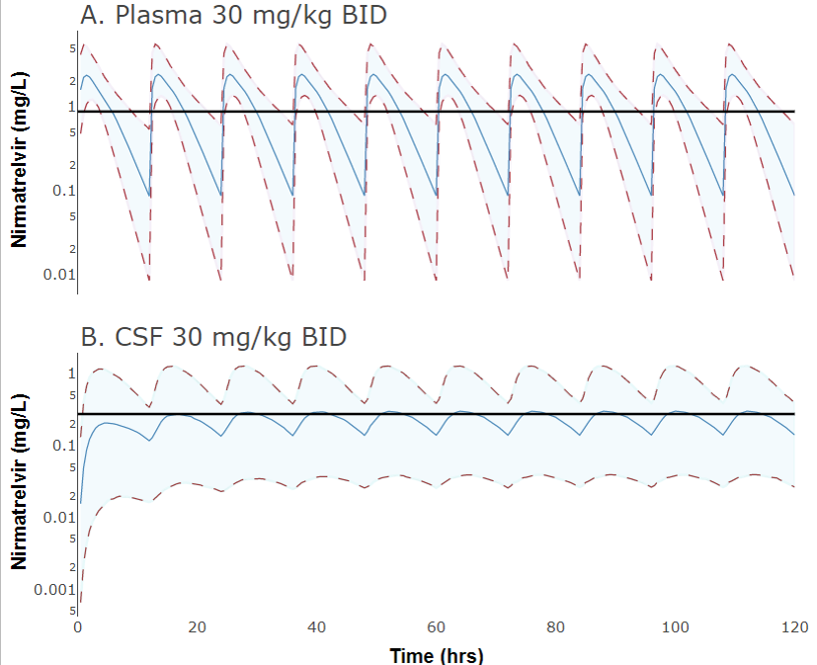
0.2715 mg/L
0.876 mg/L
Log-transformed
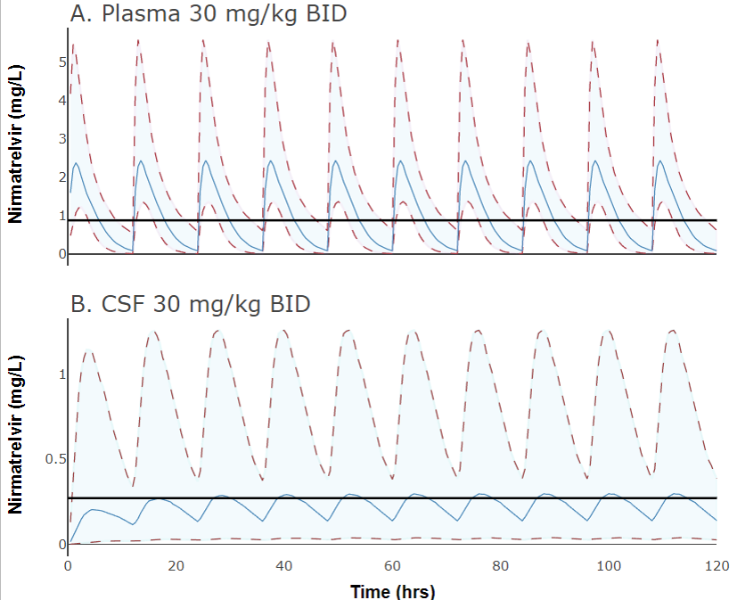
0.2715 mg/L
0.876 mg/L
Linear
(b)
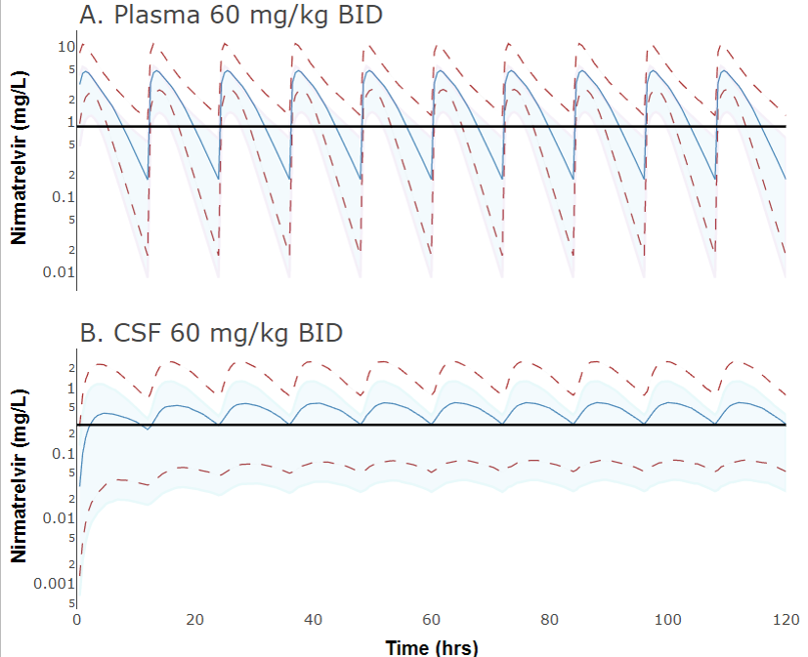
0.2715 mg/L
0.876 mg/L
Log-transformed
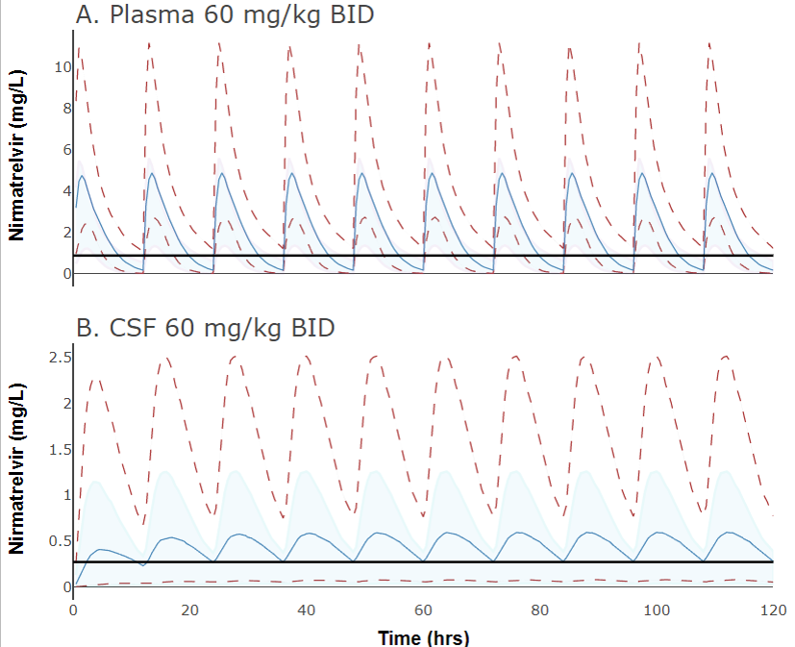
0.2715 mg/L
0.876 mg/L
Linear
(c)
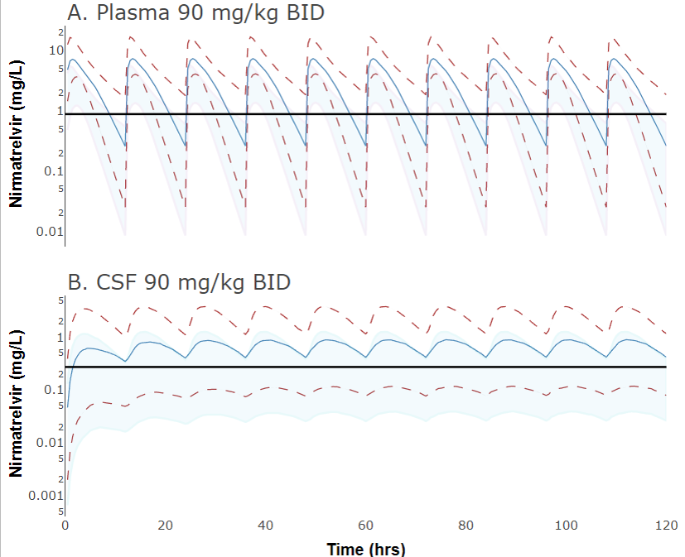
0.2715 mg/L
0.876 mg/L
Log-transformed
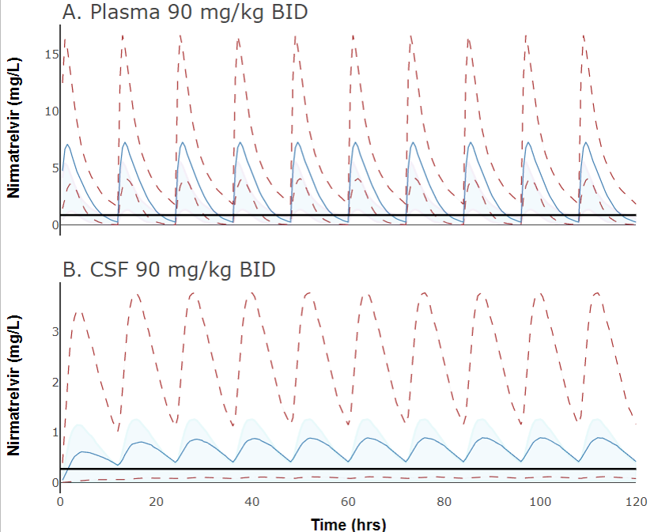
0.2715 mg/L
0.876 mg/L
Linear

Legend: Plasma (a) and CSF (b) linear and log-transformed predictions of NMR at 3 different doses (30, 60 and 90mg/kg BID) based on the Monte Carlo simulations (n=1000, assuming 300g rat). Median (solid blue line) and 95 percentiles (red dotted lines with blue shaded area) of plasma and CSF NMR PK profiles are depicted. The PK profiles are depicted against the 3xEC₉₀ (black line) for both plasma protein adjusted (0.876mg/L) in plasma and unadjusted (0.2715mg/L) in CSF.

Abbreviations: NMR=nirmatrelvir, EC₉₀= 90% maximal effective concentration, BID=twice daily, CSF=cerebrospinal fluid
Supplemental Table 1.PK Model comparison under different conditions and parameters
Model | -2LL | AIC | Bayesian  Bias  mcg/mL  (Central) | Bayesian  Imp  mcg/mL²  (Central) | R²  Bayesian  (Central) | Bayesian  Bias  mcg/mL  (CSF) | Bayesian  Imp  mcg/mL²  (CSF) | R²  Bayesian  (CSF)
Three-compartment  (final model) | 757.1 | 771.4 | -0.078 | 0.98 | 0.76 | -0.026 | -0.048 | 0.509
Four-compartment | 757.2 | 777.7 | -0.082 | 0.99 | 0.76 | NA | NA | 0.497
Three-compartment w/ Tlag | 732.8 | 749.2 | -0104 | 0.984 | 0.771 | NA | NA | 0.488
Three-compartment w/ intercompartment transfer and CSF clearance | 751.7 | 768.1 | -0.093 | 0.99 | 0.76 | NA | NA | 0.375
Three-compartment w/ intercompartment transfer, no CSF clearance | 750.4 | 764.7 | -0.05774 | 0.9962 | 0.76 | NA | NA | 0.49
Note: all model comparisons were not significantly different (P-value: >0.1) and thus, final model based on regression of observed vs. predicted concentrations, visual plots of parameter estimates, lowest -2LL/AIC and rule of parsimony.
*NA= not able to be calculated
Abbreviations: PK=pharmacokinetic, -2LL=-2 Log-likelihood, AIC=Akaike information criterion, Imp=imprecision, CSF=cerebrospinal fluid, Tlag= lag term

