Table Abstract
Table 1 Basic physical properties of the dredged slurry samples
Table 2 Experimental schemes
Table 1 Basic physical properties of the dredged slurry samples
Properties | Value
Specific gravity, G_{s} | 2.73
Water content, w (%) | 168.5
Density, ρ (g/cm³) | 1.30
Void ratio, e₀ | 4.62
Liquid limit, w_{L} (%) | 51.9
Plastic limit, w_{P} (%) | 24.8
Plasticity index, I_{p} | 23.3
PH | 8.1
Vane shear strength, C_{U} (kPa) | ≈0
Clay (0.005~0.075 mm), (%) | 34.69
Silt (0.005~0.075 mm), (%) | 49.21
Sand (0.075~2 mm), (%) | 16.10
Table 2 Experimental schemes
Case  No. | Time  ratio | A schedule of vacuum pressure applied (Days)  ( bottom vacuum top vacuum)
T1 | 1: 0.5 | 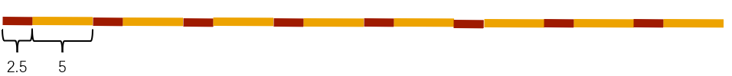
T2 | 1: 1 | 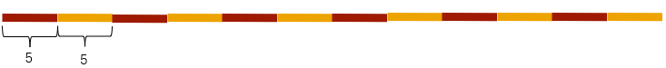
T3 | 1: 3 | 
T4 | 1: 5 | 
T5 | / | 

