Supplementary information 1
Basic design of a bur-tagging system (BurTS)
Our basic system consisted of two ultrasound sensors (ELEGOO), linked by cables to an Arduino control board linked to, and powered by, a battery (Miady 5000 mAh). The control board was linked to the tag dispenser, which consisted of a compression spring held in place by a servo-releaser (MMOBIEL SG90). The spring pushed directly on a miniature box (printed in plastic) within which the tag was held. When the servo-releaser was activated, the spring expanded to push the box rapidly down rails to an end point (approximately 100 mm from the start position) whereupon the tag was projected, following a trajectory dictated by the line of the rails (Fig. SI 1A).
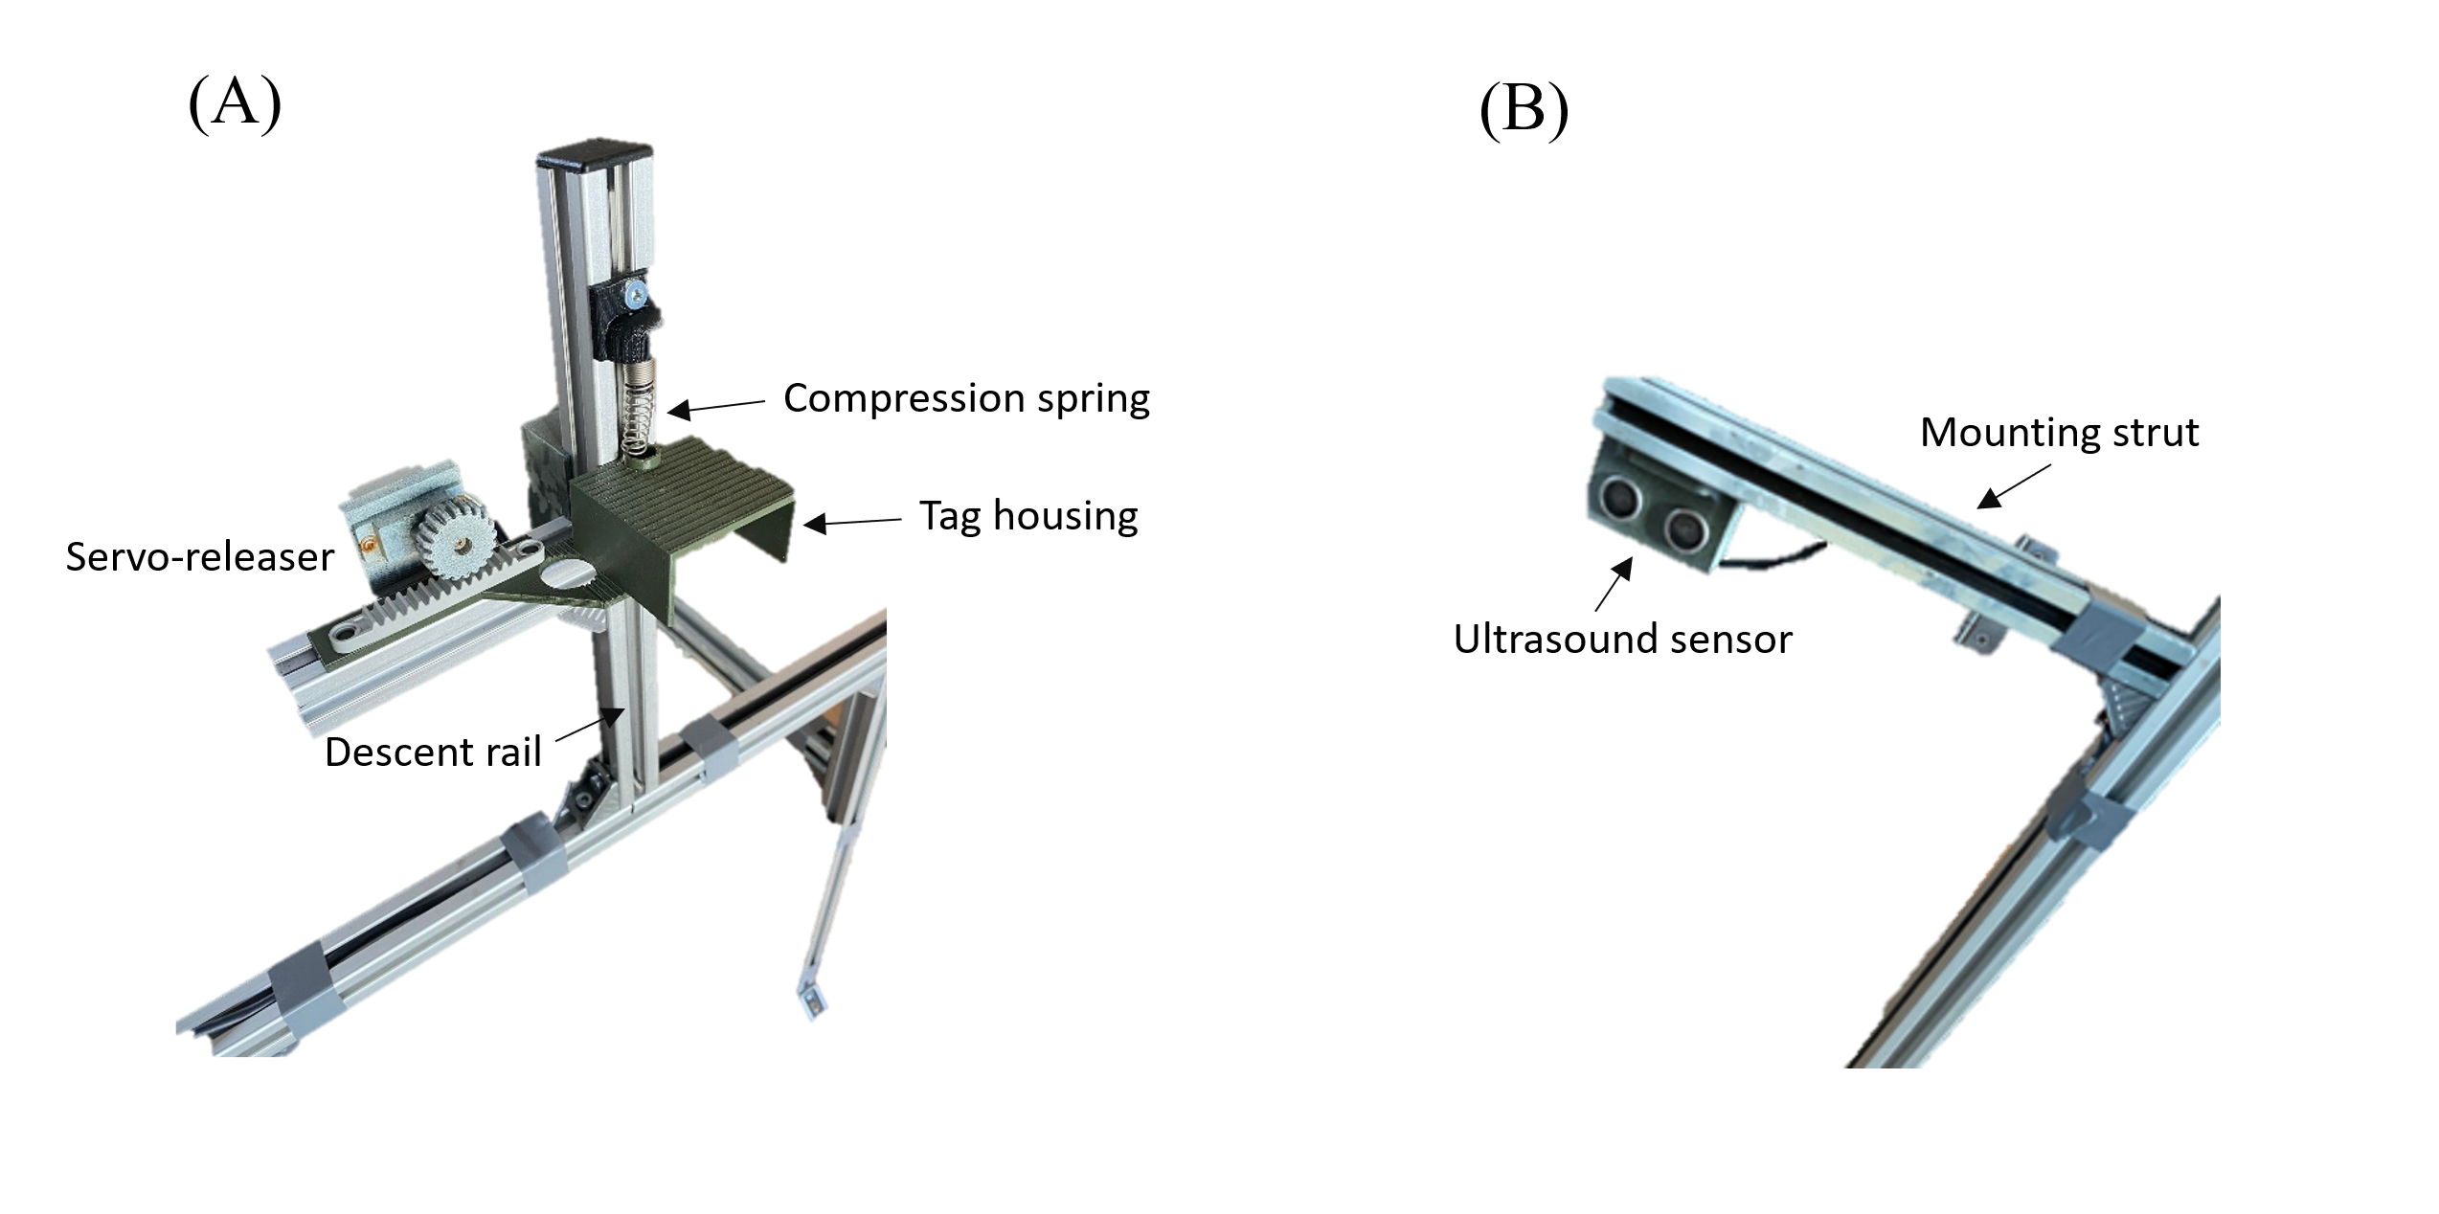
Figure SI 1 – (A) The tag dispenser system on its mounting showing the spring to power the housing containing the tag. (B) One of the ultrasound sensors on its mounting strut which itself is mounted perpendicular to one of the vertical legs of the Japanese Gate.
The details of the connections between the Arduino board and the various elements are shown in Fig. SI 2.

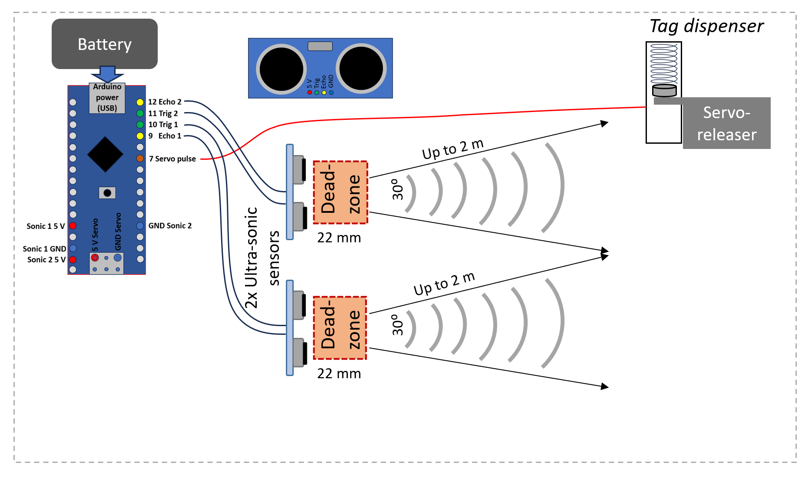

Figure SI 2 – Details of the connections between the Arduino controller and the various elements of the BurTS.

Supplementary information 2
Construction of the Japanese Gates
Our initial version of the Japanese Gate (JG 1) was constructed to be as flexible as possible, allowing us to move the elements within the BurTS to various positions. It was built from Bosch Rexroth aluminium struts (20 mm x 20 mm with a 6 mm groove). The two sides and top were attached together using aluminium Bosch Rexroth Connecting Component - Angle Brackets, allowing the size of the gate to be adjustable. However, for most of this study the system was standardized to give gate dimensions of 400 mm height and 400 mm width. Two additional Bosch Rexroth aluminium struts were also affixed to the vertical sections of the gate, projecting perpendicularly with respect to the vertical struts, one on each side of the main gate, onto which the ultrasound sensors were fixed, one on each side (Fig. SI 1B). As such, one ultrasound sensor scanned on one side of the gate while the other scanned on the other side. Two steel spikes were screwed on to the base of each side strut so the gate could be secured in soft substrate.
A second version of the Japanese Gate (JG 2) was constructed to provide data on animal reaction to the structure of JGs and assess the extent of neophobia. This version was fabricated to present animals with a much reduced footprint compared to the first version (see above). JG 2 was constructed of three pine dowels (25 mm diameter) to make up the sides and top of the arch with 2 cuboid pine feet (approx. 20 mm height x 40 mm width x 70 mm length), all held together using counter sunk wood screws. The wooden structure could be held in place using galvanised steel tent pegs (approx. 220 mm length x 6 mm diameter). The complete dimensions of the gate were 420 mm height x 400 mm width and 40 mm depth (Fig. SI 3A).
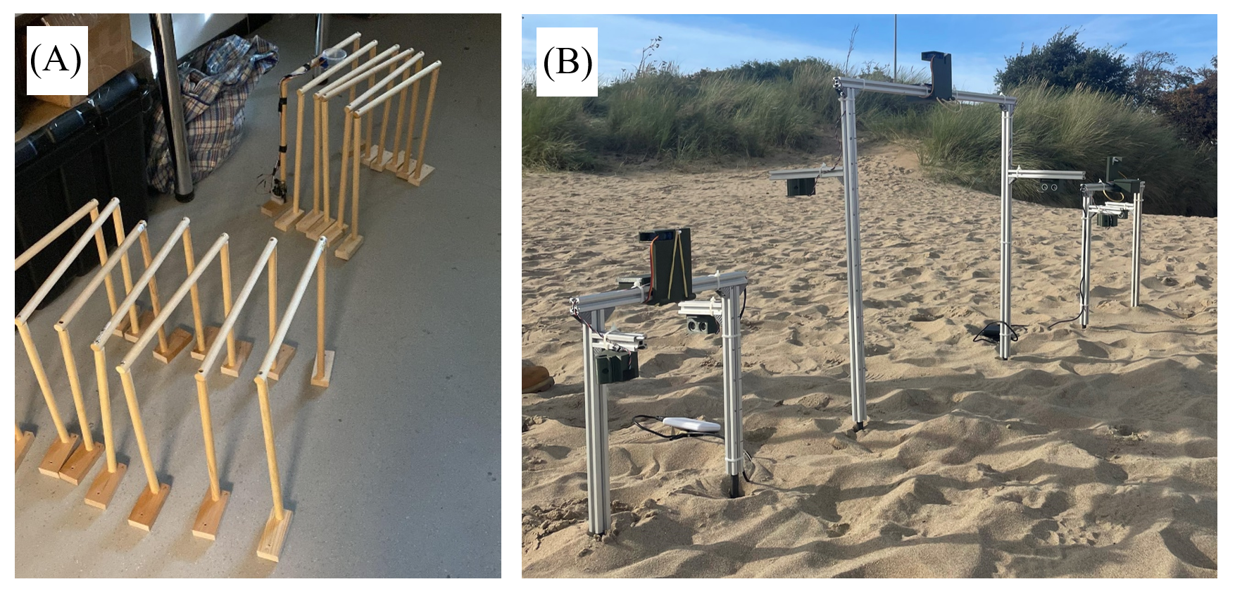
Figure SI 3 – (A) Wooden versions of the Japanese Gate (JG 2) and (B) three different sized aluminium versions of the Japanese Gate (JG 1) for comparison. The aluminium versions are fully equipped with ultrasound sensors, controllers, batteries and tag dispensers.

Supplementary information 3
Code for the Arduino control board

#include <Servo.h>
#define trigPin 11
#define trigPin2 10
#define echoPin 12
#define echoPin2 9

Servo servo;
int sound = 250;

void setup()
{
Serial.begin (9600);
pinMode(trigPin, OUTPUT);
pinMode(echoPin, INPUT);
pinMode(trigPin2, OUTPUT);
pinMode(echoPin2, INPUT);
servo.attach(7);
long duration;
int distance;
long distance2;
digitalWrite(trigPin, LOW);
delayMicroseconds(2);
digitalWrite(trigPin2, LOW);
delayMicroseconds(2);
}

void loop()
{
bool debug = true;
bool first, second;
first = false;
second = false;

long duration, distance;
long duration2, distance2;

digitalWrite(trigPin, HIGH);
delayMicroseconds(10);
digitalWrite(trigPin, LOW);
duration = pulseIn(echoPin, HIGH);
distance = (duration/2) / 29.1;

if (distance < 15)
{
if (debug = true) Serial.println("the distance of 1st is less than 10");
//delay(200);

first = true;

digitalWrite(trigPin2, HIGH);
delayMicroseconds(10);
digitalWrite(trigPin2, LOW);

duration = pulseIn(echoPin2, HIGH);
distance2 = (duration/2) / 29.1;
if (distance2 < 15)
{
second = true;
Serial.println("the distance of 2nd is less than 10");
servo.write(0);
delay(2000);
}
}
else
{
if (debug = true) Serial.println("First sensor isn't seeing nowt");
}
if (first ==true && second==true) {servo.write(90);
delay(200);}
}

Supplementary information 4
Camera traps
We recorded all interactions of animals with the BurTS using Wechamp 20MP 1080P HD trail cameras with SanDisk ultra 32gb SD cards set to record at 1080P for 30 seconds, with a 40 second lag and high motion sensitivity. Due to differences in visibility and topography at each site, it was not possible to standardise camera angle or distance to the TA.

Supplementary information 5
Baiting
To determine whether baiting the BurTS increased the frequency of animals walking through the JG, we used ‘Brambles meaty hedgehog food’ (https://www.littlepeckers.co.uk/p/brambles-meaty-hedgehog-food-12-x-400g), selected because it is recommended for foxes and badgers (RSPB, n.d). The bait was weighed to give 3 portions per JG, at 7 g/portion, and placed directly below in the centre of the TA with the additional two portions placed 20 cm either side of the TA. After initial trials with baiting during both the day and night, we concentrated on night-baiting to preclude magpies Pica pica and domestic dogs from attending the JGs. Baiting was then undertaken at 9pm each day, to capture observations of target species such as foxes, hedgehogs (Erinaceus europaeus), and badgers.

Supplementary information 6
Species common and Latin names used to gather data on the properties of fur
Species | Scientific name
Two toed sloth | Choloepus didactilus
Three toed sloth | Scoepus torquatus
European hare | Lepus europaeus
Granada hare | Lepus granatenis
Southern tree hyrax | Dendrohyrax crawshayi
Western tree hyrax | Dendrohyrax dorsalis
Common brushtail possum | Trichosurus vulpecula
Short-eared possum | Trichosurus caninus
Emin's pouched rat | Cricetomy emini
Alpine marmot | Arctomy marmota
Checkered elephant shrew | Rhynochocyon cirnei
Northern tree shrew | Tupaia belangeri
Angola colobus | Colobus angolensis
Chacma baboon | Papio ursinus
Red fox | Vulpes vulpes crucigera
African lion | Panthera leo

