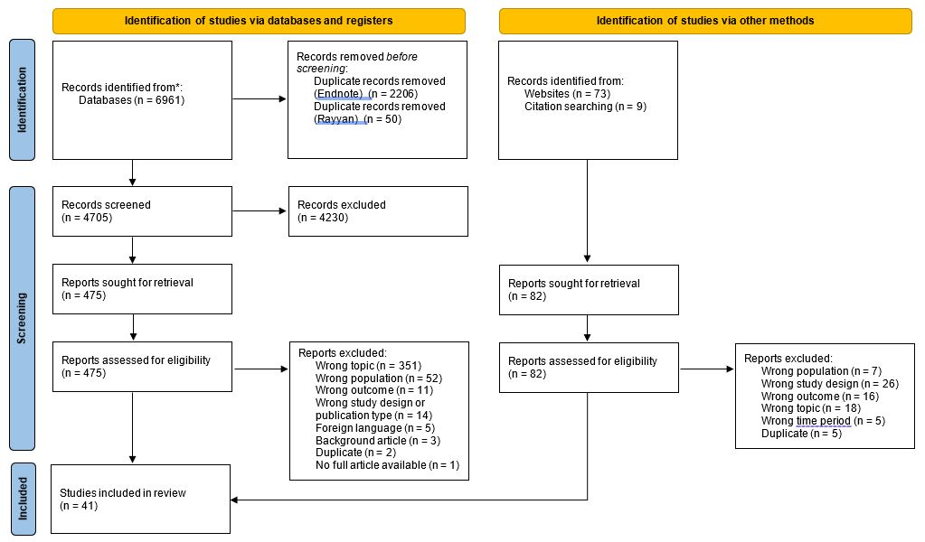

Supplementary Material 2. PRISMA diagram outlining the study selection process, from: Page MJ, McKenzie JE, Bossuyt PM, Boutron I, Hoffmann TC, Mulrow CD, et al. The PRISMA 2020 statement: an updated guideline for reporting systematic reviews. BMJ 2021;372:n71. doi: 10.1136/bmj.n71. For more information, visit: http://www.prisma-statement.org/

Supplementary Material 1. Search Strategies
 | Ovid ALL Medline
1 | (antibiotic* or anti-biotic* or antimicrobial* or anti-microbial* or antibacterial* or anti-bacterial* or antiinfection* or anti-infection*).tw,kf.
2 | bacterial resistan*.tw,kf.
3 | (antiviral resistan* or anti-viral resistan*).tw,kf.
4 | drug resistan*.tw,kw.
5 | (multiresistan* or multi-resistan*).tw,kf.
6 | AMR.tw,kf.
7 | drug resistance, microbial/ or exp drug resistance, bacterial/
8 | Anti-Bacterial Agents/
9 | Anti-Infective Agents/
10 | Antimicrobial Stewardship/
11 | 1 or 2 or 3 or 4 or 5 or 6 or 7 or 8 or 9 or 10
12 | ((public or communit* or population or neighbor?rhood* or educat* or nation* or region* or district* or state*) adj3 (campaign* or intervention* or program* or initiative)).tw,kf.
13 | (communicat* or disseminat*).tw,kf.
14 | (campaign* or mass media).tw,kf.
15 | (message* or engag* or outreach).tw,kf.
16 | social marketing.tw,kf.
17 | (television or tv).tw,kf.
18 | (radio or broadcast*).tw,kf.
19 | (internet or online).tw,kf.
20 | digital.tw,kf.
21 | (social media or facebook or twitter).tw,kf.
22 | (telephone* or cell* phone* or cell?phone* or mobile phone* or smartphone* or smart-phone* or app or apps).tw,kf.
23 | (text messag* or sms).tw,kf.
24 | (email or e-mail or electronic mail).tw,kf.
25 | publicity.tw,kf.
26 | Internet/
27 | exp Telecommunications/
28 | Social Media/
29 | Social Marketing/
30 | Mass Media/
31 | Health Communication/
32 | Health Education/
33 | Persuasive Communication/
34 | 12 or 13 or 14 or 15 or 16 or 17 or 18 or 19 or 20 or 21 or 22 or 23 or 24 or 25 or 26 or 27 or 28 or 29 or 30 or 31 or 32 or 33
35 | ((public or population or community or citizen* or household* or resident* or consumer* or carer* or caregiver* or people or adult* or men or women or mother* or father* or parent* or student* or pupil* or children or adolescent* or teenager*) adj4 (attitude* or belief* or view* or opinion* or expectation* or knowledge or awareness or risk or perception* or behav* or engagement)).tw,kf.
36 | (behav* adj3 (chang* or alter* or modification* or modify* or modifies or modified or intention*)).tw,kf.
37 | cost effectiv*.tw,kf.
38 | ((reduction or reduce* or decrease*) adj4 ("use" or "using")).tw,kf.
39 | (return on investment or ROI).tw,kf.
40 | "outcome measure*".tw,kf.
41 | Awareness/
42 | Health Knowledge, Attitudes, Practice/
43 | Health Promotion/
44 | exp Attitude to Health/
45 | Motivation/
46 | Intention/
47 | Behavior Therapy/
48 | Public Opinion/
49 | Program Evaluation/
50 | Cost-Benefit Analysis/
51 | 35 or 36 or 37 or 38 or 39 or 40 or 41 or 42 or 43 or 44 or 45 or 46 or 47 or 48 or 49 or 50
52 | 11 and 34 and 51
53 | limit 52 to yr="2010 -Current"
54 | exp Animals/
55 | exp Humans/
56 | 54 not 55
57 | 53 not 56

Supplementary Material 3. Infographic showing characteristics of campaigns included within the review

