SUPPLEMENTARY DATA
Supplementary Figure 1
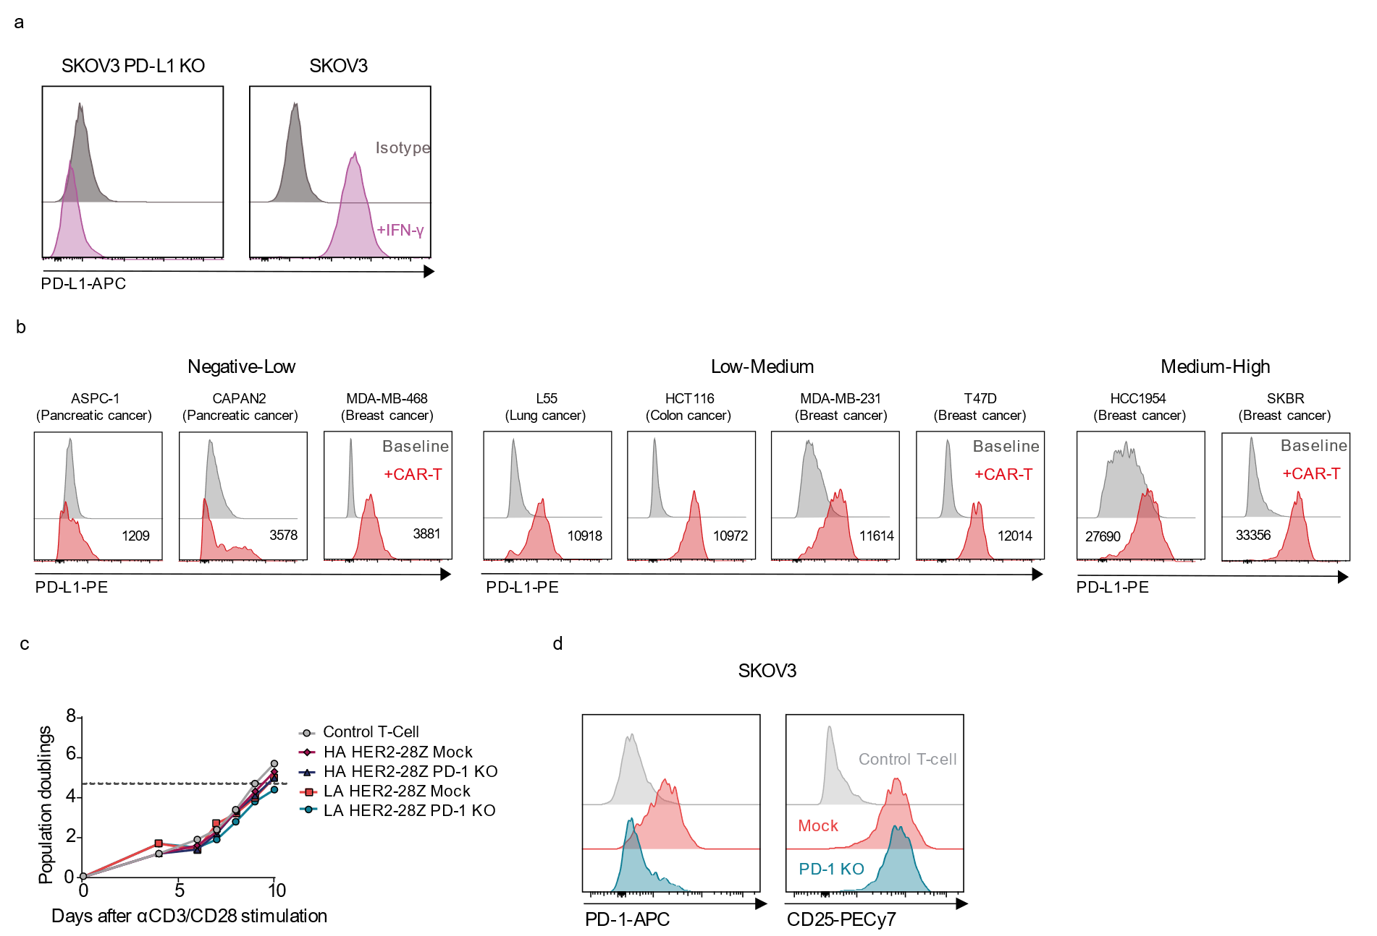

Characterization of the SKOV3 tumor model in terms of PD-L1 expression and assessment of CAR-T cell activation. a Expression and quantification of PD-L1 molecules of a panel of tumor cell lines alone (baseline, gray) or cocultured with CAR-T cells (red) for 48 hours assessed by flow cytometry. b PD-L1 expression by flow cytometry of SKOV3 PD-L1 KO and SKOV3 tumor cells treated with IFN-γ for 48h. c Representative population doubling of mock and PD-1 KO LA and HA HER2-28Z measured using trypan blue exclusion during CAR-T cell expansion (n=5 donors). d PD-1 and CD25 expression gated on LA HER2-28Z and PD-1 KO CAR⁺ T cells by flow cytometry at day 6 after co-culture with SKOV3 wild type cells.

Supplementary Figure 2
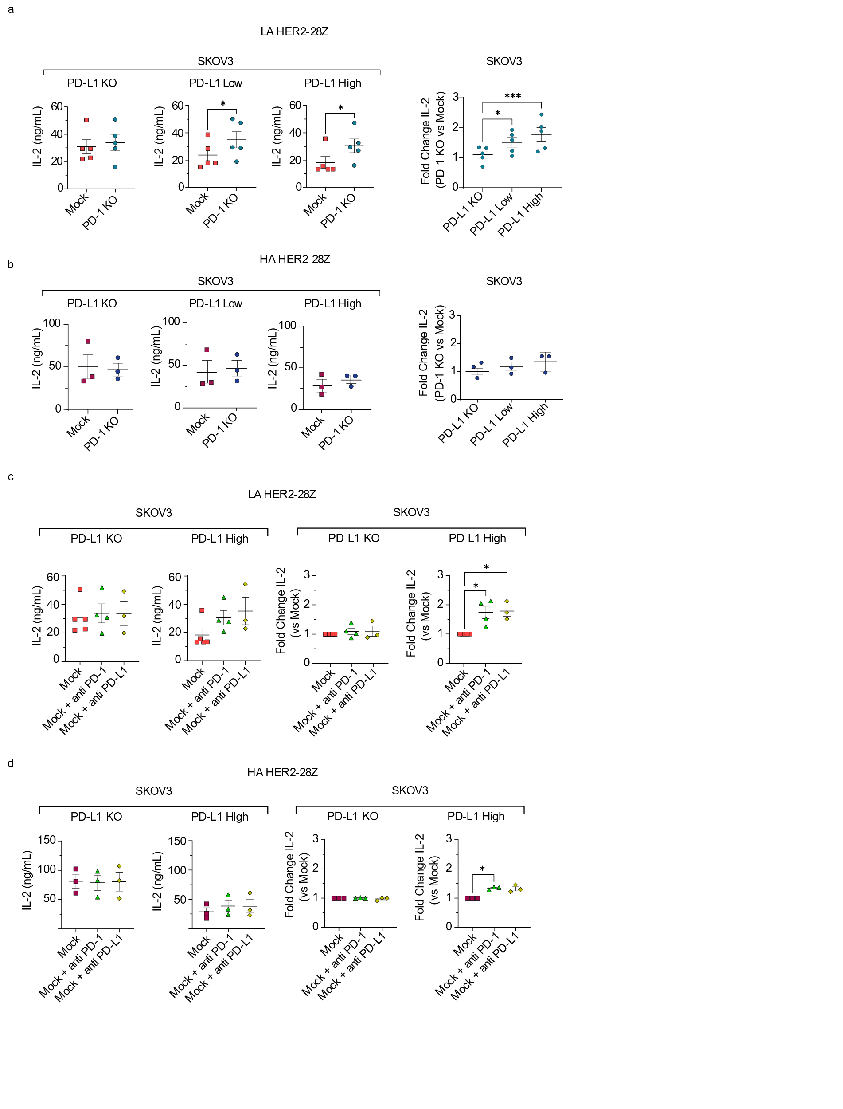
PD-1 KO restores HER2 LA-28Z CAR-T cell IL-2 secretion in vitro but does not affect HER2 HA-28Z CAR-Ts. HER2-28Z mock and PD-1-KO CAR-T cells of low a or high b affinity were co-cultured with SKOV3 tumor cells expressing variable PD-L1 densities (E:T=3:1). IL-2 release was analyzed 24 hours later by ELISA. IL-2 secretion is represented by absolute levels (left panel) or by fold change of PD-1 KO CAR-T cells as compared to mock CAR-T cells (right panel). Data are plotted as mean ± SEM (n=5 donors for LA and 3 donors for HA). *, p = 0.01, ***, p < 0.001, by paired T-test. HER2-28Z mock, mock with anti PD-1 or anti PD-L1 CAR-T cells of c low or d high affinity were co-cultured with SKOV3 tumor cells expressing variable PD-L1 densities (E:T=3:1). IL-2 release was analyzed 24 hours later by ELISA. Cytokine secretion is represented by absolute levels (left panel) or by fold change of mock CAR-T cells with anti PD-1 or anti PD-L1 as compared to mock CAR-T cells (right panel). Data are plotted as mean ± SEM (n=5 donors for mock and 3 donors for mock with anti PD-1 or anti PD-L1 of LA and 3 donors for HA). *, p = 0.01, by one-way ANOVA with Tukey post hoc test.

Supplementary Figure 3
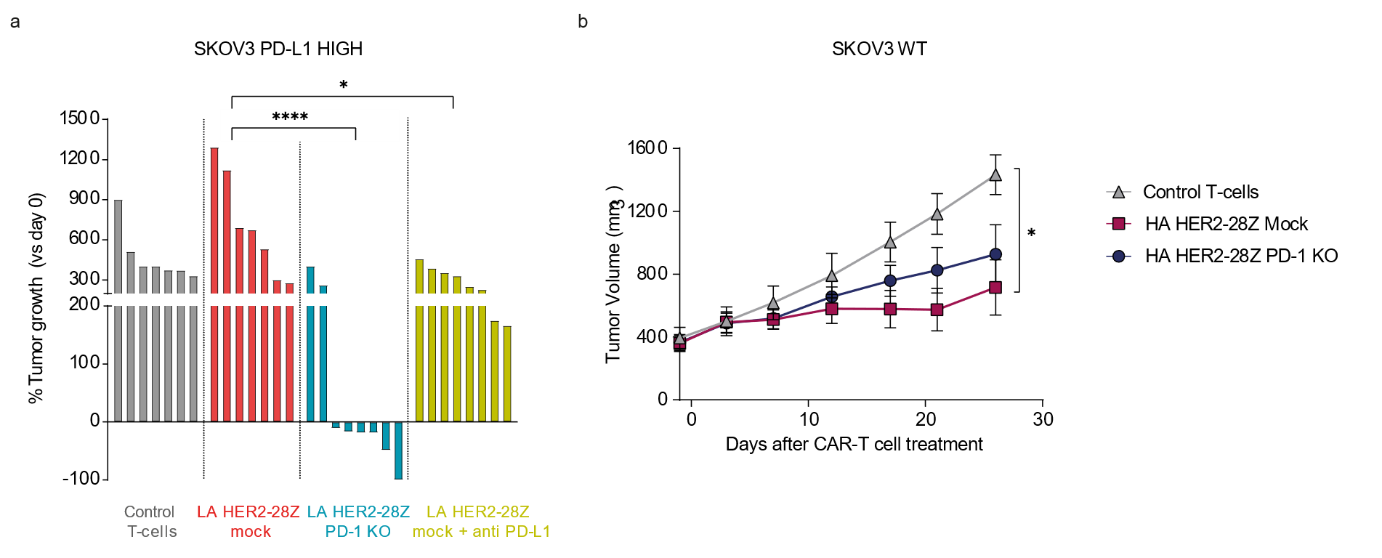
Disrupting the PD-1/PD-L1 axis improves the in vivo functionality of LA HER2-28Z CAR-T cells, with no discernible impact on HA HER2-28Z CAR-T cells. a NSG mice bearing SKOV3 PD-L1 High tumors were treated with 3x10⁶ control T cells, mock, mock + anti PD-L1 or PD-1 KO LA HER2-28Z CAR⁺-T cells. PD-L1–blocking antibody (Durvalumab) was administered intraperitoneally at a dose of 10 mg/kg every 5 days. Percentage of SKOV3 PD-L1 high tumor growth indicated as the change in tumor volume on day 20 versus baseline for individual animals (n= 7 tumors per group). ****, p < 0.0001 and *, p<0.05 by one-way ANOVA with Tukey post hoc test. b NSG mice bearing SKOV3 WT were treated with 3x10⁶ control T-cells, mock or PD-1 KO HA HER2-28Z CAR⁺-T cells. The mean tumor volume ± SEM is shown. (n ≥ 10 tumors per group).

Supplementary Figure 4
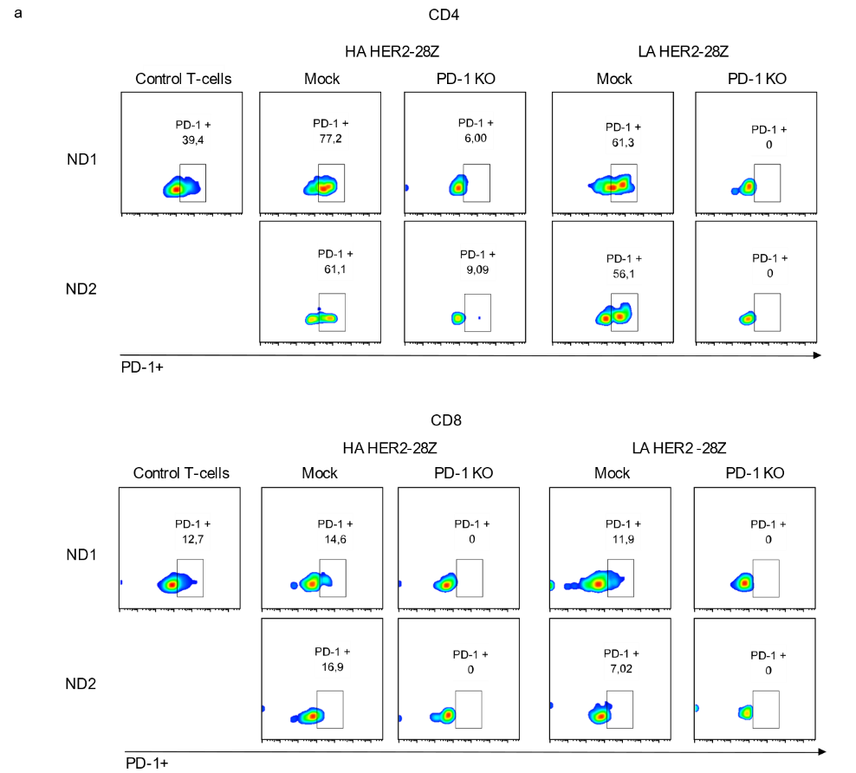
PD-1 expression in LA and HA HER2-28Z CAR-T cells prior to exposure to the bilayers. a Surface expression of PD-1 was assessed using flow cytometry on LA and HA HER2-28Z mock and PD-1 KO CAR⁺ T cells, 16 hours after thawing and just before their introduction into the bilayers.

Supplementary Figure 5
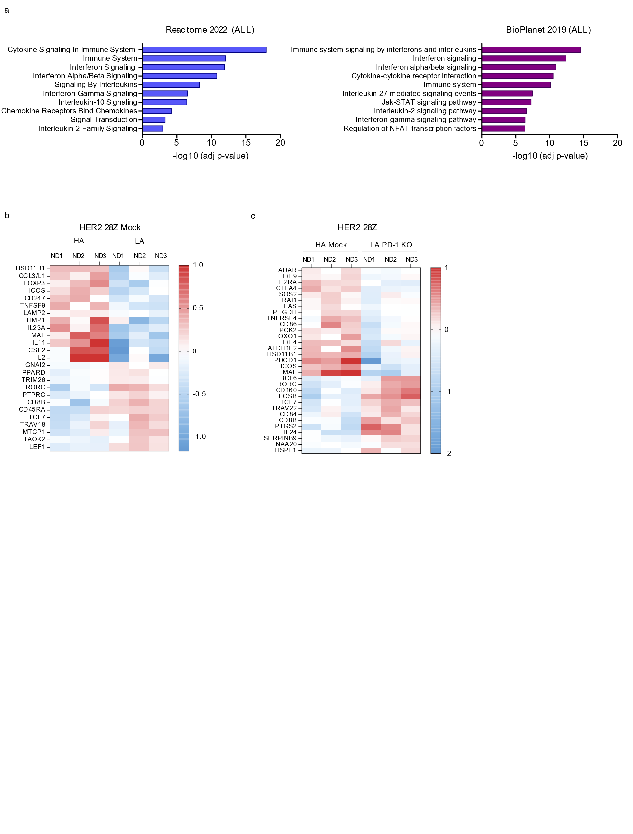
Differential transcriptomic analysis of HER2-28Z CAR-T cells in reference to scFv affinity and PD-1 KO. a Reactome (left panel) and Bioplanet (right panel) pathway analysis of all significant genes between PD-1 KO LA HER2-28Z and mock LA HER2-28Z showing the top-10 enriched pathways. -log10 (adj p-value) was derived from Enrichr. Heat map of statistically significant (P⩽0.05) genes that define distinct transcriptional profiles between b HA HER2-28Z and LA HER2-28Z CAR T cells and c HA HER2-28Z and LA HER2-28Z PD-1 KO CAR T cells after stimulation with SKOV3 tumor cells for 48 hours (n = 3 donors).

Supplementary Figure 6
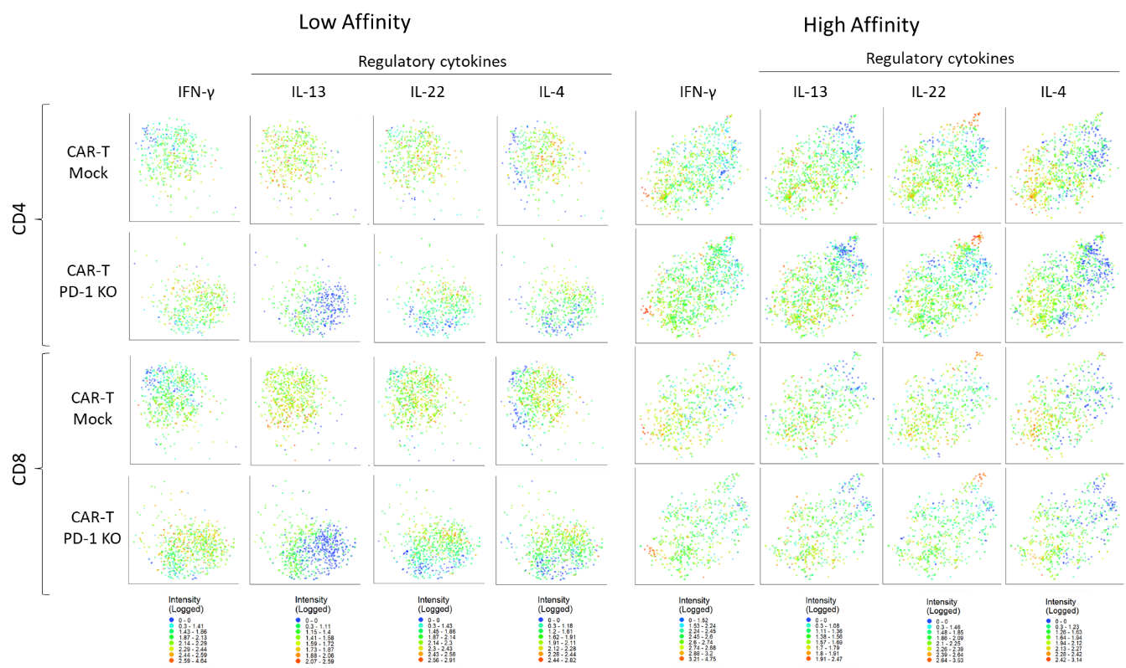
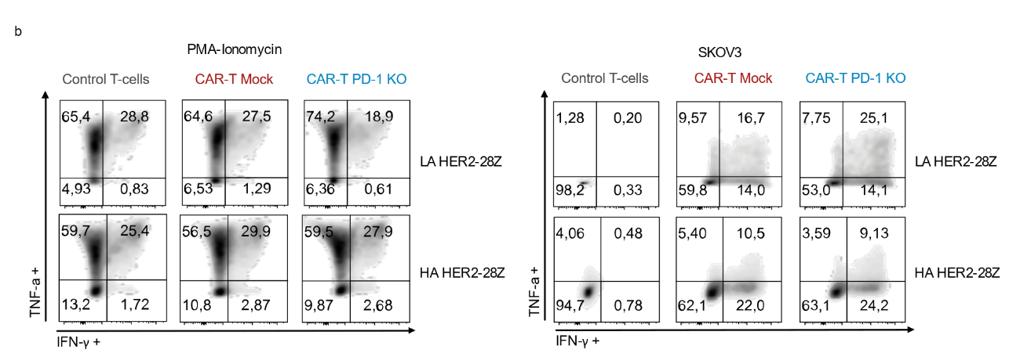
PD-1 KO induce changes in cytokine production profile in LA but not HA HER2-28Z CAR-T cells. Single-Cell Adaptive Immune panel (Isoplexis) of LA and HA HER2-28Z PD-1 KO versus mock CAR-T cells after co-culture with SKOV3 tumor cells (E:T=1:3). a Single cell t-SNE plots of IFN-y and regulatory cytokines (IL-13, IL-22 and IL-4) of LA HER2-28Z mock and PD-1 KO (right panel) or HA HER2-28Z mock and PD-1 KO (left panel) affinity. Density scale bar represents marker expression of cytokines for a given cell, ranging from low expression (blue) to high expression (red) b Flow cytometry plots of intracellular cytokine staining for TNF-α and IFN-γ in indicated groups after PMA ionomycin stimulation (left panel) or after co-culture with SKOV3 tumor cells (right panel) for 24 hours. Data is pre-gated on CD45+ T-cells.
Supplementary Figure 6
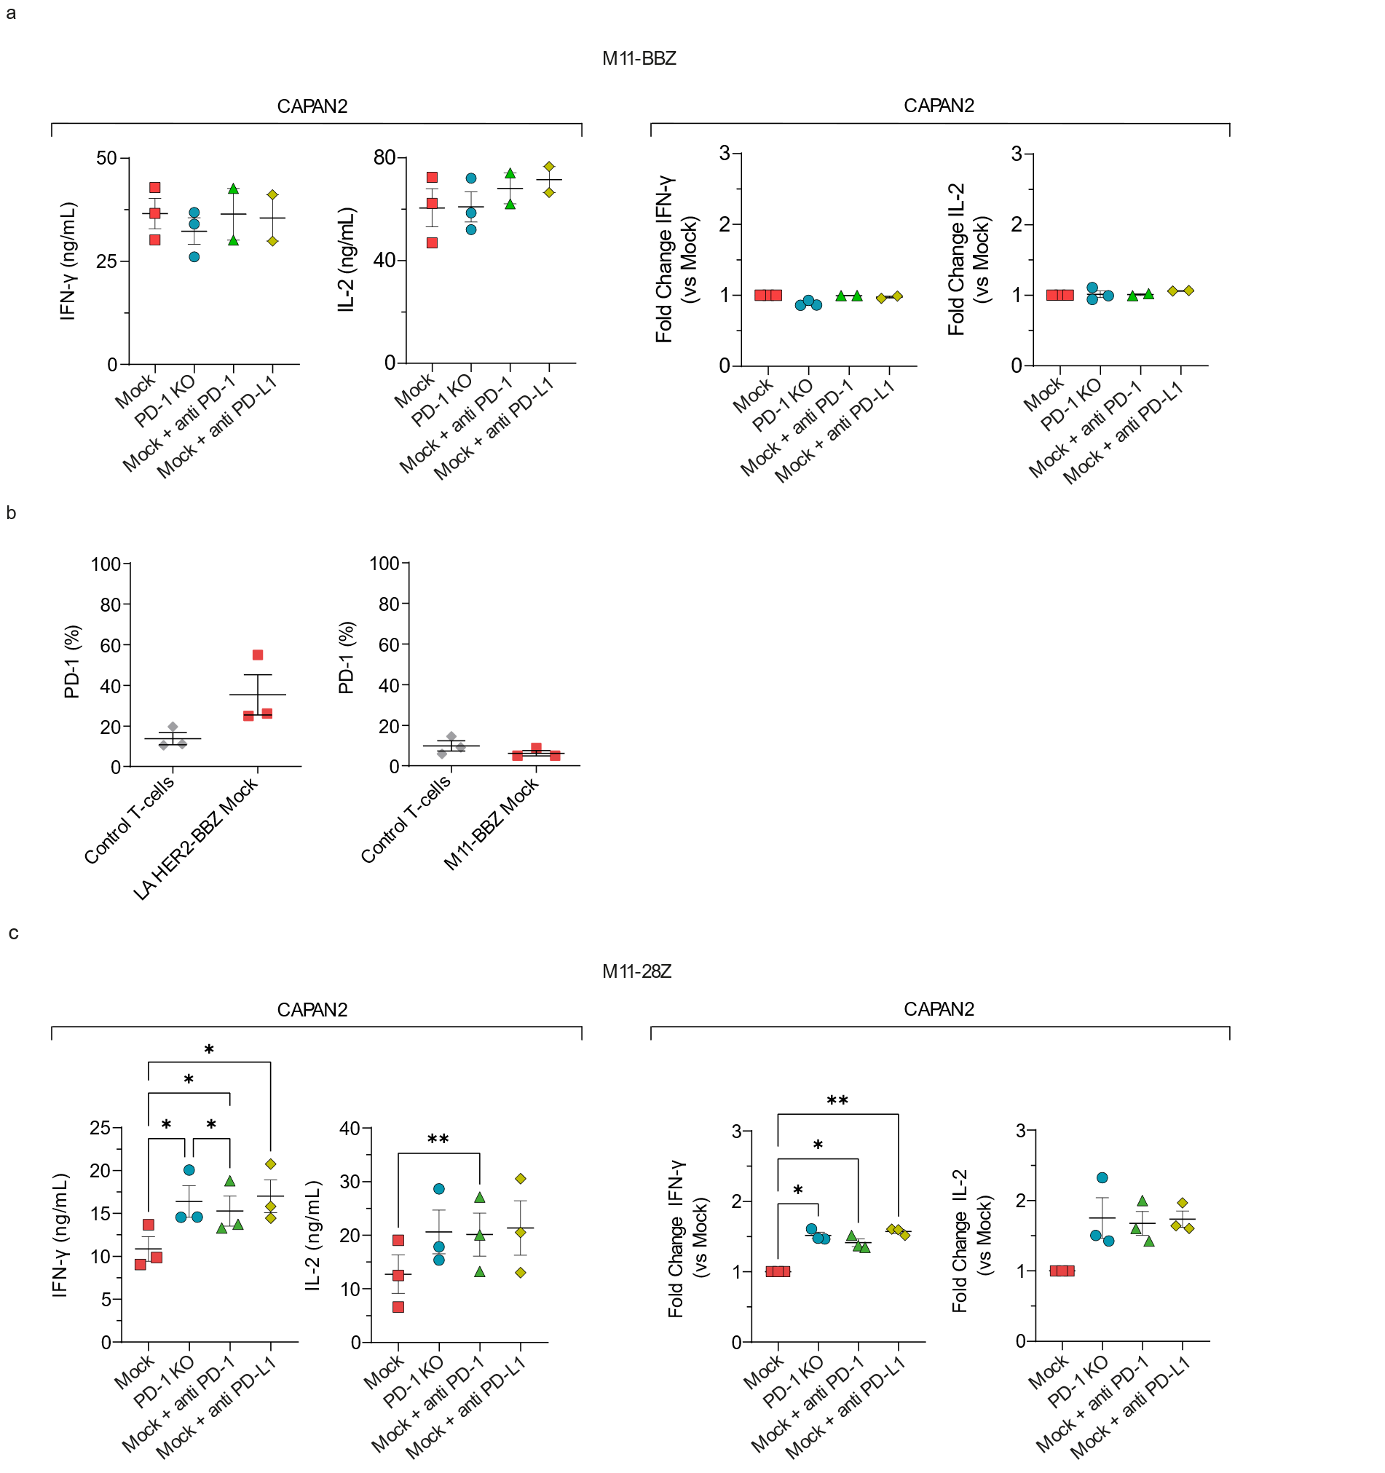
4-1BB costimulatory domain renders M11 CAR-T cells insensitive to PD-1/PD-L1 inhibition. a M11-BBZ mock, PD-1-KO, mock with anti PD-1 or anti PD-L1 CAR-T cells were co-cultured with CAPAN2 (E:T=3:1). IFN-y and IL-2 release was analyzed 24 hours later by ELISA. Cytokine secretion is represented by absolute levels (left panel) or by fold change of PD-1 KO CAR-T cells, mock CAR-T cells with anti PD-1 or anti PD-L1 as compared to mock CAR-T cells (right panel). Data are plotted as mean ± SEM (n=3 donors). b Percentage of PD-1 expression by flow cytometry of control T-cells and LA HER2-BBZ mock CAR-T cells on day 8 of T-cell expansion (left panel) and Control T-cells and M11-BBZ CAR-T cells on day 11 of the T-cell expansion (right panel). (n=3 donors). c M11-28Z mock, PD-1-KO, mock with anti PD-1 or anti PD-L1 CAR-T cells were co-cultured with CAPAN2 (E:T=3:1). IFN-y (a) and IL-2 (b) release was analyzed 24 hours later by ELISA. Cytokine secretion is represented by absolute levels (left panel) or by fold change of PD-1 KO CAR-T cells, mock CAR-T cells with anti PD-1 or anti PD-L1 as compared to mock CAR-T cells (right panel). Data are plotted as mean ± SEM. (n=3 donors). *, p = 0.01, **, p < 0.01, by one-way ANOVA with Tukey post hoc test.

