Table 3. Solubility of CTA in different solvents.
Solvent |  | Solubility | Photos
Non-Polar | Chloroform | Fully soluble | 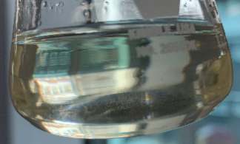
Non-Polar | Dichloromethane | Fully soluble | 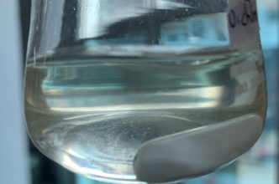
Non-Polar | Dimethylsulfoxide (DMSO) | Fully soluble | 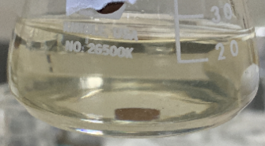
Non-Polar | Glacial acetic acid | Partially soluble | 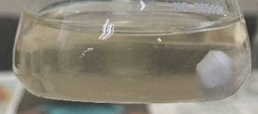
Polar | Acetone | Not soluble | 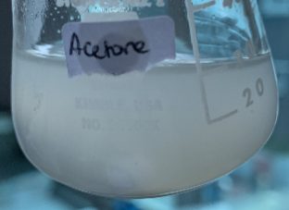
Polar | Purified water | Not soluble | 