Forest plots of meta-analyses by mortality cause
Note that the same study might be cited more than once in the meta-analyses. The reason for this is because one study can report several mortality causes.

Non-infectious causes

Predation
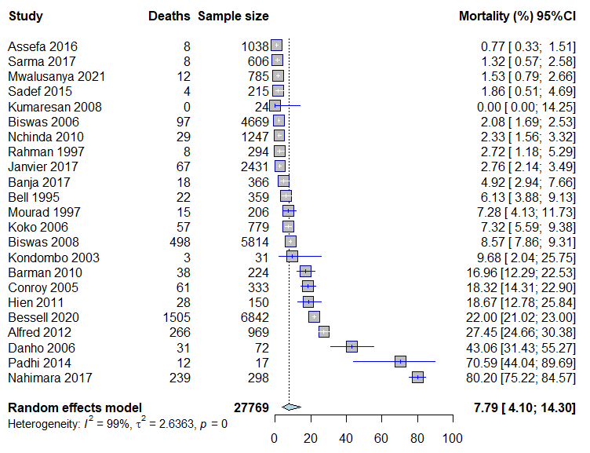

Cachexia
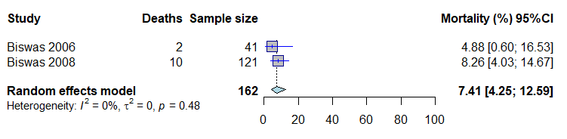

Weather conditions
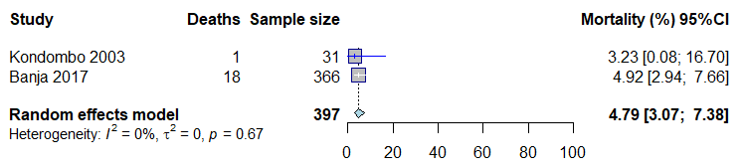

Injuries
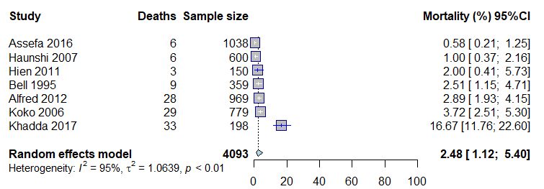

Infectious causes

Bacterial diseases
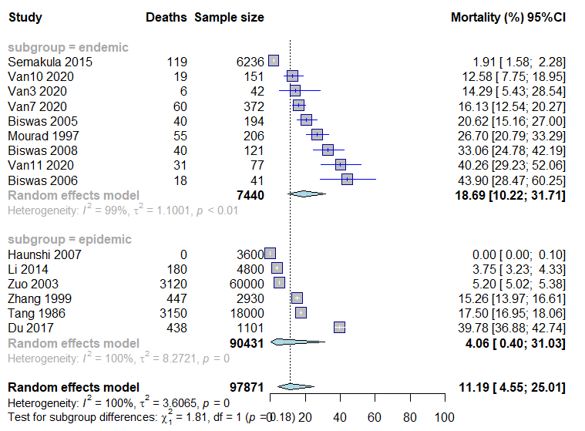

Bacterial and parasitic diseases
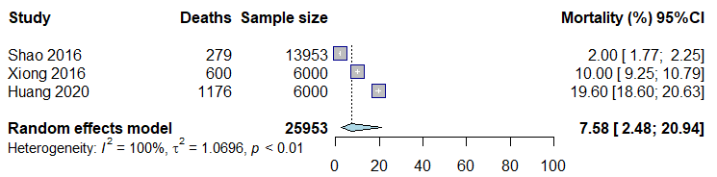

Bacterial and viral diseases
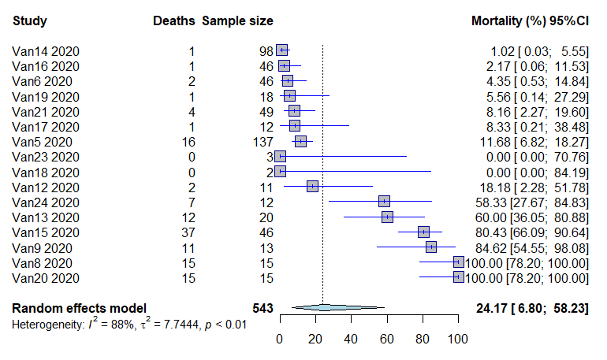

Viral diseases
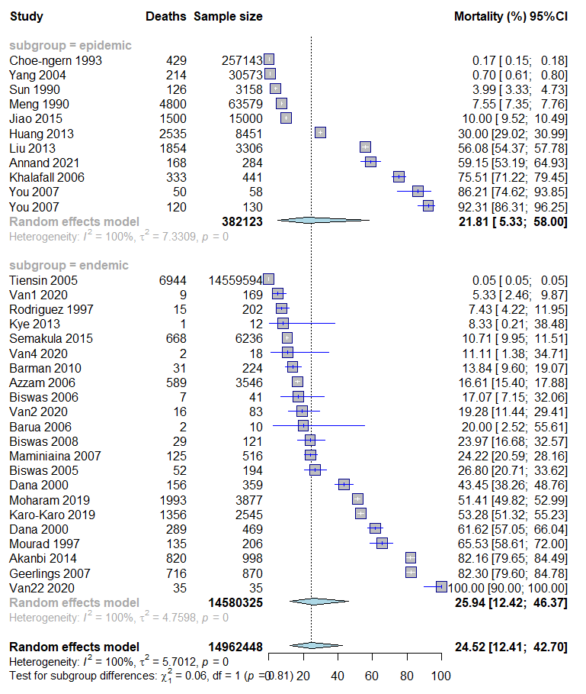

Parasitic diseases
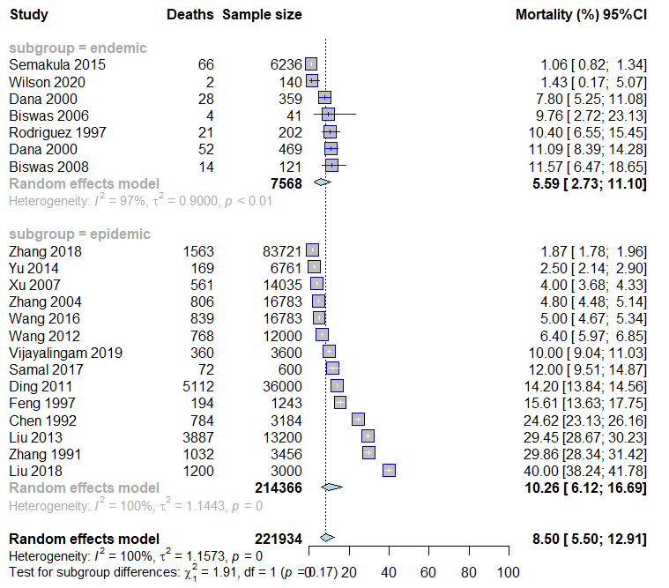

Fungal diseases
