Forest-plots of meta-analysis of economic losses by mortality cause

Infectious causes

Bacteria
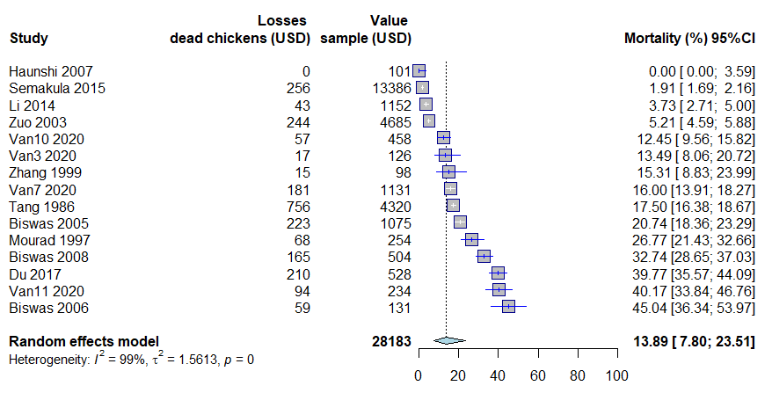

Bacteria and viral diseases
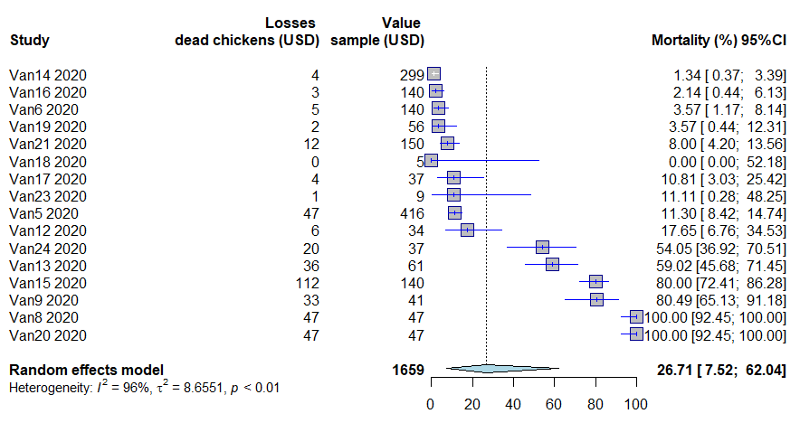

Bacteria and parasite diseases
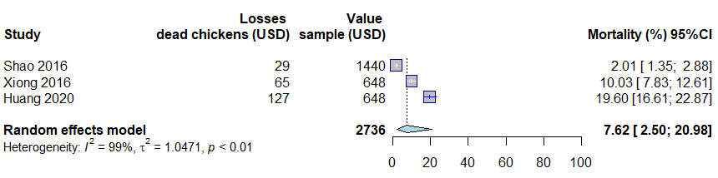

Parasite diseases
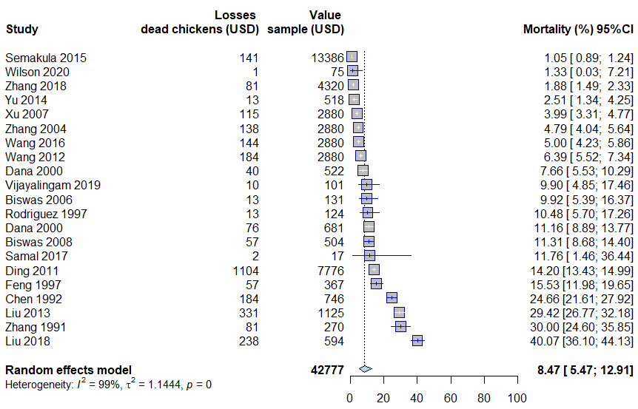

Viral diseases
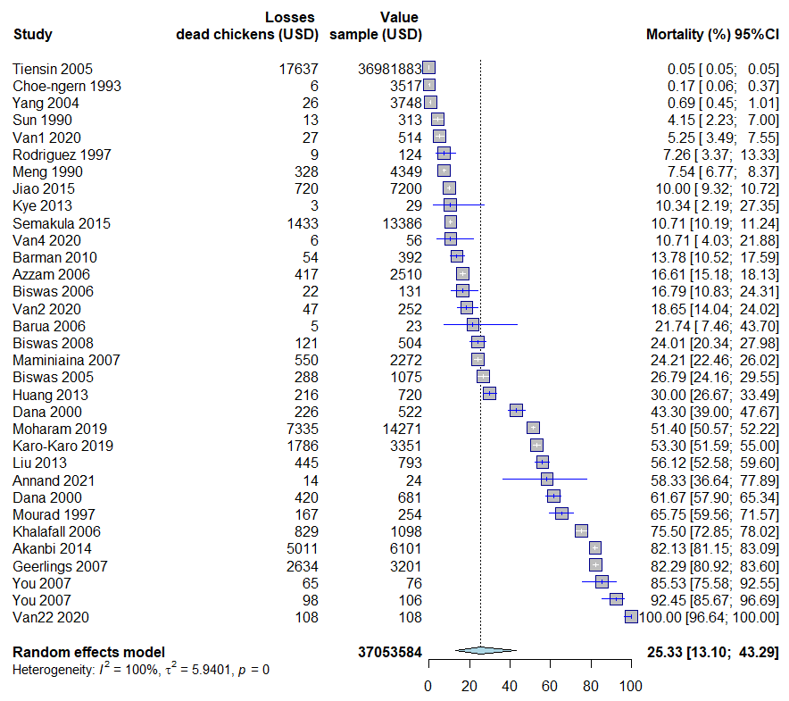

Fungus
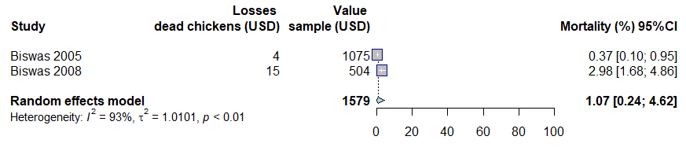

Non-infectious causes

Predation
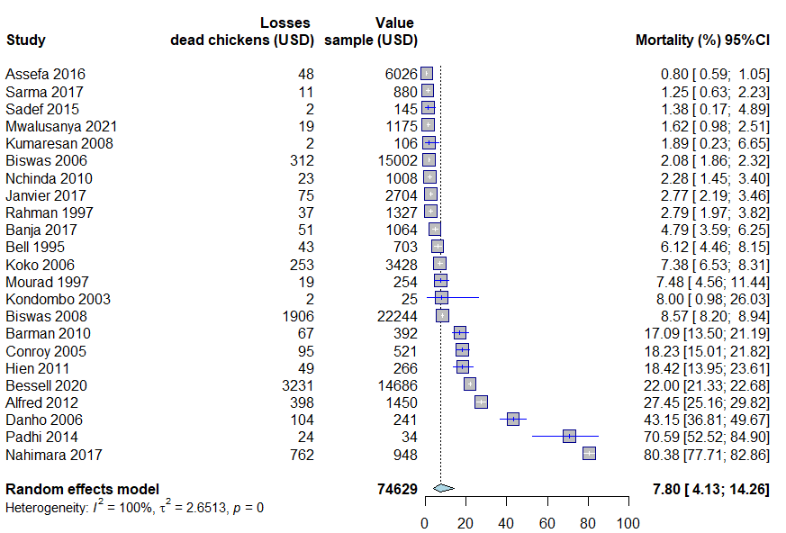

Injuries
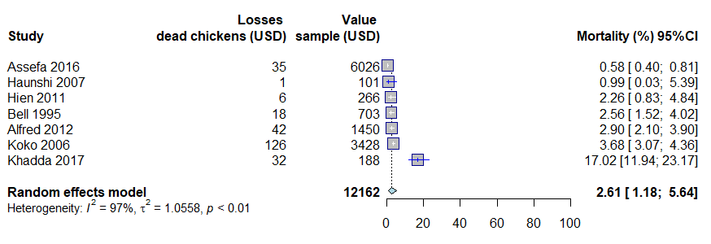

Cachexia
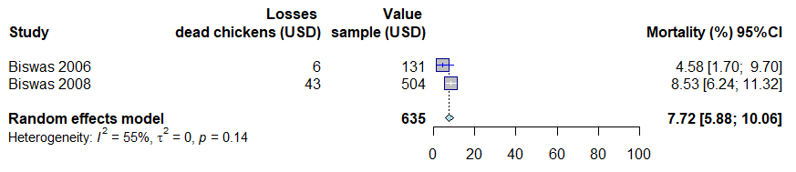

Weather
