Supporting Information

Table S1. Nominal chemical composition of 316L SS (in wt%, Bal. Fe).
Element | C | Mn | P | S | Si | Cr | Ni | Mo
Composition | 0.035 | 2.00 | 0.04 | 0.03 | 1.00 | 16.0~18.0 | 10.0~15.0 | 2.00~3.00

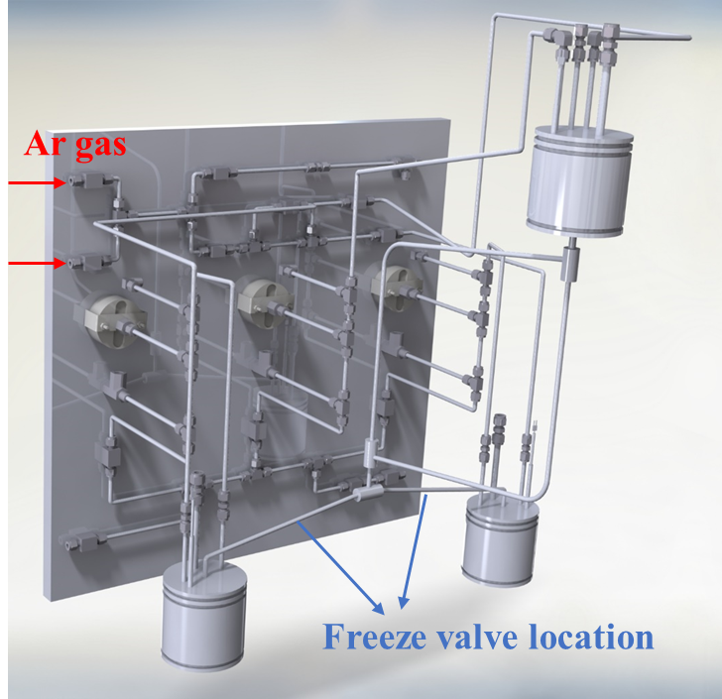
Figure S1. The Schematic of the molten salt microloop.

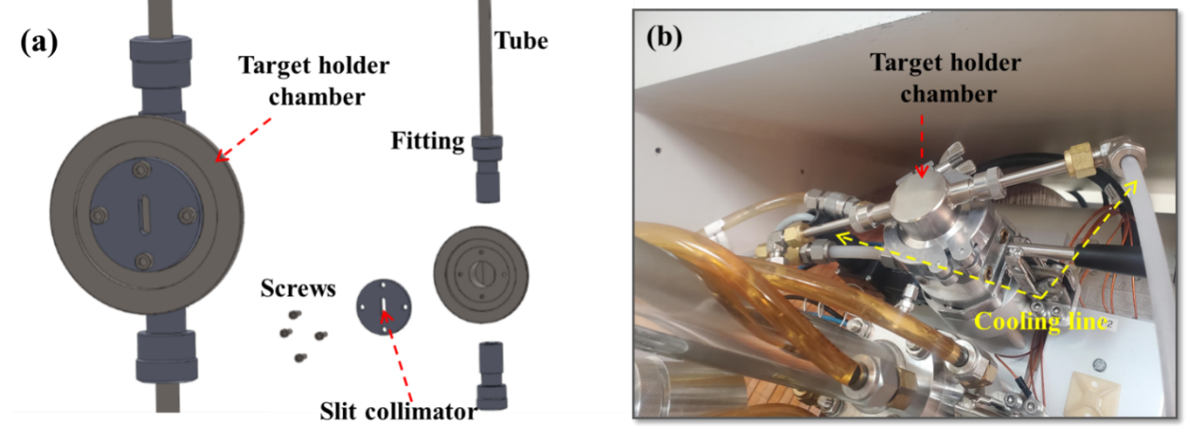
Figure S2. (a) Schematic illustration of the designed target holder and slit collimator for tube irradiation. (b) Target holder in cyclotron GE PETtrace before irradiation.

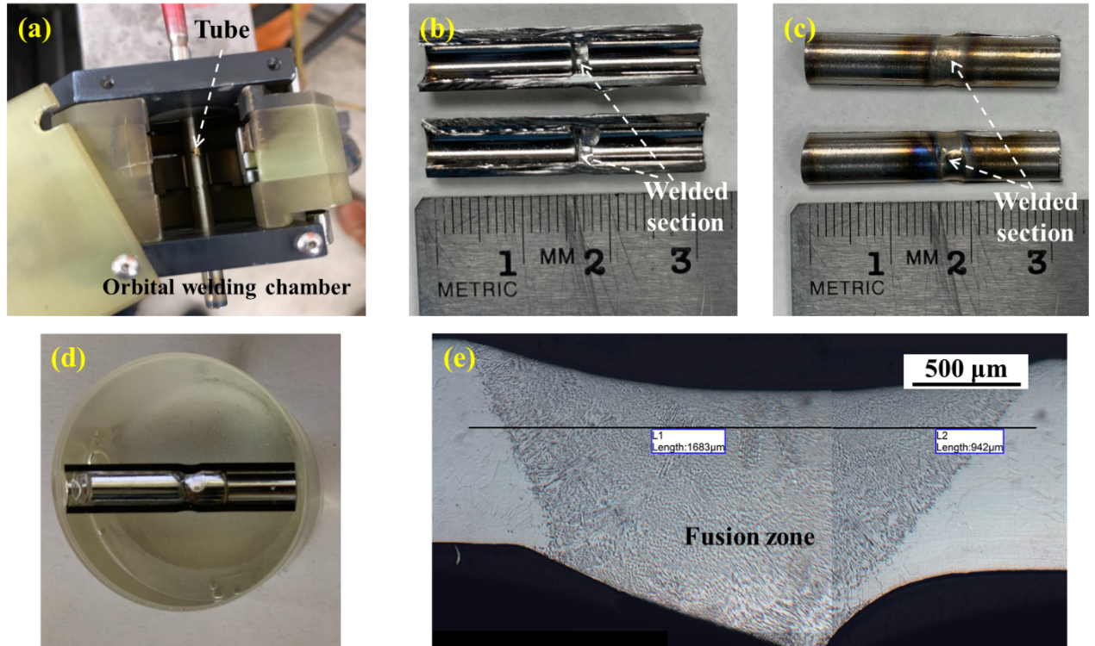
Figure S3. (a) Orbital welder chamber for the welding of 316L SS tubes. (b) Inside view of the welded tube after being cut axially. (c) Outside view of the welded tube after being cut axially. (d) Cross section of the welded tube after being mounted and polished. (e) Heat affected/fusion zone of the orbital welding on two 316L SS tubes.

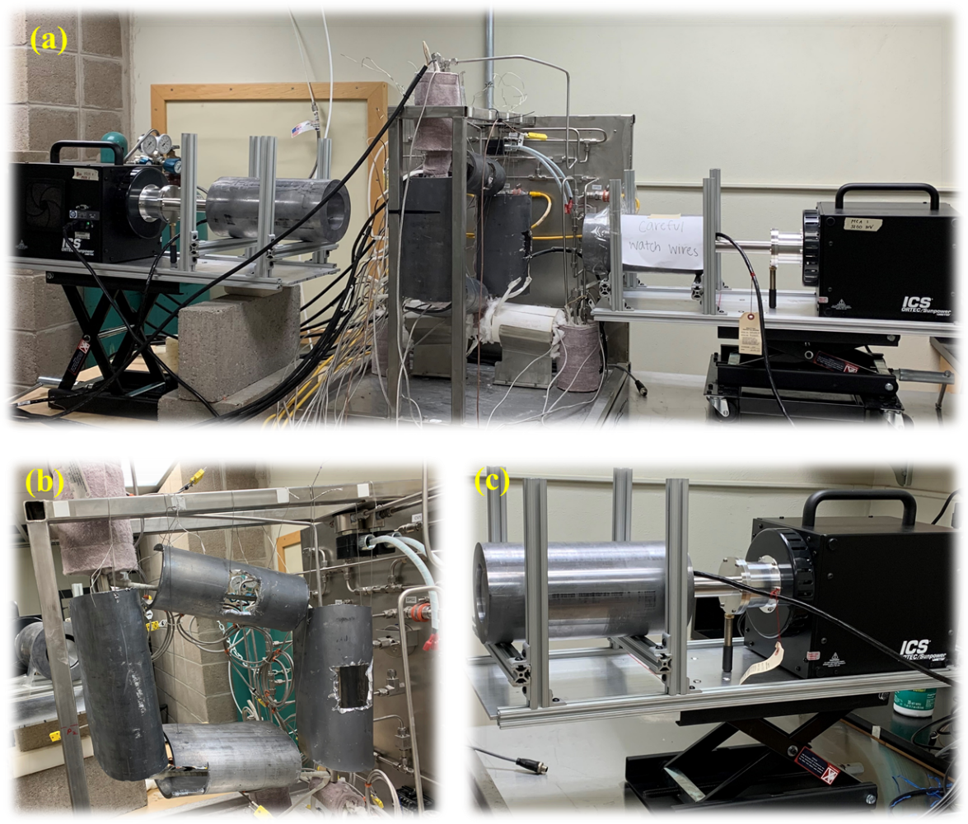
Figure S4. (a) Microloop in situ corrosion monitoring system. (b) Lead shielding for the microloop. (c) Cylindrical lead shielding for the HPGe detector.
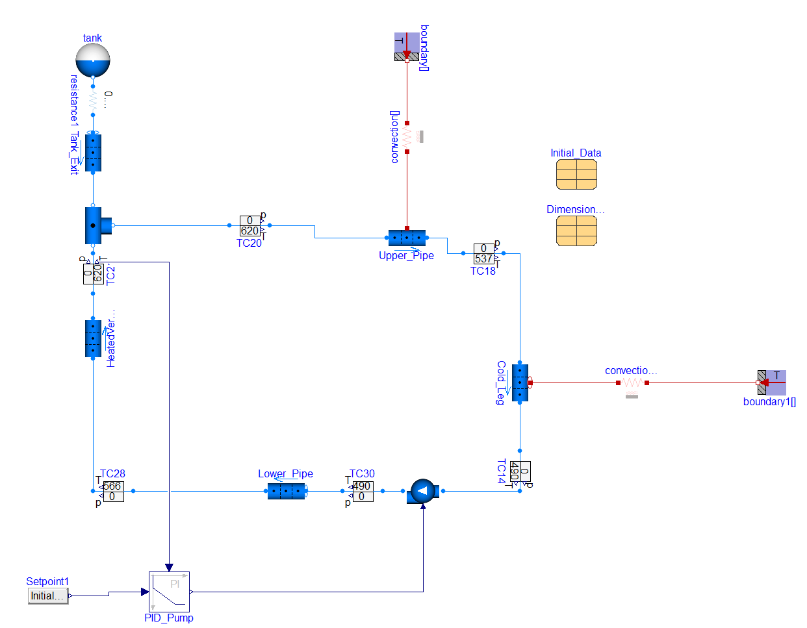
Figure S5. Schematic diagram of the TRANSFORM model of the natural circulation microloop.
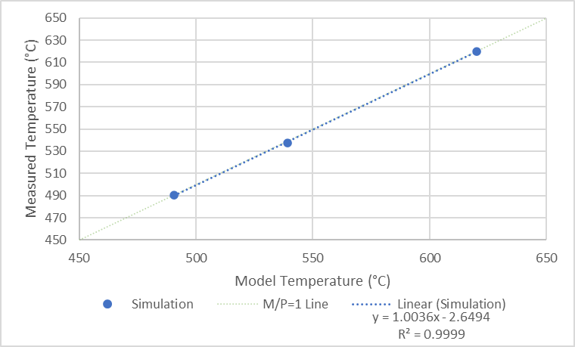
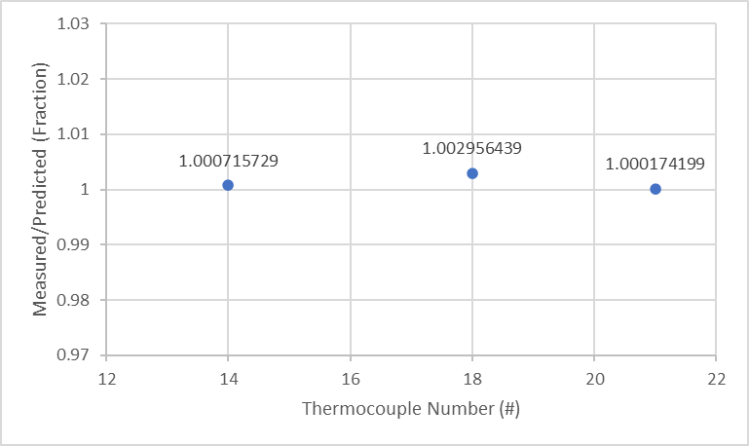
Figure S6. The comparison of the predicted and measured thermocouple reading in the microloop by TRANSFORM model.

