Supporting Information
Facile Synthesis of MgO-Carbon nanocomposites for Advanced Capacitive Electrode Materials
Aniruddha Mondal^{1*}, Mohd Afzal² Sudip Mondal^{3*}
¹Department of Chemical Engineering and Biotechnology, Tatung University, No. 40, Sec. 3, Chungshan North Rd., Taipei City 104, Taiwan
²Department of Chemistry, College of Science, King Saud University, Riyadh 11451, Saudi Arabia.
³Post Graduate Department of Chemistry, Seth Kesarimal Porwal College of Arts, Science and Commerce, Kamptee 441001, Maharashtra, India
Email: aniruddhacsmcri@gmail.com , sudipmondal5555@gmail.com

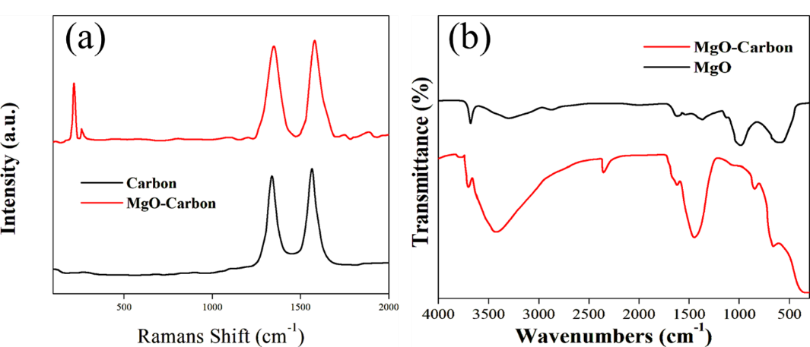
Figure S1: (a) Raman (b) FTIR and of the synthesized materials MgO-Carbon nanocomposites

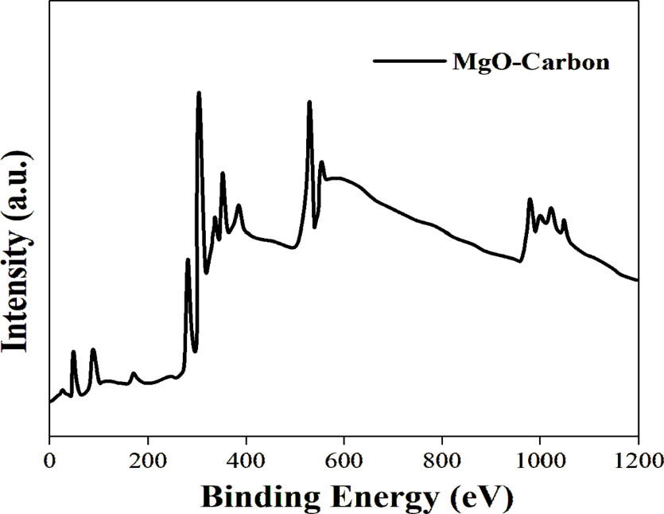
Figure S2: XPS Survey Spectra of MgO-Carbon nanocomposites

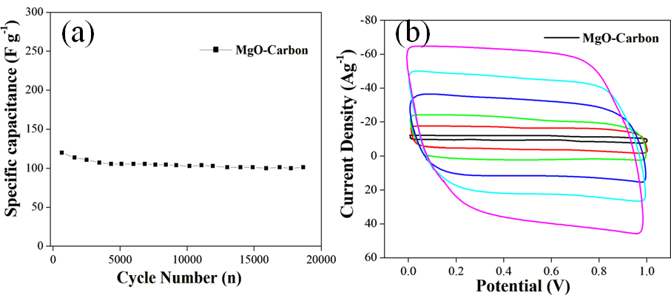
Figure S3: (a) Cycling performances (b) CV of at different scan rates MgO-Carbon nanocomposites.

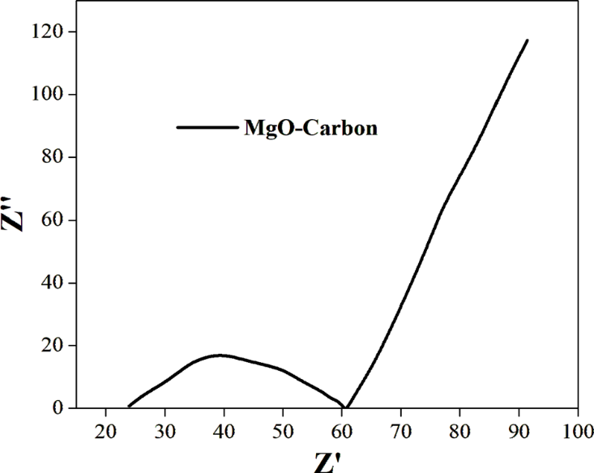
Figure S4: Nyquist plot of MgO-Carbon nanocomposites cells

