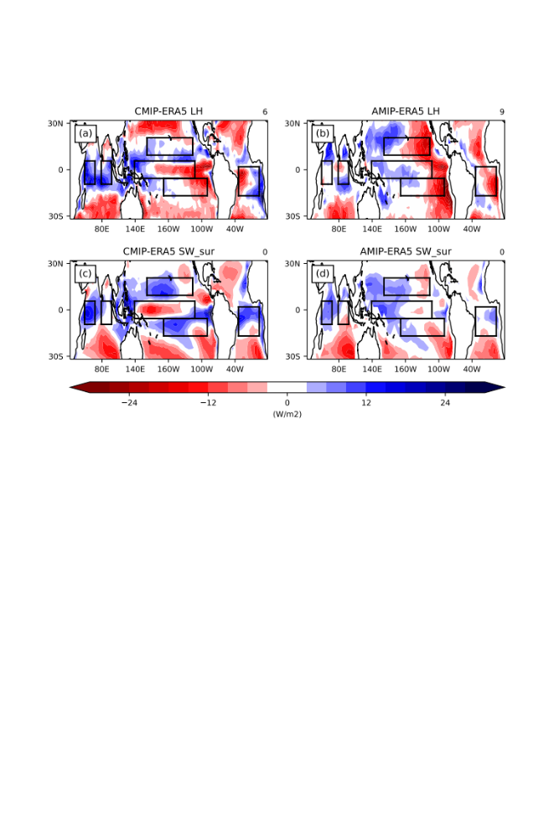
Fig. S1. Element bias from the CMIP ensemble minus ERA5 (left column) and from the AMIP ensemble minus ERA5 (right column). From top row to bottom row, respectively, $LH$ and ${SW}_{sur}$. Positive (negative) values represent the atmosphere gains (losses) energy.

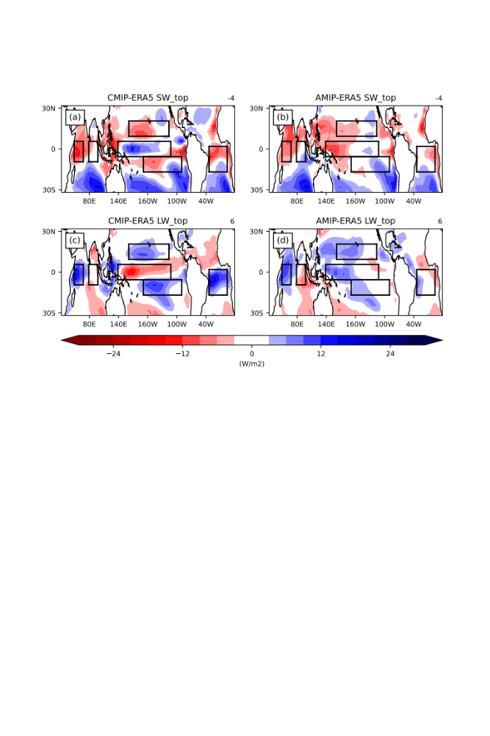
Fig. S2. Element bias from the CMIP ensemble minus ERA5 (left column) and from the AMIP ensemble minus ERA5 (right column). From top row to bottom row, respectively, ${LW}_{top}$ and ${SW}_{top}$. Positive (negative) values represent the atmosphere gains (losses) energy.

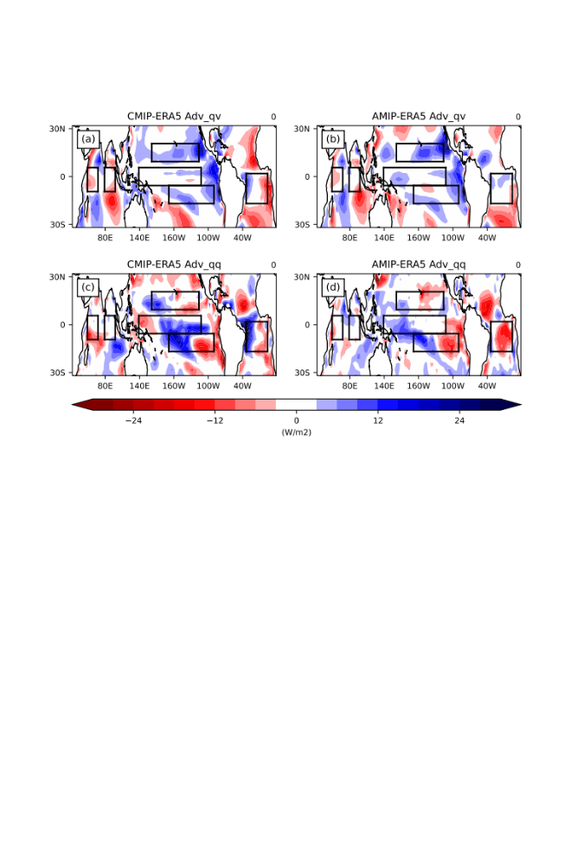
Fig. S3. Element bias from the CMIP ensemble minus ERA5 (left column) and from the AMIP ensemble minus ERA5 (right column). From top row to bottom row, respectively, ${Adv}_{qv}$ and ${Adv}_{qq}$. Positive (negative) values represent the atmosphere gains (losses) energy.

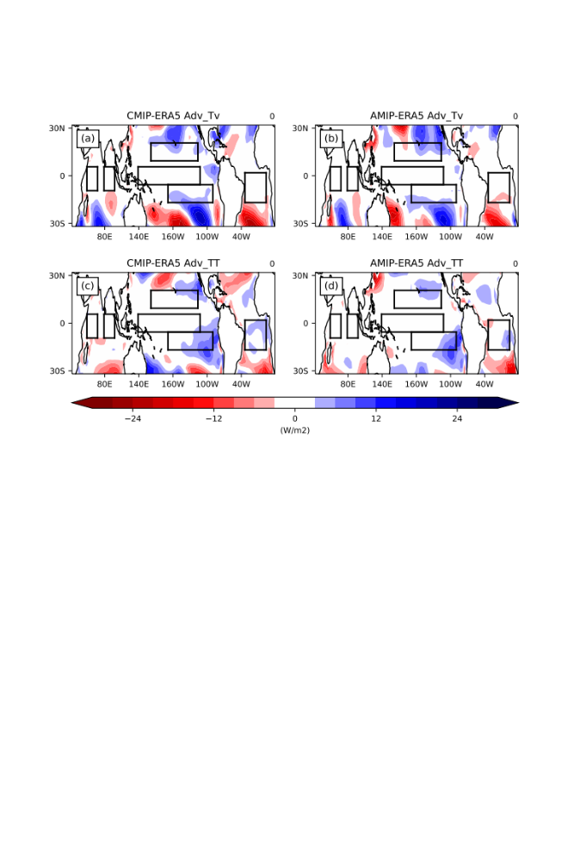
Fig. S4. Element bias from the CMIP ensemble minus ERA5 (left column) and from AMIP ensemble minus ERA5 (right column). From top row to bottom row, respectively, ${Adv}_{Tv}$ and ${Adv}_{TT}$. Positive (negative) values represent the atmosphere gains (losses) energy.

