Supplementary figures of the Manuscript “Probiotics reshape the coral microbiome in situ without affecting the surrounding environment”

Authors: Nathalia Delgadillo-Ordoñez 1,2, Neus Garcias-Bonet 1, Inês Raimundo 1,2, Francisca C. García 1, Helena Villela 1, Eslam O. Osman 1, Erika P Santoro 1, Joao Curdia 1, Joao G D Rosado 1,2, Pedro Cardoso 1,2, Ahmed Alsaggaf 1,2, Adam Barno 1,2, Chakkiath Paul Antony 1, Carolina Bocanegra 1, Michael Berumen 1,2, Christian R Voolstra 3, Francesca Benzoni 1,2, Susana Carvalho 1,2, Raquel S Peixoto 1,2

1 Red Sea Research Center and Computational Biology Research Center, King Abdullah University of Science and Technology, Thuwal, 23955, Saudi Arabia

2 Marine Science and Bioscience Programs, Biological and Environmental Science and Engineering Division, King Abdullah University of Science and Technology, Thuwal, 23955, Saudi Arabia

3 Department of Biology, University of Konstanz, Konstanz, Germany

Figure S1
Bacterial community structure of P. verrucosa according to sampling time and treatment. Nonmetric multidimensional scaling ordination (nMDS) of bacterial communities of coral in T1 (squares), T2 (circles), T3 (tringles), and T4 (trapeziums) (k = 2). The placebo (blue) and probiotic (pink) treatments are shown.
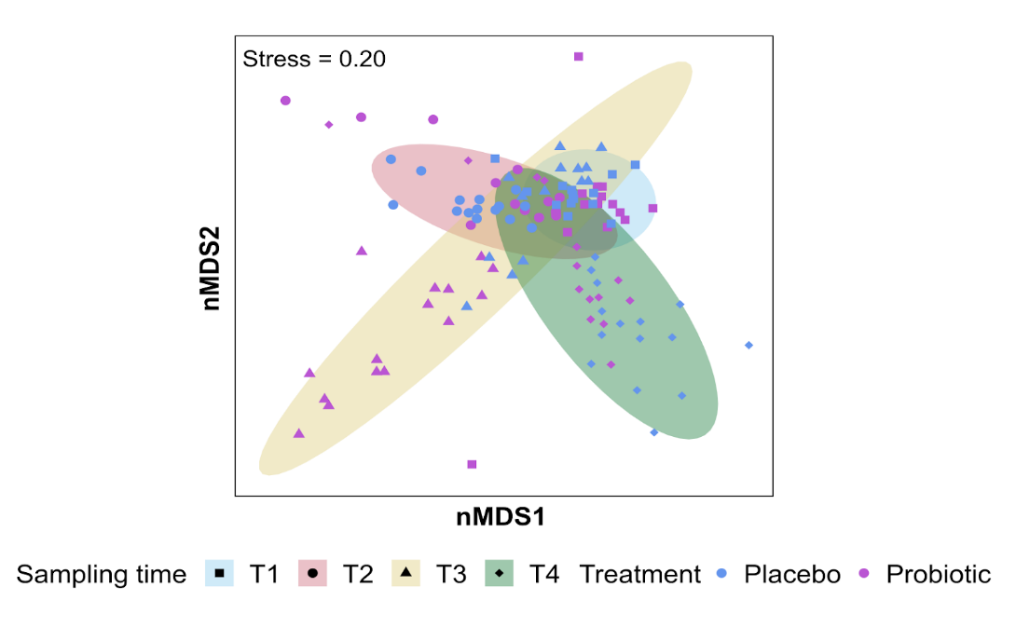

Figure S2
Bacterial community structure of coral, water and sediment bacterial communities. Nonmetric multidimensional scaling ordination (nMDS) of coral, seawater and sediment biological components (k = 2). The placebo (blue) and probiotic (pink) treatments are shown.
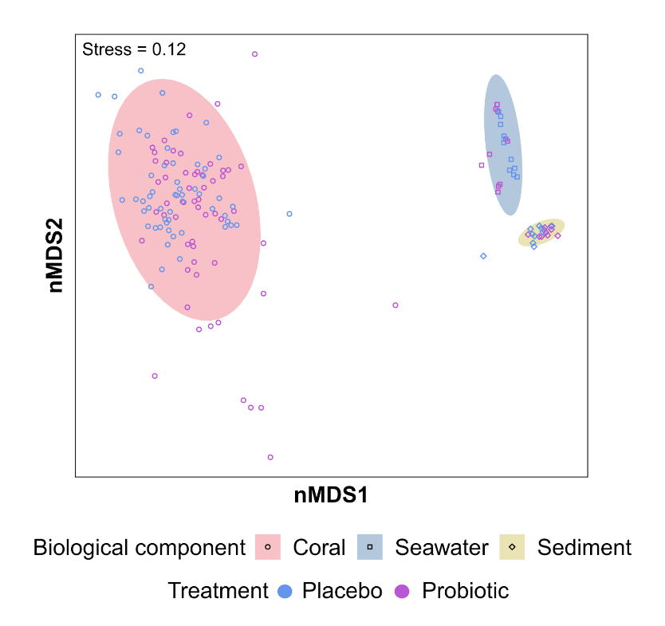

Figure S3
Coral health proxies monitored in Pocillopora verrucosa. A) In situ photosynthetic efficiency (F_{v}/F_{m}) profiles by treatment (placebo and probiotic) and sampling times (T1-T4). The X-axis represents the treatments and the Y-axis shows the F_{v}/F_{m} values. F_{v}/F_{m} values below 0.6 indicate potentially stressed or damaged photochemical systems of the algae symbionts in corals. B) ED50 (thermal threshold) (Y-axis) for each treatment (placebo and probiotic) by sampling time (T1-T4) in CBASS experiments.
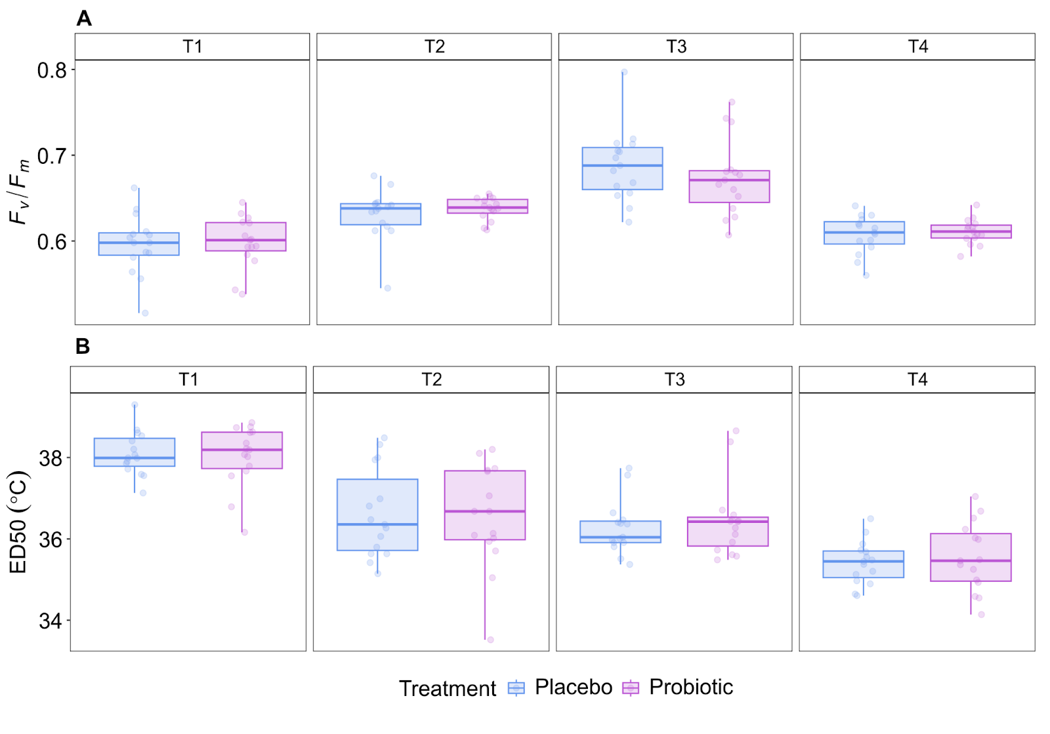

Figure S4
In situ inoculation of the probiotic consortium to healthy colonies of Pocillopora verrucosa in the Coral Probiotic Village (CPV) in the Central Red Sea. 30 mL of the probiotic solution were released over the colony using a plastic syringe. Photo by Morgan Bennett-Smith.
