Table 1 Development stages of inflorescences of B. simplicifrons.
Stage | 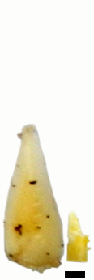 | 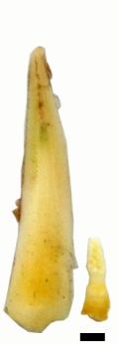 | 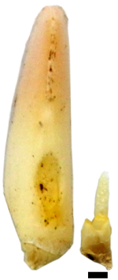 | 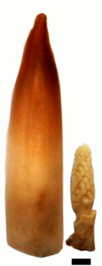 | 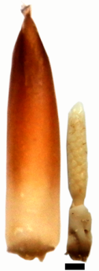 | 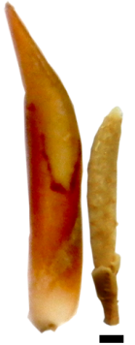
Stage | I | II | III | IV | V | VI
Qualitative | Immature axillary buds showing early prophyll initiation | Inflorescence bud shortly after prophyll initiation | Inflorescence buds showing elongation of prophyll | Inflorescence buds showing peduncular bract initiation |  | Late inflorescence buds showing elongation of prophyll and peduncular bracts
Length (cm) | 0.3-0.5 | 0.5-0.9 | 0.9-1.2 | 1.2-1.5 | 1.5-1.8 | 1.8-2.1

