Appendix:
Time history responses of FE models subjected to El-Centro horizontal excitation.

Base Shear Responses
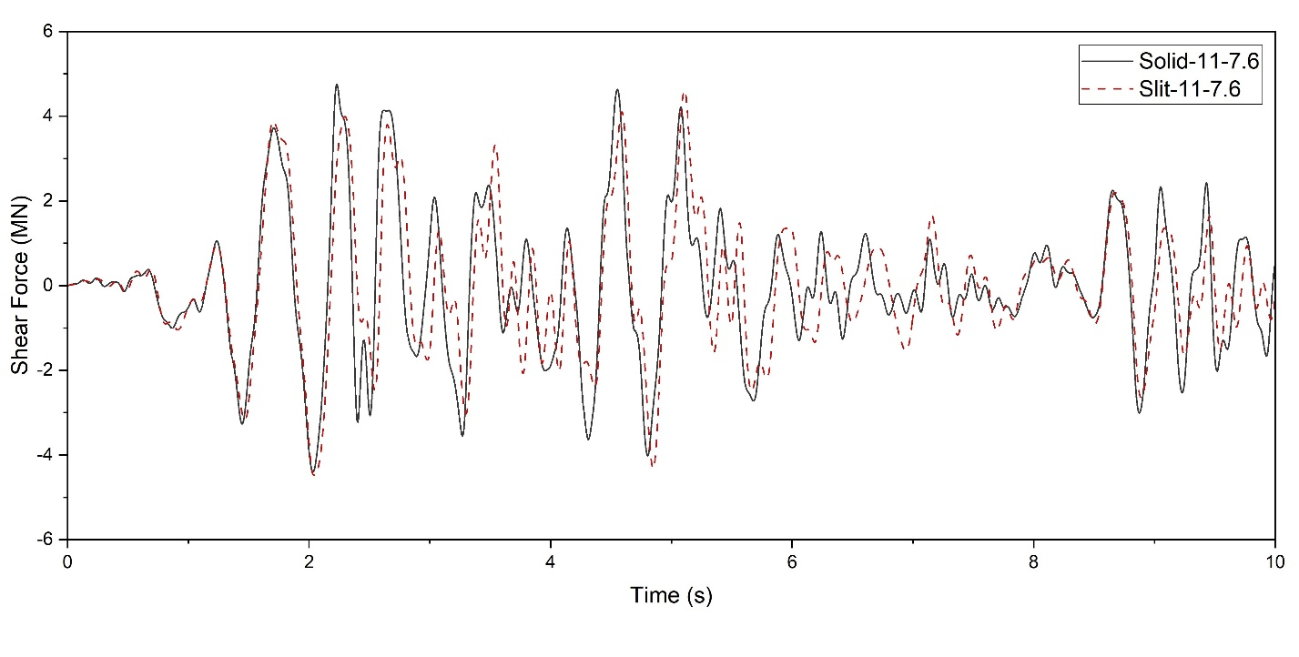
Fig. 1. Time history base shear response of Solid-11-7.6 and Slit-11-7.6 FE models

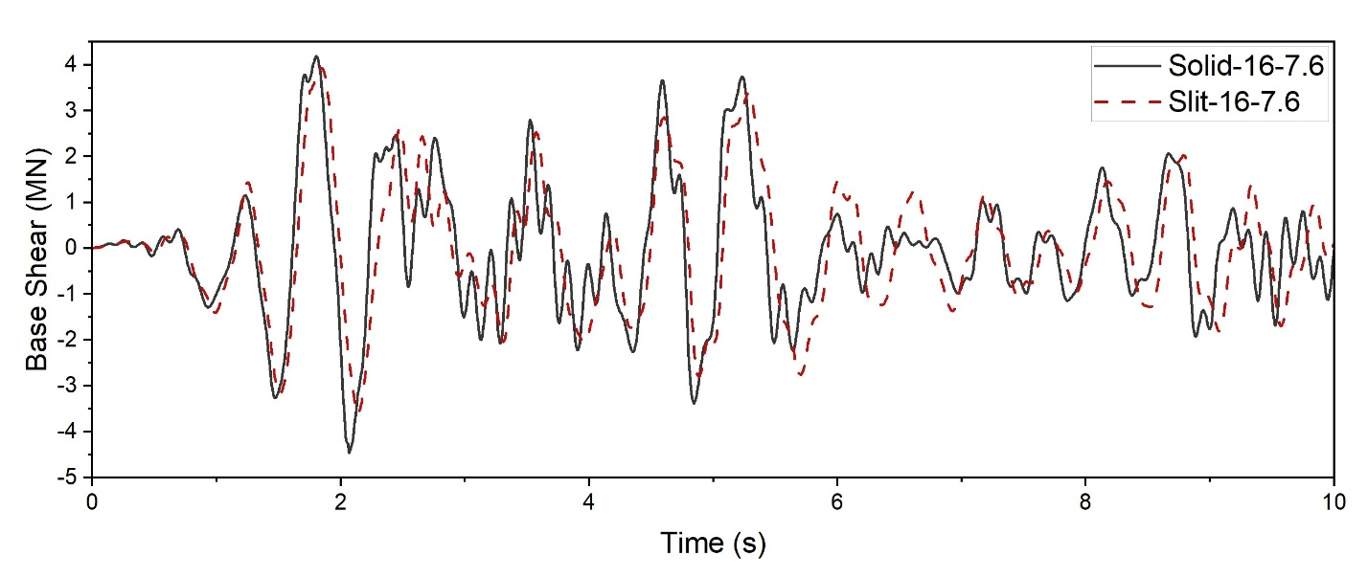
Fig. 2. Time history base shear response of Solid-16-7.6 and Slit-16-7.6 FE models

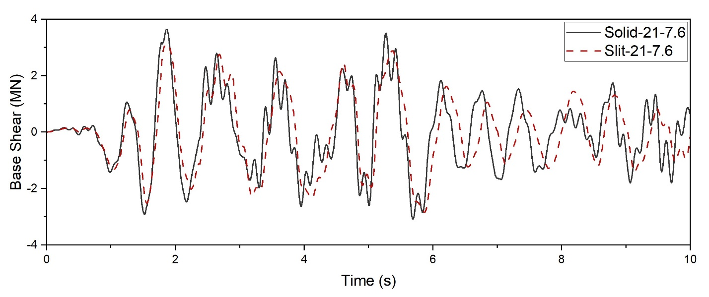
Fig. 3. Time history base shear response of Solid-21-7.6 and Slit-21-7.6 FE models

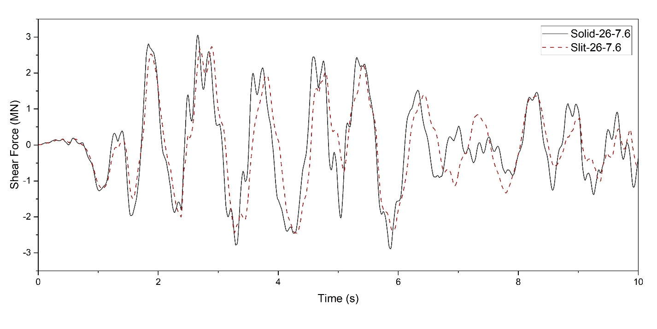
Fig. 4. Time history base shear response of Solid-26-7.6 and Slit-26-7.6 FE models
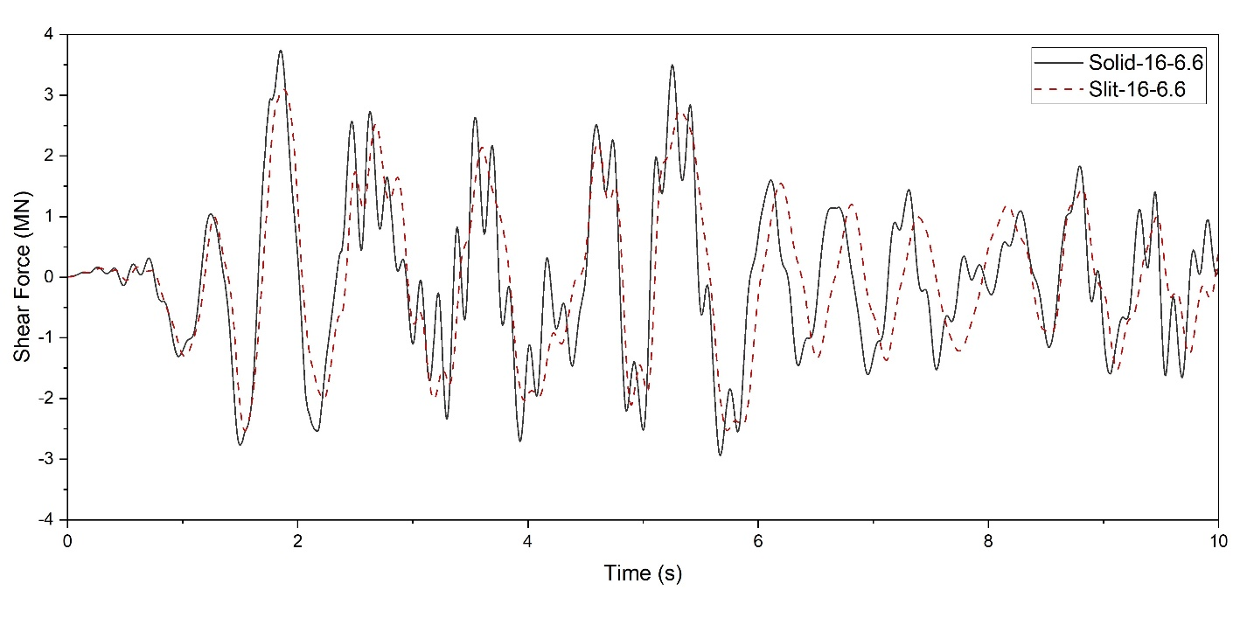
Fig. 5. Time history base shear response of Solid-16-6.6 and Slit-16-6.6 FE models

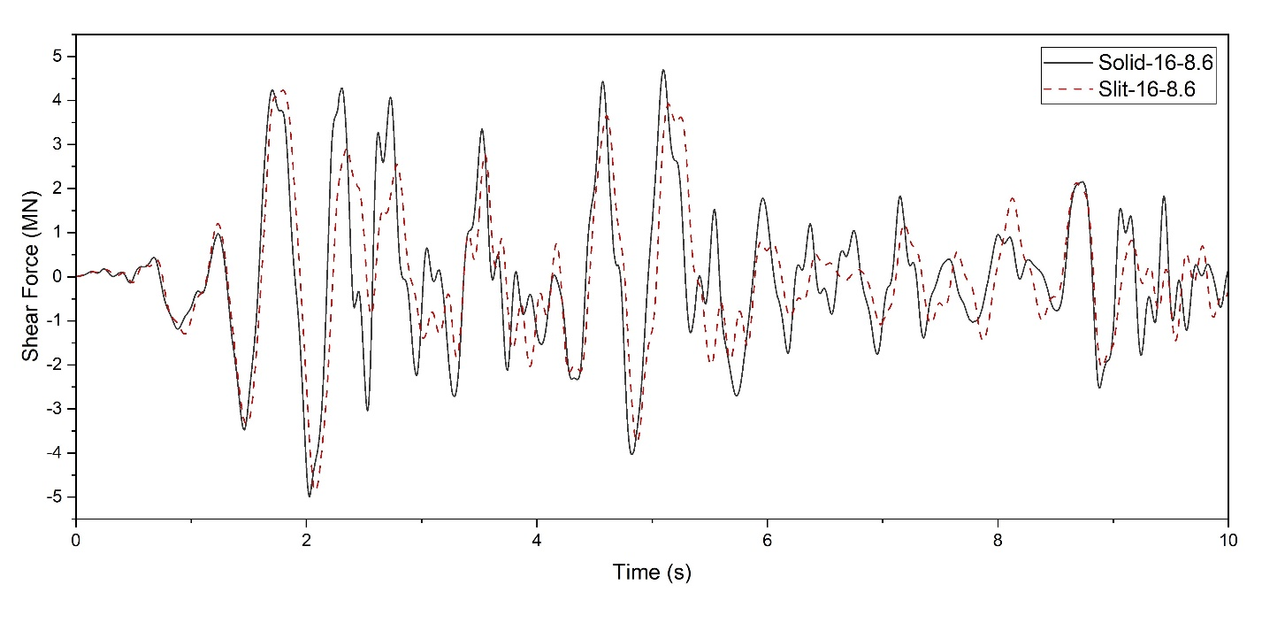
Fig. 6. Time history base shear response of Solid-16-8.6 and Slit-16-8.6 FE models

Base Moment Responses

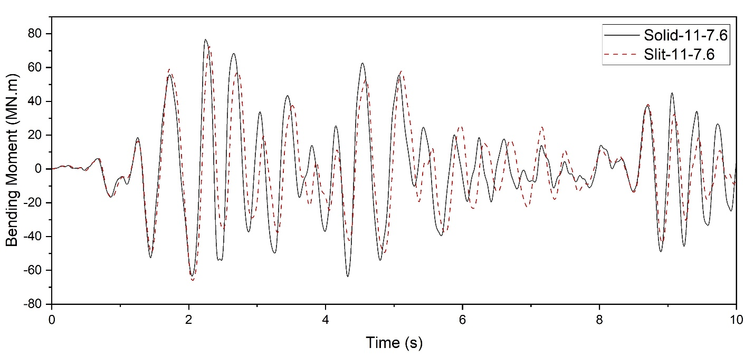
Fig. 7. Time history Base Moment response of Solid-11-7.6 and Slit-11-7.6 FE models
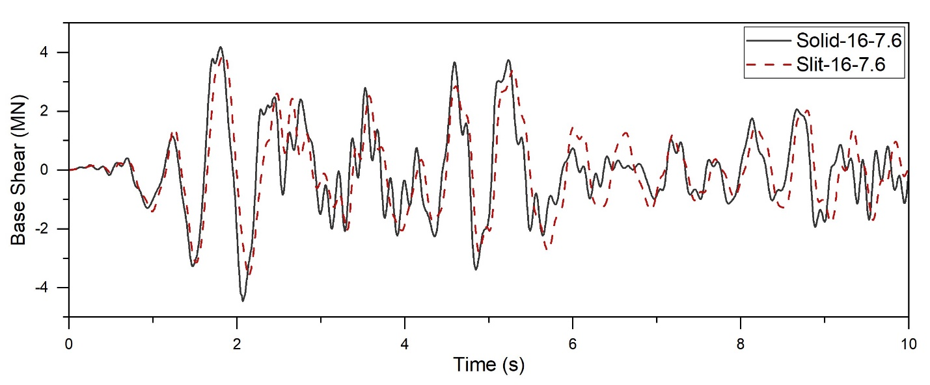
Fig. 8. Time history Base Moment response of Solid-16-7.6 and Slit-16-7.6 FE models
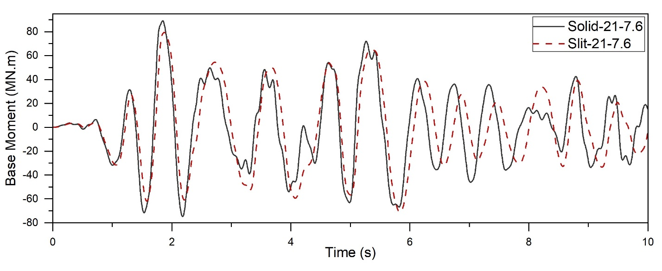
Fig. 9. Time history Base Moment response of Solid-21-7.6 and Slit-21-7.6 FE models

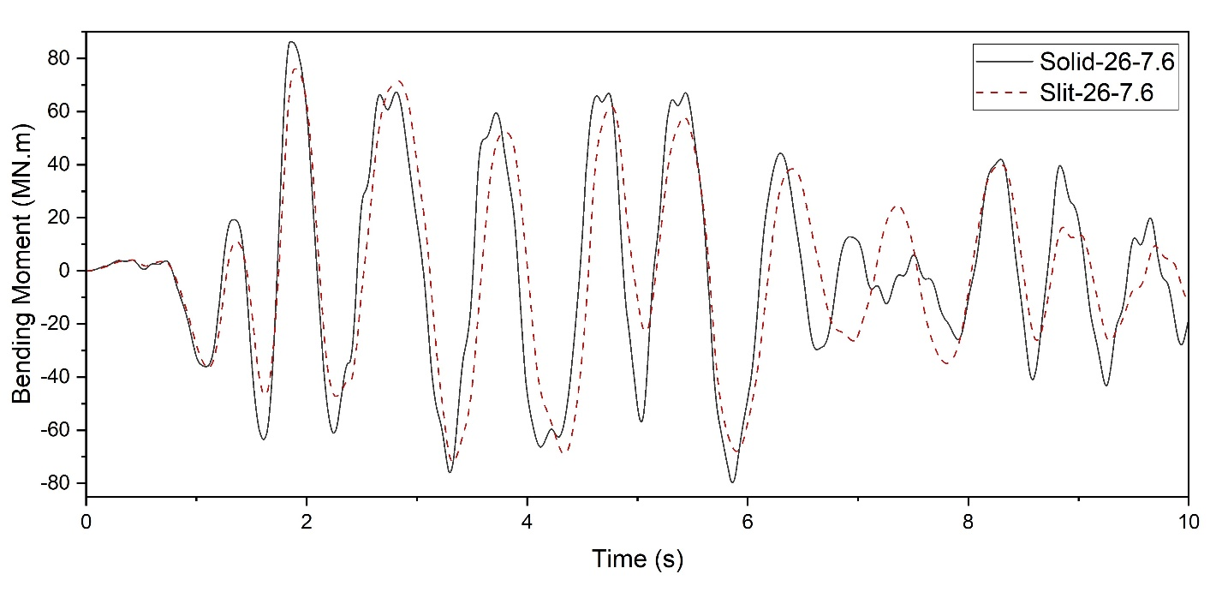
Fig. 10. Time history Base Moment response of Solid-26-7.6 and Slit-26-7.6 FE models

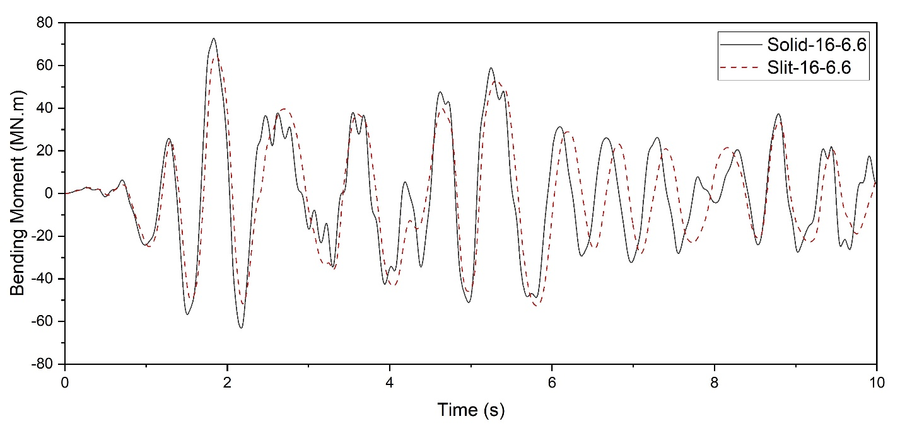
Fig. 11. Time history Base Moment response of Solid-16-6.6 and Slit-16-6.6 FE models
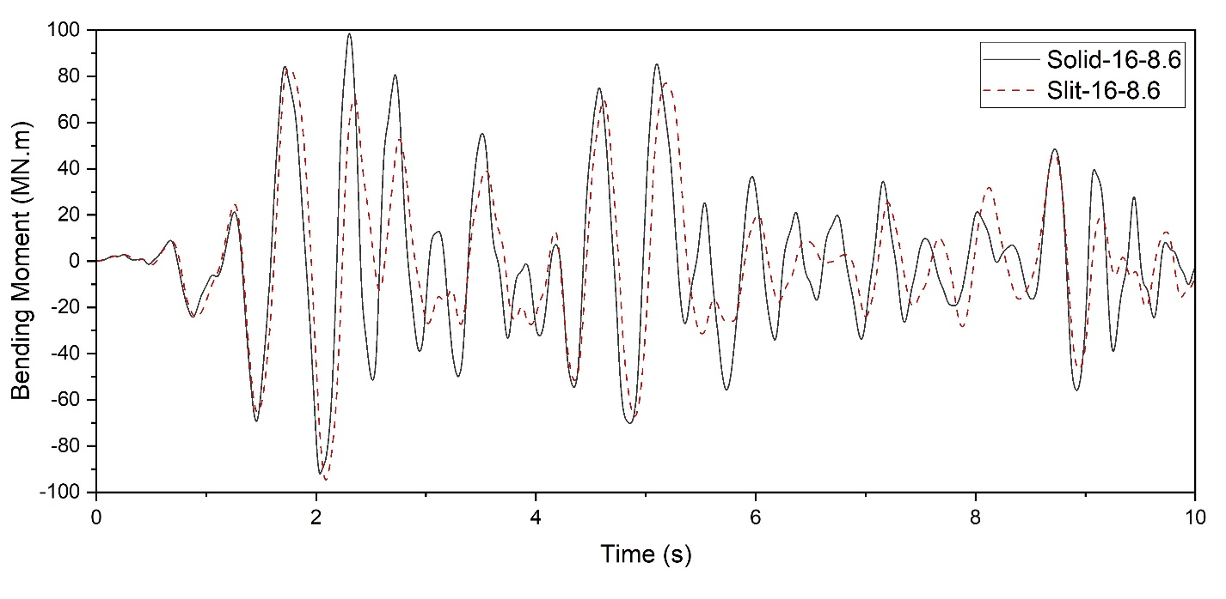
Fig. 12. Time history Base Moment response of Solid-16-8.6 and Slit-16-8.6 FE models

Top Lateral Displacements
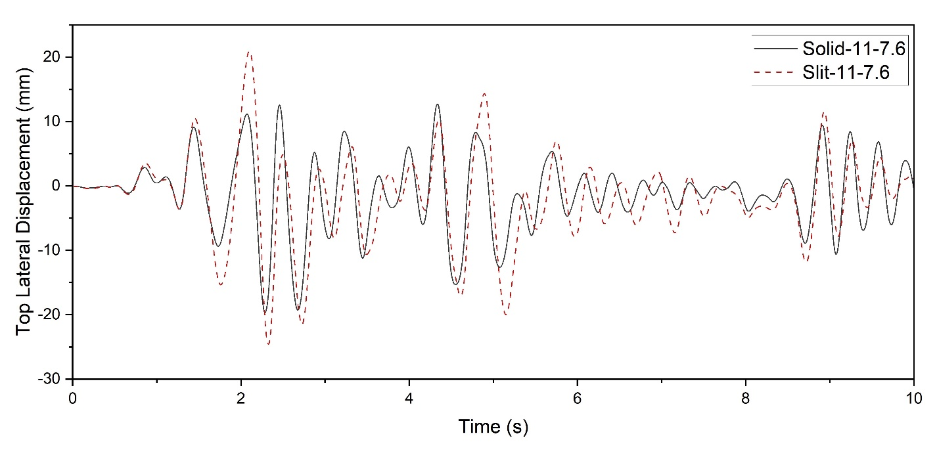
Fig. 13. Time history Top Lateral Displacement response of Solid-11-7.6 and Slit-11-7.6 FE models

Fig. 14. Time history Top Lateral Displacement response of Solid-16-7.6 and Slit-16-7.6 FE models

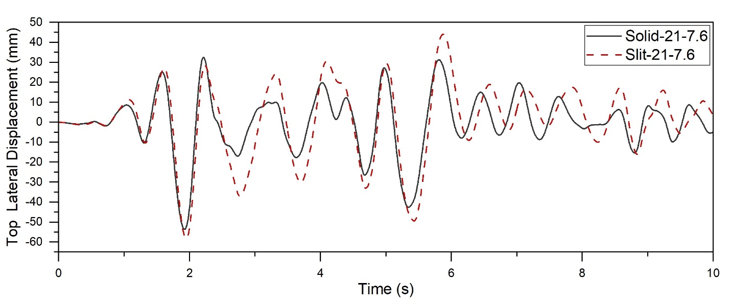
Fig. 15. Time history Top Lateral Displacement response of Solid-21-7.6 and Slit-21-7.6 FE models
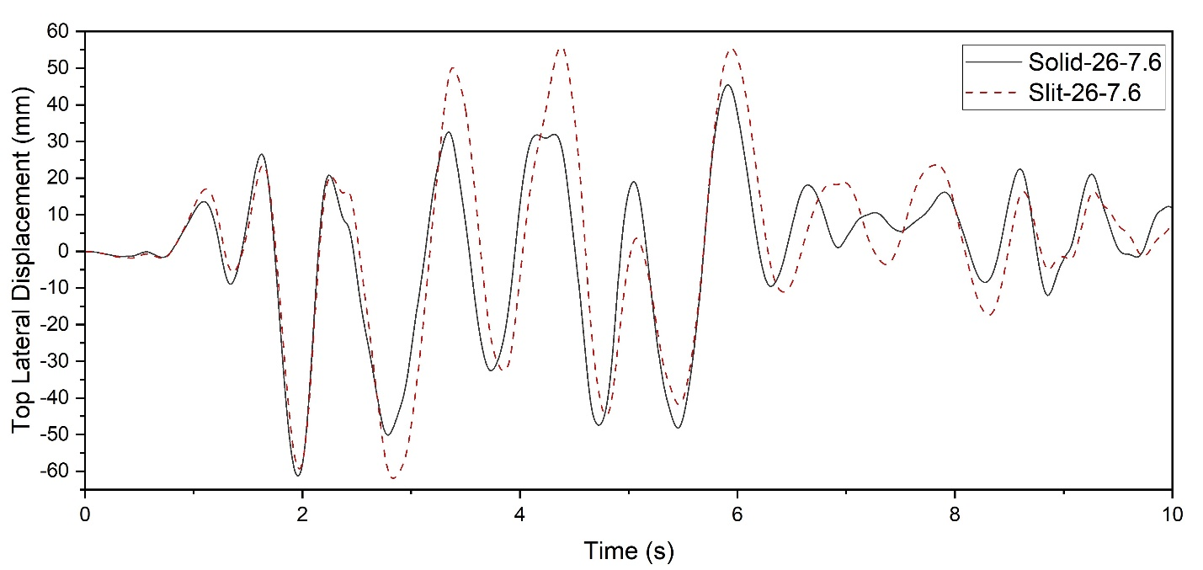
Fig. 16. Time history Top Lateral Displacement response of Solid-26-7.6 and Slit-26-7.6 FE models
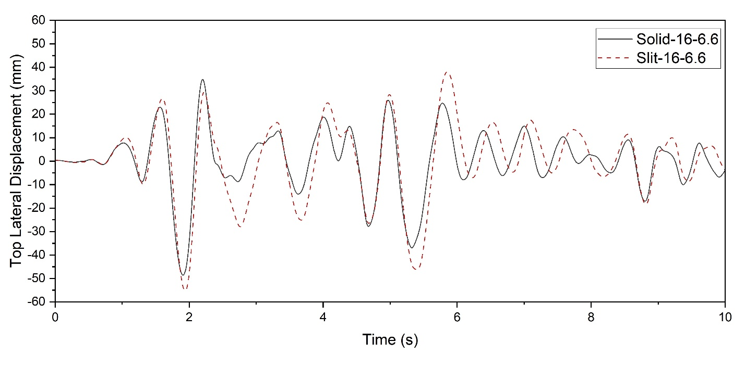
Fig. 17. Time history Top Lateral Displacement response of Solid-16-6.6 and Slit-16-6.6 FE models

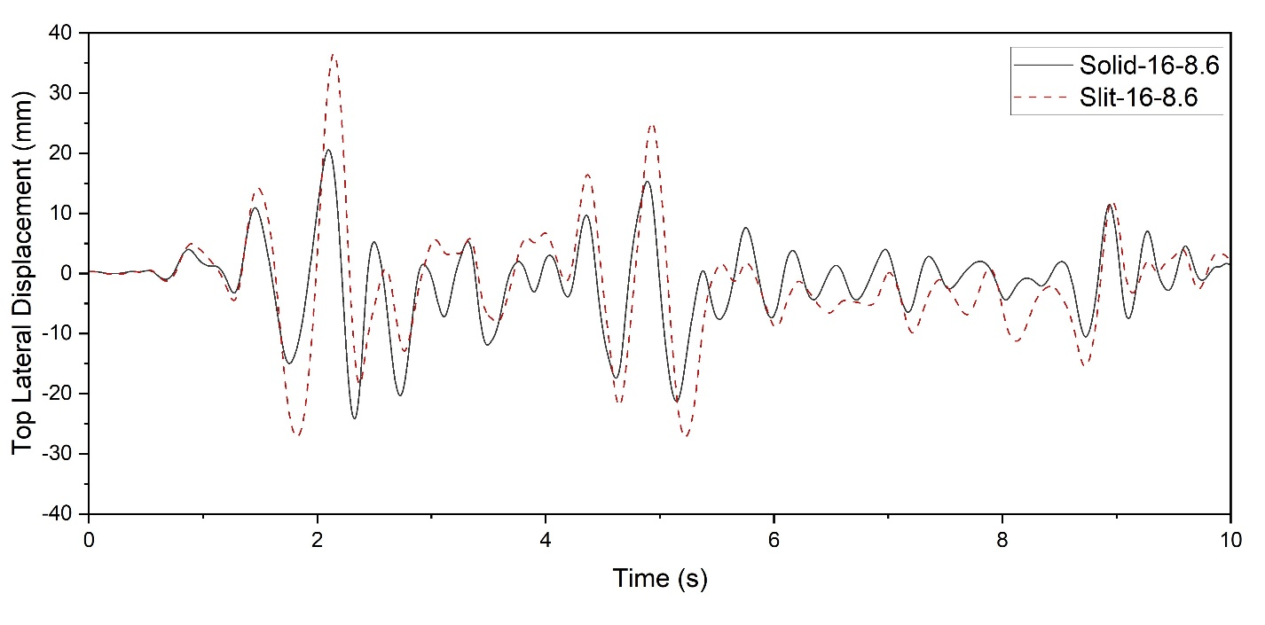
Fig. 18. Time history Top Lateral Displacement response of Solid-16-8.6 and Slit-16-8.6 FE models

